Supporting information
Modification with ultrasonication for enhanced properties of Cobalt-based zeolitic imidazolate framework
Sun Shuyangª, Wang Pengcheng^{b}, Lu Ming^{c,}*
School of Chemical Engineering, Nanjing University of Science and Technology, Nanjing 210094, Jiangsu Province, People’s Republic of China
a email: sunshuyang11@hotmail.com
b email: alexwpch@njust.edu.cn
c email: luming@mail.njust.edu.cn; Fax: (+86)-025-84315030
* Corresponding Author

Table of contents
- Supporting Figures
- Supporting Table

- Supporting figures:
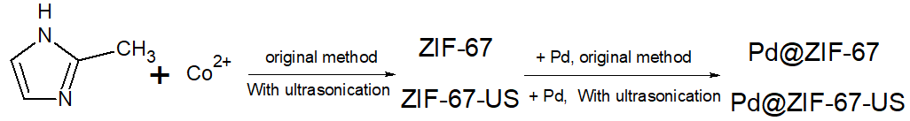
Scheme S1. Synthesis process of ZIF-67-US and Pd@ZIF-67-US
Figure S1. XRD patterns of ZIF-67-US and ZIF-67 recorded for 2θ = 5–80°.

Figure S2. TG curve of synthesized ZIF-67-US
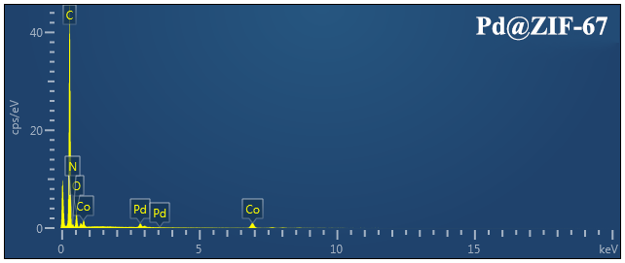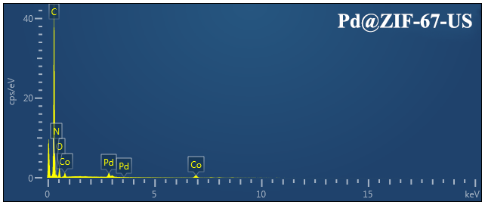
Figure S3. EDS spectrum of Pd@ZIF-67-US and Pd@ZIF-67-US
Figure S4. Nitrogen adsorption isotherms of synthesized products
Figure S5. Pore Diameter distribution of ZIF-67, ZIF-67-US, Pd@ZIF-67 and US Pd@ZIF-67
Figure S6. Yield comparison between o/m/p-chloronitrobenzene. Reaction conditions: reactant (2 mmol), DMF (20 mL), US treated catalyst (20 mg), HCOOH (500 μL), 60 °C.

Figure S7. Recycling experiment: reactant (2,6-dinitrotoluene, 2 mmol), DMF (20 mL), recycled Pd@ZIF-67-US (20 mg), HCOOH (500 μL), 60 °C, reaction time of 2 h.

Table S1. BET surface areas of synthesis compounds
 | ZIF-67 | ZIF-67-US | Pd@ZIF | US Pd@ZIF
BET Surface Area (m²/g): | 1093.02 | 1165.11 | 107.13 | 123.55
t-Plot External Surface Area (m²/g): | 7.55 | 27.43 | 15.15 | 24.75
t-Plot micropore volume (cm³/g): | 0.56 | 0.59 | 0.05 | 0.05

