**An Emerging Nanostructured Molybdenum Trioxide Based Biocompatible Sensor Platform for Breast Cancer Detection**

Shine Augustine,Nanobioelectronics Laboratory, Department of Biotechnology, Delhi Technological University, Delhi-110042, India.

Amish G. JoshiCSIR- National Physical Laboratory, Dr. K.S. Krishnan Road, New Delhi 110012, India.

Birendra Kumar Yadav Rajiv Gandhi Cancer Institute and Research Centre, Rohini, Delhi 110085, India.

Anurag Mehta, Rajiv Gandhi Cancer Institute and Research Centre, Rohini, Delhi 110085, India.

Pragati Kumar, Administrative Supervisor, Department of Electrical Engineering, Delhi Technological University, Delhi 110042, India.

Venkatesan Renugopalakrishna, Boston Children’s Hospital, Harvard Medical School, Boston,

Massachusetts, 02115, USA

Bansi D. Malhotra*, Nanobioelectronics Laboratory, Department of Biotechnology, Delhi Technological University, Delhi-110042, India

*Corresponding Author’s email id: [bansi.malhotra@gmail.com](mailto:bansi.malhotra@gmail.com)

**Preparation and functionalization of 1D nMoO3**

1D nanorods of MoO3 were prepared using one- step low temperature hydrothermal method. In brief, a solution of Na2MoO4.2H2O (0.2 M) was prepared in 50 mL milli-Q water and concentrated HNO3 (5 mL, 60-70 %) was added drop wise at constant stirring (250 rpm) for 2h. The color of the solution changes from transparent to pale yellow. Subsequently, the solution was transferred to a Teflon-lined stainless steel hydrothermal pressure vessel for 18h at 170 ˚C. After cooling, the precipitate obtained was rinsed thoroughly with milli-Q water and ethanol via a centrifuge at 8000 rpm for 10 mins to remove the by-products. The white precipitate thus obtained was dried at 60 ˚C for 24h. After drying, the synthesized nanomaterials were kept at room temperature (25 ˚C) till further use. The, 0-D MoO3 was similarly prepared to investigate the effect of morphology on biosensing characteristics (Please see supplementary information). The reaction mechanism and pictorial representation of synthesized 1D nMoO3 are shown in **Scheme 1 (a) and (b),** respectively.

To promote conjugation of biomolecules with the synthesized nMoO3, the functionalization with a linker molecule (APTES) was carried out.Forthis purpose, 100 mg of nMoO3 was mixed in 25 mL of isopropyl alcohol (IPA) and was stirred at 300 rpm for 2h. Next, 200 μL of 98% APTES and 10 mL of milli-Q water were added dropwise simultaneously with continuous stirring (300 rpm) for 48h at 40 ˚C.[31] Addition of water during functionalization resulted in hydrolysis of ethoxy groups present in APTES, leading to bond formation with the nMoO3. The product was washed with Milli-Q water and dried at 60 ˚C for 24h to remove unbound APTES molecules. After drying, the resulting product was stored at room temperature till further use.

**Collection of serum samples of breast cancer patients**

The serum samples of breast cancer patients were obtained under the protocol approved by Rajiv Gandhi Cancer Institute and Research Centre institutional Review Board (RGCRIC/IRB/12/2016). Written consent from all the patients was taken prior to collection of the serum samples.

**Quantification of HER-2 in serum samples**

ELISA technique was used for quantification of HER-2 in serum samples of breast cancer patients. The double-antibody sandwich ELISA was performed in precoated HER-2 micro titer wells. After following all the required steps, incubation was accomplished in two hours followed by serial washing and subsequently after, the colorimetric reaction the absorbance was measured by the ELISA plate reader at 450 nm.

**Instrumentation**

The crystallinity and phase analysis were determined using X-ray diffractometer [Bruker D-8 Advance] with Cu-Kα radiation (λ = 1.5406 Å). Structural and morphological studies were conducted through scanning electron microscopy (SEM, Hitachi SN-3700) and transmission electron microscopy (TEM, JEOL-JEM-2100F). Raman experiments were performed using Enspectr R532 instrument. The functional groups and bonds present in nMoO3, APTES/nMoO3/ITO electrode and anti-HER-2/APTES/nMoO3/ITO platform were investigated via Fourier transform infrared spectroscopy (FT-IR) [Perkin-Elmer, Spectrum BX II]. Brunauer–Emmett–Teller (BET) analysis was carried out to calculate the pore size distribution and total surface area using Quantachrome Instruments, USA. The X-ray photoelectron spectroscopy (XPS) experiments were performed using Omicron Multi-probe® Surface Science System, GmbH, equipped with a dual anode, non-monochromatic Mg/Al X-ray source (DAR400), and a hemispherical electron energy analyzer (EA 125). Photoemission experiments were carried out at an average base pressure of ∼ 6.6 × 10−10 torr with power (300 Watt). The total energy resolution, estimated from the width of the Fermi edge, was about 0.70 eV for the non-monochromatic MgKα line with photon energy 1253.6 eV. The pass energy for survey scan spectra and core level spectra were kept at 50 eV and 30 eV, respectively. Further, to investigate the hydrophilic/hydrophobic behaviour of ITO, APTES/nMoO3/ITO and anti-HER-2/APTES/nMoO3/ITO electrode, the contact angle studies were carried out using Data Physics OCA15EC instrument. The electrochemical studies were conducted using Autolab, Potentiostat (Netherlands). Three electrode system was employed where modified ITO coated glass electrode as the working electrode, platinum (Pt) as counter and Ag/AgCl as a reference electrode. The PBS solution (50 mM, 0.9 % NaCl) pH 7.0 containing 5 mM of [Fe(CN)63-/4-] as redox species was used as the electrolyte. The quantification of HER-2 concentration in serum samples of breast cancer patients was performed using ELISA plate reader [Bio-Rad, Model 680].Cytotoxicity of APTES/nMoO3 was evaluated on an HEK 293T cell line by methyl thiazol tetrazolium (MTT) colorimetric assay. In this assay MTT was reduced by mitochondrial succinate dehydrogenase in live cells into colored (dark purple) formazan product. These formazan crystals were further solubilized in a buffer, followed by measuring the intensity spectrophotometric ally at 540 nm using an ELISA plate reader.

**Contact angle (CA) studies**

The CA studies based on the sessile drop method were conducted to determine the hydrophobic/hydrophilic surface behaviour of the fabricated electrodes after modification at each step (Figure S1).The CA (66.22˚) for the bare hydrolyzed ITO electrode indicated hydrophobic nature. After EPD of APTES/nMoO3 onto ITO electrode, the CA decreased to 44.6 ˚ indicating hydrophilic nature of the APTES/nMoO3/ITO electrode providing the favourable environment for immobilization of antibodies. CA was found to decrease further to 10.92° after immobilization of anti-HER-2/APTES/nMoO3/ITO indication the increase in the hydrophilic behaviour.[38]

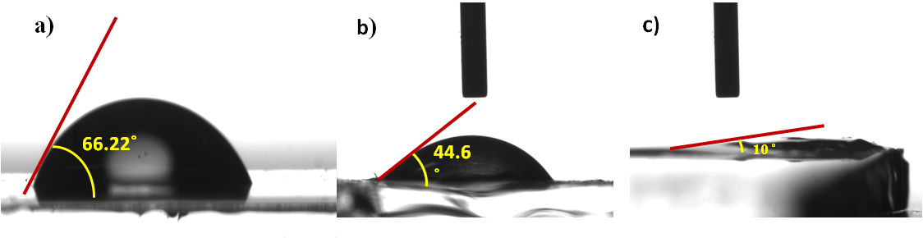

**Figure S1**: Contact angle studies of ITO (a), APTES/1-D-nMOO3/ITO (b) and anti-HER-2/APTES/1-D-nMOO3/ITO electrodes.

**Cytotoxicity Studies**

Cytotoxicity of APTES/nMoO3 was evaluated on an HEK 293T cell line by methyl thiazol tetrazolium (MTT) colorimetric assay. In this assay MTT was reduced by mitochondrial succinate dehydrogenase in live cells into colored (dark purple) formazan product. These formazan crystals were further solubilized in a buffer, followed by measuring the intensity spectrophotometrically at 540 nm using an ELISA plate reader. Initially, the cell density of 105 cells/well was maintained in a 96 - well plate and at 37 ᵒC in a humidified 5% CO2 atmosphere. When the cells attained 70% confluence, APTES/nMoO3 was added to wells in the range, 0-30 µg mL-1. Subsequently the samples were introduced to the cells and were incubated for 48h after which the MTT assay was performed. For MTT assay, 100 μL of MTT (1 mg mL-1) in DMEM was added to wells. The formazan crystals so formed were solubilised in DMSO. Spectrophotometrically intensity of the color was recorded at 540 nm on an ELISA plate reader. To calibrate the spectrophotometer to zero absorbance blank MTT reagent without cells were used and untreated cells with 100% viability was taken as control. All experiments were carried out in triplicate. The viability of cell was calculated by using

Cell Viability (%) = (Abs) treated / (Abs) control x 100

In brief, the cytotoxicity of the functionalized nMoO3 (APTES/nMoO3) was determined in the concentration range, 0-30 μg mL-1 by MTT assay on HEK 293T cells (Fig. S2) As observed, the level of toxicity of the 1-D nMoO3 was found to vary as a function of concentration. The APTES /1-D nMoO3 did not exhibit any significant cytotoxicity on HEK 293 cell lines up to 15μgmL-1 which was adequate for development of the biosensing platform. Figure S3 (a-d) shows morphology of the HEK 293 cell lines on exposure to different concentrations. The % cell viability of APTES/1-D nMoO3 with respect to control was found to be about 75 % for 15 μg mL-1

**Figure S2**: Cell viability, morphology of HEK 293 cell line with (a) 0 μg mL-1 (b) 5 μg mL-1 (c) 10 μg mL-1 and (d) 15 μg mL-1 concentration of APTES/nMoO3

**C:\Users\Suveendev\Desktop\Graph1.tif**

**Figure S3**: %Cell viability at different concentration of APTES/1D-nMoO3.

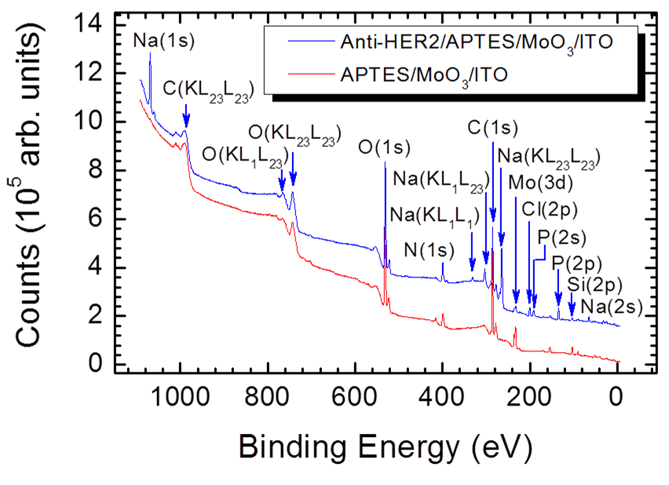

**Figure S 4**: Survey scan XPS spectra of APTES/1-D-nMoO3/ITO and anti-HER-2/APTES/1-DnMoO3/ITO electrode.

**C:\Users\Suveendev\Desktop\Picture6.tif**

**Figure S5**: Incubation time studies of BSA/anti-HER-2/APTES/nMoO3/ITO immunoelectrode with 2 ng mL-1 concentration of HER-2.

**Atomic Force Microscopic Studies**

AFM studies were carried out to investigate the uniformity and thickness of the electrophoretic ally deposited APTES/nMoO3 onto the Indium tin oxide platform. (Shown in Figure ……). deposited film was found to be ~ 2.93 nm, confirming the formation of uniform layer onto APTES/MoO3 ITO electrode.

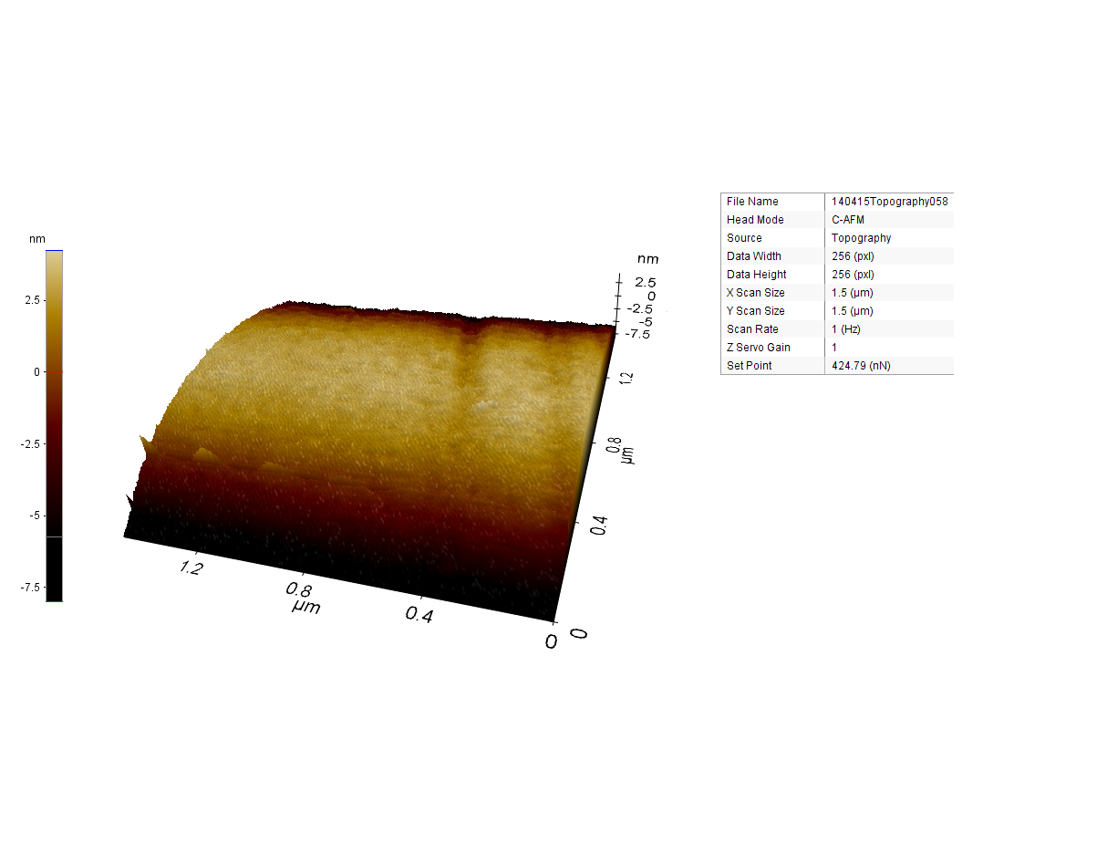

**Figure S6:** AFM image of APTES/MoO3/ITO electrode

**Synthesis and functionalization of spherical MoO3**

For the synthesis of spherical MoO3, Initially 2g of Na2MoO4.2H2O was mixed in 15 mL deionised water and kept for stirring at 300 rpm for 1h.Subsequently, 0.5g of CTAB was taken in ethanol and added to the solution kept under stirring at room temperature. Thereafter the pH of the solution was adjusted in between 4-5 by adding HNO3 gradually and kept for stirring for another 30 mins. The solution was transferred to Teflon coated stainless steel vessel and kept for 24h at 160 ̊C. Further, the solution was collected and washed with DI water to remove the impurities followed by washing with absolute ethanol. The precipitate was collected and kept for drying at 60 ̊C for 12 h. The final product was collected and stored at room temperature until further usage. For the functionalization of the as synthesized spherical MoO3 with APTES, similar protocol was followed as discussed in the main manuscript. Further, this APTES functionalized spherical MoO3 has been used to fabricate BSA/anti-HER-2/APTES/spherical MoO3/ITO immunoelectrode. The electrochemical response studies recorded at different concentration of HER-2 (0-80 ng mL-1) (Figure S7 (b)).The linear range was obtained between (5-60) ng mL-1.

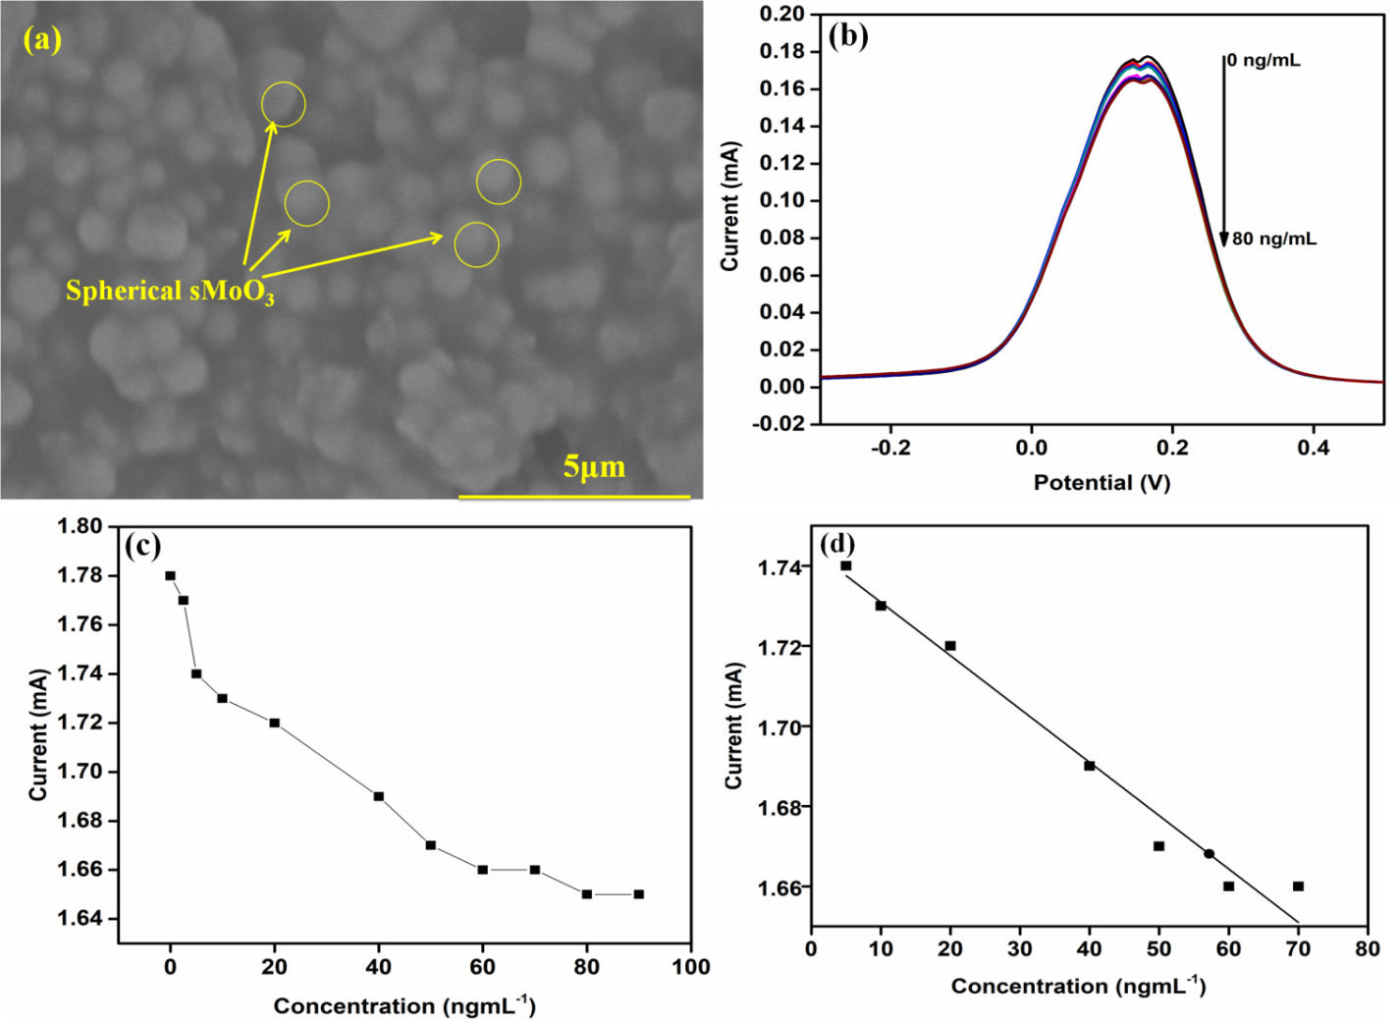

+

**Figure S7:** SEM of the (spherical) nMoO3 (a) Electrochemical response study of BSA/anti-HER-2/APTES/2D nMoO3 with different concentration (0-80 ng mL-1) of HER-2 biomarker (b), and calibration curve between magnitude of peak current and concentration of HER-2 (0- 80 ng mL-1) (c) Linearity graph between magnitude of peak current and concentration of HER-2 (5 to 60 ng mL−1) (d).

C:\Users\Suveendev\Desktop\Graph2.tif

**Figure S8:** Hanes Woolf plot BSA/anti-HER-2/APTES/ nMoO3/ITO electrode



**Figure S9** : Regeneration of the BSA/anti-HER-2/APTES/ nMoO3/ITO based biosensor.



**Figure S10:** Selectivity study of BSA/anti-HER-2/APTES/nMoO3/ITO electrode against the potential interferents present in serum.

**C:\Users\Suveendev\Desktop\Graph1.tif**

**Figure S11:** Shelf life study of BSA/anti-HER-2/APTES/nMoO3/ITO immunoelectrode.

|  |  |  |  |  |  |
| --- | --- | --- | --- | --- | --- |
| S.No | HER-2 concentration (ng mL-1) determined through ELISA | Peak current obtained in patient’s serum sample (mA) |  | Current value obtained with Standard Sample (mA) | % Relative Standard Deviation |
| 1 | 10 | 0.253 |  | 0.246 | 1.98 |
| 2 | 15 | 0.248 |  | 0.244 | 0.86 |
| 3 | 25 | 0.246 |  | 0.243 | 0.87 |
| 4 | 50 | 0.236 |  | 0.238 | 0.30 |
| 5 | 100 | 0.231 |  | 0.226 | 1.86 |

**Table S2:** Determination of HER-2 antigen concentration in serum sample using a BSA/anti-HER-2/APTES/nMoO3/ITO electrode.