**Supplementary Material**

The laser beam was discretized as bundles of laser rays that are directly absorbed by the top surface of the metallic phases. A dimensionless variable, $f_{absorb}$, ranging from 0 to 1, was introduced to track the top surface of the metal. FIG. S1 shows part of the metal powder with the heat source travelling from the top row to the bottom row. The sum of $f_{absorb}$ for each column cannot be more than 1 to ensure that the amount of heat energy absorbed by the column will not exceed the heat energy entering the column. The calculation of $f_{absorb}$ for each cell depends on the volume fraction of metallic phases.

In column 2 of FIG. S1, row 1 and row 2 consist solely of gaseous phase ($α_{1}=0$). Therefore, the $f_{absorb}$ for the two cells are 0 and no heat energy is absorbed by the cells. When the heat source reaches the first cell with metallic phase ($α_{1}≠0$), the $f_{absorb}$ will take on the value of the corresponding $α_{1}$. Therefore, in row 3, $α_{1}$ has a value of 0.4 and the value of $f_{absorb}$ will be updated to 0.4. In row 4, the cell comprises only the metallic phase and hence, $α_{1}$ has a value of 1. However, $f_{absorb}$ was set to 0.6 to ensure the sum of the $f_{absorb}$ for the column is less than or equal to 1. Table. S1 summarises the values of the $f_{absorb}$ for column 2.

In column 3, row 1 is purelygaseous $(α_{1}=0)$, and the corresponding $f_{absorb}$ value for the cell is 0. Row 2 has an $α_{1}$ value of 0.05 and therefore $f_{absorb}$ will be set as 0.05. In row 3, the cell has an $α_{1}$ value of 0.94 and the $f_{absorb}$ value for the cell will be set as 0.94. Row 4 consists of only the metallic phase and its $α_{1}$ value will be 1.0. However, the $f_{absorb}$ will be 0.01. Table. S2 shows the values of $f_{absorb}$ for column 3.

Such implementation of $f_{absorb}$ was employed to ensure that the heat flux is only applied at the top surface of the workpiece.

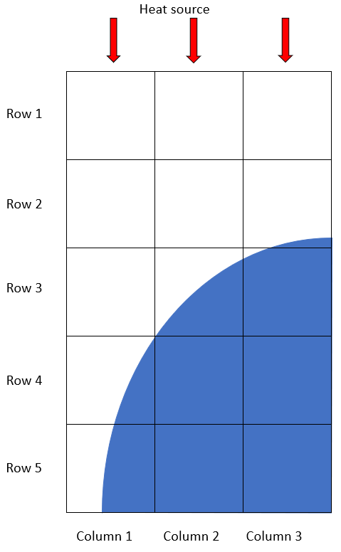

FIG. S1. Mesh cells showing part of a metal powder. The blue regions represent the metallic phases while the white regions represent the gaseous phases.

Table.S1 for Column 2

|  |  |  |  |  |  |
| --- | --- | --- | --- | --- | --- |
| Row | 1 | 2 | 3 | 4 | 5 |
|  | 0 | 0 | 0.4 | 1.0 | 1.0 |
|  | 0 | 0 | 0.4 | 0.6 | 0 |

Table.S2 for Column 3

|  |  |  |  |  |  |
| --- | --- | --- | --- | --- | --- |
| Row | 1 | 2 | 3 | 4 | 5 |
|  | 0 | 0.05 | 0.94 | 1.0 | 1.0 |
|  | 0 | 0.05 | 0.94 | 0.01 | 0 |