Supplementary Material
Atomic-level insights through spectroscopic and transport measurements into the large-area synthesis of MoS₂ thin films
Hassana Samassekou*, Asma Alkabsh, Kenneth Stiwinter, Avinash Khatri, and Dipanjan Mazumdar*
Department of Physics, Southern Illinois University, Carbondale IL 62901

*Corresponding author: dmazumdar@siu.edu
Growth Method | Precursor (CVD)  or  Target (PVD) | Growth Conditions | Morphology  (number of MoS₂ layers) | Device Performance |  | Ref.
 |  |  |  | RT  μ_{FET}  (cm² V⁻¹s⁻¹) | I_{On}/I_{Off}
Powder Vaporization  Metal-Organic CVD  Atomic Layer Deposition  Thermolysis  Two-step Process | Mo  MoO₃  MoCl₅  Mo(CO)₆ +(C₂H₅)₂S  MoCl₅  (NH₄)₂MoS₄  Mo  MoO₃  MoS₂  Mo  MoS₂  MoS₂  MoS₂  MoS₂ | H₂S at T> 600C  S at 850C  S at T> 800C  H₂ presence  H₂S at 300C  T> 800C  S at 600C  S at 650C  S at 700C  S at 500-1100C  485C annealing  75-100C  750C-900C | 1  1  1  1  1  3  1  2  2  1  1  3  1  1 | ~20  ~4.3  ~0.003-0.03  ~30  ~6  ~12 (p-type)  ~21  ~29  ~12  ~12 (p-type)  ~21 | ~10⁶  ~10⁶  ~10⁴  ~10⁵  ~10⁶  ~10⁷  ~10⁴  ~10³ | [1]  [2]  [3]  [4]  [5]  [6]  [7]  [8]  [9]  [10]  [11]  [12]  [13]  [14]
Ebeam-CVD
Magnetron Sputtering

Pulse Laser Deposited
Molecular Beam Epitaxy
Table S.1. Overview of MoS₂ large-area fabrication methods of MoS₂ thin films

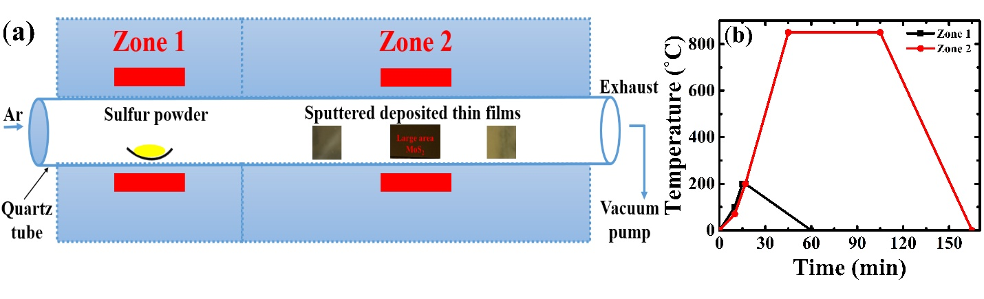
Fig. S.1. (a) Low pressure CVD system. (b) Quantitative description of the sulfurization process.
Fig. S.1 (a) demonstrates the experimental set-up of the sulfurization method that consists of a two-zone furnace equipped with a variable temperature control. Firstly, the substrate is subject to a simple RCA cleaning process prior to the deposition: a 10 min-Isopropyl alcohol bath followed by a 10 min-acetone bath after a quick rinsing in deionized water, then a drying step by means of a nitrogen gun after a final rinsing in methanol. Then, the samples were loaded and baked at 400C for 15 mins in an ultra-high vacuum sputtering chamber of base pressure 1 × 10⁻⁹ Torr. Then, an examination of different growth methods has been assessed to produce scalable 2D MoS₂ thin films. Prior to each run, the target was pre-sputtered for 5 mins in an ultra-high purity argon (Ar) environment. The sulfurization process was conducted via an ex-situ process involving a CVD-type process. The samples are placed at a minimum distance of 15 cm from the sulfur powder to ensure an efficient and stable environment for the synthesis of high quality MoS₂ thin films. Fig. S.1 (b) represents the temperature ramp-up and cool-down illustration of the sulfurization process.
Upon fabrication of the MoS₂ thin films, the first characterization that was conducted was X-ray diffraction techniques (XRR and XRD). Let’s discuss briefly some details about the measurements. Parallel beam (PB) geometry was used for the measurements, requiring minimal sample preparation in the form of an amorphous 1in² silicon plate underneath the sample. This flattens the background by getting rid of the fluorescence and unwanted diffraction peaks from the wafer scale iron reference plate (4in diameter). Additionally, PB optics are coupled with cross beam optics to practically eliminate instrumental errors that contribute to asymmetric peak broadening and axial divergence. Moreover, a rocking curve measurement is performed to not only investigate the crystal imperfections of the substrate but also precisely align the substrate while reaching a half-width minimum of 0.0033º. Overall, the particularities of our XRD measurements provide us with an ultra-fine precision of the lattice constants.
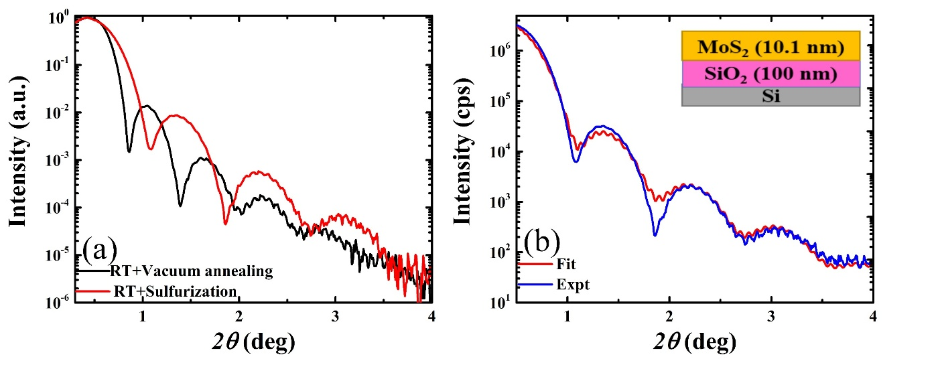
Fig. S.2. (a) XRR curve of many-layer MoS₂ grown on Si/SiO₂ under vacuum annealing treatment labeled “RT+Vacuum annealing” (black) noted M₁ and sulfurization process labeled “RT+Sulfurization” (red) referred to as M₂. (b) A many-layer optimized sample is fitted to obtain the layer-specific thickness, roughness, and density. The thickness values of the layers are listed in the inset diagram.
The XRR data, which refers to Fig. S.2, revealed valuable information about each individual layer such as thickness, roughness, and density values. Parratt formalism, a generalization of Fresnel’s reflectivity for multiple interfaces, is a recursion formalism which accounts for the effect of reflection from each internal interface. As mentioned in our previous work, the thickness and roughness values decreased dramatically from room temperature (RT) growth to post-deposition annealing (485C) whereas the density increased to bulk-like value at 485C. By sulfurizing the “as-deposited” samples, an improvement is noted. Sulfurized samples reach a bulk-like MoS₂ density of 5.06 g/cm³ compared to 4.92 g/cm³ for their vacuum annealed counterpart. In addition, sulfurized samples note a 10% decrease in thickness compared to the vacuum annealed samples sputter-coated simultaneously and that for the same duration. This is consistent with reduction in out of plane lattice that is noted in the XRD measurements. Though, both techniques, namely M₁ and M₂, exhibited sharp interfaces and bulk-like MoS₂ density, the room temperature deposition followed by a sulfurization at 850C for 1hr revealed itself as the optimum condition for synthesis of high quality MoS₂ thin films. A clear agreement between the experimental data and the fit for a sulfurized sample, from which the physical parameters have been extracted, is shown in Fig. 1. (b). Both samples revealed a low roughness and a bulk-like MoS₂ density with clear, sharp, and deep fringes up to 2Ɵ = 4 deg which was indicative of sharp interfaces and formation of heterostructures. Overall, XRR revealed low roughness and good interfaces in all three cases though slightly favoring M₂.
Fig.S.3. SEM images of MoS₂ thin films at different growth conditions: (a) M₁. (b) M₂. (c) M₃.
The SEM/EDS scans were performed at 20KV with a width of 11.3-11.8mm. Respective measurements conditions are shown at the bottom of each image. Each sample had measurements performed at 5 different spots. EDS revealed that sulfurization plays an important role in the replenishment of sulfur atoms as expected. Particulates seen in Fig. S.3 (b) and (c) are small pieces of sulfur that congregated at the surface. In the case of M₁, the results vary significantly depending on the spot size. A quantitative analysis for all three methods demonstrated the variation in stoichiometry as shown in Table S.2.
Table S.2. Results of SEM-EDS Analysis for MoS₂ grown under different conditions
Growth Conditions | Measurement Conditions |  |  | Atomic Percentage (%)
 | Energy Dispersive Spectroscopy (EDS) |  |  | Mo | S
 | Number of spots | Accelerating voltage (kV) | Spot size  (mm) | Average value | Average value | Standard deviation
M₁ | 5 | 20 | 3 | 41.53  33.19  36.72 | 58.47 | 5.49
M₂ | 5 | 20 | 3.5 |  | 66.81 | 4.88
M₃ | 5 | 20 | 3.5 |  | 63.28 | 3.94

Fig. S.4. Atomic force microscopy scans and surface profiles of MoS₂ thin films of different thicknesses: (a) 12nm (18L). (b) 2.3nm (4L).
Large atomic force microscopy scans of MoS₂ thin films of different thicknesses are shown in Fig. S.4.The expected thicknesses in terms of MoS₂ layers (1L=0.615nm) were respectively 18L and 4L. The surface morphologies put in evidence the presence of particulates associated to sulfur pieces via Energy dispersive spectroscopy (EDS). Consequently, this leads to rougher MoS₂ thin films limiting the growth to 2nm (4L-MoS₂), consistent with Raman spectroscopy which demonstrates a Raman shift of 24cm⁻¹. Our attempt to fabricate thinner MoS₂ thin films resulted in a similar topography as the 4L samples. Overall, successful synthesis of scalable MoS₂ thin films was achieved down to 4L.
Sulfurization Temperature  (˚C) | 2θ Peak Position (deg) | 2θ Peak Intensity (cps) | FWHM (deg) | Out of plane interplanar spacing (nm)
550  700  850 | -  14.1  14.3  14.4 | -  224  1709  5944 | -  1.3  0.8  0.7 | -  0.629  0.616  0.614
1000
Table S.3. MoS₂ (0002) 2θ peak position as a function of sulfurization temperature
The peak position of the (0002) MoS₂ reflection progressively shifts towards the actual value 14.3˚ (c=12.3 Å) with increasing sulfurization temperature which is indicative of better crystallization with the sulfurization process at high temperature. The peak intensity of the (0002) MoS₂ reflection also increases while a narrow Full Width at Half Maximum labeled (“FWHM”) is noted at high sulfurization temperature. The interplanar spacing at each temperature was calculated from the (0008) MoS₂ reflection. Our previous report mentioned a lattice expansion due to annealing whereas in this case the interplanar spacing reaches the bulk value of 0.615 nm with increasing sulfurization temperature up to 1000C. This is indicative of lattice relaxation towards bulk value as the sulfurization temperature increases. Overall, synthesis of high crystalline scalable MoS₂ thin films with higher intensities, sharp interfaces, and persuasive excitons demonstration is achieved by means of sputter deposition followed by a high temperature sulfurization.
The structural characteristics of samples sulfurized MoS₂ samples grown on different substrates (Si/SiO₂, quartz, and sapphire) were compared in Table S.4. We found that films on sapphire show a higher intensity and lower FWHM. (0004) MoS₂ reflection was omitted for Si/SiO₂ due to the overlap with a peak at 2Ɵ=28.44 deg present in high temperature annealed Si/SiO₂ samples.
Table S.4. Comparison of structural characteristics of samples grown on different substrates
Parameters | Si/SiO₂ | Quartz | Sapphire | Simulated bulk MoS₂
(hkil) indices | (0002)
2Ɵ position (deg) | 14.26 | 14.28 | 14.28 | 14.39
Intensity (cps) | 2289 | 1746 | 1956 | 100
FWHM (deg) | 0.80 | 0.83 | 0.65 | -
Interplanar spacing (nm) | 0.621 | 0.620 | 0.620 | 0.615
(hkil) indices | (0004)
2Ɵ position (deg) | - | 28.76 | 28.93 | 29.01
Intensity (cps) | - | 24 | 30 | 1.6
FWHM (deg) | - | 0.90 | 0.73 | -
Interplanar spacing (nm) | - | 0.621 | 0.618 | 0.615
(hkil) indices | (0006)
2Ɵ position (deg) | 43.96 | 44.00 | 44.00 | 44.14
Intensity (cps) | 32 | 38 | 103 | 7.0
FWHM (deg) | 0.99 | 1.2 | 0.81 | -
Interplanar spacing (nm) | 0.617 | 0.617 | 0.617 | 0.615
(hkil) indices | (0008)
2Ɵ position (deg) | 59.58 | 59.74 | 59.76 | 60.13
Intensity (cps) | 21 | 28 | 66 | 5.8
FWHM (deg) | 1.16 | 1.1 | 0.87 | -
Interplanar spacing (nm) | 0.620 | 0.619 | 0.618 | 0.615

A 12nm-MoS₂ thin films have been subject to sulfurization up to 1000C resulting in clear shifts in excitons and Raman peak’s positions and noticeable changes in the peak’s broadening quantified by the FWHM. A quantitative analysis of the MoS₂ A-B excitonic data is shown in table S4. Similarly, a sulfurization temperature dependence on Raman peaks’ positions of 12nm-MoS₂ thin films is shown in table S5.
Table S.5. Evolution of excitons’ positions as a function of sulfurization temperature (12nm film)
Growth Temperature  (˚C) | Excitons’ positions (Full Width at Half-Maximum)  (eV)
 | A | B
RT |  | 2.13 (0.544)
250 |  | 2.098 (0.682)
350 | 1.916 (0.266) | 2.084 (0.365)
450 | 1.888 (0.143) | 2.042 (0.405)
550 | 1.868 (0.137) | 2.027 (0.361)
650 | 1.837 (0.119) | 1.998 (0.332)
700 | 1.829 (0.099) | 1.979 (0.250)
850 | 1.796 (0.084) | 1.956 (0.183)
1000 | 1.784 (0.077) | 1.946 (0.165)

Table S.6. Raman peaks’ positions as a function of sulfurization temperature
Growth Temperature |  | Peaks positions (Full Width at Half-Maximum)  (cm⁻¹) |  | Raman shift  (cm⁻¹) | Ratio of E¹_{2g} and A_{1g} peaks
(˚C) | (K) | E¹_{2g} | A_{1g}
RT | 273 | 380.1 (25) | 405.8 (11) | 25.7 | 0.29641
250 | 523 | 381.2 (17) | 405.8 (10) | 24.6 | 0.33849
350 | 623 | 381.1 (11) | 405.7 (10) | 24.6 | 0.30823
450 | 723 | 382.4 (11) | 405.5 (10) | 23.1 | 0.33324
550 | 823 | 381.8 (11) | 405.5 (10) | 23.7 | 0.30821
650 | 923 | 381.5 (9) | 405.5 (9) | 24.0 | 0.32114
700 | 973 | 381.4 (8) | 405.4 (9) | 24.0 | 0.36834
850 | 1123 | 381.1 (5) | 408.0 (5) | 26.9 | 0.4089
1000 | 1273 | 378.2 (6) | 405.8 (6) | 27.6 | 0.47454

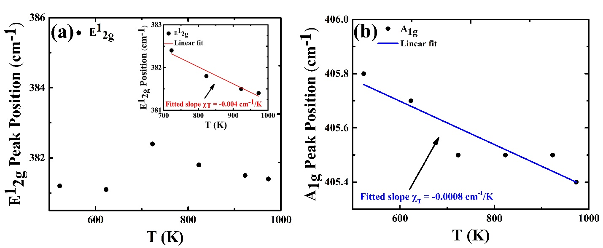
Fig. S.5. (a) Variation in E¹_{2g} peaks’ positions as a function of temperature of a many-layer MoS₂ thin film. The inset shows the fitted data for structurally stable temperatures. (b) Shift in A_{1g} peaks’ positions as a function of temperature of a many-layer MoS₂ thin film.
The variation in Raman peaks’ positions for both modes as a function of temperature shows a linear dependence. The fitted slopes are -0.004 cm⁻¹/K and -0.0008 cm⁻¹/K for the in-plane and out-of-plane modes respectively with corresponding R² values for fits, 95.48% and 85.88%. The variation in Raman peaks’ positions for both modes as a function of temperature was fitted to a line. The fitted slopes, corresponding to the first order temperature coefficients χ, were -0.004 cm⁻¹/K and -0.0008 cm⁻¹/K for the in-plane and out-of-plane modes respectively.
Fig. S.6. (a) IV curves of the 12nm-MoS₂ thin films as a function of temperature. (b) Photoconductivity measurements on sulfurized samples at different temperatures.
A comparative Current-Voltage (I-V) measurements of many-layer vacuum annealed and sulfurized MoS₂ thin films in Fig. S.6. For the I-V measurements, samples were forward and reverse biased by applying ±5V between the contacting electrodes. The contact electrodes for I-V and photocurrent were prepared by depositing Ag paint directly on the sample. Light contacts were made using Au/Cr electrodes using a 2-probe device structure. Hall measurements were performed using Van der Pauw (VDP) geometry. The Au/Cr electrodes were placed onto a PCB board while the contacts were ensured using In filaments and Ag paint. The sulfurized samples were semiconducting and the contacts for I-V measurements were prepared using the same protocol described earlier. The linear behavior of our I-V measurements suggests ohmic-like contact in the low bias voltage regime. This was mainly due to a low contact resistance. Photoconductivity measurements for temperatures (700C-1000C) are shown in Fig. S.6. They put in evidence repeated pulse cycling for 1000C along with varied pulse width. The results indicated a quicker response for the 850C and 1000C samples. Moreover, the sharp rise and fall of the 850C sample make it the optimum temperature, consistent with structural and spectroscopic investigations.
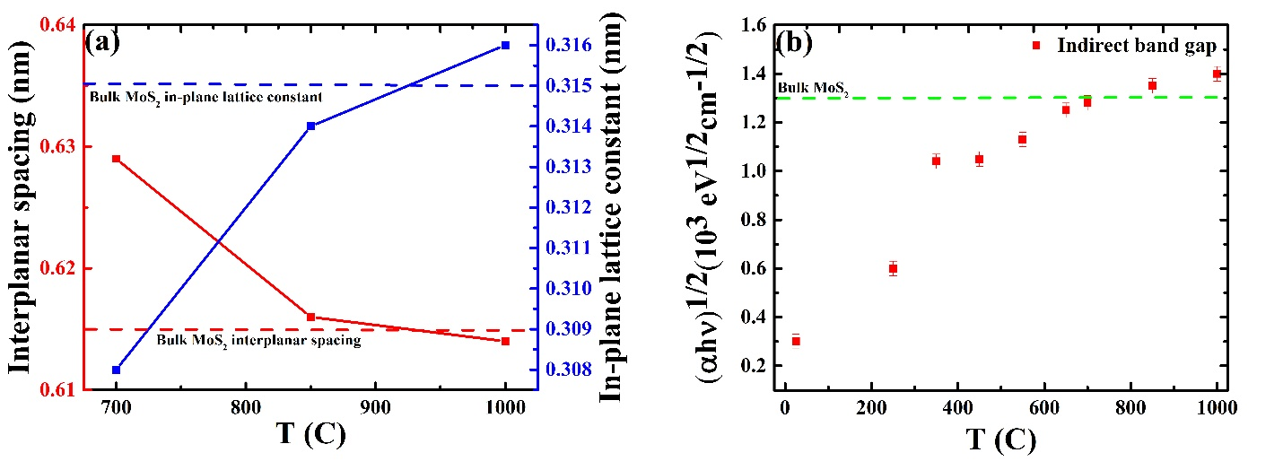
Fig.S.7. (a) Variation in lattice parameters as a function of temperature. (b) Band gap analysis as a function of temperature.
Figure S.7. (a) reveals the variation of lattice parameters as a function of temperature. As the sulfurization temperature increases, the lattice parameters gradually reach the bulk values of 0.615 nm and 0.315nm (calculated assuming constant volume) for the interplanar spacing and the in-plane lattice constant respectively. This is a good evidence of high crystalline quality with increasing sulfurization temperature. Figure S.7. (b) demonstrates the relationship between the indirect band gap of the 12nm-MoS₂ thin film and temperature. A blue shift of the indirect band gap is noted with increasing temperature. At room temperature, a band gap of 0.3 eV is noted; and, this value progressively increases towards bulk value of 1.3eV with increase in temperature. One may attribute these results to the sulfur vacancies of the thin films at room temperature, leading to a higher contribution of molybdenum and/or perhaps the amorphous nature of the thin films. As the many-layer MoS₂ thin films are replenished, and specifically at T>650C, bulk band gap is reached. This is consistent with the structural investigations that suggests highly ordered films at T>650C.

REFERENCES
[1] Dumcenco D., Ovchinnikov D., Sanchez O.L., Gillet P., Alexander D.T.L., Lazar S., Radenovic A., and Kis A.: Large-area MoS₂ grown using H₂S as the sulphur source. 2D Materials 2, 044005 (2015).
[2] Najmaei S., Liu Z., Zhou W., Zou X., Shi G., Lei S., Yakobson B.I., Idrobo J.C., Ajayan P.M., and Lou J.: Vapour phase growth and grain boundary structure of molybdenum disulphide atomic layers. Nat. Mater.12, 754 (2013).
[3] Yu. Y., Li C., Liu Y., Su L., Zhang Y., and Cao L.: Controlled scalable synthesis of uniform, high-quality monolayer and few-layer MoS₂ films. Sci. Rep. 3, 1866 (2013).
[4] Kang K., Xie S., Huang L., Han Y., Huang P.Y., Mak K.F., Kim C.J., Muller D., and Park J.: High-mobility-three-atom-thick semiconducting films with wafer-scale homogeneity. Nature 520, 656 (2015).
[5] Tan L.K., Liu B., Teng J.H., Guo S., Low H.Y., and Loh K.P.: Atomic layer deposition of a MoS₂ film. Nanosclae 6, 10584 (2014).
[6] Liu K.K., Zhang W., Lee Y.H., Lin Y.C., Chang M.T., Su C.Y., Chang C.S., Li H., Shi Y., Zhang H., Lai C.S., Li L.J.: Growth of large-area and highly crystalline MoS₂ thin layers on insulating substrates. Nano Lett. 12, 1538 (2012).
[7] Choudhary N., Park J., Hwang J.Y., and Choi W.: Growth of large-scale and thickness-modulated MoS₂ nanosheets. ACS Appl. Mater. Interfaces 6, 21215 (2014).
[8] Hussain S., Singh J., Vikraman D., Singh A.K., Iqbal M.Z., Khan M.F., Kumar P., Choi D.C., Song W., An K.S., Eom J., Lee W.G., and Jung J.: Synthesis and characterization of large-area and continuous MoS₂ atomic layers by RF magnetron sputtering. Nanoscale 7, 4340 (2016).
[9] Hussain S., Singh J., Vikraman D., Singh A.K., Iqbal M.Z., Khan M.F., Kumar P., Choi D.C., Song W., An K.S., Eom J., Lee W.G., and Jung J.: Large-area, continuous and high electrical performances of bilayer to few layers MoS₂ fabricated by RF sputtering via post-deposition annealing method. Sci. Rep. 6, 30791 (2016).
[10] Laskar M.R., Ma L., Kannappan S., Park P.S., Khrishnamoorthy S., Nath D.N., Lu W., Wu Y., and Rajan S.: Large area single crystal (0001) oriented MoS₂. Applied Physics Letters 102, 252108 (2015).
[11] Tao J., Chai J., Lu X., Wong L.M., Wong T.I., Pan J., Xiong Q., Chi D., and Wang S.: Growth of waferscale MoS₂ monolayer by magnetron sputtering. Nanoscale 7, 2497 (2015).
[12] Samassekou H., Alkabsh A., Wasala M., Eaton M., Walber A., Walker A., Pitkänen O., Kordas K., Talapatra S., Jayasekera T., and Mazumdar D.: Viable route towards large-area two dimensional MoS₂ using magnetron sputtering. 2D Mater. 4, 021002 (2017).
[13] Serna M.I., Yoo S.H., Moreno S., Xi Y., Oviedo J.P., Choi H., Alshareef H.N., Kim M.J., Minary-Jolandan M., and Quevedo-Lopez M.A.: Large-area deposition of MoS₂ by pulsed laser deposition with in situ thickness control. ACS Nano 10, 6054 (2016).
[14] Fu D., Zhao X., Zhang Y.Y., Li L., Xu H., Jang A.R., Yoon S.I., Song P., Poh S.M., Ren T., Ding Z., Fu W., Shin T.J., Shin H.S., Pantelides S.T., Zhou W., and Loh K.P.: Molecular beam epitaxy of highly crystalline monolayer molybdenum disulfide on hexagonal boron nitride. J. Am. Chem. Soc. 139, 9392 (2017).

