Supplementary Material

A Novel Approach to Study of the Conductivity Behavior of CaCu₃Ti₄O₁₂
Using Scanning Probe Microscopy Technique

M. S. Ivanov¹, F. Amaral^{2,3}, V. A. Khomchenko¹, L. C. Costa³ and J. A. Paixão¹

¹CFisUC, Department of Physics, University of Coimbra, 3004-516 Coimbra, Portugal
²College of Health Technology of Coimbra, Polytechnic Institute of Coimbra, 3040-162 Coimbra, Portugal
³I3N and Physics Department, University of Aveiro, 3810-193 Aveiro, Portugal

*Corresponding authors: Dr. M. S. Ivanov
CFisUC, Department of Physics, University of Coimbra, P-3004-516 Coimbra, Portugal
E-mail: maxim.ivanov@uc.pt
Phone: +351 239 410 637
Fax: +351 239 829 158

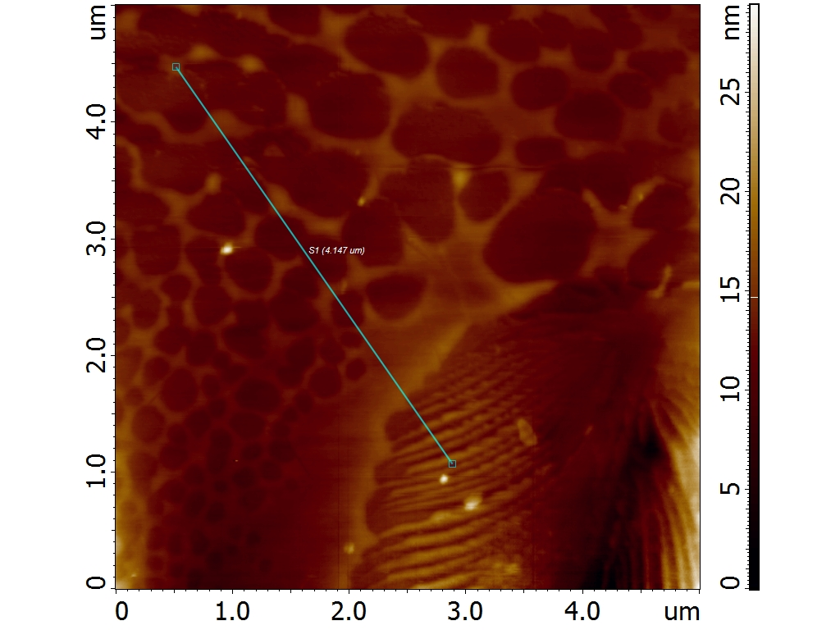

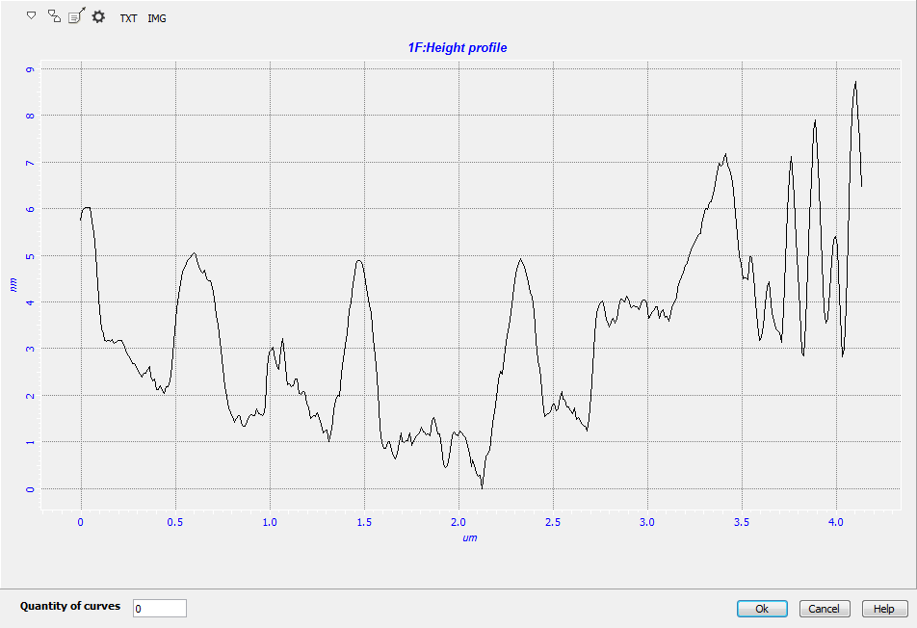

Fig. S1. Surface topography of mechanically-polished CCTO sample and typical cross-section indicating the RMS roughness of around 5 nm.

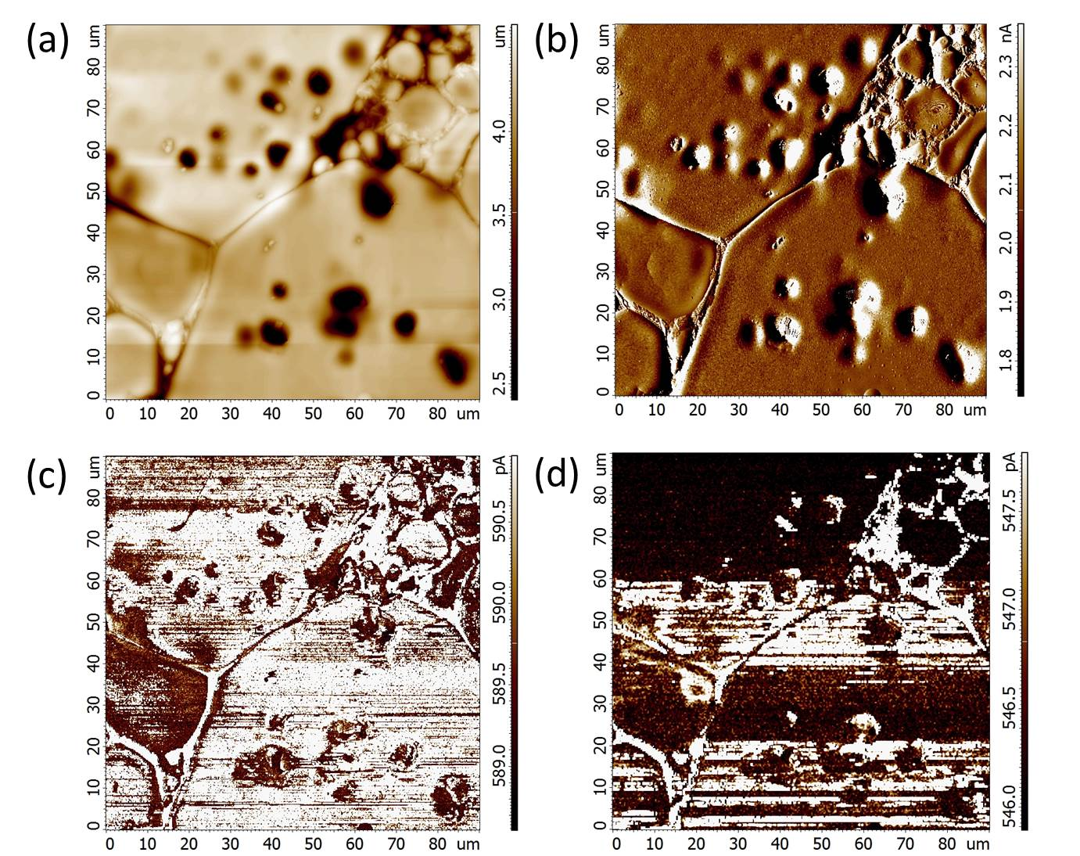

Fig. S2. (a) Topography, (b) DFL response and corresponding SR signal decay due to the degradation of the Pt/Ir coating: (c) new tip, (d) the same tip after 3 hours cycling at 0.1 Hz (512 x 512 pixels) (d).

Fig. S3. (a) Surface topography and (b, c) Spreading Resistance scan images illustrating oxygen vacancies-enriched structures. The scanning was done at 0.1 Hz (512 x 512 pixels) and dc bias voltage of -10 V (b) and +10 V (c): in contrast to a negative bias voltage resulting in the appearance of the oxygen vacancies-enriched structures in the SR scans, application of a positive voltage does not induce the contrast associated with enhanced conductivity, as expected for p-type semiconductors.

The average MBLC and NBLC gap widths in the CCTO ceramics reach 5 µm and 200 nm, respectively. These are approximately 170 and 7 times larger than the Pt/Ir-coated tip apex (~ 30 nm) (Fig. S4). Taking into account the small topography roughness as well as the scanning parameters described in the section “Experimental” (i.e. the large setpoint, high cantilever stiffness and low scanning rate) we consider that we maintain a permanent tight tip-surface contact during the scanning. Accordingly, we believe that our measurements adequately reflect the MBLC and NLBC mechanisms proposed. In order to confirm the origin of the SR signal and exclude the possibility that the observed effects are solely determined by the reduction in contact area at step edges, we repeated the experiments at different scan directions (Fig. S5).
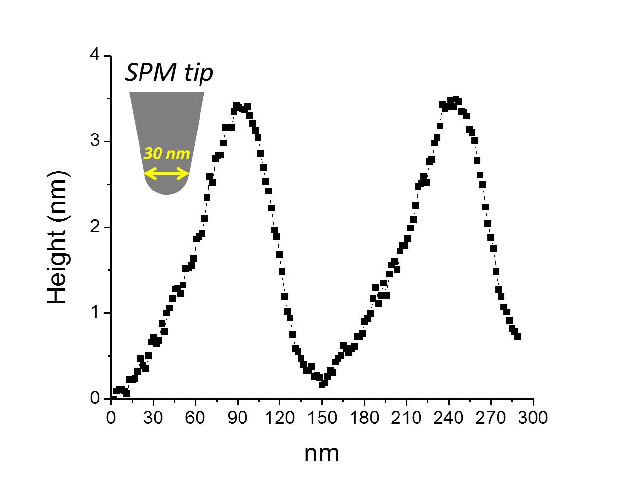

Fig. S4. The size relation between the apex of the SPM probe and the typical roughness of the CCTO sample (the profile of terrace ledge topography is presented).

Fig. S5. (a, d) Topography and corresponding (b, e) top –to-down and (c, f) left-to-right SR scans. The scanning was done at 0.3 Hz (512 x 512 pixels) and dc bias voltage of 1 V.

