Supplementary Material

Direct Visualization of Nano and Microscale Polymer Morphologies in As-Prepared and Dialyzed Polyampholyte Hydrogels by Electron Microscopy Techniques

Xinda Li¹, Hemant Charaya¹, Thuy Nguyen Thanh Tran¹, Byeongdu Lee², Jae-Young Cho³, Hyun-Joong Chung^{1,*}

¹Department of Chemical and Materials Engineering, University of Alberta, Edmonton, Alberta T6G 1H9, Canada

²Advanced Photon Source, Argonne National Laboratory, Argonne, Illinois 60439, United States

³National Research Council of Canada (NRC), 11421 Saskatchewan Drive NW, Edmonton, Alberta T6G 2M9, Canada

* Address all correspondence to Hyun-Joong Chung at chung.hj13@ualbrerta.ca

Polyampholyte Hydrogel Synthesis. The protocol of polyampholyte synthesis was described in previous works.^{S1} Briefly, 1 M Sodium 4-vinylbenzenesulfonate (NaSS) and 1 M [3-(methacryloylamino)propyl] trimethylammonium chloride (MPTC) with Irgacure 2959 (photoinitiator, 0.25 mol%, compared to the total concentration of NaSS and MPTC) and NaCl were dissolved in deionized water to form the precursor solution. In the precursor solution, NaCl concentration is 10 wt%. Here, sodium and chloride ions in the monomers of NaSS and MPTC were accounted into the total concentration. The aqueous precursor solution was injected into the gap between two glass plates separated by a 1 mm thick spacer, followed by polymerization initiated by irradiating the sample with UV light with a lamp-to-sample distance of 5 mm (broadband light with a maximum peak at 365 nm with the intensity of 22 mW/cm², Jelight UVO-Cleaner Model-342, US). The list of prepared samples are in Table 1. Here, we denote the samples using the code PA-#-c, where the # is the NaCl concentration (wt%) in the polyampholyte hydrogel, c is the total monomer concentration (M). The NaCl concentration in the as-prepared hydrogel is calculated as:
$C_{NaCl}=\frac{m_{NaCl}}{{m_{NaCl}+m}_{water}}×100\%$ (1)
where $m_{NaCl}$ is the total mass of NaCl, and $m_{water}$ is the mass of water added in the precursor solution. It is noted that NaSS and MPTC contain sodium and chloride ions, respectively which were accounted in the calculation for the $m_{NaCl}$ value.
Small Angle X-Ray Scattering (SAXS) Characterization. SAXS samples were made by irradiating bees wax sealed glass capillaries (Charles Supper, US) containing a precursor solution with UV. After polymerization, one end of the glass capillary was manually broken and dialyzed in the 6 M KOH solution for one week to prepare K-PA-10-2.1. The SAXS experiments were performed with the beamline 12-ID-B of the Advanced Photon Source at the Argonne National Laboratory in the US. The 14 keV X-ray beam was exposed to the 1.5 mm diameter capillary sample with an exposure time of typically 0.1 s. Scattered X-ray photons were measured with a Pilatus 2M (Dectris Ltd.) detector located about 2 m downstream of the sample. Ten images per sample were collected and averaged to confirm that no beam damage had occurred and to increase counting statistics. Background scattering from a capillary containing water was subtracted from sample data. The SAXS data in Figure S1 was fitted using our fitting model developed in our earlier study; details are in the reference [^{S1}]. The fitting result was shown in Table S1, where $f_{p}$ is the number concentration (e.g., molar concentration) of primary particles. $D_{f}$ is the fractal power-law. ${\overline{R}}_{p}$ and $σ_{p}$ are the mean radius and variance of the external size of the primary particles, respectively. $R_{g,p}$ is the radius of gyration of the primary particle calculated from ${\overline{R}}_{p}$ and $σ_{p}$. $R_{g,c}$ and $P$ are radius of gyration and the Porod constant of the cluster, respectively. $v$ is the volume fraction of the primary particles in a cluster, respectively. The $R_{g,p}$ value of PA-10-2.1 is different from Reference [^{S1}], where we calculated the value assuming solid spheres to emphasize the external size, whereas in the current analysis we used the original formula in Reference [^{S2}] taking into account porous nature of the sphere.
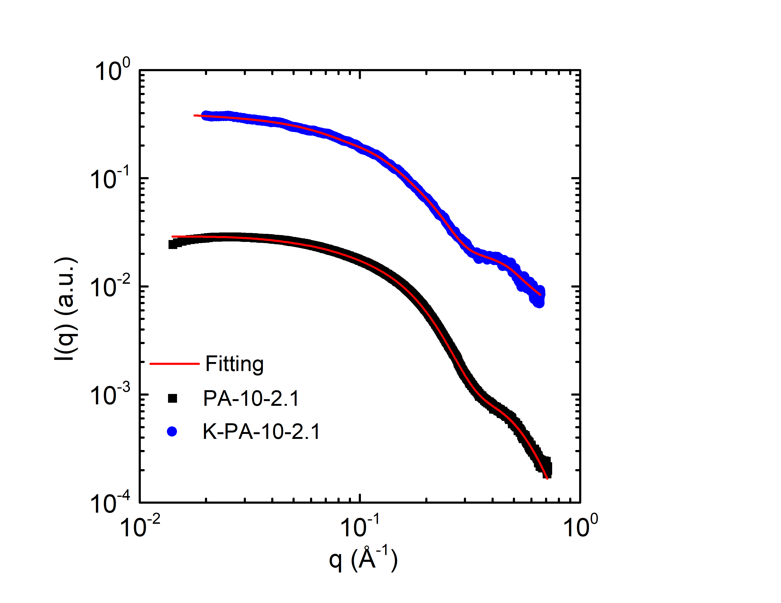
Figure S1 SAXS data for PA-10-2.1, K-PA-10-2.1. Here, the subtracted background are the capillaries filled with 10 wt% NaCl and 6 M KOH solution for PA-10-2.1 and K-PA-10-2.1, respectively. The red lines are the fits of the experimental data.

Table S1 Fitting parameters for SAXS results.
Sample | Cluster |  |  |  | Primary Particle (globule)
 | $$f$$ | $R_{g,c}$(Å) | $$P$$ | $v$(%) | $f_{p}$(a.u.) | ${\overline{R}}_{p}$(Å) | $σ_{p}$(Å) | $$D_{f}$$ | $R_{g,p}$(Å)
K-PA-10-2.1 | 1.6 | 13.1 | 3.2 | 0 | 0.232 | 19.9 | 3.7 | 1.5 | 9.91
PA-10-2.1 | 1.2 | 13.1 | 1.2 | 0 | 0.024 | 18.1 | 4.7 | 1.8 | 9.56

References for Supporting Information
S1. X. Li, H. Charaya, G.M. Bernard, J.A.W. Elliott, V.K. Michaelis, B. Lee, H-J. Chung: Low-Temperature Ionic Conductivity Enhanced by Disrupted Ice Formation in Polyampholyte Hydrogels. Macromolecules 51, 2723-2731 (2018).
S2. R. Besselink and J.E. ten Elshof: Mass-fractal growth in niobia/silsesquioxane mixtures: a small-angle X-ray scattering study. Journal of Applied Crystallography 47, 1606-1613 (2014).

