Supplementary Material

Lithography-free variation of the number density of self-catalyzed GaAs nanowires
and its impact on polytypism

Philipp Schroth,*,†,‡,¶ Julian Jakob,‡,¶ Ludwig Feigl,¶ Seyed Mohammad
Mostafavi Kashani,† Ullrich Pietsch,† and Tilo Baumbach‡,¶

E-mail: philipp.schroth@kit.edu

*To whom correspondence should be addressed
†University of Siegen, Solid State Physics, Emmy-Noether Campus, Walter-Flex Straße 3, D-57068 Siegen,Germany
‡Laboratory for Applications of Synchrotron Radiation, Karlsruhe Institute of Technology, Kaiserstraße
12, D-76131 Karlsruhe, Germany
¶Institute for Photon Science and Synchrotron Radiation, Karlsruhe Institute of Technology, Hermann-von-Helmholtz-Platz 1, D-76344 Eggenstein-Leopoldshafen, Germany

SEM evaluation
The values shown in Tab.1 have been obtained by evaluating over 2000 Ga-droplets for droplet density, approx. 200 droplets for evaluation of droplet height and diameter. NW length and diameter were obtained from measuring over 100 NW in total. The Ga-droplet wetting angles at the NW tip was evaluated at 59 NW. For the NW and crystallite density, over 5000 objects were counted.

Subtraction of contribution from GaAs islands to x-ray profile
In the presented case, the measured x-ray Profiles can be modeled empirically using a sum of 4 Gaussian curves for each profile. Each Gaussian can be attributed to a signal peak originating from WZ, ZB, 4H (or a disordered phase with the same hexagonality as 4H) in the NWs and from parasitic GaAs islands (ZB). The resulting fits are given in Fig. S1 a). This way the contributions of NWs (solid black lines) and parasites (broken lines) to the x-ray profile can be decomposed. The Gaussians obtained for the parasitic GaAs islands are shown in Fig. S1 b), the resulting NW signal is depicted in Fig. S1 c). Please note, that this approach, modeling the X-ray profiles by Gaussians, may likely fail in case of NWs with low phase purity μp < 100 layers. Even for high phase purity NW, and if the X-ray profile shows pronounced peaks, the phase fraction obtained from the Gaussian fits may not properly account for contributions of very short segments. Therefore, we suggest to use the Markov model instead.

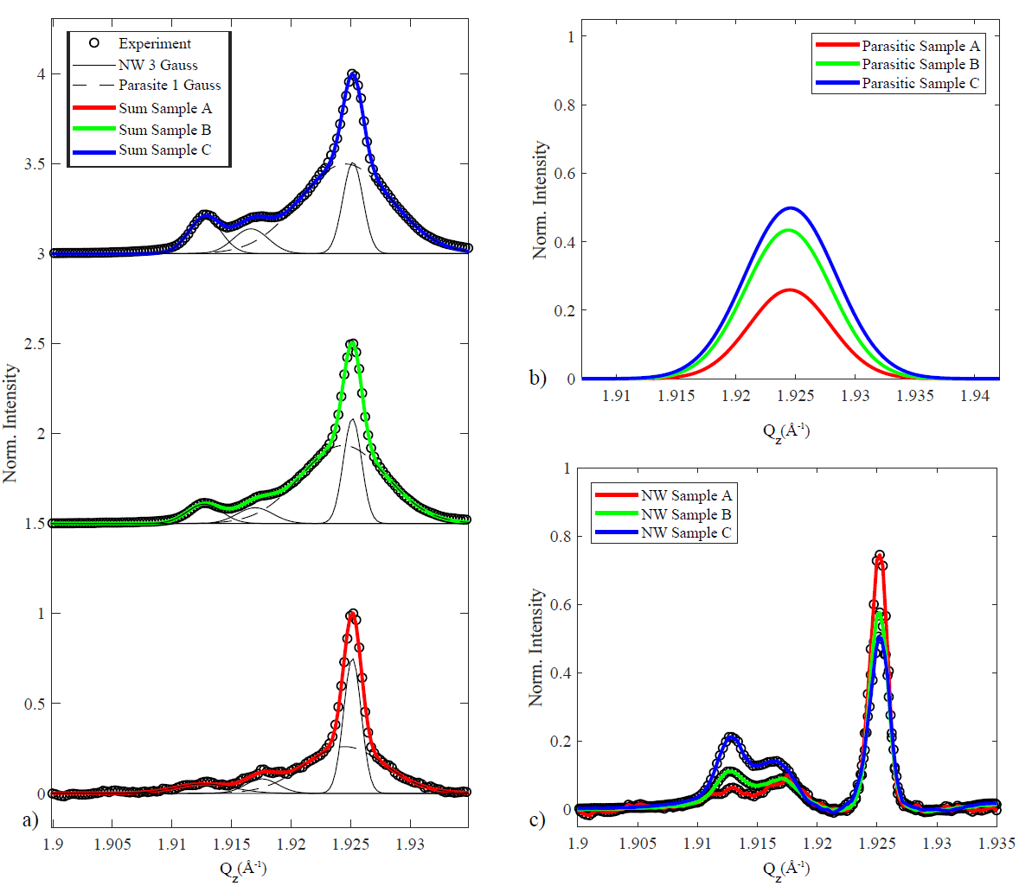
FIG S1:
Subtraction of the signal of parasitic GaAs islands using Gaussian functions. a) X-ray intensity profiles of samples A, B, and C. The black open circles show the experimental data. The contribution of parasitic islands is given by the broken line. The black solid lines represent NW contributions from WZ, 4H (or disordered phase), and ZB (from left to right). The colored solid line is the sum of the Gaussians for parasitic, WZ, 4H and ZB. b) Separate representation of the contributions of parasitic GaAs islands. c) Experimental data after subtraction of contribution from parasitic islands.
TEM evaluation
HR-TEM images of segments showing characteristic features of the NW crystal structure of sample C are shown in Fig. S2. Segments with disordered crystal structure, high number of stacking faults and very short segments are visible in Fig. S2 a). We attribute the X-ray signal between ZB and WZ to regions with such disordered crystal phase. In Fig. S2 b) extended ZB and WZ segments are shown. Figure S2 c) shows an overview-image of a NW of sample C featuring long WZ segments and disordered regions. Also the Ga droplet with wetting angle close to 90° at the tip can be seen.
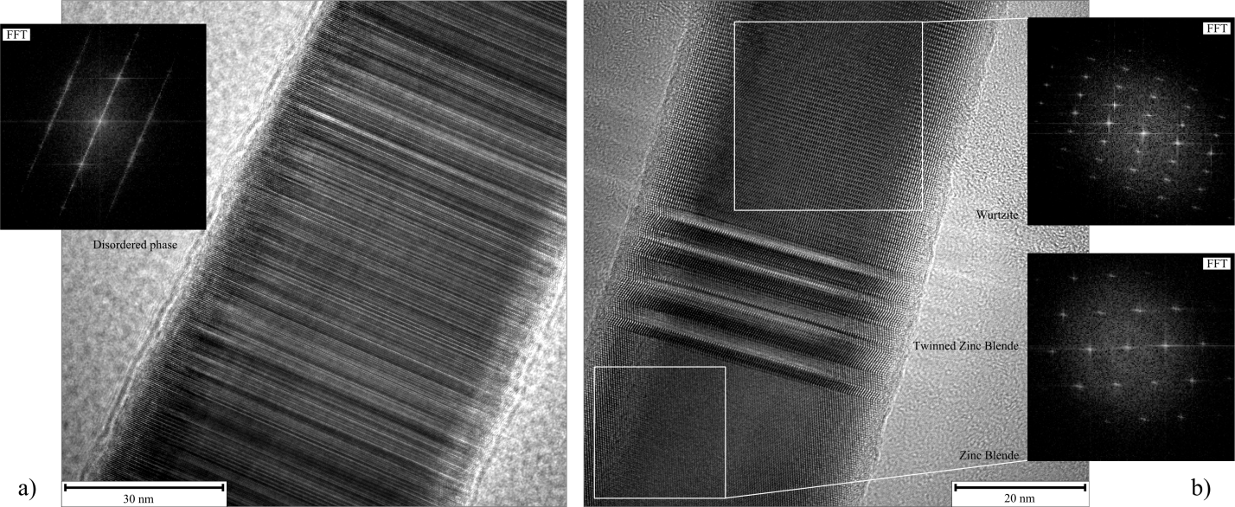
c)

FIG S2:
HR-TEM images. a) Disordered phase of short alternating WZ, twinned ZB and ZB segments. b) Extended WZ and ZB segments separated by disordered region. Insets show the fast Fourier transform of a quadratic region of the disordered region, ZB and WZ segments. c) overview of a whole NW of sample C.

