**Supplementary Material**

Synthesis and applications of near-infrared absorbing additive copper hydroxyphosphate

Elena Pérez-Barrado1,2, Richard J. Darton1* and Dieter Guhl2

*1 School of Chemical and Physical Sciences, Keele University, Staffordshire ST5 5BG, United Kingdom.*

*2 Keeling & Walker Ltd, Whieldon Rd, Stoke-on-Trent ST4 4JA, United Kingdom.*

* Corresponding author: r.j.darton@keele.ac.uk

*Chemicals and materials*

All chemicals were used as received without further purification. Cu(NO3)2·2.5H2O (98+%, ACS reagent) and NH4H2PO4 (99.9 %, trace metal basis) were purchased from Acros Organics, NH3 25-30% solution (extra pure) was purchased from Fisher Scientific. IR transparent ink for banknotes was kindly supplied by Gleitsmann Security Inks (Germany); VitoBond soft polyvinyl chloride formulation was purchased from Vita Liquid Polymers Ltd. (UK).

**Table S1.** Cell parameters, calculated from the diffractogram (Fig. 1a), BET area values and energy band-gap (Eg) for all samples.

|  |  |  |  |  |  |
| --- | --- | --- | --- | --- | --- |
| Sample | Cell parameters | | | BET area (m2/g) | Eg (eV) |
| *a* (Å) | *b* (Å) | *c* (Å) |
| Lib01 | 8.083 | 8.404 | 5.89 | < 1 | 3.02 |
| Lib02 | 8.066 | 8.405 | 5.883 | < 1 | 3.11 |
| Lib03 | 8.066 | 8.398 | 5.878 | 24 | 3.16 |
| Lib04 | 8.059 | 8.392 | 5.874 | 12 | 3.03 |
| Lib05 | 8.05 | 8.392 | 5.887 | 13 | 2.81 |
| Upscaled sample | 8.053 | 8.385 | 5.884 | 7 | 3.26 |

**Table S2.** CIE *L* a* b\** coordinates for all print tests.

|  |  |  |  |  |  |
| --- | --- | --- | --- | --- | --- |
| Print test sample | *L\** | *a\** | *b\** | Illuminant | STA |
| blank | 93.19 | -1.33 | 14.60 | 3 | 10 |
| Cu2PO4OH 5% | 93.91 | -2.03 | 13.42 | 3 | 10 |
| Cu2PO4OH 10% | 93.47 | -2.35 | 13.28 | 3 | 10 |
| Cu2PO4OH 15% | 93.53 | -3.10 | 14.17 | 3 | 10 |
| Cu2PO4OH 20% | 93.95 | -3.59 | 13.93 | 3 | 10 |
| CPM10C 5% | 89.41 | -2.41 | 8.74 | 3 | 10 |
| CPM10C 10% | 85.21 | -3.03 | 6.60 | 3 | 10 |
| CPM10C 15% | 82.68 | -3.30 | 4.65 | 3 | 10 |
| CPM10C 20% | 79.14 | -3.33 | 3.85 | 3 | 10 |



**Figure S1.** FT-IR spectra of (a) Lib01, (b) Lib02, (c) Lib03, (d) Lib04 and (e) Lib05 samples.

All samples exhibit the IR spectrum bands for Cu2PO4OH. The lattice OH- vibration bands appear at 3470 and 810 cm-1 [S1]. Vibration bands ascribed to PO43- appear at around 1035, 915, 610 and 540 cm-1. The bands centred at 1459 and 1326 cm-1 in Lib04 sample could belong to shifted stretching bands of nitrate ions (residue not eliminated during washing step).



**Figure S2.** Raman spectrum of Lib03 sample.

The lattice OH- stretching band appeared at 812 cm-1 whilst bending band at 973 cm-1. ʋ modes of the phosphate anion appeared at 451, 1017, 645, 625, 553, 380, 361 and 295 cm-1 [S2].

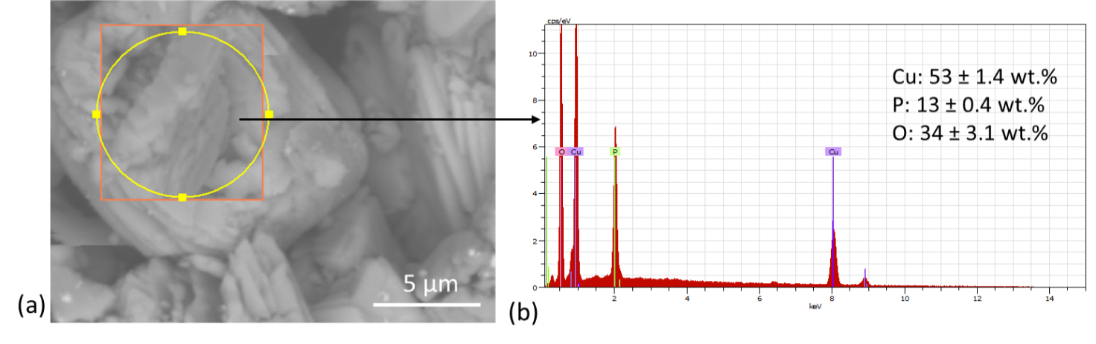

**Figure S3. (**a)SEM micrograph of Lib02 sample (x7k) and (b) EDX analysis for Lib02 sample.



**Figure S4.** Absorbance spectra (from Kubelka-Munk function) of Cu2PO4OH samples.

The energy band gap values (Eg) have been calculated from the absorption edges from the spectra (Kubelka-Munk function) (Table S2).

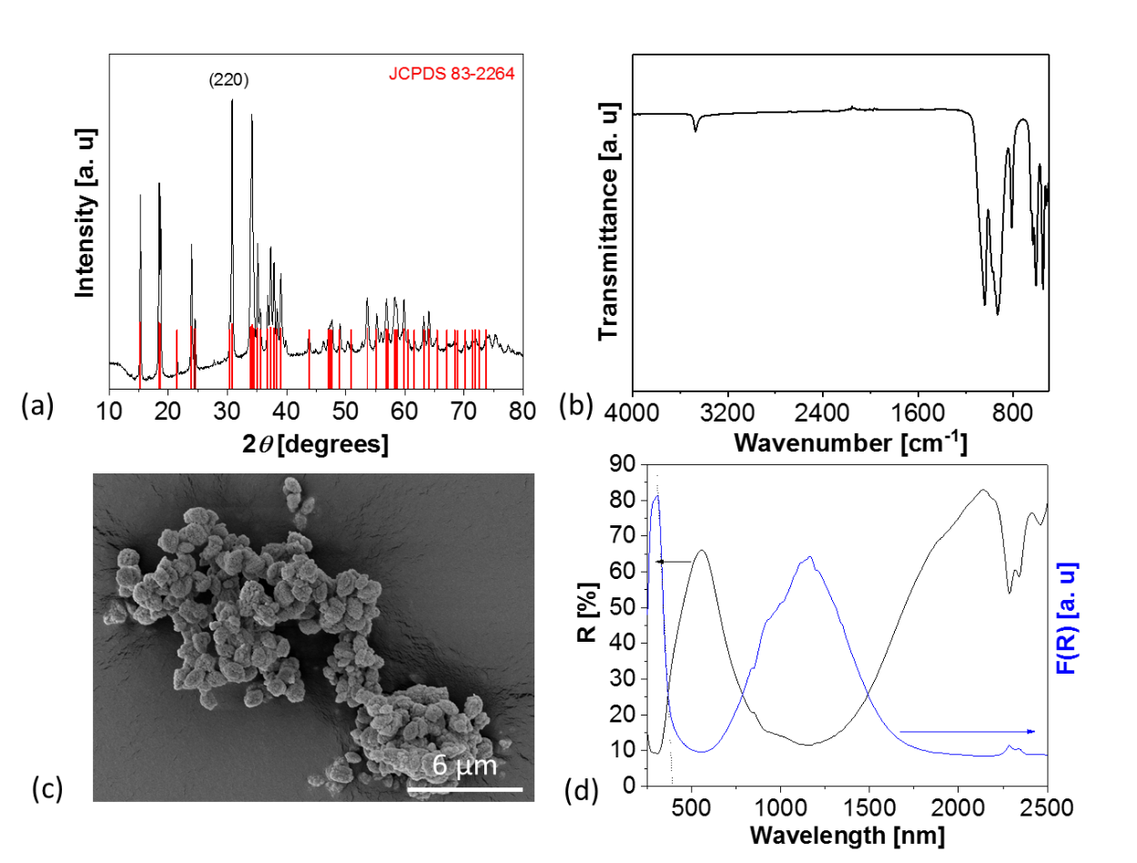

**Figure S5.** Characterization of upscaled Libethenite sample:(a) powder diffractogram, (b) IR spectrum, (c) SEM micrograph (x5k), (d) reflectance and absorption (Kubelka-Munk function) spectra.

**F:\KTP\Keele University\Camera Forensic Sc\Paper Images\drive-download-20180515T082909Z-001\4c.tif**

**Figure S6.** Laser-marked LDPE (low-density polyethylene) plate with logos.

References

[S1] G. Socrates: Infrared and Raman characteristic group frequencies: tables and charts, 3rd ed. (Wiley, 2004).

[S2] I-S. Cho, D. W. Kim, S. Lee, C. H. Kwak, S-T. Bae, J. H. Noh, S. H. Yoon, H. S. Jung, D-W. Kim and K. S. Hong: Synthesis of Cu2PO4OH hierarchical superstructures with photocatalytic activity in visible light. *Adv. Func. Mater*. **18**, 2154 (2008).