Supplementary material for
“Mitochondrion selective hemicyanine dyes suitable for fiber laser excitation two-photon microscopy”
H. Moritomo¹, S. Onishi², N. Asamura³, K. Matsumoto³, Y. Suzuki^{2, 3}, J. Kawamata^{2, 3}
¹ Department of Integrated Science and Technology, National Institute of Technology Tsuyama College, 624-1 Numa, Tsuyama, Okayama 708-8509, Japan
² Graduate School of Sciences and Technology for Innovation, Yamaguchi University, 1677-1 Yoshida, Yamaguchi 753-8512, Japan
³ Department of Biology and Chemistry, Faculty of Science, Yamaguchi University, 1677-1 Yoshida, Yamaguchi 753-8512, Japan
Corresponding author: J. Kawamata j_kawa@yamaguchi-u.ac.jp

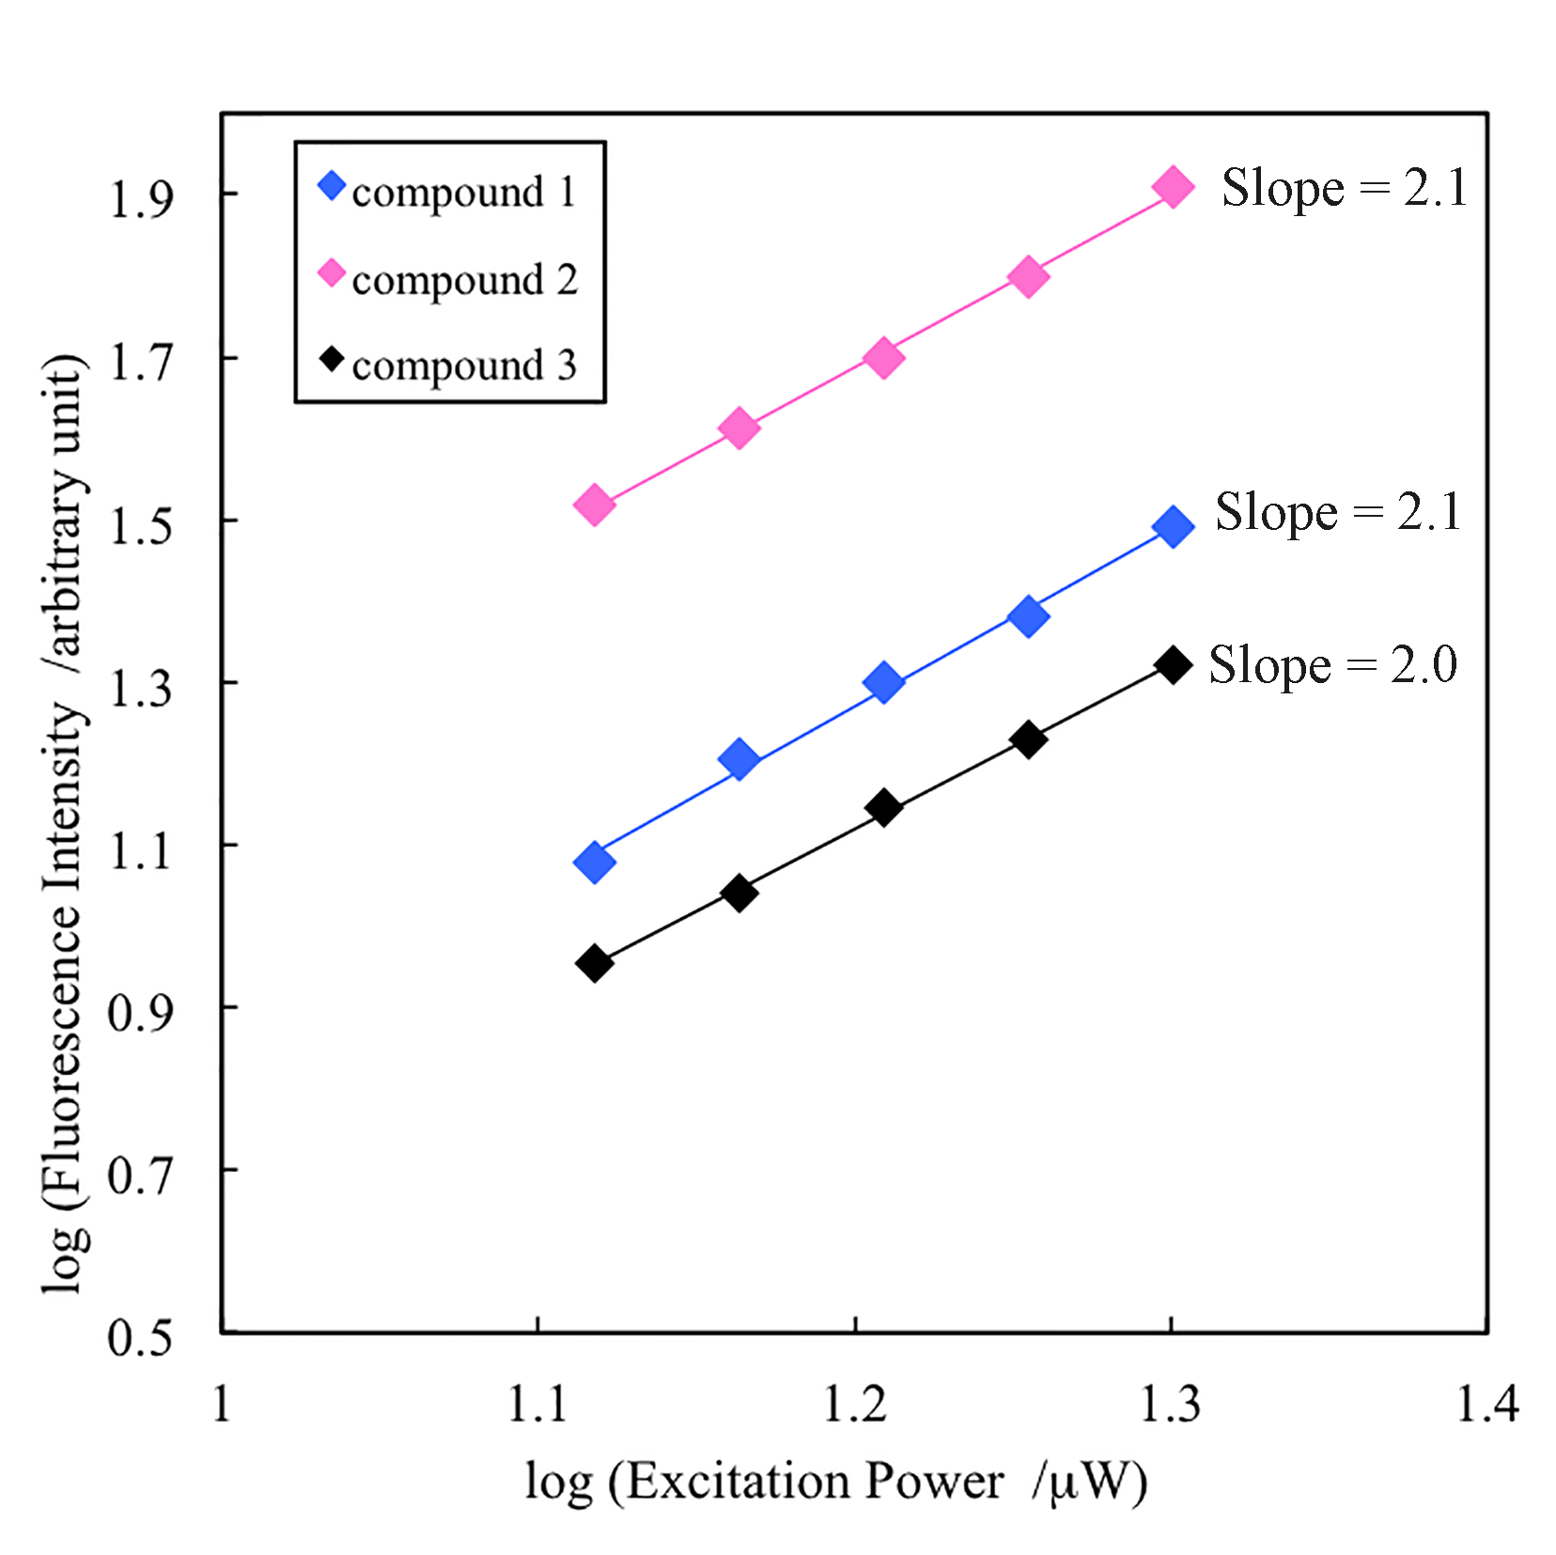
FIG. S1. Incident laser power dependences of two-photon excited fluorescence intensities of compounds 1–3 at 1030 nm.

