Supplementary Material
Transmission surface plasmon resonance image detection
by a smartphone camera

Chutiparn Lertvachirapaiboon*, Chammari Pothipor, Akira Baba*, Kazunari Shinbo, and
Keizo Kato
Graduate School of Science and Technology, Niigata University, 8050 Ikarashi
2-nocho, Nishi-ku, Niigata 950-2181, Japan
E-mail: *chutiparn.l@eng.niigata-u.ac.jp, *ababa@eng.niigata-u.ac.jp

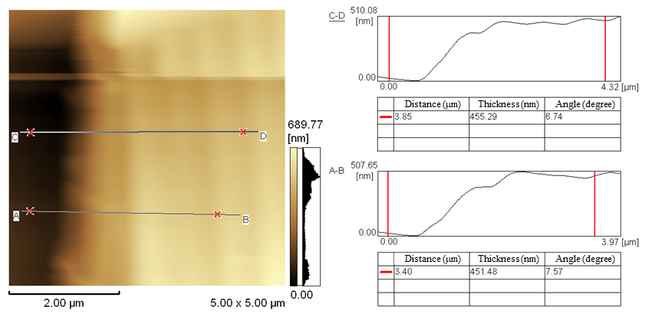

Figure S1. AFM image of total thickness of gold-coated CYTOP grating film. The average total thickness of the substrate is around 450 nm.
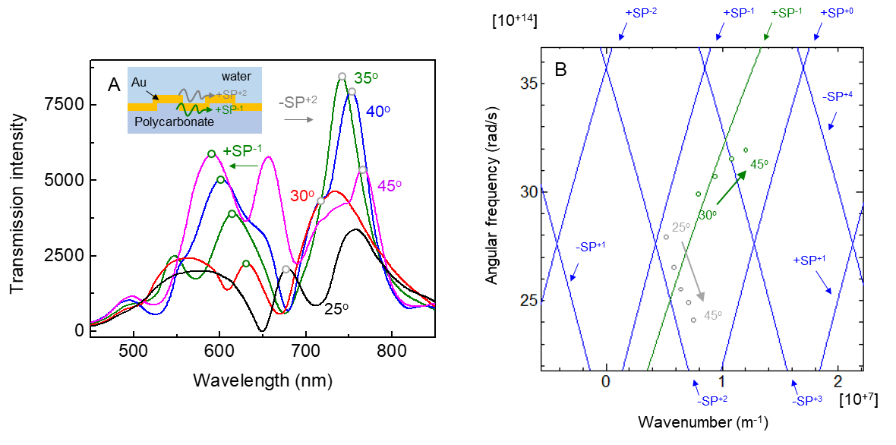
Figure S2. (A) TSPR spectra of gold-coated polycarbonate grating substrate (inset shows schematic of a substrate) and (B) the experimental (dot plots) and calculated (solid lines) results of SP dispersion of the TSPR substrate. The blue and green calculated SP dispersion curves are for gold/water and gold/polycarbonate interfaces, respectively. TSPR peaks for
−SP⁺² (gray dot plots) and +SP⁻¹ (green dot plots) modes were observed in the near-infrared and visible light regions, respectively. The TSPR peaks of the −SP⁺² mode originated from the gold/water interface, while the TSPR peak of the +SP⁻¹ mode originated from the gold/polycarbonate interface. All TSPR spectra were recorded in an aqueous environment.

