Supporting information
Ultra-low Pt decorated NiCu Bimetallic Alloys Nanoparticles Supported on Reduced Graphene Oxide for Electro-oxidation of Methanol
Ammar Bin Yousaf*, Sajeda Adnan Mutlaq Alsaydeh, Fathima Sifani Zavahir, Peter Kasak and Syed Javaid Zaidi*
Center for Advanced Materials, Qatar University, Doha 2713, Qatar
Corresponding Authors E-mails: ammar.chemist18@gmail.com , ammar@mail.ustc.edu.cn , muhammad.ammar@qu.edu.qa (A.B. Yousaf), szaidi@qu.edu.qa (S.J. Zaidi)
Synthesis of graphene oxide: The graphene oxide (GO) was prepared by the modified Hummers and Offenmans method. [1] In a typical experiment, 2 g of blank graphite powder was first added into 100 mL concentrated H₂SO₄ at room temperature. Under stirring, the mixture was cooled to 5 ºC using an ice bath, and the temperature of the mixture was kept below 5 ºC for 30 minutes. 8 g KMnO₄ was then added gradually under stirring and cooling, maintaining the temperature below 10 ºC. 100 mL distilled water was added into the mixture, stirred for 1 h, and further diluted to approximately 300 mL with distilled water. After that, 20 mL of 30% H₂O₂ was added to the mixture to reduce the residual KMnO₄. The solid was filtered, washed with 5% HCl aqueous solution to remove metal ions and afterwards with distilled water until the pH was 6. The resulting graphene oxide was dried at 50 ºC for 24 h.
Reference
- W.S. Hummers, R.E. Offeman, Preparation of Graphitic Oxide. J. Am. Chem. Soc. 80, 1339 (1958).
Table S1: ICP-MS results for real Pt, Ni and Cu loading measurements of all the catalysts included in present study
No. | Catalyst | ICP-MS measurements
 |  | Pt  (mol) | Ni  (mol) | Cu  (mol) | Pt  (wt%) |  | Ni  (wt%) | Cu  (wt%) | Pt  (wt%) |  | Ni  (wt%) | Cu  (wt%)
 |  |  |  |  | “Actual Loadings” |  |  |  | “Nominal Loadings”
1 | Pt-Ni₁Cu₃/rGO | 2.185×10⁻⁶ | 0.002×10⁻³ | 0.0168×10⁻³ | 1.93 | 59.4 |  | 18.9 | 2 | 20 |  | 60
2 | Pt-Ni₁Cu₁/rGO | 2.211×10⁻⁶ | 0.005×10⁻³ | 0.0145×10⁻³ | 1.96 | 38.9 |  | 39.3 | 2 | 40 |  | 40
3 | Pt-Ni₃Cu₁/rGO | 2.204×10⁻⁶ | 0.008×10⁻³ | 0.0119×10⁻³ | 1.98 | 19.7 |  | 58.8 | 2 | 60 |  | 20

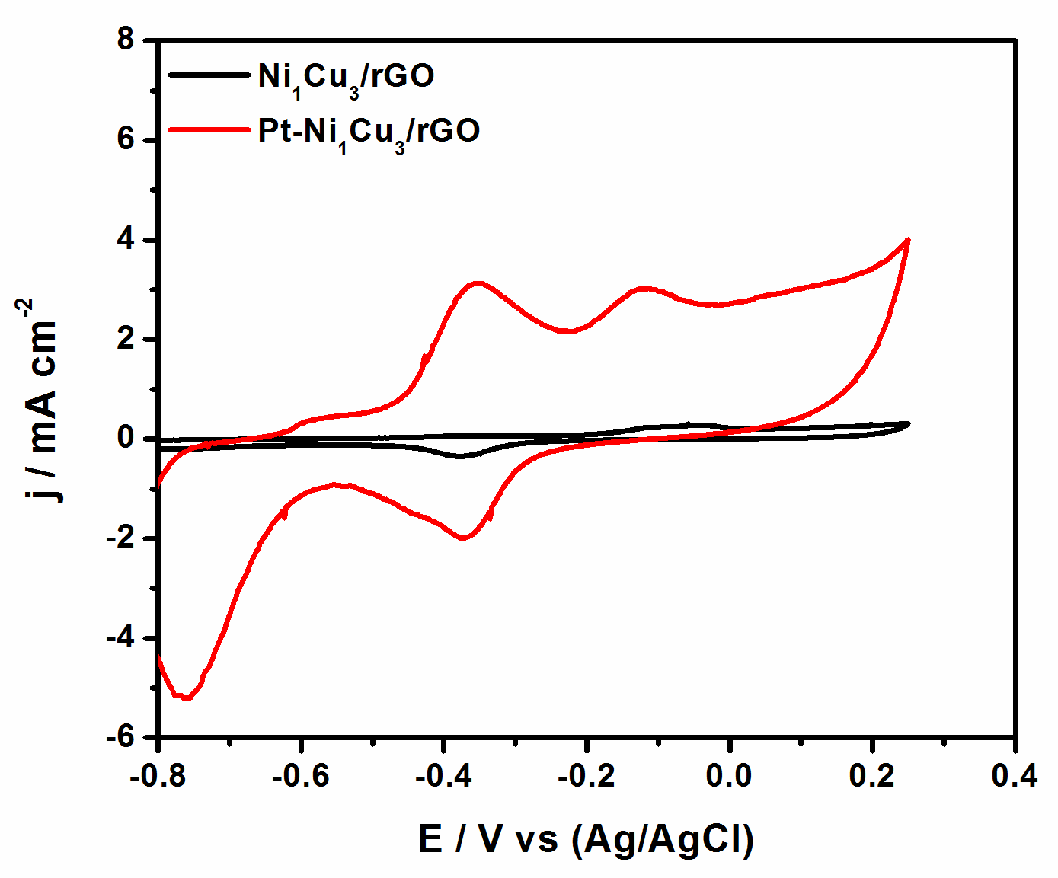
Figure S1: Electrochemical CV results taken in presence and absence of Pt loading in 0.1M KOH + 1 M CH₃OH, for the analysis of electrocatalytic MOR performance of Ni₁Cu₃/rGO and Pt-Ni₁Cu₃/rGO catalysts.

