Supplementary material:
Defect engineering in Boron Nitride for catalysis
Yi Ding^{1,2}, Fernand Torres Davila^{1,3}, Ahmad Khater¹, David Nash³, Richard Blair⁴, and Laurene Tetard^{*1,2,3}
¹NanoScience Technology Center, University of Central Florida, 12424 Research Parkway, Orlando, FL, 32826, USA
²Department of Materials Science and Engineering, University of Central Florida, 12760 Pegasus Drive, Orlando, FL, 32816, USA
³Physics Department, University of Central Florida, 4111 Libra Drive, Orlando, FL 32816, USA
⁴Florida Space Institute, University of Central Florida, 4111 Libra Drive, Orlando, FL 32816, USA
Corresponding author: Laurene Tetard, Laurene.tetard@ucf.edu

SEM flake analysis of the ball-milled samples
Higher resolution SEM images of the ball-milled and heat-treated flakes are presented in Fig. S1. This clearly depicts the effect of ball milling on reducing the size of the flakes compared to heat treatment for which the flakes maintain their initial dimensions.
Fig. S1. SEM image of the powder obtained after 2 h of ball milling with ZrO₂ (left) and of the powder heat treated at 950˚C for 2 h (right). Both treatments were carries out under argon atmosphere.
SEM images acquired at 5000x magnification were selected for flake size analysis. We assigned three size category (> 5 μm, 2-5 μm, < 2 μm) for which the number of the flakes was estimated. The percentage of the number of flake in the image belonging to each category was calculated.

Table S1. Summary of the flake size distribution percentage for the different ball-milled dh-BN powders
 | >5 μm | 2-5 μm | <2 μm
ZrO₂ 30 min | 17.9 | 52.2 | 29.9
ZrO₂ 60 min | 12.2 | 76.4 | 11.4
ZrO₂ 90 min | 13.5 | 18.9 | 67.6
ZrO₂ 120 min | 0 | 15.8 | 84.2
WC 120 min | 4.8 | 47.6 | 47.6

IR spectroscopy analysis of the ball-milled samples
FTIR spectra obtained for dh-BN indicated a change in the relative intensity of the A_{2u} and E_{1u} modes. We extracted the intensity of each band and we present their ratio below.
Table S2. Absorption_{(A2u)}/ Absorption_{(E1u)} ratio in the IR spectrum of pristine h-BN and ball-milled dh-BN
 | Absorption_{(A2u)}/ Absorption_{(E1u)}
Pristine | 1.36
ZrO₂ 30 min | 0.81
ZrO₂ 60 min | 0.58
ZrO₂ 90 min | 0.55
ZrO₂ 120 min | 0.55
WC 120 min | 0.84

Raman spectra obtained for dh-BN indicated a change in the relative intensity of the band at 1371 cm⁻¹, making it difficult to compare the width of the band. We fitted the band with a Lorentzian function and extracted the position and FWHM for each powder. The results are summarized in the table below.
Table S3. Summary of the position and FWHM of the E_{2g} band in heat treated dh-BN
Sample | Position (cm⁻¹) | FWHM (cm⁻¹)
800˚C 2 h | 1371 | 8.2
850˚C 2 h | 1371 | 8.4
850˚C 12 h | 1371 | 8.3
850˚C 24 h | 1371 | 8.3
900˚C 2 h | 1371 | 8.4
900˚C 12 h | 1371 | 7.9
900˚C 24 h | 1371 | 8.1
950˚C 2 h | 1371 | 8.4

Raman spectrum of the dh-BN obtained by heat treatment of 950˚C for 2h under Argon atmosphere in the glove box
The effect of heat treatment on h-BN was investigated. As it required long hours of high temperature in the furnace, for security considerations, optimization was carried out in air. We identified a treatment at 950˚C for 2 h to be a good condition to reproduce the treatment under argon atmosphere in the glovebox. The Raman spectrum of the dh-BN obtained under argon is presented in Fig. S2. Using a deconvolution algorithm with two Lorentzian fits, we assigned the position of the E_{2g} band at 1371 cm⁻¹ with a FWHM of ~7 cm⁻¹. A secondary broader band (FWHM of ~ 53 cm⁻¹) at 1356 cm⁻¹ was observed in the spectrum, likely resulting from defects in the lattice. This band has previously been assigned to h-BN with 5:5:8 N-N grain boundaries ¹ of BN. Further studies will be performed to pinpoint the nature of the sub-band. However, the measurement allows us to confirm that oxidation in the 800-900 cm⁻¹ range disappeared.
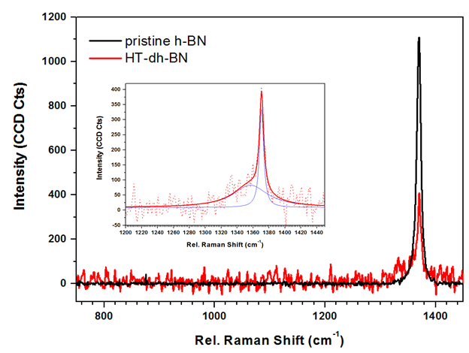
Fig. S2. Raman spectrum of the powder heat treated at 950˚C for 2 h under argon atmosphere. No sign of oxidation was observed in the 800-900 cm⁻¹ region. The E_{2g} band and secondary band at 1356 cm⁻¹ are identified with deconvolution as shown in the inset.

1. R.C.N. Rao and W.U. Vasudeo: 2d Inorganic Materials Beyond Graphene, (World Scientific Publishing Company 2017).

