**Boosting interfacial charge transfer for efficient water splitting photoelectrodes: progress in bismuth vanadate photoanodes using various strategies**

*Supplementary Material.*

Taemin Ludvic Kim†, Min-Ju Choi†, and Ho Won Jang*

Department of Materials Science and Engineering, Research Institute of Advanced Materials, Seoul National University, Seoul 08826, Republic of Korea

E-mail: hwjang@snu.ac.kr

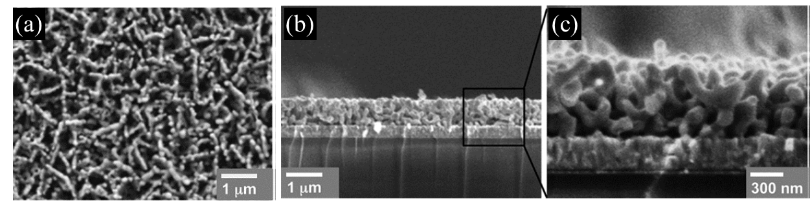

**FIG. S1** (a-c) SEM surface and cross-sectional images of nanoporous BVO electrodes using DMSO/VO(acac)2. Reproduced with permission from ref. 50. American Association for the Advancement of Science, 2014.



**FIG. S2** (a)Photocurrent-potential curves under AM 1.5G sunlight, (b) charge transfer, (c) charge transport efficiencies, and (d) IPCEs of CoOx/ND-BVO/BaON, ND-BVO/GaON, P-BVO/GaON, BVO, and GaON photoanodes. (e) Illustration of improved effects of ND-BVO/GaON photoanode. Reproduced with permission from ref. 52. WILEY-VCH Verlag GmbH & Co. KgaA, Weinheim, 2017.

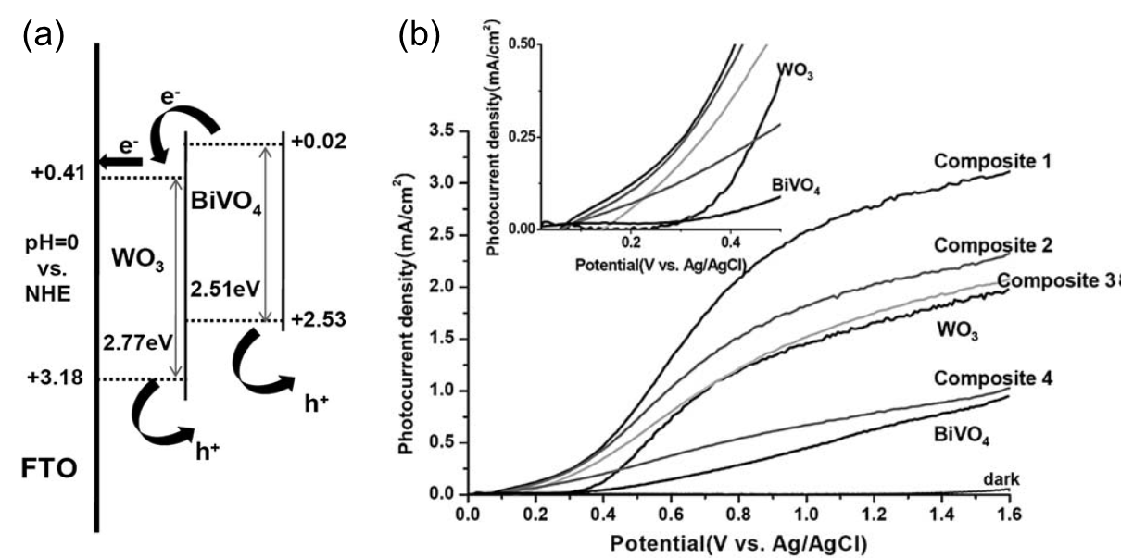

**FIG. S3** (a) Schematics of the potential energy diagram and (b) Photocurrent-potential (J-V) curves. Reproduced with permission from ref. 71. Royal Society of Chemistry, 2011.

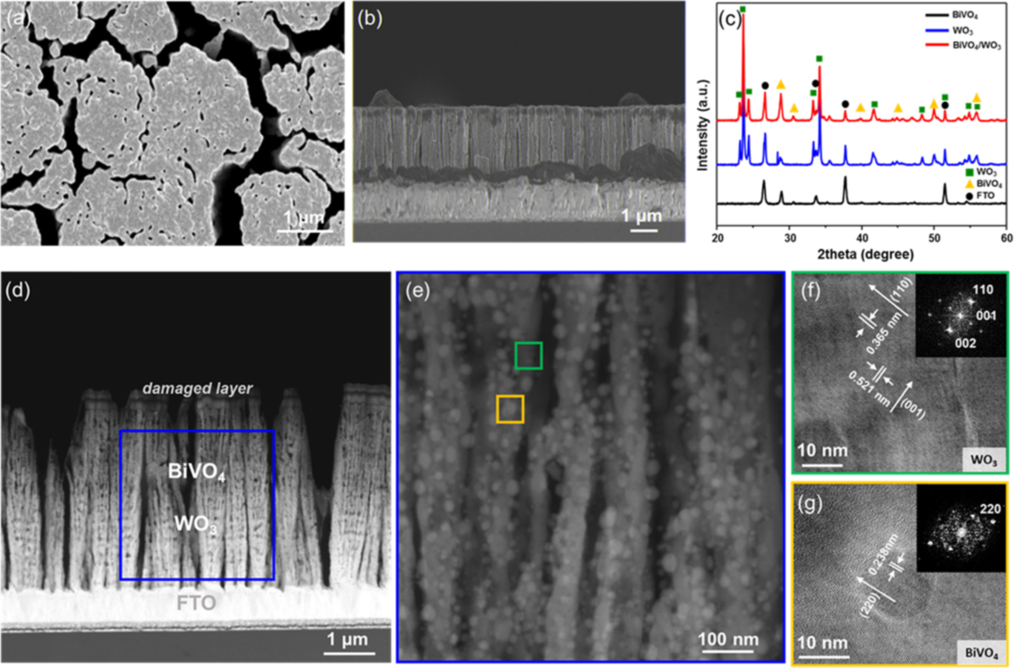

**FIG. S4** (a,b) SEM surface and cross-sectional images of BVO/WO3 nanorods, (c) X-ray diffraction patterns of BVO, WO3, and BVO/WO3 nanorods. (d) Corresponding TEM images, (e) expanded image of BVO/WO3 nanorods, and (f,g) HRTEM images. Reproduced with permission from ref. 72. Elsevier, 2016.

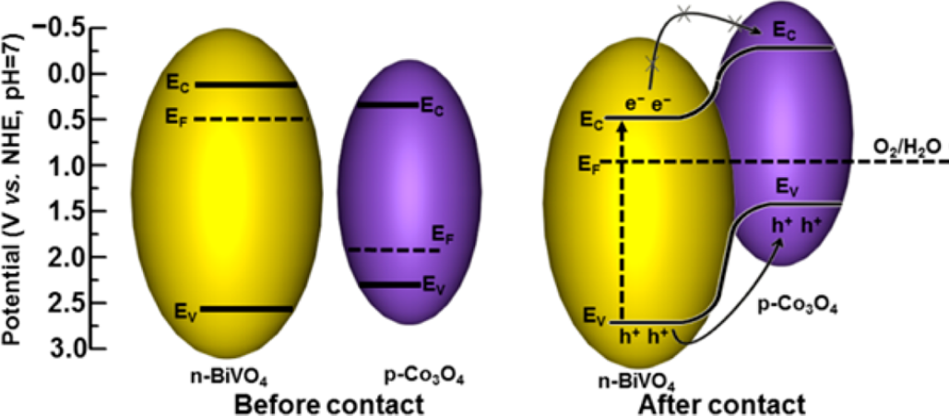

**FIG. S5** Band diagram and mechanism of charge separation. Reproduced with permission from ref. 75. American Chemical Society Publications, 2015.

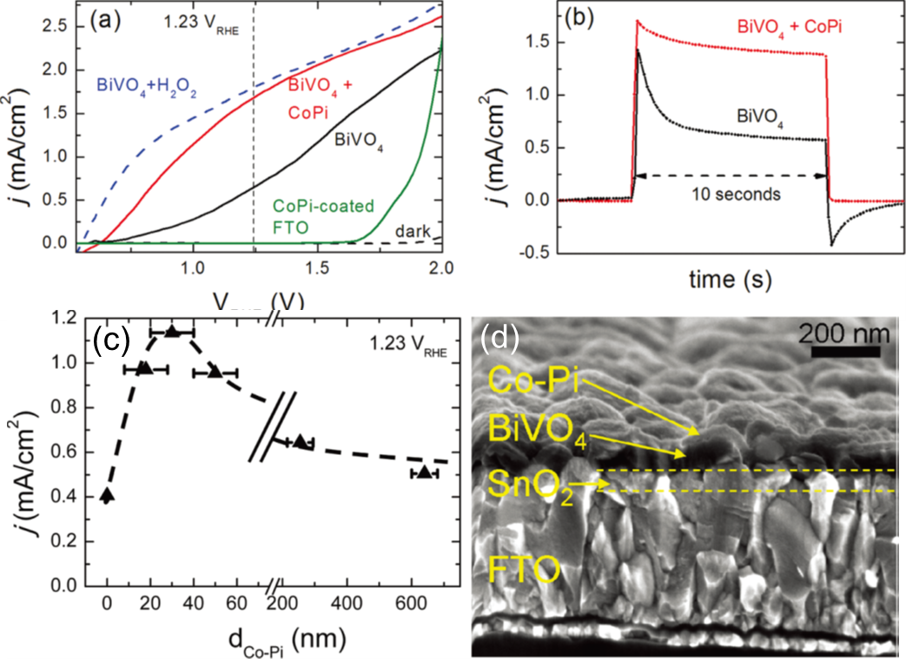

**FIG. S6** (a) Photocurrent-potential (J-V) curves and (b) chopped chronoamperometry plot. (c) Photocurrent density as a function of Co-Pi catalyst thickness and (d) SEM cross-sectional image. Reproduced with permission from ref. 32. American Chemical Society Publications, 2012.