Supplementary Materials
Investigation of the Redox State of Magnetite upon Aβ Fibril Formation or Proton Irradiation; Implication of Iron Redox Inactivation and β-Amyloidolysis
Younshick CHOI¹ and Jong-Ki KIM¹
1Department of Biomedical Engineering & Radiology, School of Medicine, Catholic University of Daegu, Daegu 42472 Korea

Correspondence: Jong-Ki Kim
Professor in Biomedical Engineering and Radiology,
School of Medicine, Catholic University of Daegu, Korea
jkkim@cu.ac.kr
+82-53-650-4335
+82-109685-4335

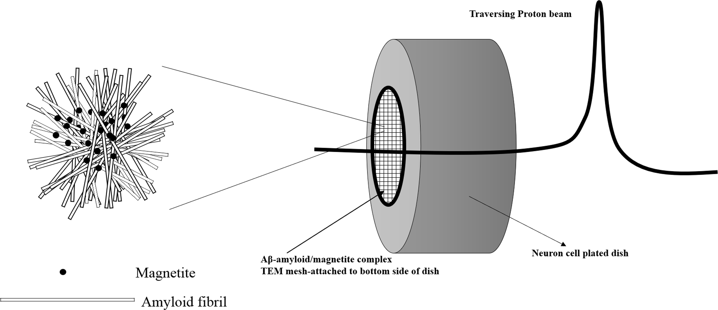
Figure S1. Schematic diagram depicting separate compartments of neuronal cells and β-amyloid/magnetite fibrils on the TEM mesh that was irradiated by a 100 MeV traversing proton beam.

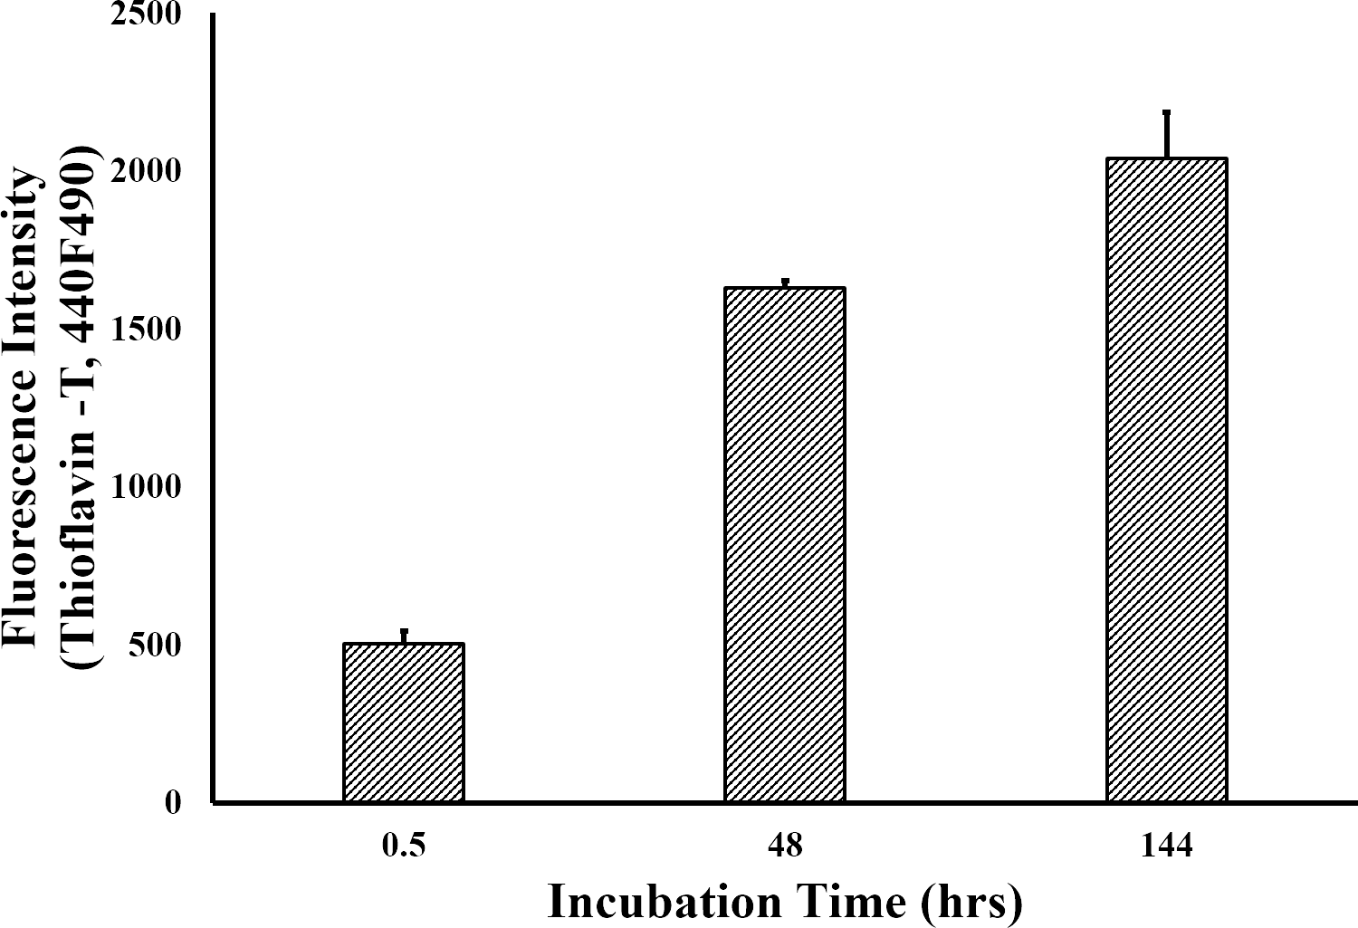
Figure S2. Aβ fibrillization was assessed by fluorescence evaluation of the ThT binding to the magnetite-amyloid complex over a 6-day incubation period. Thioflavin T-fluorescence was enhanced upon for fibril formation.

