Supplementary Material
Natural Eggshell Membranes Exhibiting Programmable
Shape Recovery Characteristics
Chang Liu†,‡, Chen Liu†, Qian Li‡, Miao Song¶, Dun Niu‡,*, Mingming Ma#,*, Xing Zhang†,§,*
†Shenyang National Laboratory For Materials Science, Institute of Metal Research, Chinese Academy of Sciences, Shenyang, Liaoning 110016, China
‡Department of Chemistry, Northeastern University, Shenyang, Liaoning 110004, China
¶Pacific Northwest National Laboratory, Richland, WA 99352, USA
#Department of Chemistry, University of Science and Technology of China, Hefei, Anhui, 230026, China
§School of Materials Sciences and Engineering, University of Science and Technology of China, Hefei, Anhui, 230026, China

*Corresponding authors: xingzhang@imr.ac.cn (Xing Zhang), niudun666@hotmail.com (Dun Niu), mma@ustc.edu.cn (Mingming Ma).

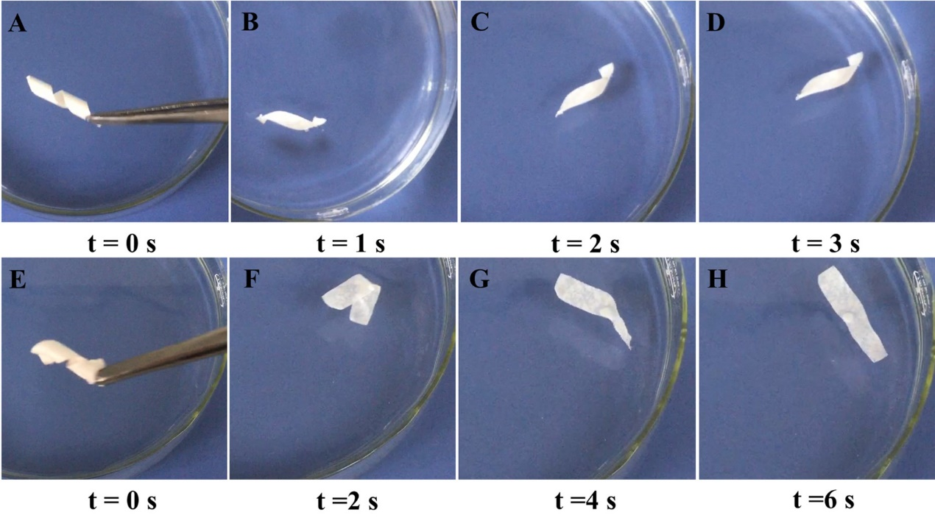
Figure S1. The shape recovery process for (A-D) a goose ESM sample and (E-H) a quail ESM sample from the temporary helical shape in dry status to the original flat shape through hydration in water at room temperature.

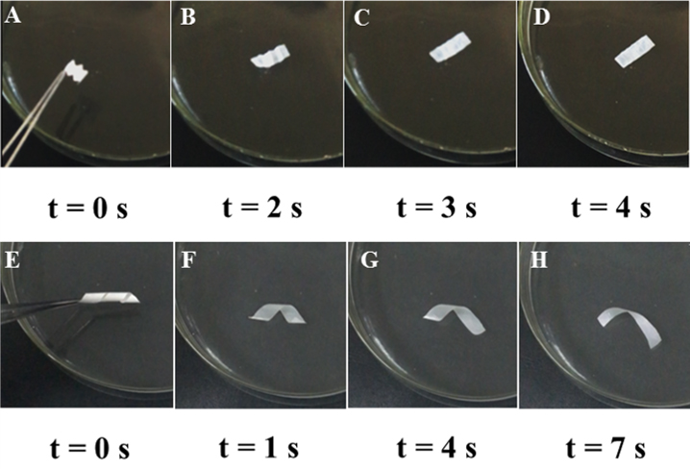
Figure S2. The shape recovery process for (A-D) a dry zigzag-shape ESM sample and (E-H) a dry helical-shape ESM sample through hydration in a 70% (v/v) ethanol-water solution at room temperature.

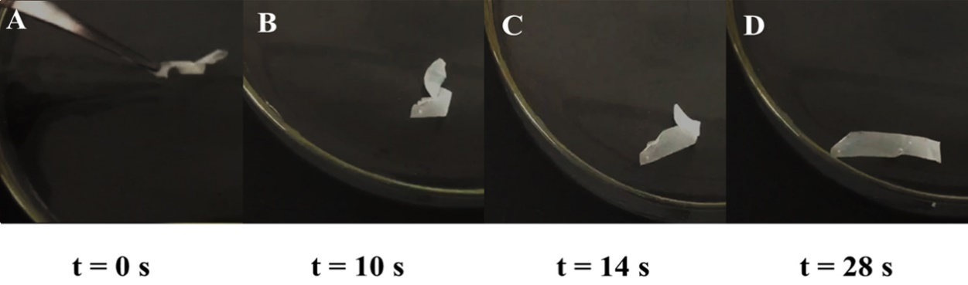Figure S3. (A-D) The shape recovery process for a dry helical-shape thiolated-ESM sample through hydration in water at room temperature.

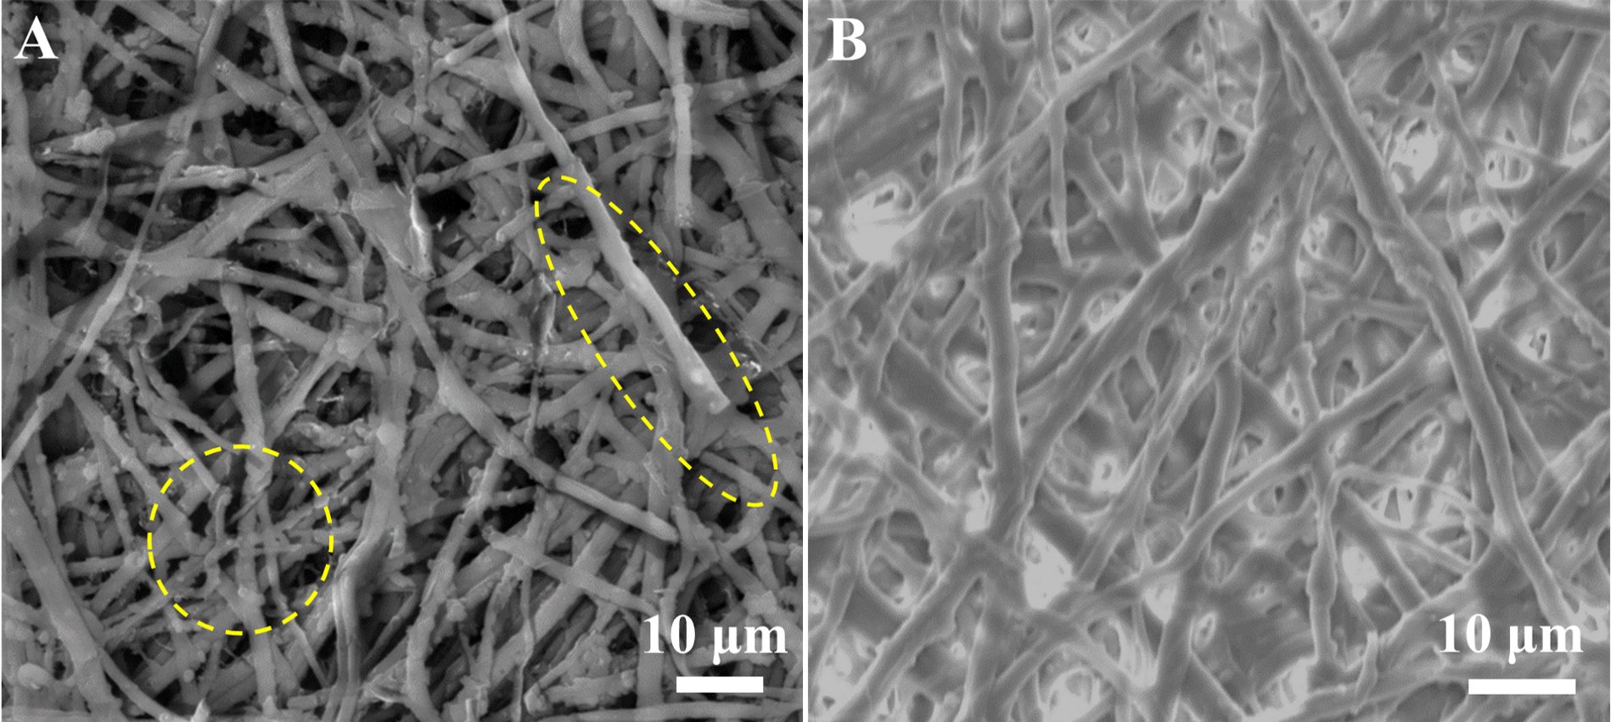
Figure S4. SEM morphology of fiber structures for (A) denatured-ESM samples and (B) the thiolated-ESM. Yellow dash circles in (A) indicate the disruption of fiber structures by denaturation.
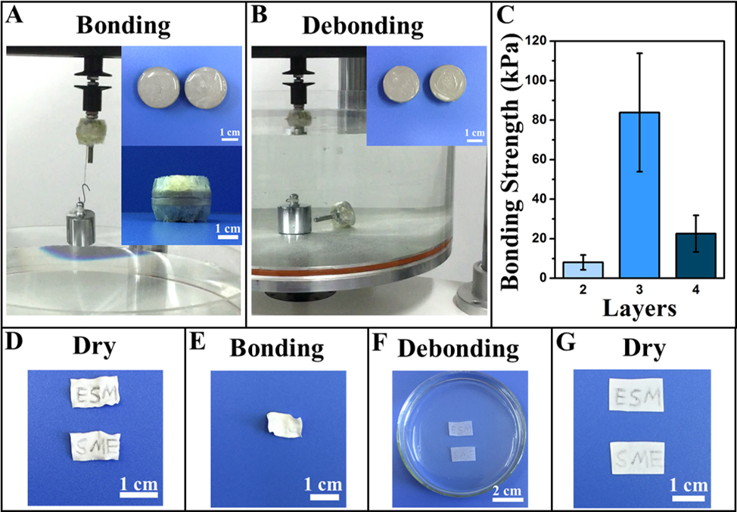
Figure S5. (A,B) The adhesion trials between different ESM layers. (C) Bonding strength among ESM layers based on tension tests. (D-G) Illustration of reusable adhesive by ESM samples using their shape memory effects.

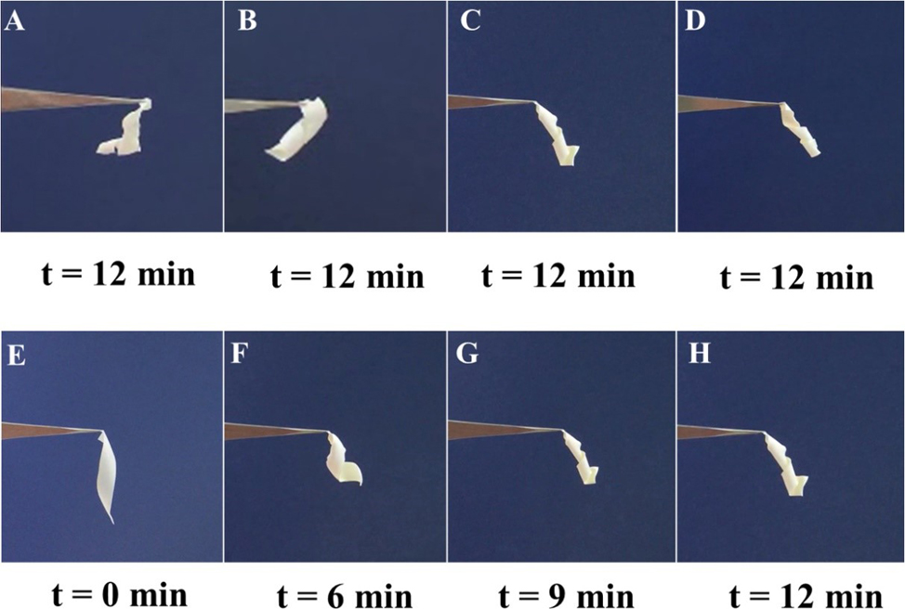
Figure S6. (A-D) The shape recovery of wet helical-shape GA-ESM samples with GA crosslinking for different periods: (A) 15 min, (B) 30 min, (C) 1 hour, (D) 2 hours, followed by dehydration in air for 12 min. (E-H) The shape recovery process of a wet GA-ESM sample with GA crosslinking for an hour through dehydration in air.

Figure S7. Schematic illustration of hierarchical structures of ESM and their roles in the shape memory effect. (A) Illustration of the double-layer membranes of an ESM sample. (B) The core-mantle structure of an ESM fiber. (C) The well-aligned collagen triple-helical molecular chains. (D) The triple-helical molecular chain and intramolecular H-bonds and disulfide bonds. (E) The thiolation reaction by S-S bond cleavage. (F) Disruption of assembled triple-helical molecular chains by denaturation.
Figure S8. Schematic illustration of (A) the ESM fiber network under dry status and (B) the ESM fiber network with water diffusion under wet status. (C) The intermolecular H-bonds among ESM proteins under dry status. (D) The H-bonds between ESM proteins and bound water under wet status.

