Supplementary Material:
Materials:
CL31 Aluminum Silicon Magnesium Alloy Micropowder: Aluminum Silicon Magnesium alloy micropowder was purchased from Concept Laser Inc. The powder consisted of Al(Balance), Si(9.0-10.0%) Mg (0.2-0.45%) Fe(<0.55% Trace) Mn(<0.45% Trace) Ti(<0.15% Trace), in weight per cent. Particle size optimized for selective laser melting and proprietary to the manufacturer.
Tungsten Carbide nanopowder (55nm) was purchased from US Research Nanomaterials Inc.
Lattice Matching:
Lattice matching methods can be found in Martin, J.H, et al. Nature 2017
Selective Laser Melting:
Additive manufacturing of the stock aluminum alloy and functionalized aluminum alloy powders were performed on a Concept Laser M2 selective laser melting machine. The Concept Laser M2 machine specifications are listed in Supplementary Table 1. Samples consisted of 60mm x 20mm x 40mm tensile block specimens and 10mm x 10mm x 40mm blocks for examining microstructure. Images of the as-printed samples on the build plates can be seen in Supplementary Figure 1. Samples were processed with Concept Laser “islanding” scan strategy specifically developed for the CL31 AlSi10Mg alloy material to minimize thermal and residual stress build up in the part. Islands which compose the core of the build geometry were 2mm x 2mm in size. Standard machine parameters provided by the Concept Laser for conventional AlSi10Mg alloy were utilized for all builds. The parameter values are considered proprietary by Concept Laser and cannot be accessed by the user. The 70mm x 70mm build plates were machined out of aluminum alloy 6061 and sandblasted on the surface. Layers of the build were incremented by a range from 25µm to 80μm depending on part geometry and location in the build. Processing was done under a flowing, inert nitrogen atmosphere with oxygen monitoring. All processing was completed at room temperature with no applied heat to the build plate. Samples were removed from the machine and cleaned of extra powder by sonicating in water. Parts were then dried with clean compressed dry air.
Heat Treatment:
Samples were then heat treated to the manufacturer’s recommended CL31 treatment: ramp to 240°C in 1 hour, 6 hour hold, furnace cool 10 100°C and remove to ambient atmosphere, all completed in a lab air atmosphere.
Sectioning and Sample Preparation:
All samples were removed from the build plates via wire electro discharge machining (EDM). Tensile specimens were sectioned with wire EDM to a thickness of 2mm. Tensile specimens were prepared for mechanical testing by polishing the surfaces of the gauge section with 240, 360, 400, 800, and 1200 grit sand paper by hand. One side of the mechanical test samples was painted with white and spackled with black paint with an airbrush for digital image correlation (DIC) using a GOM ARAMIS- 3D Motion and Deformation Sensor.
Microstructure blocks were sectioned with a water-cooled saw and mounted in epoxy resin for polishing. Grinding was done with 240, 360, 400, 800, and 1200 grit sand paper. Final polishing of the samples was accomplished with 1µm diamond and 50nm Al₂O₃ polishing compounds from PACE Technologies. Some polished samples were etched with Keller’s Etch for 10 seconds to reveal microstructure. Additional imaging was conducted using SEM.
Materials Characterization:
To observe microstructural differences, mounted samples were analyzed via scanning electron microscopy.
Mechanical Testing:
Tensile tests were performed on a servo-electric INSTRON 5960 frame equipped with a 50kN load cell (INSTRON). Samples were clamped by the ends of the dog-bone samples. The extension rate was 0.2mm/min and samples were loaded until fracture. Testing was conducted following ASTM E8. A Universal-joint was used to account for any misalignment in the sample.
Wear testing was conducted by Element Materials Technology in accordance with ASTM G133. Samples were taken from the grip region of tested tensile specimens. They were polished to remove any surface damage from the tensile grips and then mounted on the test fixture by Element. The samples were tested at 4.545 kg (10 lbs) first and then 2.273 kg (5 lbs) with mass loss calculated at the end of the test.
Data Availability:
The data that support the findings of this study are available from the corresponding author upon reasonable request.

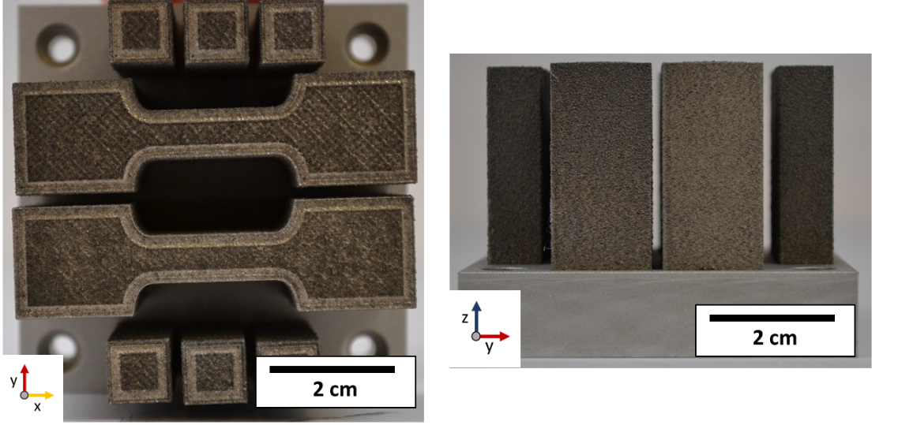
Figure S1: Typical Build Geometry. Extruded tensile bar geometries are produced in the center of the 70 mm x 70 mm build plate with microstructure blocks on either side. Tensile bar extrusions are sliced horizontally via wire EDM to produce ~2mm thick tensile coupons.

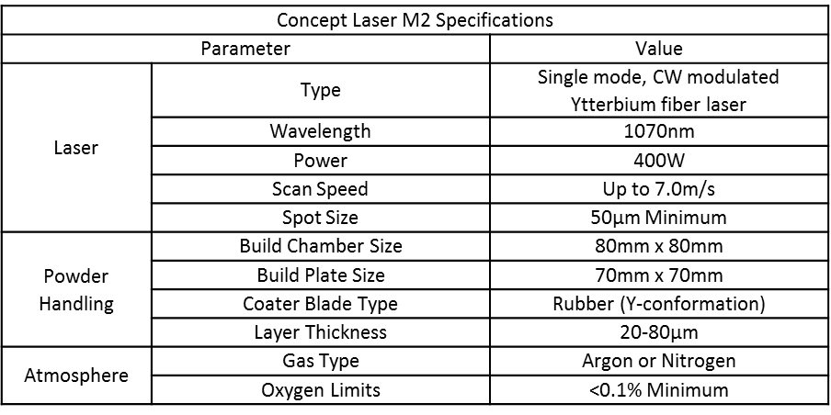
Table S1 Specifications of Concept Laser M2 selective laser melting system.

