SUPPLEMENTARY MATERIAL

Anode Performance of Hydrothermally Grown Carbon Nanostructures and Their Molybdenum Chalcogenides for Li-ion Batteries

Hamza Simsir^{a,b}, Nurettin Eltugral^{a,*}, Robert Frohnhoven^{b}, Tim Ludwig^{b}, Yakup Gönüllü^{b}, Selhan Karagoz^{c}, Sanjay Mathur^{b}
^{a.}Department of Metallurgical and Materials Engineering, Karabuk University, 78050 Karabuk, Turkey
^{b}Institute of Inorganic Chemistry, University of Cologne Greinstrasse 6, D-50939 Cologne, Germany
^{c}Department of Chemistry, Karabuk University, 78050 Karabuk, Turkey.

Asterisk shows corresponding author: nurettineltugral@karabuk.edu.tr (N. Eltugral)
Tel.: + 90 370 418 70 50; fax: + 90 370 418 70 01

- 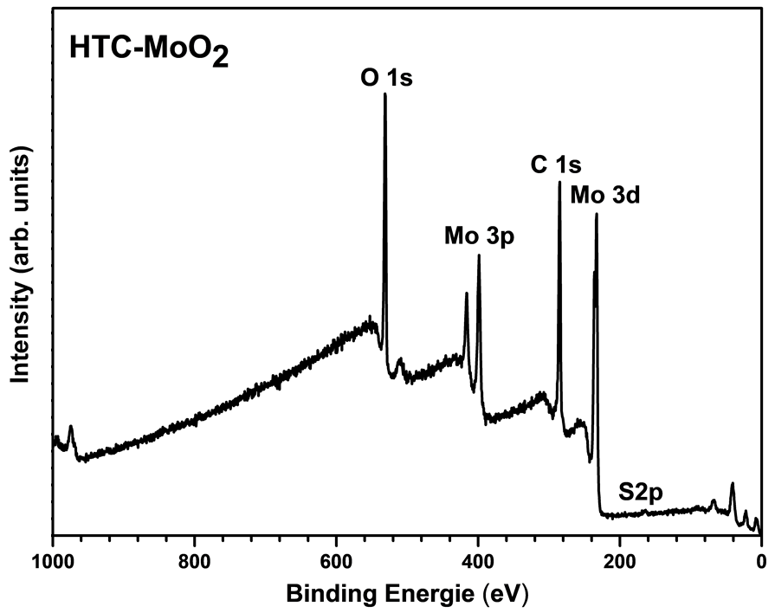

- 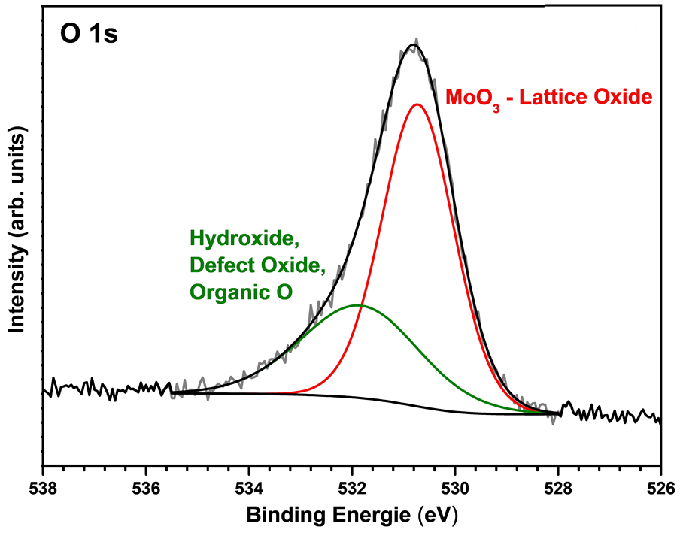
- 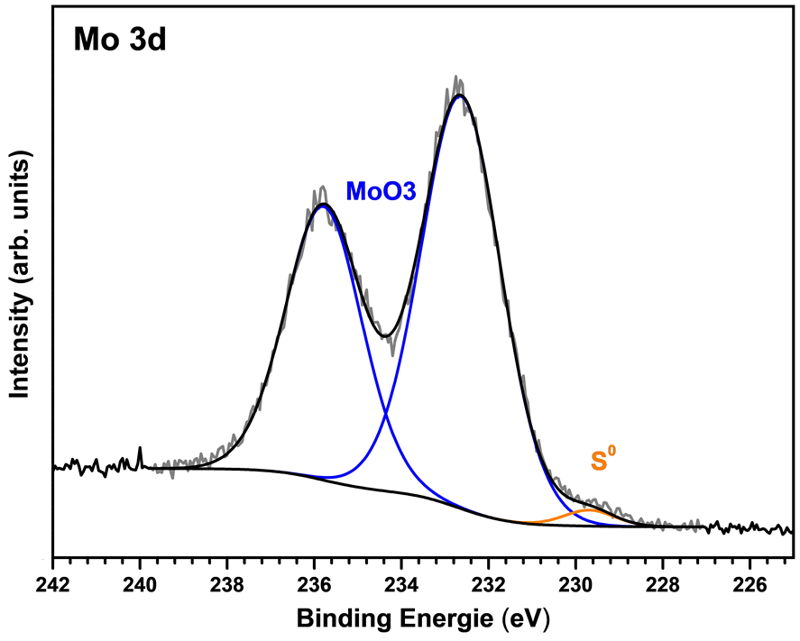

- 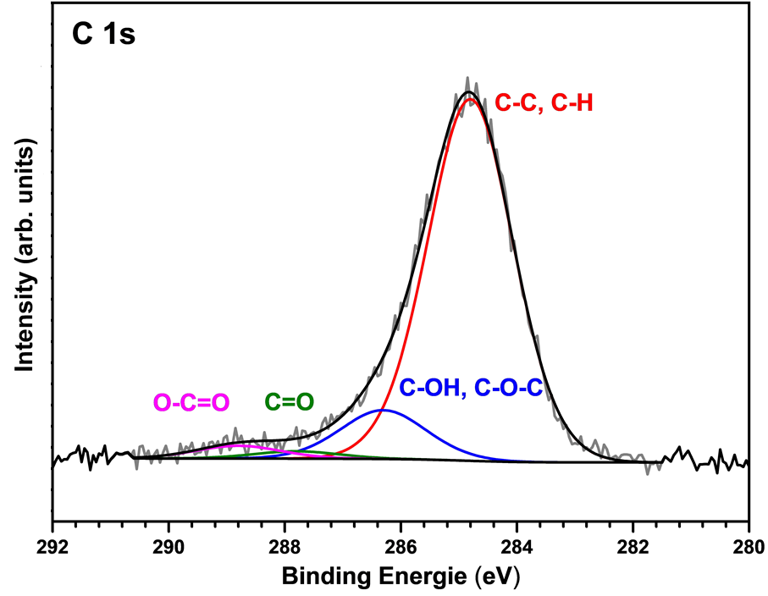

FIG. S1. XPS analysis of HTC-MoO₂ a) survey spectrum b) O1s, c) Mo3d and d) C1s.

- 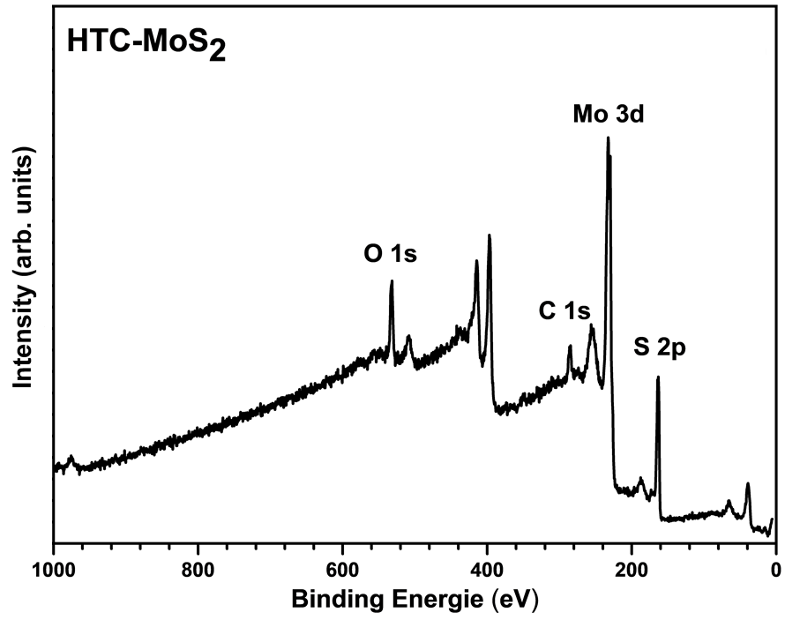

- 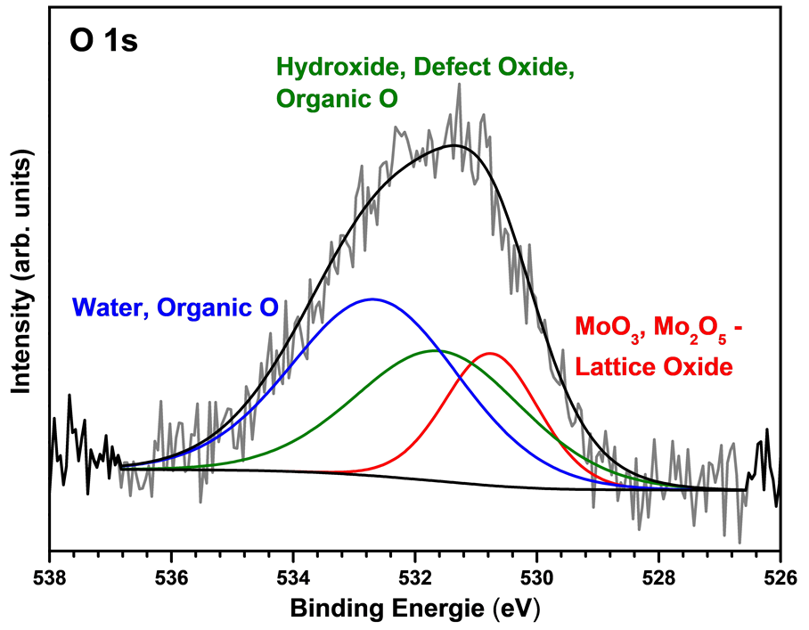

- 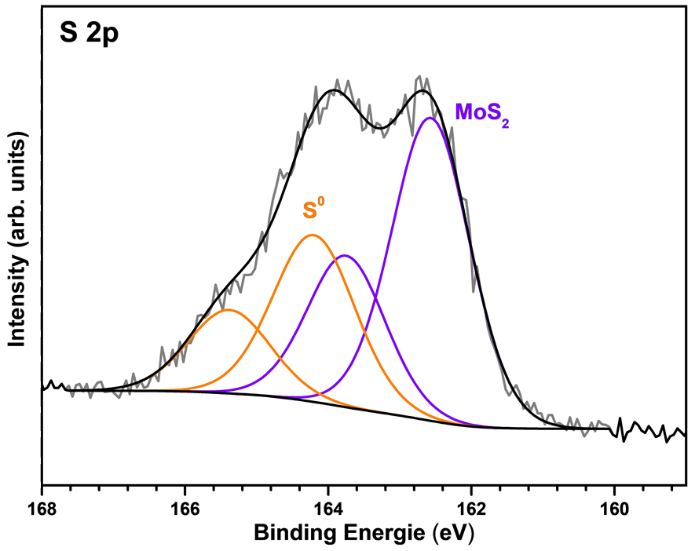

- 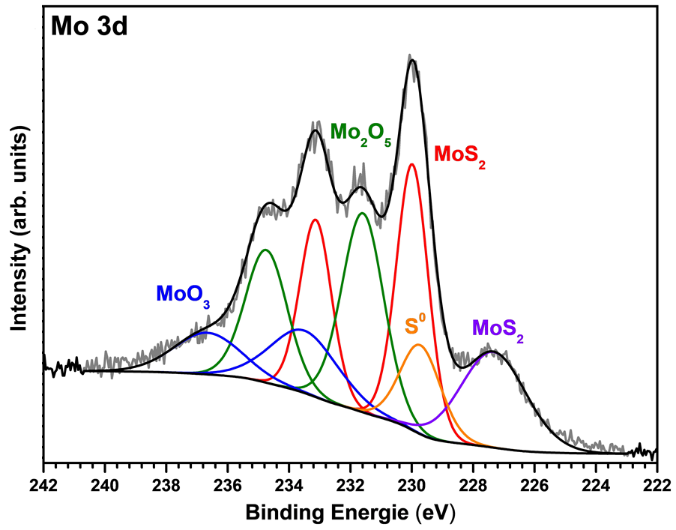

- 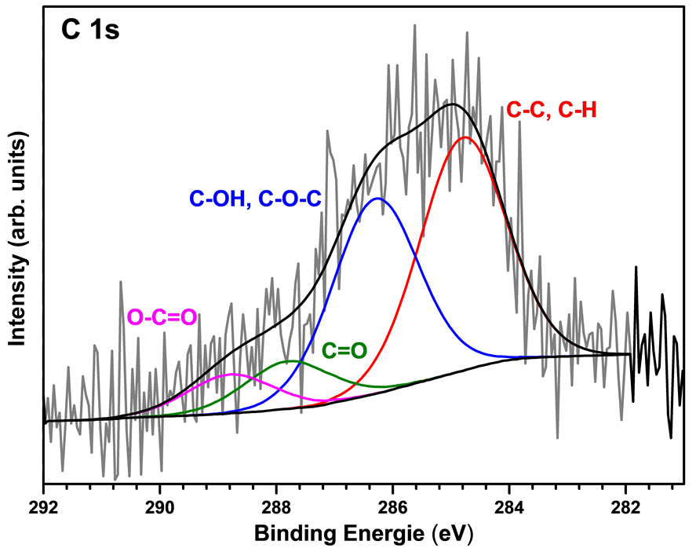

FIG. S2. XPS analysis of HTC-MoS₂ a) survey spectrum b) O1s, c) S2p, d) Mo3d and e) C1s.

