**Supplementary Material**

**A novel approach for *in situ* monitoring of Zn2+ in citrus plants using two-step square wave anodic stripping voltammetry**

**Jared Church**and **Woo Hyoung Lee**, Department of Civil, Environmental, and Construction Engineering, University of Central Florida, Orlando, Florida, 32816, USA

Address all correspondence to W.H. Lee at [Woohyoung.lee@ucf.edu](mailto:Woohyoung.lee@ucf.edu)

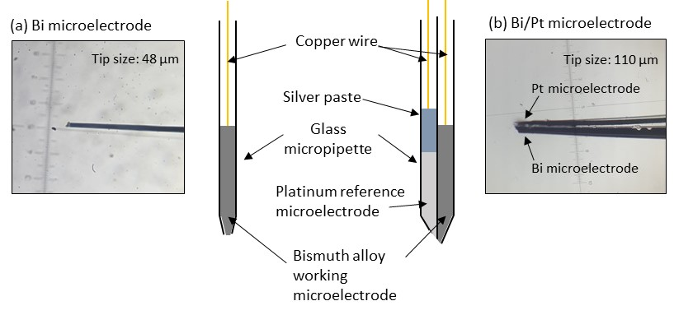

**Figure S1.** A schematic diagram and microscopic images of (a) the developed single barrel Bi microelectrode and (b) the double barrel Bi/Pt microelectrode for the detection of Zn2+ in citrus plants.

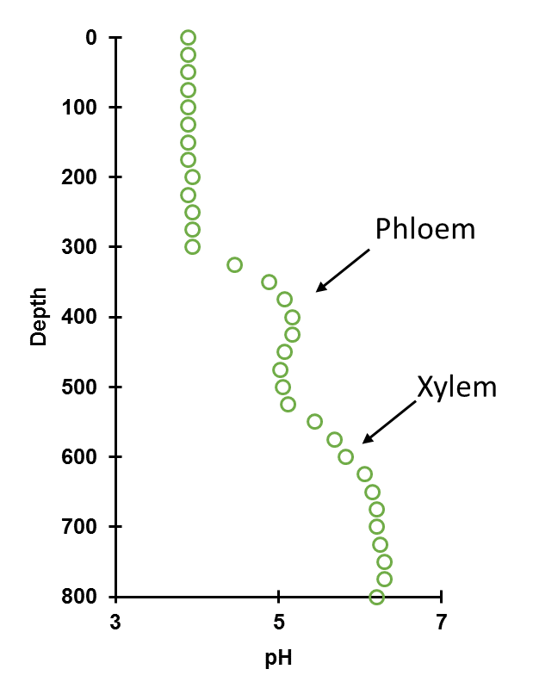

**Figure S2.** A representative pH microprofile of the midrib of a sour orange leaf using a pH microsensor.

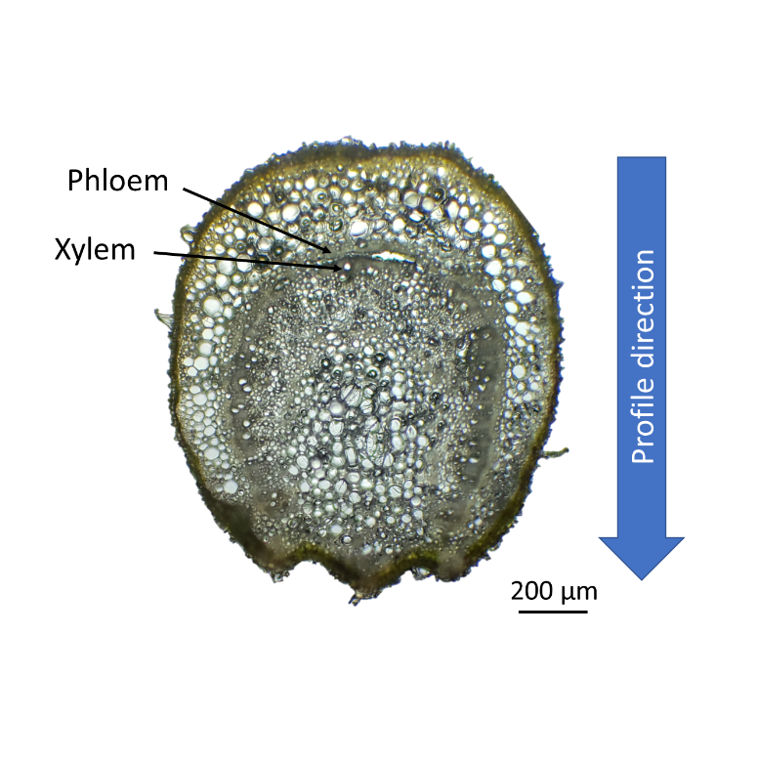

**Figure S3.** A cross-sectional photograph of a sour orange seedling leaf stem at 100× magnification.



**Figure S4.** pH effect on SWASV responses to Zn2+ concentrations during pre-concentration (inset: SWASV voltammogram of the Bi microelectrode with various pre-concentration pH values).

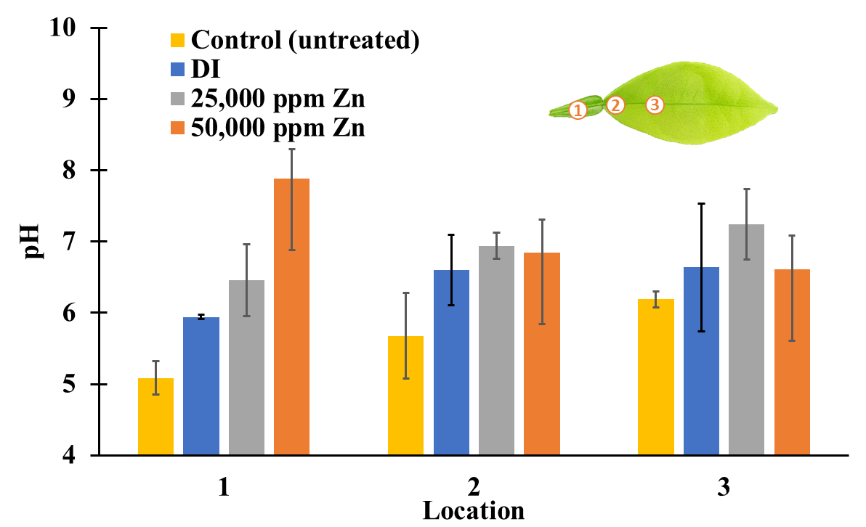

**Figure S5.** *In situ* pH measurements of a sour orange vascular bundle using a pH microsensor after 6 hours of exposure to various zinc treatments. Zn(NO3)2 was used for the zinc treatments.

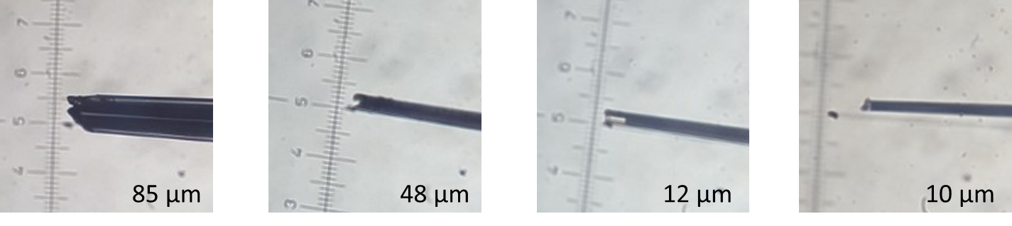

**Figure S6.** Microscopic images of bismuth microelectrodes for determination of tip size effect and recess on mass transport effects of SWASV response to zinc.



**Figure S7**. Response of the developed Bi microelectrode to 100 ppm Zn2+ over 18 uses.