Electronic Supplementary Information (ESI†).

Alkyne Modified Water Stable Alkylammonium Lead(II) Iodide Perovskite

Sayantan Sasmal and Suresh Valiyaveettil Department of Chemistry, National University of Singapore, 3 Science Drive 3, Singapore 117543
Sayantan Sasmal, Arun P. Upadhyay, Raj G. S. Pala and Sri Sivakumar, Department of Chemical Engineering, Materials Science Programme, Indian Institute of Technology Kanpur, UP-208016, India
Dharmadoss Sornadurai and Chakram S. Sundar, Materials Science Group, Indira Gandhi Centre for Atomic Research, Kalpakkam 603102, India

Address all correspondence to Raj G. S. Pala, Sri Sivakumar and Suresh Valiyaveettil, at rpala@iitk.ac.in; srisiva@iitk.ac.in; chmsv@nus.edu.sg.

Materials and characterization
Methylamine (40% in methanol) and γ-Butyrolactone were purchased from TCI Chemicals. HI (57% in water), 4-Aminobenzoic acid, Lead Iodide (98%), 1-Ethyl-3-(3-dimethylaminopropyl)carbodiimide (EDC) and 1-Amino-3-butyne (95%) were purchased from Sigma Aldrich. A Millipore system was used to purify the water. Powder X-ray diffraction analyses of all samples were done at room temperature using a X’Pert Pro diffractometer, PAN Analytical, Netherlands, with Cu-Kα (1.54 Å) radiation. TEM micrographs were obtained using FEI Technai G2 Twin TEM 120 KV instrument. 4-[(N-3-butyne)carboxyamido]anilinium lead iodide encapsulated MAPbI₃ sample was deposited on the TEM grid using ethanol as a dispersant. All other samples were prepared by placing one drop of precursor solution on a TEM grid and heated to remove the solvents. The absorbance and diffuse reflectance spectra of the samples were measured using Uv-Vis-NIR spectrophotometer (Cary 5000, Agilent Technologies). The hydrophobicity of the sample was characterized by contact angle measurements using a goniometer with a CCD camera. XPS analyses were done with PHI 5000 Versa Probe II, FEI INC instrument. Infrared spectra were recorded on a Bruker Vector 22 FT-IR spectrophotometer using KBr as the matrix. All photoelectrochemical water splitting measurements were done using a Potentiostat (Autolab 302N, Metrohm India Ltd, the Netherlands) and solar simulator (ORIEL SOI3A, Newport suppliers, the Netherlands) in 0.1M NaOH solution. Syntheses requiring inert atmosphere were done inside a Glove box (Campus, JACOMEX).
Photoelectrochemical water splitting performance of the modified hydrophobic perovskite photoanode was evaluated in three electrodes set up using a potentiostat (Autolab 302N, Metrohm India Ltd., The Netherlands). In a typical water splitting experiment, Ag/AgCl electrode and a platinum wire mesh (1 cm × 1 cm) were used as a reference and counter electrodes, respectively, in aqueous NaOH (20 ml, 0.1M, pH ~12.57) electrolyte solution. Applied bias was measured between working and counter electrode (Pt) using a voltmeter and plotted against the observed current density. The scans were done in dark and in presence of light using a solar simulator (ORIEL, SOI3A, Newport suppliers, the Netherlands) having AM 1.5G filter with power intensity of 100 mW/cm² and using a scan rate of 1 mV/sec. To estimate the Applied bias Photon-to-current Efficiency (ABPE), applied bias was measured between working and counter (Pt) electrodes using a voltmeter with the same electrochemical cell described above. Evolved gas was detected using a gas chromatograph (Thermo Fisher Scientific trace GC 800) equipped with a TCD detector at 2V applied bias. As regeneration of NBCAnPbI₃{MAPbI₃} was limited by low activity of p25-TiO_{2,} quantitative measurement of evolved H₂ and O₂ were not performed but the qualitative measurement was done by passing evolved gas through GC and examined with the previously calibrated position. Impedance spectroscopy and Mott-Schottky equation were used to calculate the flat band potential. Here 4-[(N-3-butyne)carboxyamido]anilinium lead(II) iodide coated over ITO, Pt wire mesh and Ag/AgCl electrode were used as working, counter and reference electrodes, respectively. K₃[Fe(CN)₆] (7 × 10⁻⁴ M) dissolved in 1 M KCl solution was used as electrolyte to study the impedance spectroscopy using the potential window from +0.8 to -0.35 V (Ag/AgCl). We used the equation, E (vs. NHE) = E (Ag/AgCl) + 0.197V to convert the observed potential against the normal hydrogen electrode (vs. NHE).^{[1]}

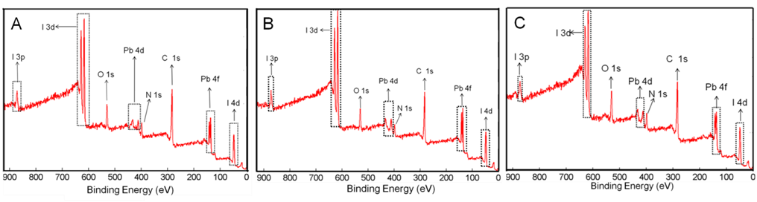
Fig. S1: XPS survey scan on three different points (A), (B) and (C) of bare 4-[(N-3-butyne) carboxyamido]anilinium lead iodide film. The atomic ratio of Pb: I is 1 : 3.2 (A), 1 : 2.88 (B), 1 : 2.75 (C) which implies a formula of the sample as NBCAnPbI_{3.}
Fig S2: UV-Vis absorption spectra of pure MAPbI₃ (i), NBCAnPbI₃ (ii) and NBCAnPbI₃{MAPbI₃} (iii).

Fig. S3: TEM micrographs of discrete crystals of MAPbI₃ with no network structure. Inset shows the d-spacing of ~ 0.278 nm, which correspond to the tetragonal MAPbI₃.

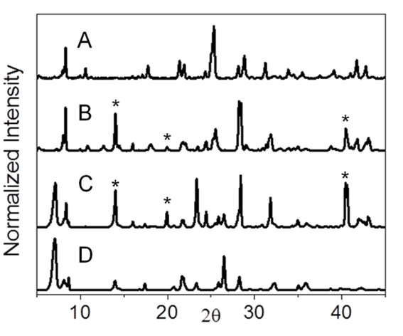
Fig. S4: Comparison of XRD spectra of CAnPbI₃ (A), CAnPbI₃{MAPbI₃} (B), TPbI₃{MAPbI₃}(C) and TPbI₃ (D); * represents presence of MAPbI₃ .

Fig. S5: Comparison of XRD spectra of NBCAnPbI₃{MAPbI₃} exposed to 95% humidity for 2 days (A), 10 days (B), dotted line indicates the presence of 110 plane of MAPbI₃ in both the samples proved the presence and stability of the MAPbI₃ in NBCAnPbI₃{MAPbI₃}.

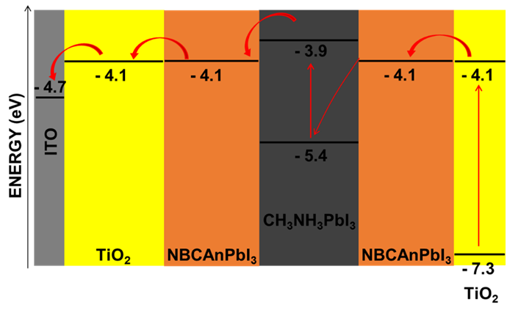
Fig. S6: Schematic representation of photogenerated electron - hole separation in presence of NBCAnPbI₃{MAPbI₃}.
Fig. S7: Gas chromatography curve comparing calibration curve of oxygen (A) and gas evolved from NBCAnPbI₃{MAPbI₃} anode (B) confirming the evolution of oxygen from NBCAnPbI₃{MAPbI₃} during water splitting reaction.

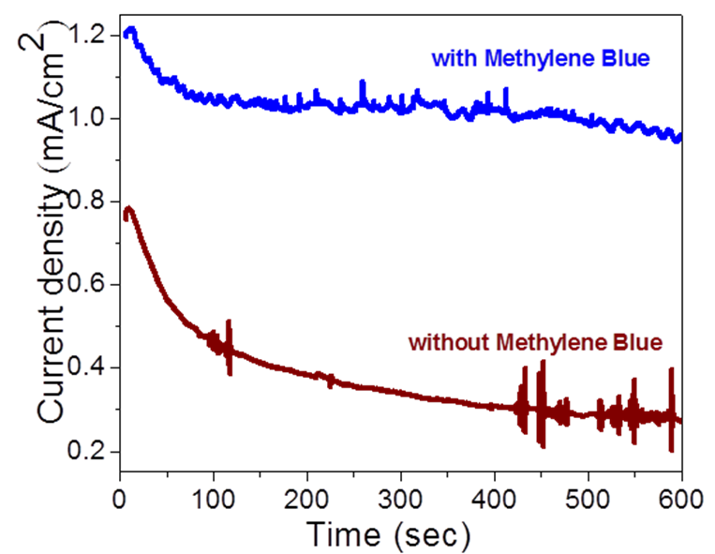
Fig. S8: Chronoamperometry analysis with and without methylene blue at 0.5 V applied potential (vs. Ag/AgCl) in 0.1M NaOH.
References
- X. Tang, Q. Tay, Z. Chen, Y. Chen; G. K. L. Goh, and J. Xue: CuInZnS-decorated graphene nanosheets for highly efficient visible-light-driven photocatalytic hydrogen production. J. Mater. Chem. A. 1, 6359 (2013).

