Supporting information
Q-Carbon Harder than Diamond
Jagdish Narayan^{1*}, Siddharth Gupta¹, Anagh Bhaumik¹, Ritesh Sachan^{1, 2}, Filippo Cellini^{3,4}, Elisa Riedo^{3,4,5}
¹ Department of Materials Science and Engineering, North Carolina State University, Raleigh, NC 27695-7907, USA
² Materials Science Division, Army Research Office, Research Triangle Park, NC 27709, USA
³ Advanced Science Research Center, CUNY, New York, NY 10031, USA
⁴ CUNY Graduate Center, Ph.D. Program in Physics, New York, NY 10031, USA
⁵ Department of Physics, CUNY-City College of New York, New York, NY 10031, USA
*Correspondence to: narayan@ncsu.edu

ADDITIONAL INFORMATION
Structure of Q-carbon: Even though amorphous materials are disordered, they possess short-range ordering. The prime example is the preservation of tetrahedra for amorphous silicon. Short-range ordering is studied to highlight the novel properties observed for Q-carbon. Fig. S1 shows the selected area electron diffraction (SAED) pattern of Q-carbon. The diffraction pattern is a set of broad diffraction rings with spots observed for prominent diffraction arising from sapphire substrate. The RDF analysis was performed utilizing the as-acquired undamped reduced intensity for Q-carbon diffraction rings. To perform accurate RDF analysis, it is essential that the calibration scale of the diffraction pattern be accurately set. The diffraction spots arising from the sapphire substrate work perfectly as accurate markers as their d spacing is already known. The radial distribution function has intensity peaks at 0.154 nm and 0.252 nm in the electron diffraction pattern. These peaks provide strong evidence towards preservation of tetrahedral short-range ordering for highly-dense Q-carbon nanostructures.
Nanohardness experiments: Nanohardness experiments are conducted with a Bruker Multimode Atomic Force Microscope using a Microstar Technologies AFM diamond probe (TD26913, cantilever stiffness 152 N/m). Indentation experiments are performed by applying a ramp force at a rate of 45.6 µN/s up to a maximum of 106.4 µN, and subsequently decreasing the force to zero at the same rate. The topography of the sample is scanned before and after the indentation to verify the presence of residual plastic deformation on the surface. Figure S2(a) displays a region of the DLC film where a Q-carbon filament has formed. Indentation is performed on both the DLC film and the Q-carbon filament to determine the ability of the diamond indenter to penetrate the surface. Figures S2 (c) and (d) display a close-up view of the regions where the indentation is performed on the DLC film and the Q-carbon filament, respectively. Figure S2(b) displays the depth profile along a line crossing the indentation regions in (c) and (d). Notably, the diamond indenter produces a permanent plastic deformation of the DLC film, creating an indent with depth ranging between 6 and 10 nm. Similarly, indentation experiments performed on bulk Silicon Carbide (elastic modulus ~ 400 GPa) produce indents with depth ranging between .6 and 1 nm (results not shown). The same indenter does not produce any residual deformation when pressed on the Q-carbon filament, as it can be observed in Fig. S2(d). We attribute this result to the superhardness of Q-carbon, which is predicted by theory to be larger than the hardness of diamond, as already discussed in the paper and in agreement with the stiffness measurements obtained in the MoNI experiments.

FIGURES

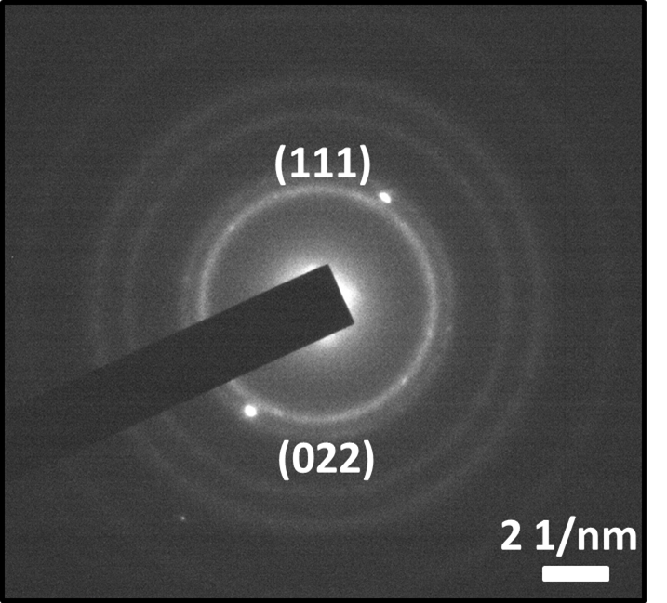

Figure S1. Selected area electron diffraction (SAED) pattern of Q-carbon showing its amorphous nature and the presence of (111) and (022) diffraction rings. The sharp Bragg reflections from the first two planes are indicated.

Figure S2. (a) Cross-section of a Q-Carbon filament after indentation with a diamond indenter. Dashed lines delimit the regions where indentation is performed on (c) the DLC film and (d) the Q-carbon filament. (b) Profile of the indentation region for the DLC film (red line) and the Q-carbon filament (blue line). (c) Close-up view of the region of indentation on the DLC film. (d) Close-up view of the region of indentation on the Q-carbon filament.
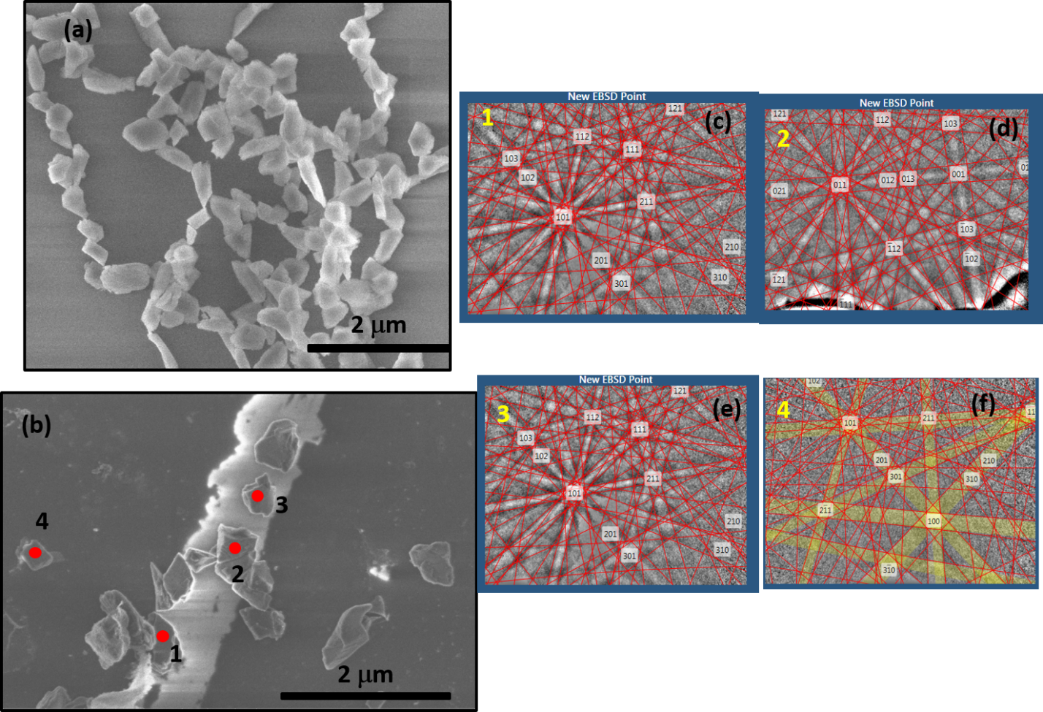
Figure S3. (a) SEM micrograph from Q-diamond; (b) Nucleation of Q-diamond (regions 1,2,3) from Q-carbon and diamond (region 4); EBSD patterns of (c) region 1; (d) region 2; (e) region 3; and (f) region 4. The EBSD patterns of Q-diamond show (200) reflections.

