Grafting of glycerol methacrylate onto silicone rubber using gamma-rays: derivatization to 2-oxoethyl methacrylate and immobilization of lysozyme
G.G. Flores-Rojas,¹, F. López-Saucedo,¹ M. Quezada-Miriel,² E. Bucio^{1,}*
¹Departamento de Química de Radiaciones y Radioquímica, Instituto de Ciencias Nucleares, Universidad Nacional Autónoma de México, Circuito Exterior, Ciudad Universitaria, México CDMX 04510, México.
²Instituo de Química, Universidad Nacional Autónoma de México, Circuito Exterior, Ciudad Universitaria, México CDMX 04510, México.

Supplementary material

S1. Experimental
Materials
Silicone rubber (SR) films, with density from 1.1 to 1.5 g cm⁻³ and 1 mm in thickness, were purchased from Goodfellow (Huntingdon, UK). Ethanol, silver nitrate, formaldehyde (30%), sodium periodate, ammonium hydroxide, ethylene glycol, acetic acid (AcOH), dichloromethane (DCM), tetrahydrofuran (THF), Micrococcus lysodeikticus (M. lysodeikticus), and glycidyl methacrylate (GMA) were purchased from Sigma Aldrich (St. Louis, MO, USA). The monomer was distilled at reduced pressure previously to be used. Lysozyme was obtained from MP Biomedicals (Germany).

Synthesis of glycerol methacrylate (GlyMA)
50 mL of GMA was added to 500 mL of bidistilled water in constant stirring and flow of air, the reaction was kept at 80 °C for 8 h. Then, it was extracted 3 times using 20 mL of DCM to remove the non-reacted GMA, and finally; it was obtained the GlyMA by extractions with THF/DCM (1:1 vol.).

Synthesis of SR-g-GlyMA
The SRs (1×12 cm) were placed in an ampoule containing 22 mL of GlyMA solution, varying the monomer concentration in ethanol. The ampoules were degassed by repeated freeze-thaw cycles (6 times per 10 min) and sealed under vacuum. Afterward, the ampoules were exposed to a gamma-rays source of ⁶⁰Co at different absorbed doses. To remove the residual monomers formed during grafting reaction, the samples were soaked in water/methanol (3:1 vol.), changing the solvent by 12 h (six times), and followed by drying under vacuum at 40 °C to constant weight.
The grafting yield (G%) was calculated using the Equation 1:
$$G_{\%}=100 [(W_{f}-W_{i})/{W]}_{i}$$ | (Eq. 1)
where W_{f} and W_{i} are the weights of the initial and grafted SR, respectively.

Chemical activation and lysozyme immobilization
The chemical activation of SR-g-GlyMA was done using 1x2.5 cm of the sample and placed in 5 mL of distilled water and added 1.3 equivalents of NaIO₄ with respect to grafting degree. The reaction was carried out at 40 °C under fixed stirring for 24 h. after the reaction time, it was added 0.5 mL of ethylene glycol and kept the reaction at 40 °C, 1 h, then, the activated films (SR-g-OxMA) were washed with water for 4 h.
Lysozyme immobilization was performed using a SR-g-OxMA sample (1x1 cm). This film was placed in 2.5 mL of a lysozyme solution, with a concentration of 4 mg mL⁻¹ pH = 7, 0.01 M, for 72 h at 25 °C. The films with immobilized lysozyme (SR-g-Lys) were washed with NaCl solution 0.1 M and distilled water three times per 10 min each one, and finally sonicated by 30 s before to perform the enzymatic activity assay.

Non-specific assay of lysozyme and quantification
The non-specific test of immobilized lysozyme was performed using silver solution (0.5 g L⁻¹), which is a non-specific protein stain. The samples were washed firstly with ethanol for 1 h and dried under vacuum for 12 h. Then, it was added 5 mL of silver solution and soaked for 1 h at room temperature, and washed with distilled water for 12 h. Finally, it was added 2 mL formaldehyde solution (30%) and after 1 h the samples were washed with an AcOH/H₂O 2:8 vol. solution for 4 h at 25 °C.
Quantification of immobilized lysozyme was calculated by the remaining free lysozyme in the solution after the immobilization process by means of spectrophotometric calibration curve at 280 nm, pH = 7, 0.01 M. as is indicated in the Equation 2.
$${Ly}_{m}\left(μg {cm}^{-2}\right)=\left[V({Ly}_{fi}-{Ly}_{ff})\right]/A$$ | (Eq. 2)

where Ly_{m} is the immobilized lysozyme, V is the volume of solution used in mL, Ly_{fi}, and Ly_{ff} are the amounts of free lysozyme in the solution at the beginning and after the immobilization process, and A is the area of the film with units of cm².

Enzymatic activity test
The enzymatic activity of SR-g-Lys was monitored by the decrease in absorbance at 450 nm, using 0.025 cm² of SR-g-Lys and 3 mL of M. lysodeikticus (coccus, Gram-positive) suspension (0.6 mg mL⁻¹, Ab_{i} ≈ 0.6). The enzymatic activity was calculated using Equation 3 where Ab_{i} and Ab_{f} are the initial and the final absorbance measured in the system, A is the area (cm²), t is the time (h), and 0.001 is the definition of unit enzymatic activity.
$$Enzimatic activity \left(0.001{ h}^{-1}{cm}^{-2}\right)=[({Ab}_{i}-{Ab}_{f})({Ab}_{bi}-{Ab}_{bf}]/(0.001At)$$ | (Eq. 3)

Characterization
FTIR-ATR spectra were recorded using a Perkin-Elmer Spectrum 100 (Perkin Elmer Cetus Instruments, Norwalk CT, USA) fitted with a Universal ATR sampling accessory (DiCompTM crystal, which is composed of a diamond ATR with a zinc selenide focusing element in direct contact with the diamond). Thermogravimetric analyses were performed using a TGA Q50 (TA Instruments, New Castle, DE) at a heating rate of 10 °C min⁻¹ in the temperature interval from 25 to 800 °C under a nitrogen atmosphere. Kruss DSA 100 drop shape analyzer (Matthews NC, USA) was used to measure the water contact angle at different times. The mechanical properties of the samples were measured with a sample size of 5 x 0.5 cm using a tensile compression tester (model 1125, Instron Inc., MA, USA) at 23 °C and the analysis speed of 10 mm min⁻¹. ¹H- and ¹³C{¹H}-NMR were recorded on a Jeol 300 MHz with tetramethylsilane (TMS) as an internal reference. Mass spectrometry (MS-EI⁺) of pure compounds were performed on a Thermo-Electron DFS spectrometer.
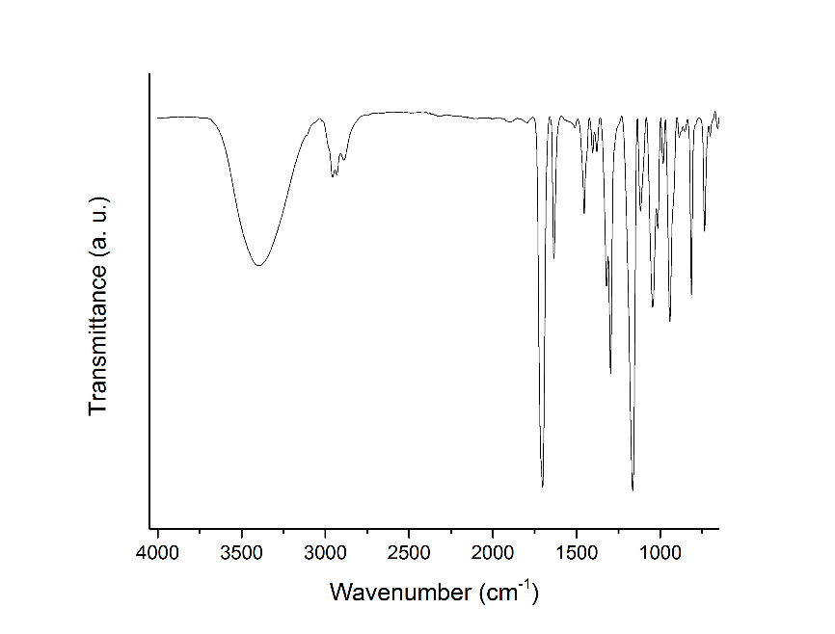
FIG. S1. ATR-FTIR spectrum of glycerol methacrylate (GlyMA). 3426 cm-1 ν(OH), 1705 cm-1 ν(C=O), and 1637 cm-1 ν(C=C).

FIG. S2. Mass-EI⁺ spectrum of GlyMA and fragments of monomer.

FIG. S3. Swelling degree of SR-g-GlyMA in water as solvent after 24 h. a) SR grafted at different absorbed doses, b) SR grafted at different monomer concentration with an absorbed dose of 5 kGy.
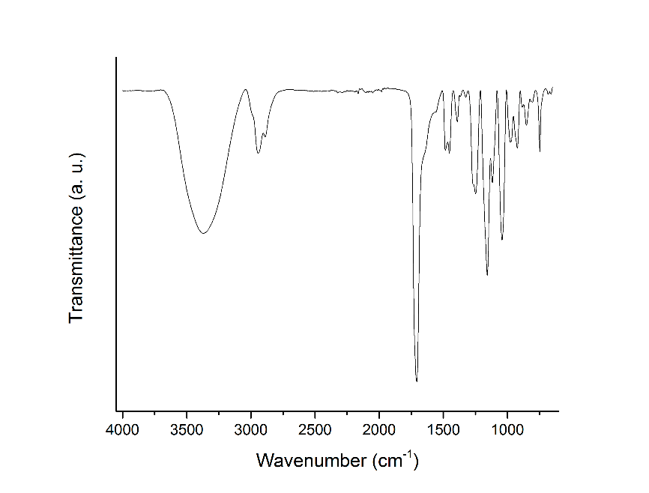
FIG. S4. ATR-FTIR spectra of poly(GlyMA). 3398 cm-1 ν(OH), 1712 cm-1 ν(C=O), and 1637 cm-1 ν(C=C).

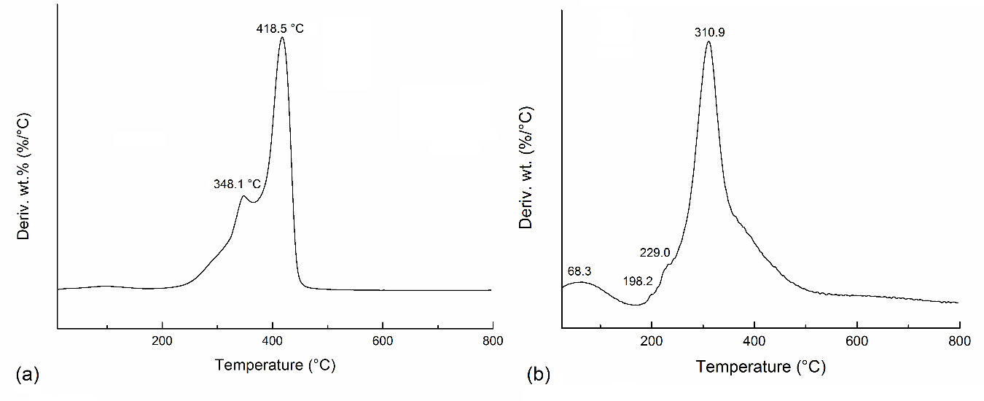
FIG. S5. Weight loss derivate as a function of temperature a) poly(GlyMA) and b) lysozyme.

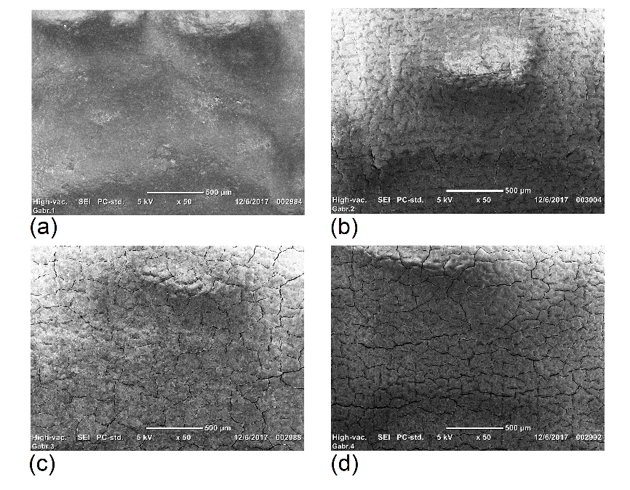
FIG. S6. SEM images of SR samples through immobilization process of lysozyme using a SR-g-GlyMA with 4.9% of grafting. a) SR, b) SR-g-GlyMA, and c) SR-g-OxMA, d) SR-g-Lys

S2. Releasing of lysozyme
The releasing of lysozyme was carried out soaking a SR-g-Lys (1x1 cm) in 3 mL of buffer with different pH values from 5 to 10 and monitored by spectrophotometry from 190-1100 nm after 24 h.

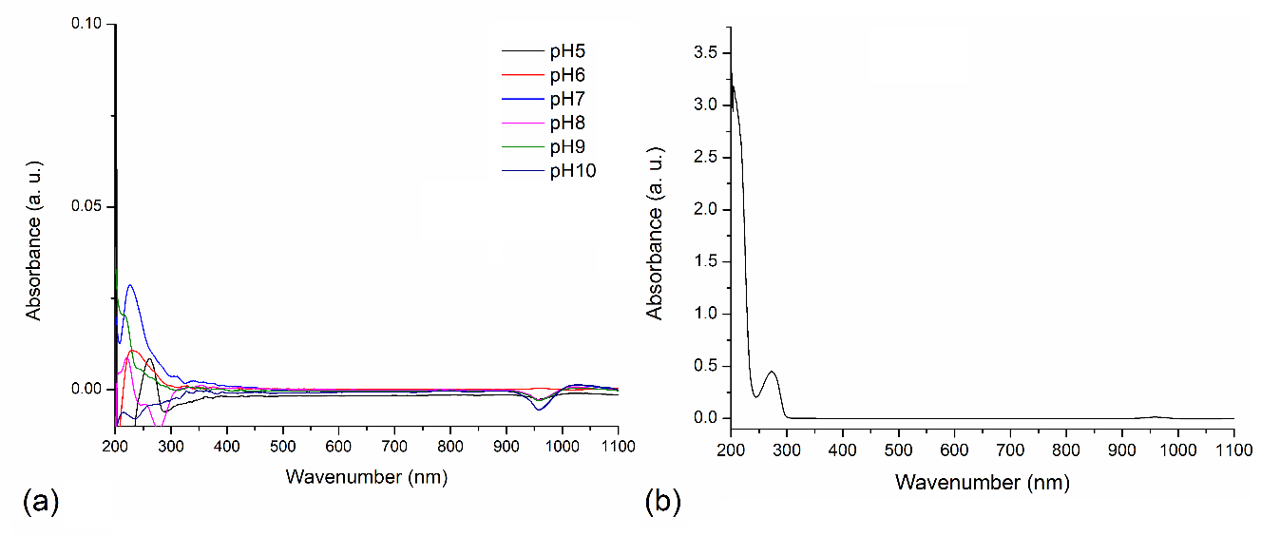
FIG. S7. a) Absorbance spectra of buffer solutions after soaked a SR-g-Lys sample for 24 h. The spectra did not show considerable evidence of lysozyme releasing. b) absorbance curve with lysozyme as a control of releasing at pH = 7.

Corresponding author: Tel.: +52 (55) 5622-4674 E-mail address: ggabofo@hotmail.com (G.G. Flores-Rojas) E-mail address: ebucio@nucleares.unam.mx (E. Bucio)

