Supplementary material
Polypropylene-films modified by grafting-from of EGDMA/GMA using gamma-rays and antimicrobial biofunctionalization by Schiff bases

G.G. Flores-Rojas^{1,2,∗}, F. López-Saucedo¹, J.E. López-Barriguete^{1,2},T. Isoshima², M. Luna-Straffon¹, E. Bucio^{1,∗}

¹Departamento de Química de Radiaciones y Radioquímica, Instituto de Ciencias Nucleares, Universidad Nacional Autónoma de México, Circuito Exterior, Ciudad Universitaria, México CDMX 04510, México.
²Nano Medical Engineering Laboratory, RIKEN, 2-1 Hirosawa, Wako, Saitama 351-0198, Japan.

S.1. Methodology

S.1.1. Materials
Polypropylene (PP) films with 1 mm in thickness were purchased from Goodfellow (Huntingdon, UK). Ethylenediamine, tetrahydrofuran (THF), glutaraldehyde (50 vol.%), Micrococcus lysodeikticus, sodium cyanoborohydride, ethylene glycol dimethacrylate (EGDMA), and glycidyl methacrylate (GMA) were acquired from Sigma Aldrich (St. Louis, MO, USA). All the monomers were distilled at reduced pressure before use. Lysozyme was obtained from MP Biomedicals (Germany), and ethanol from J.T. Baker (Mexico).

S.1.2. Grafting of EGDMA/GMA on PP-films
Four series of grafted PP-films were made by the grafting-from method to examine the dependence of the grafting degree on absorbed gamma-ray dose, monomer concentration, reaction temperature, and reaction time. In the first series, the grafting degree was studied at different absorbed doses using PP-films (1x5 cm) irradiated in presence of air with a ⁶⁰Co gamma-rays source (Gammabeam 651 PT, Nordion Co., Canada) from 20 to 120 kGy with an average dose rate of 10.9 kGy h⁻¹. The irradiated samples were placed into glass ampoules containing 8 mL of monomer solution (EGDMA/GMA, 1:1 mol) at 50 vol.% in toluene as solvent. The second series was carried out with PP-films irradiated at 20 kGy and placed in ampoules variating the monomer concentration (EGDMA/GMA, 1:1 mol) from 10 to 100 vol.%. All ampoules were degassed by repeated freeze-thaw cycles (3 times for 10 min.), sealed under vacuum, and heated at 70 °C for a reaction time of 22 h. The third and fourth series were prepared at different reaction temperatures and times, using PP-films irradiated at 20 kGy and introduced in 8 mL of monomer solution (EGDMA/GMA, 1:1 mol) at 50 vol.%. All the ampoules were degassed and sealed as mentioned above. For the study at different temperatures, the samples were heated from 40 to 80 °C for 24 h. The study at different reaction times was performed from 0 to 24 h at 70 °C.
To extract the residual monomer and copolymer formed in the grafting polymerization, the samples were soaked in ethanol for 48 h (changing the solvent), followed by drying under vacuum at room temperature (25 °C) until constant weight.

The grafting yield (G%) was calculated by the following equation (Eq. A.1)
$$G_{\%}=100((W_{f}-W_{i})/W_{i})$$ | (Eq. A.1)
where W_{i} and W_{f} are the initial (PP-film) and final (PP-g-(EGDMA/GMA)) weights, respectively.

S.1.3. Activation of PP-g-(EGDMA/GMA) and immobilization of lysozyme
The chemical activation was divided into two steps: the first step was the reaction with ethylenediamine and the second one was the reaction with glutaraldehyde and the reduction of imine groups.
PP-g-(EGDMA/GMA) (1x0.5 cm) was placed in 3 mL of THF with 57 µL (0.85 mmol) of ethylenediamine. The reaction was carried out at 60 °C under fixed stirring for 4 h. When the reaction was completed, the films [(PP-g-(EGDMA/GMA))-g-NH, hereafter abbreviated as PP-g-NH] were washed firstly with water and then with ethanol. The number of amine groups was calculated by the difference of the weight using the samples dried in vacuum.
Subsequently, the PP-g-NH samples were placed in 4 mL of THF and added 114 mg (0.57 mmol) of glutaraldehyde solution (50 vol.%). The reactions were performed at 40 °C for 24 h. Then, the samples were washed with THF, followed by the reduction of imine groups using 114 mg (1.8 mmol) of NaBH₃CN in 4 mL THF with a reaction time of 2 h at 40 °C. After the reaction time, the films [((PP-g-(EGDMA/GMA))-g-NH)-g-AI, hereafter abbreviated as PP-g-Al] were washed with distilled water.
Finally, the lysozyme immobilization was accomplished placing the PP-g-Al films in 2 mL of lysozyme solution at 33 vol.% methanol-phosphate buffer pH = 7 [0.01M] with 2.6 mg of lysozyme per mL, for 72 h at 5 °C. After the incubation time, the films ((((PP-g-(EGDMA/GMA))-g-NH)-g-AI)-g-Lys, hereafter abbreviated as PP-g-Lys) were washed for 1h with a solution of NaCl [0.1M].

S.1.4. Enzymatic activity assay
The enzymatic assay was carried out utilizing a sample of PP-g-Lys (0.5 cm²), and 4 mL of M. Lysodeikticus suspension with a concentration of 0.6 mg mL⁻¹ (Ab_{i} ≈ 0.55). The loss of absorbance at 450 nm was monitored at different temperatures and pH values.
The enzymatic activity was calculated using the Eq. A.2 where Ab_{i} and Ab_{f} are the initial and final absorbance, respectively, measured in the system where A is the area in cm², t is the time in minutes, and 0.001 is the definition of activity unit.
$$Enzimatic activity \left(0.001\min^{-1}{cm}^{-2}\right)=({Ab}_{i}-{Ab}_{f})/(0.001At)$$ | (Eq. A.2)

S.1.5. Characterization
Infrared spectra were recorded on dry and swollen conditions using an FT-IR equipment (Perkin-Elmer Spectrum 100, Perkin Elmer Cetus Instruments, Norwalk CT, USA) fitted with a universal attenuated total reflection (ATR) sampling accessory. Thermogravimetric analyses (TGA) were performed using a TGA Q50 (TA Instruments, New Castle, DE) at a heating rate of 10 °C min.⁻¹ in the temperature interval from 25 to 800 °C under a nitrogen atmosphere. Differential scanning calorimetry analyses (DSC) were carried out in a DSC 2010 (TA Instruments, New Castle, DE) from 25 to 450 °C, under a nitrogen atmosphere at a flow rate of 60 mL min.⁻¹ and a heating rate of 10 °C min.⁻¹. Kruss DSA 100 drop shape analyser (Matthews NC, USA) was used to measure the water contact angle, which was recorded at 1 and 5 min. after a bi-distilled water droplet was deposited on the dry films. The surface morphology was determined by atomic force microscopy (AFM) using an MFP-3D equipment (Asylum Research/Oxford Instruments PCI, CA. USA). The surface height images were obtained in AC (tapping) mode, using a NCH-W chip (Nanoworld Technologies AG, Switzerland).
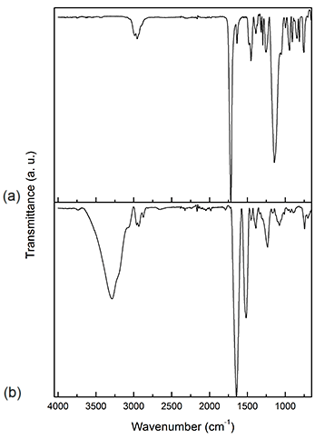
Fig. S1. Infrared spectra of a) P(EGDMA/GMA), C=O 1720 cm⁻¹, C=C 1638 cm⁻¹, epoxide group 994 and 1091cm⁻¹ and b) Lysozyme, amide I 1646 cm⁻¹, C=O of carboxyl groups and amide II 1517 cm-1.

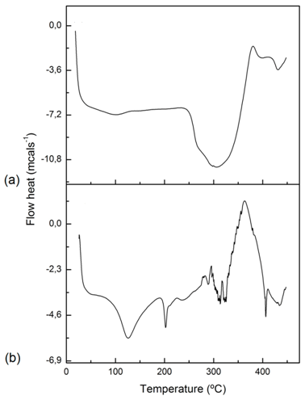
Fig. S2. DSC thermograms of a) P(EGDMA/GMA), Onset point 257.1°C, Peak max. 290.9 °C, and b) Lysozyme, Onset point 100.3 °C, Peak max. 125.8 °C, Onset point2, 197.3 °C, Peak max2 202.2 °C.

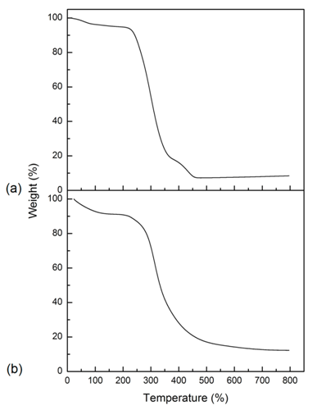
Fig. S3. TGA thermograms of a) P(EGDMA/GMA), 242.0 °C at 10 wt. % loss and b) Lysozyme, 220.8 °C at 10 wt. % loss.

S4. Quantification of remained double bonds in the PP-g-(EGDMA/GMA)
We calculated the rate of double bonds regarding carbonyl groups since we considered these last ones as the total grafting copolymer. Therefore, it was computed the area of each corresponding band to the double bonds and the carbonyl groups in the infrared spectrum. The results were plotted with the enzymatic activity indicating an improvement of this one. The results are shown in the Fig. S4.
Ratio of remained double bonds in the grafting copolymer was computed for the next equation:
$$Rate of double bonds \left(\%\right)=100(A_{C=C}/(A_{P\left(EGDMA/GMA\right)}+ A_{C=C}))$$ | (Eq. A.3)
where A_{C=C} is the area for the band of double bonds, and A_{P(EGDMA/GMA)} is the area for corresponding carbonyl band of P(EGDMA-co-GMA).^{[27]}

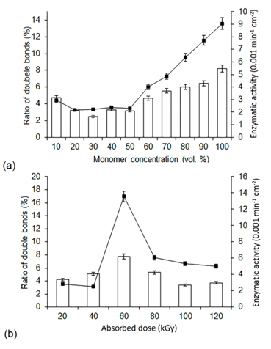
Fig S4. a) Ratio of double bonds at different monomer concentrations, b) Ratio of double bonds at different absorbed doses. remained double bonds, enzymatic activity of immobilized lysozyme.

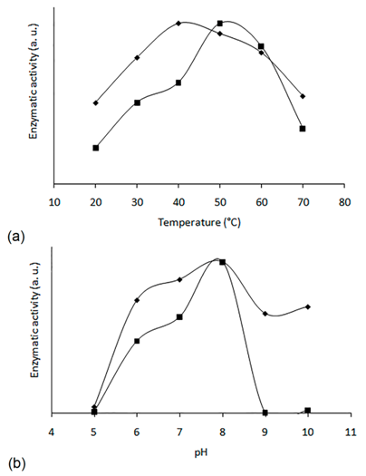
Fig. S5. Comparison of enzymatic activity between free and immobilized lysozyme at different a) temperatures and b) pH values. free lysozyme, immobilized lysozyme. The enzymatic activity was normalized to better comparison.

∗ Corresponding author: Tel.: +52 (55) 5622-4674 E-mail address: ggabofo@hotmail.com (G.G. Flores-Rojas), ebucio@nucleares.unam.mx (E. Bucio)

