- Supporting Information -

Rapid Microwave Synthesis and Optical Activity of
Highly Crystalline Platinum Nanocubes

Clare Davis-Wheeler, Sara Akbarian-Tefaghi, Juana Reconco-Ramirez, and John B. Wiley,*

Department of Chemistry and Advanced Materials Research Institute, University of New Orleans, New Orleans, LA 70148
E-mail: jwiley@uno.edu; Tel.: (504)280-6849; Fax: (504)280-6860

Table of Contents
Figure S1 | TEM images of MW-NPs synthesized under various conditions | S2
Figure S2 | Effect of reaction time and temperature on MW-NP sizes | S3
Figure S3 | Description of ligand exchange procedure and FTIR results | S4-5

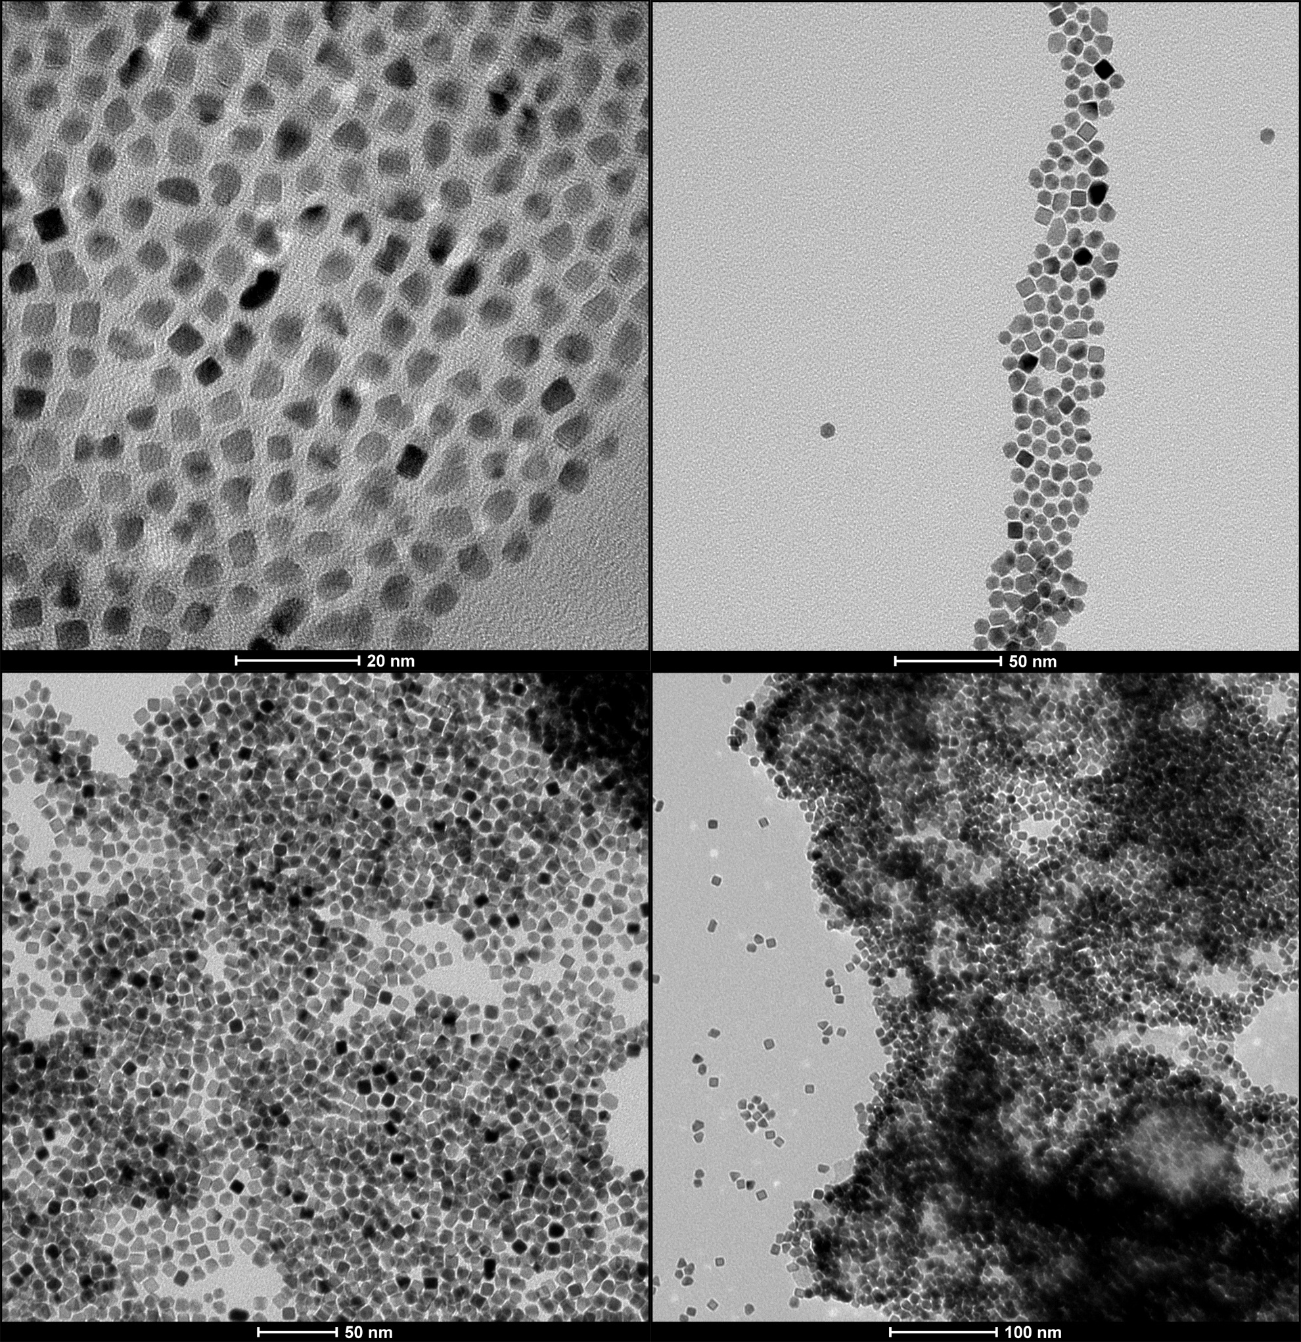
a)
b)
c)
d)
Figure S1. Effects of altering reaction temperature of 60 minute reactions on MW-NP size and morphology: (a) lowest temperature (125 °C) produces smallest MW-NPs with wide size and morphological variation; (b) polydispersed morphology including polycrystalline NPs, less cubic and more octahedral NPs produced at 130 °C; (c, d) higher temperatures and 60 minute reaction time produced wide size and morphology distribution with areas of agglomeration

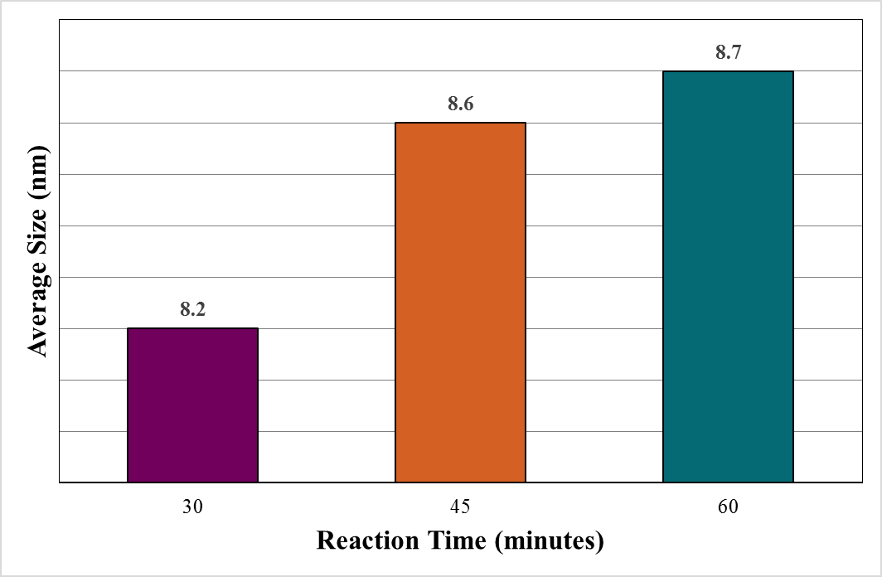
a)

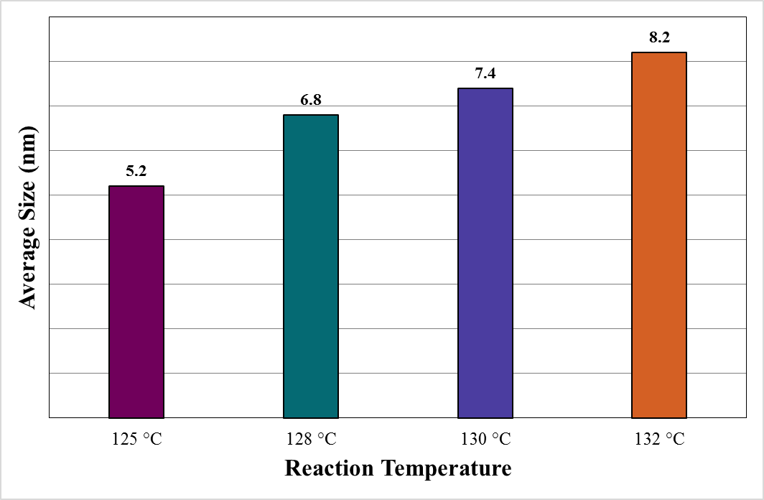

Figure S2. (a) Effect of reaction time on MW-NP size, (b) effect of reaction temperature on average size of MW-NPs produced in 30 minute reactions.

b)
Ligand Exchange on Commercial Pt Nanospheres: Replacement of Citrate Capping Ligand with Oleylamine
In order to support the investigation of possible quenching effects, a ligand exchange procedure was performed to replace the citrate capping ligands on the as-obtained commercial Pt nanospheres with the same OAm capping ligand found on the as-synthesized MW-NPs. This facilitated the comparison between the MW-synthesized Pt nanocubes and the commercial Pt nanospheres by standardizing the capping ligand to OAm for both sets, since the alteration of the dielectric function and thus the plasmonic response of the NPs is known to be significantly altered by changes in electron density caused by surface adsorbates. This also allowed for the redispersal of the commercial NPs in a solvent free from species present in the original citrate buffer that are known to strongly absorb in the same region as the prediction LSPR λ_{max} for small Pt NPs.

To carry out the replacement of citrate ligands with OAm ligands on the surface of the commercial Pt NPs (C-NPs), 2 mL of the as-obtained aqueous suspension was centrifuged for 10 minutes at 13,000 rpm. The precipitate was redispersed in EtOH and sonicated 1-2 minutes until fully dispersed. This suspension was transferred to a glass scintillation vial and combined with 1 mL OAm and 1 mL hexane. This mixture was sonicated for 2 minutes, then covered with foil and magnetically stirred at 55 °C for 48 h. The ligand-exchanged commercial Pt NPs (LC-NPs) were isolated by adding 15 mL EtOH and centrifuging for 10 minutes at 6,000 rpm. The product was redispersed in hexane via sonication. This precipitation-redispersal process was repeated twice to remove any excess citrate species, after which the product was dried overnight in air. Finally, the LC-NPs were dispersed in EtOH and transferred to a glass scintillation vial.

Confirmation of ligand exchange was conducted via Fourier transform infrared spectroscopy (FTIR). FTIR spectra of LC-NPs show the presence of OAm ligands, with characteristic amine peaks including an NH₂ bends at 722 and 1574 cm⁻¹ (respectively), asymmetric and symmetric C-H stretches at 2921 and 2852 cm⁻¹ (respectively), and a bend of the C-H group near the C=C at 3006 cm⁻¹ (Figure S4). Figure S3 shows consistent similarities between spectra recorded for LC-NPS and for pure OAm, which indicate that the ligand exchange procedure was successful in a nearly complete replacement of the citrate groups with OAm. Furthermore, Figure S3 shows significant differences between the FTIR spectra for sodium citrate and the LC-NPs, supporting a thorough ligand exchange.

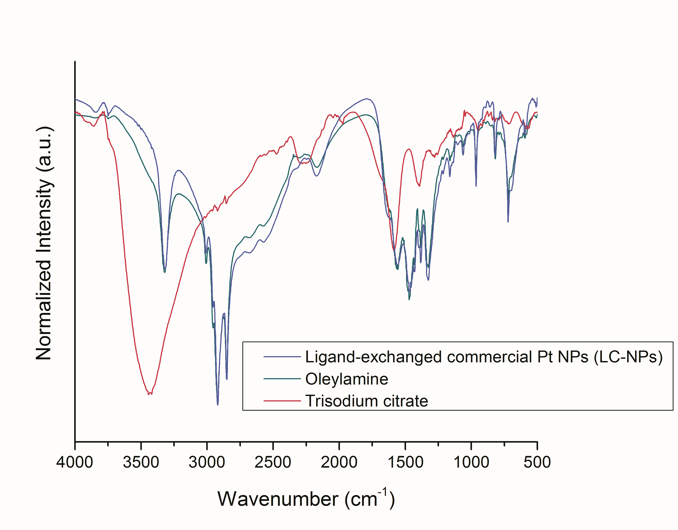
Figure S3. Confirmation of ligand exchange on commercial Pt NPs via FTIR spectroscopy.

