Supplementary Material

Long-term Stability of Mechanically Exfoliated MoS₂ Flakes

Prachi Budania^{1*}, Paul Baine¹, John Montgomery¹, Conor McGeough², Tony Cafolla², Mircea Modreanu³, David McNeill¹, Neil Mitchell¹, Greg Hughes² and Paul Hurley³
¹School of Electronics, Electrical Engineering and Computer Science, Queen’s University, Belfast, BT9 5AH, UK.
²School of Physical Sciences, Dublin City University, Glasnevin, Dublin, D09 NR58, Ireland
³Tyndall National Institute, University College Cork, Cork, T12 R5CP, Ireland
Address all correspondence to P. Budania at pbudania01@qub.ac.uk

Experimental methods
Layers of MoS₂ were mechanically exfoliated from a commercially available natural molybdenum disulphide crystal (supplied by 2D Semiconductors) using Scotch® tape. Thereafter, the Scotch® tape was sequentially folded 3 times to reduce the average thickness of the exfoliated flakes and to distribute them across different regions of the same piece of tape. A fresh piece of Scotch® tape was then placed over the first tape. After manually pressing the two pieces of tape together, they were separated from each other to obtain two individual pieces of Scotch® tape both with exfoliated flakes on their surfaces. Exfoliated flakes were then transferred from one piece of Scotch® tape onto a PF-X4 gel-film as obtained from Gel-Pak®, before final transfer onto a thermally oxidized (315 nm) silicon substrate. Another piece of Scotch® tape was used to directly transfer flakes onto an oxidized substrate. Prior to this, the oxidized silicon substrate was ultrasonically rinsed in acetone and isopropanol for 2 minutes each, followed by DI water rinsing and N₂ blow dry.

Long-term effect of storage conditions
Figs. S1(a) and (b) show optical microscope images of MoS₂ flakes on the control sample taken on the day of sample preparation and after 222 days respectively. Figs. S1(c) and (d) are red channel contrast profiles for the flake encircled in Figs. S1(a) and (b) respectively. The measured contrast difference value of 27 represents a monolayer MoS₂ flake with a thickness of approximately 0.7 nm.^{[1, 2]} It was observed that the optical contrast and dimensions of all MoS₂ flakes on the control sample remained unchanged in vacuum storage even one year after sample preparation.

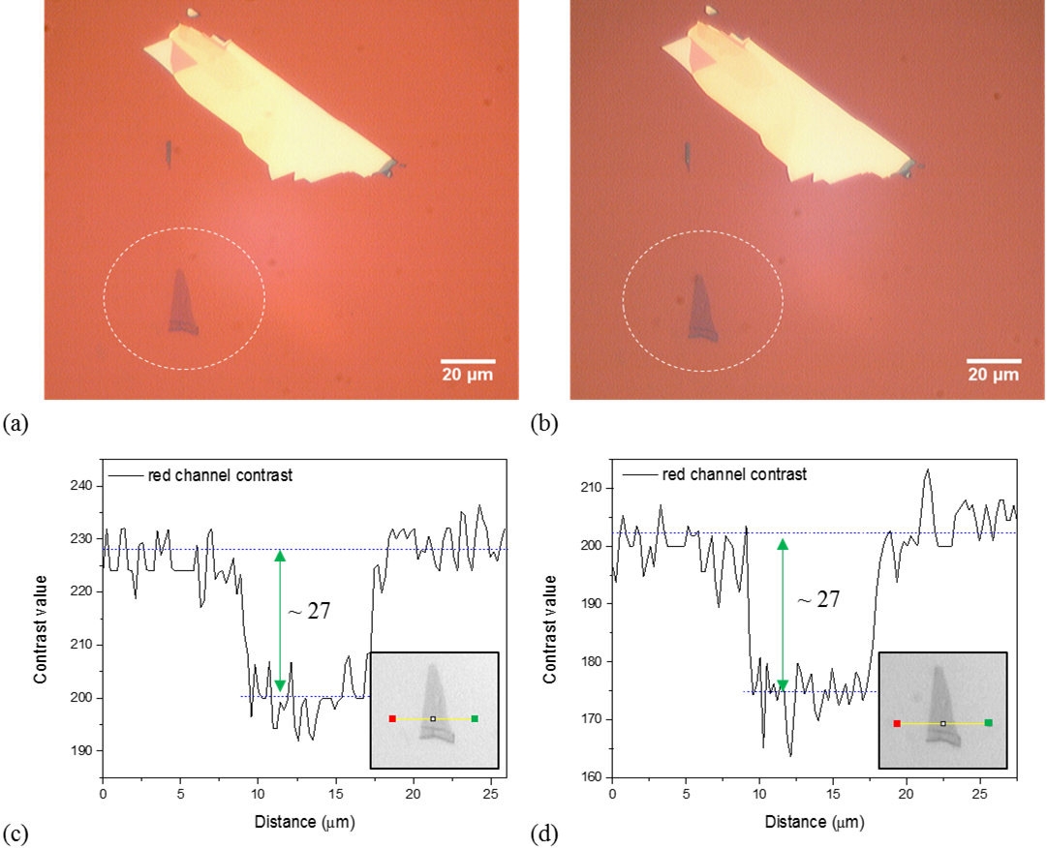
FIG. S1 Optical microscope images of MoS₂ flakes on the control sample (a) on the day of sample preparation and (b) after 222 days. Red channel optical profile lines of the encircled MoS₂ flake in Figs. S1(a) and (b) are shown in (c) and (d) respectively. Inset is the red channel optical image of the measured region. The measurement was done in the direction of red to green dot.
Figs. S2(a) and (b) show optical microscope images of bulk MoS₂ flakes on the sample stored under vacuum on the day of sample preparation and after 222 days respectively. The lateral dimensions of thin as well as bulk flakes were unchanged on this sample.

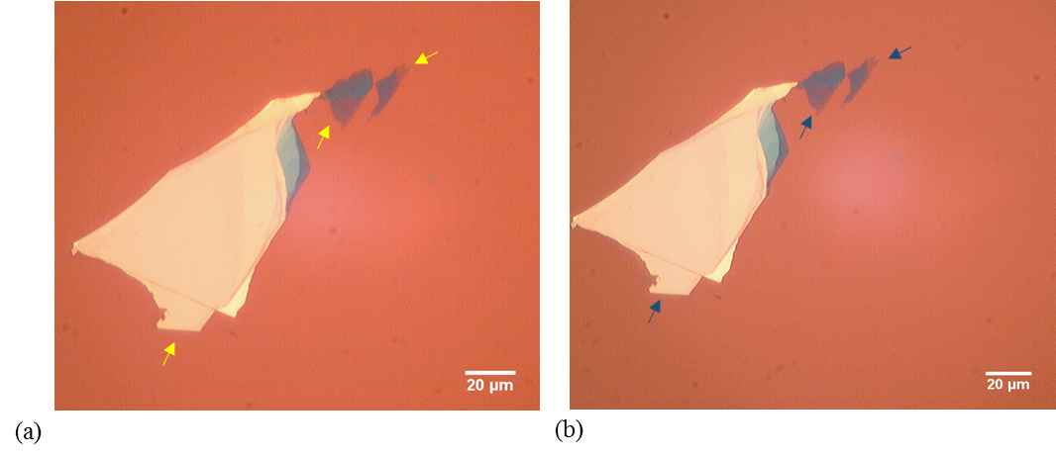
FIG. S2 Optical microscope images of bulk MoS₂ flakes on the control sample stored under vacuum (a) on the day of sample preparation and (b) after 222 days. Arrows are used for identification of the same region.
Figs. S3(a) and (b) show the optical microscope images of ultra-thin MoS₂ flakes on the sample stored in air on the day of sample preparation and after 55 days respectively. The encircled thin flake with dark purple optical contrast in Fig. S3(a) had a uniform surface on the day of sample preparation. However, after 55 days of storage, a crack had developed across the surface of this flake as seen in Fig. S3(b). The corresponding red channel contrast profiles are shown in Figs. S3(c) and (d) respectively. The contrast difference value of 55 is nearly equivalent to the reported red channel contrast difference value for a bilayer MoS₂ flake on a 300 nm SiO₂/Si substrate.^{[1]} The spike highlighted by the red arrow in the optical profile shown in Fig. S3(d) tallies with the crack observed in the bilayer flake in Fig. S3(b).

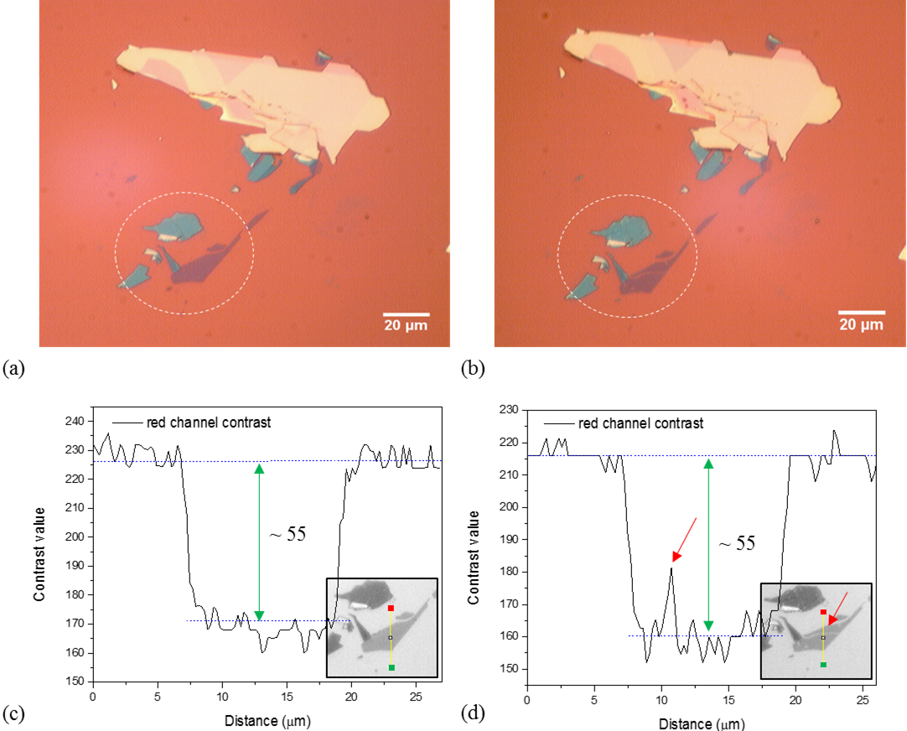
FIG. S3 Optical microscope images of MoS₂ flakes on the sample stored in air (a) on the day of sample preparation and (b) after 55 days. Red channel optical profile lines of the encircled MoS₂ flakes in Figs. S2(a) and (b) are shown in (c) and (d) respectively. Inset is the red channel optical image of the measured region. The measurement was done in the direction of red to green dot.
Figs. S4(a) and (b) show the optical microscope images of bulk MoS₂ flakes on the sample stored in air on the day of sample preparation and after 55 days respectively. Small speckles had started to appear on the surface of the bulk flakes after 55 days, as seen in Fig. S4(b).
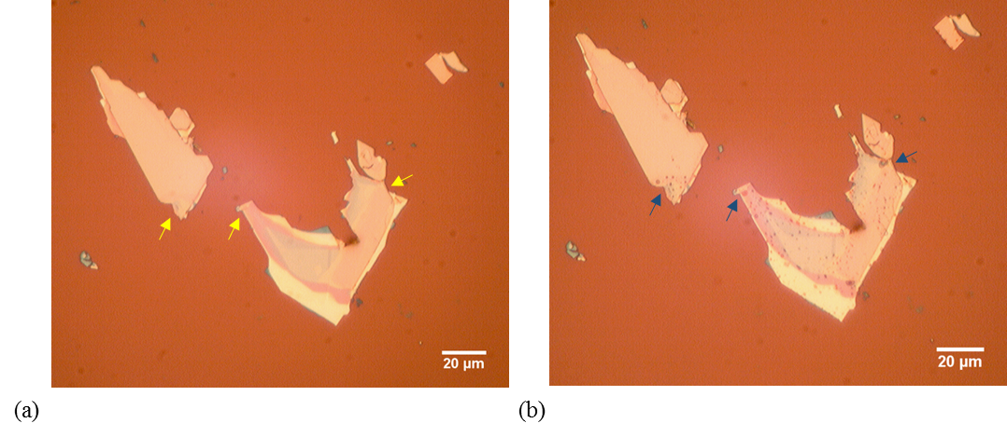
FIG. S4 Optical microscope images of bulk MoS₂ flakes on the sample stored in air (a) on the day of sample preparation and (b) after 55 days. Arrows are used for identification of the same region.
Fig. S5(a) shows an optical microscope image of MoS₂ flakes on the sample stored in air on the day of sample preparation. Fig. S5(b) shows a magnified image of the bilayer MoS₂ flake encircled in Fig. S5(a). The surface area of this flake was determined by the region enclosed within the yellow border marking the original boundaries of the flake. It was calculated to be approximately 208 µm².

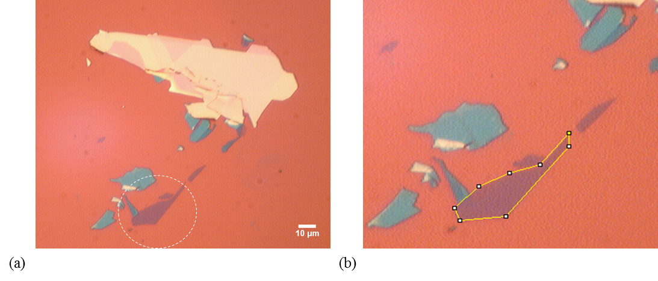
FIG. S5 (a) Optical microscope image of MoS₂ flakes on the sample stored in air on the day of sample preparation and (b) Magnified image of the bilayer MoS₂ flake encircled in Fig. S5(a). The surface area of the flake is enclosed within the yellow border.
Fig. S6(a) shows an optical microscope image of the MoS₂ flakes shown in Fig. S5 after 380 days of storage in air. A new microscope imaging unit was installed during the course of this experiment. Therefore, the optical contrast of the flakes in Fig. S6 has changed in comparison to Fig. S5. It can be observed that over the period of one year, the encircled thin MoS₂ flake has significantly reduced in lateral dimensions. After 380 days, the flake had split into three different parts. Therefore, the surface area of this flake was determined by the regions enclosed within yellow borders shown in Figs. S6(b) to (d). The surface area for each enclosed region shown in Figs. S6(b) to (d) was calculated to be 71 µm², 24 µm² and 10 µm² respectively. The total surface for this was equivalent to 105 µm². Therefore, the total surface area of bilayer MoS₂ flake had reduced from 208 µm² to 105 µm². The percent change in the surface area of the flake due to a year of air storage was approximately 50%.

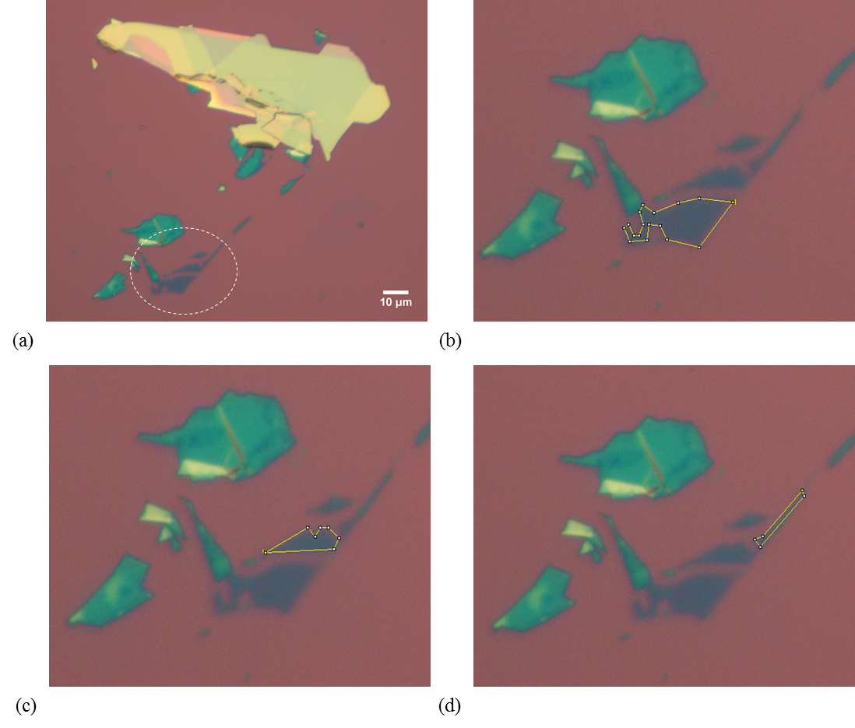
FIG. S6 (a) Optical microscope image of MoS₂ flakes on the sample stored in air after 380 days of sample preparation and (b) to (d) Magnified images of the bilayer MoS₂ flake encircled in Fig. S6(a). The surface area of the flake is enclosed within the yellow borders.
Figs. S7(a) and (b) show the optical microscope images of speckled MoS₂ flakes after annealing and subsequent vacuum storage of 5 days and 133 days respectively. No significant changes are observed, indicating that the flakes remain stable under vacuum storage.

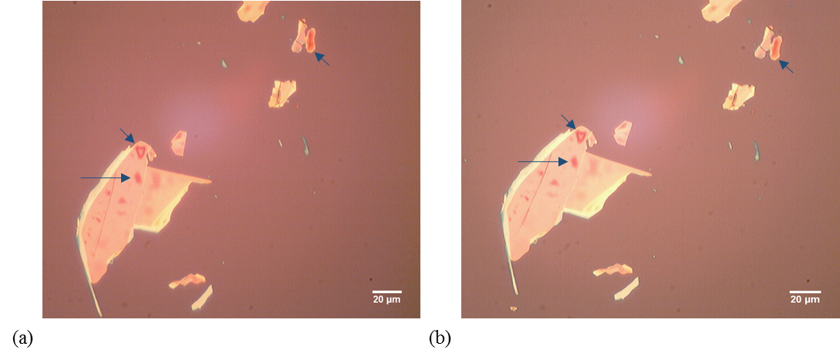
FIG. S7 Optical microscope images of speckled MoS₂ flakes after vacuum annealing and (a) after 5 subsequent days of vacuum storage and (b) after 133 subsequent days of vacuum storage. Arrows are used for identification of the same region.
Fig. S8 shows optical images of speckled flakes before and after annealing and subsequent storage in air. Arrows 1 and 2 in Fig. S8(b) point towards the speckles that changed their shape from an open ring to a closed ring after vacuum annealing. There was no speckle before or after annealing at the location indicated by arrow 3 in Figs. S8(a) and (b), but a speckle has appeared at this location after 133 days of storage in air, as shown in Fig. S8(d). The closed ring speckle indicated by arrow 1 in Fig. S8(b) had split into two open rings as shown in Fig. S8(d). Thus, it is seen that annealed flakes begin to decompose again if they are exposed to air ambient.

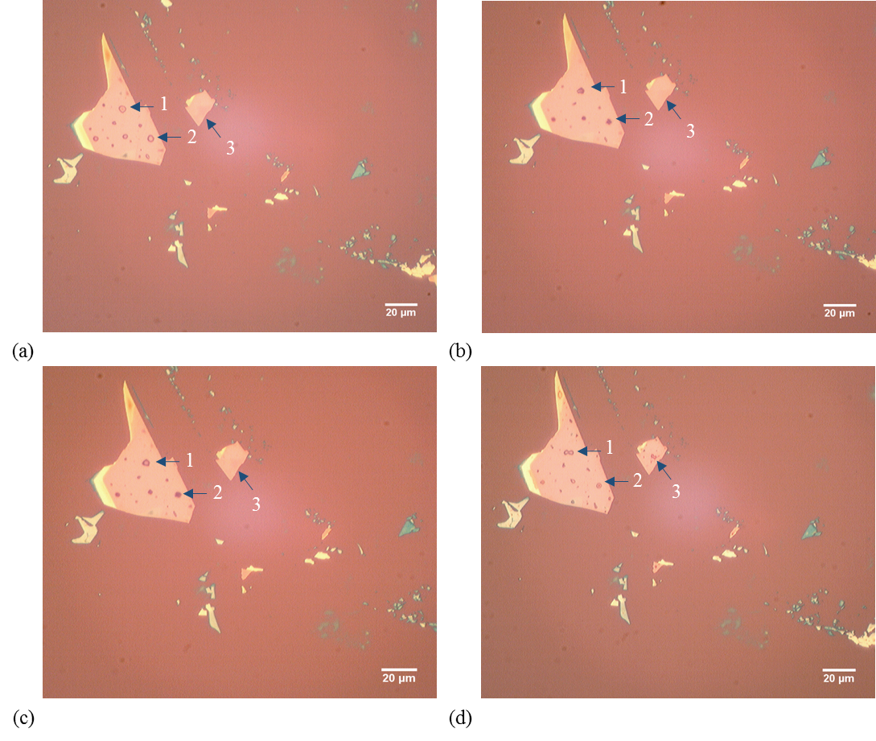
FIG. S8 Optical microscope images of MoS₂ flakes with speckles on the sample which was stored in air after annealing (a) before annealing, (b) just after annealing, (c) after 5 subsequent days of air storage and (d) after 133 subsequent days of air storage. Arrows and numbers are used for identification of the same region.
Figs. S9(a) and (b) are optical images of MoS₂ flakes on the day of preparation and after 200 days respectively on a sample prepared by Scotch® tape exfoliation and thereafter stored in air. The flake indicated by arrow 1 in Fig. S9(a) has developed cracks along its edges and speckles are spread all over its surface. Arrow 2 in Fig. S9 points towards a flake that has almost decomposed due to storage in air, with only some regions of its speckled boundary remaining after 200 days of exposure to air. Speckles had also developed on the bulk flake indicated by arrow 3 shown in Fig. S9.

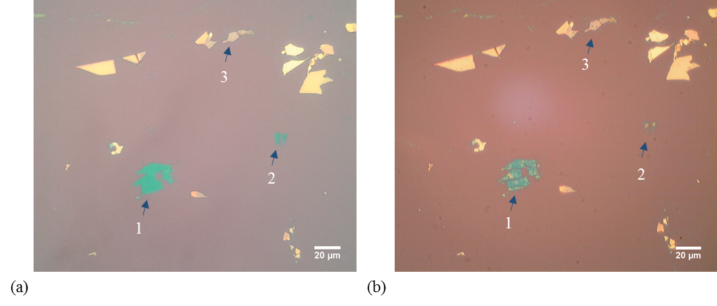
FIG. S9 Optical microscope images of speckled MoS₂ flakes on a sample prepared by Scotch® tape and stored in air after sample preparation (a) on the day of preparation and (b) 200 days after sample preparation. Arrows and numbers are used for identification of the same region.
Figs. S10(a) and (b) are optical images of MoS₂ flakes on the day of preparation and after 125 days respectively on a sample prepared by the gel-film transfer method and thereafter stored in air. The region of the thin MoS₂ flake indicated by arrow 1 in Fig. S10(a) has completely decomposed. A few speckles can be seen at the decomposed region of the flake. Other regions of the flake were also affected by air storage as small patches on the otherwise uniform surface of the flake have started to form as shown by arrow 2 in Fig. S10(b). This emphasized that the flakes were affected by the ambient storage irrespective of the mechanism used to transfer them onto the oxidized silicon substrate.

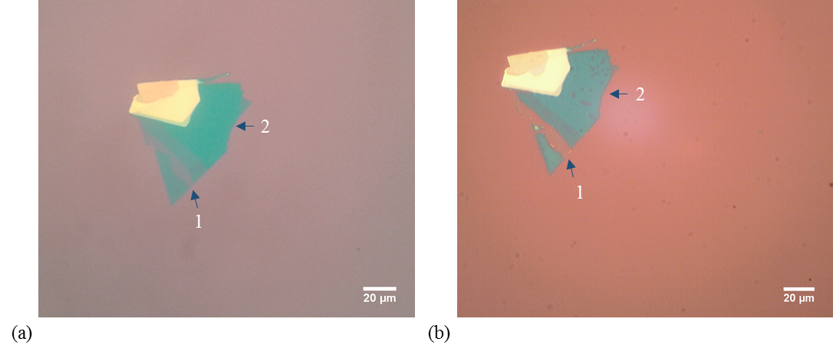
FIG. S10 Optical microscope images of speckled MoS₂ flakes on the sample prepared by the gel-film transfer method and stored in air after sample preparation (a) on the day of preparation and (b) 125 days after sample preparation. Arrows and numbers are used for identification of the same region.

Investigation of degradation mechanism
Fig. S11 shows SEM imaging of selected flakes on the control sample and the sample stored in air, all taken 240 days after sample preparation. A LEO SUPRATM 25 field emission scanning electron microscope with accelerating voltage between 10 and 12 kV was used for this analysis. A thin MoS₂ flake on the control sample did not undergo any change in lateral dimensions even 240 days after the sample preparation as shown in Fig. S11(a). The cracks seen on the surface of this thin MoS₂ flake in the SEM image are thought to have been present on it due to the mechanical exfoliation procedure. However, it can be seen in Fig. S11(b) that the thin MoS₂ flake on the sample stored for 240 days in air was lined with small beads along the original edges of the flake. These beads trace the original boundary of the flake, which has reduced with the passage of time. The speckles on the surface of bulk MoS₂ flakes on the same sample were spread across the flakes as seen in Fig. S11(c).

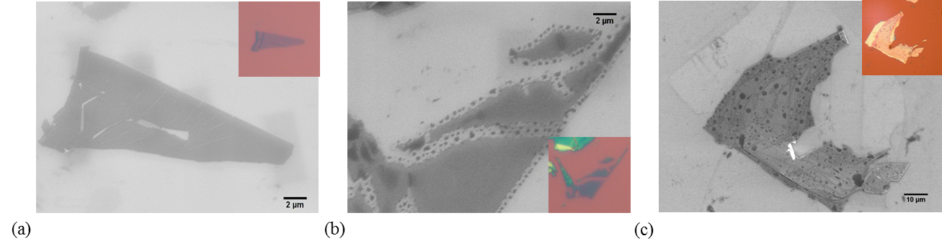
FIG. S11 SEM images of (a) thin MoS₂ flake on the control sample (b) thin MoS₂ flake on the sample stored in air and (c) bulk MoS₂ flake on the sample stored in air. All images were taken 240 days after sample preparation. Inset are the optical microscope images of the respective flakes.
Raman measurements were performed using the excitation laser line of 514nm on a Renishaw inVia MicroRaman spectroscope. Raman spectra were collected through a 50× objective and dispersed by a 2400 l mm⁻¹ grating with a spectral resolution of 1.4 cm⁻¹. Initial Raman spectra were calibrated by using a bulk monocrystalline Si wafer using the Si phonon peak at 520.5 cm⁻¹. The laser power on the sample was kept below 1 mW to avoid heating effects. Fig. S12 shows the Raman spectra taken from a speckled region (red curve) and from an unaffected region (blue curve) on a bulk MoS₂ flake. Table S1 gives details of in-plane (E¹_{2g}) and out-of-plane (A_{1g}) Raman peak values, peak width, peak intensity and intensity ratios for the affected and unaffected regions of the flake shown in Fig. S12. The E¹_{2g} and A_{1g} peak values for the affected region were obtained at 383.49 cm⁻¹ and 408.78 cm⁻¹ which was similar to the values obtained at the unaffected region. The full width half maximum (FWHM) for E¹_{2g} and A_{1g} peak was also maintained at a constant value of 2.5 cm⁻¹ and 3.0 cm⁻¹ respectively. Also there was no significant change in E¹_{2g} and A_{1g} peak intensity ratios at affected and unaffected sites of the bulk flake.

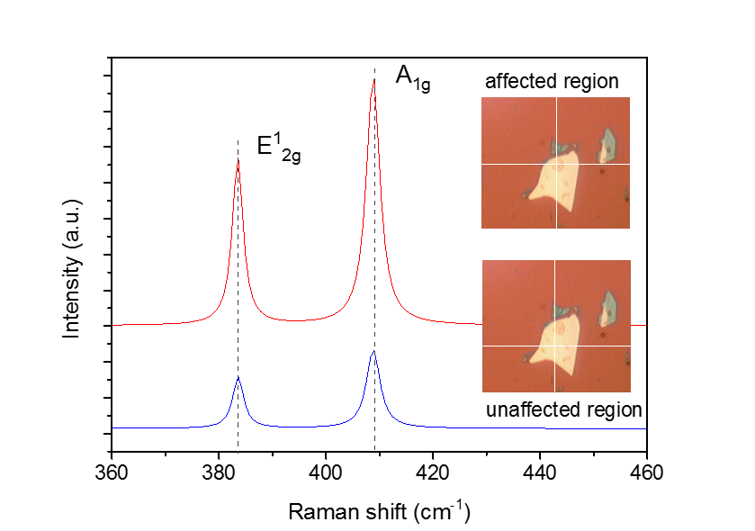
FIG. S12: Raman spectra on an affected region and on an unaffected region on a bulk MoS₂ flake on the sample stored in air. Inset are the optical images of the measured flakes. The measurement was done at the intersection point of the markers on the inset images.
Peak values | Centre (cm⁻¹) |  | Width (cm⁻¹) |  | Intensity (a.u.) |  | Height ratio
 | E¹_{2g} | A_{1g} | E¹_{2g} | A_{1g} | E¹_{2g} | A_{1g}
On affected region | 383.49 | 408.78 | 2.45 | 3.08 | 9399 | 13949 | 0.67
On unaffected region | 383.58 | 408.80 | 2.50 | 3.04 | 2875 | 4430 | 0.64
TABLE S1 Details of the Raman peak values obtained from affected and unaffected sites on a bulk MoS₂ flake shown in Fig. S12.

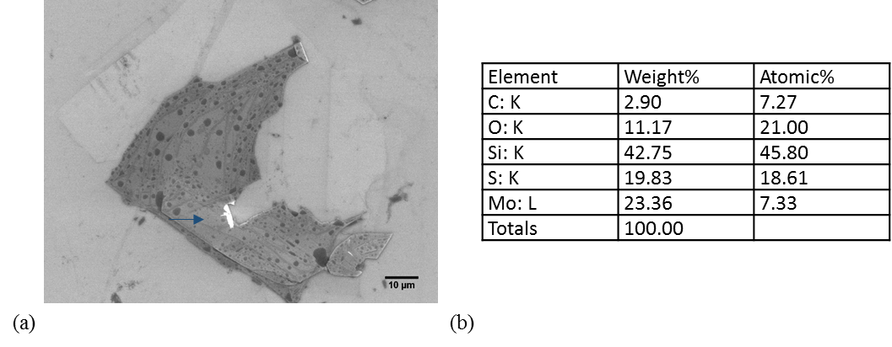
FIG. S13 (a) SEM image of decomposing thick MoS₂ flake on the sample stored in air (b) weight and atomic percentages obtained by energy dispersive X-ray (EDX) spectroscopy for the unaffected region marked by the arrow in Fig. S13(a).

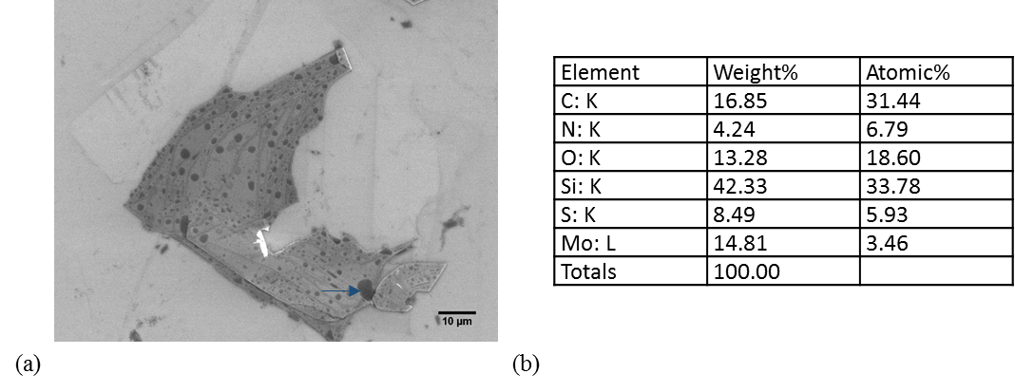
FIG. S14 (a) SEM image of decomposing thick MoS₂ flake on the sample stored in air (b) weight and atomic percentages obtained by energy dispersive X-ray (EDX) spectroscopy for the affected region marked by the arrow in Fig. S14(a).
References
[1] H. Li, J. Wu, X. Huang, G. Lu, J. Yang, X. Lu, Q. Xiong and H. Zhang: Rapid and reliable thickness identification of two-dimensional nanosheets using optical microscopy. ACS Nano 7, 10344-10353 (2013)
[2] B. Radisavljevic, A. Radenovic, J. Brivio, V. Giacometti and A. Kis: Single-layer MoS₂ transistors. Nat. Nanotechnol. 6, 147-150 (2011)

