Supporting Information
Rapid and scalable synthesis of crystalline SnO₂ nanoparticles with superior photovoltaic properties by flame oxidation
Easwaramoorthi Ramasamy^{a,}*, P Kathirvel^{b}, S. Kumar^{a,}*, Koppoju Sureshª, V Ganapathyª
ªInternational Advanced Research Centre for Powder Metallurgy and New Materials,
Hyderabad 500005, India
^{b}PSG College of Technology, Coimbatore 641004, India
*Corresponding author. Tel.: +91-40-24452457
Fax: +91-40-24442699
E-mail: easwar@arci.res.in, skumar@arci.res.in

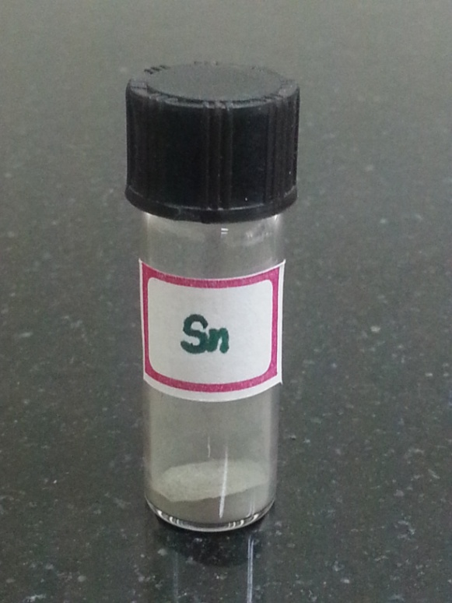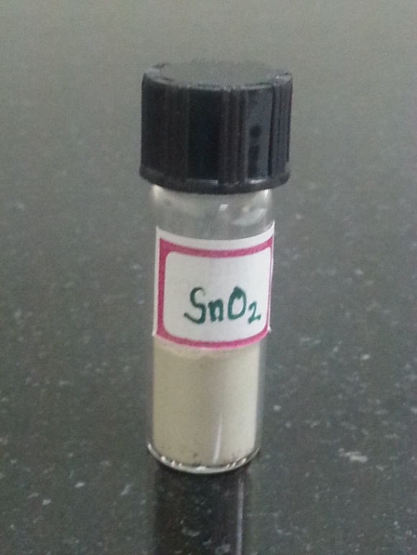

Fig. S1 Digital photograph of Sn feedstock (left) and flame syntheisized SnO₂ nanoparticles (right) in a glass vial. To facilitate the volume comparison, both samples are weighed 1 g.

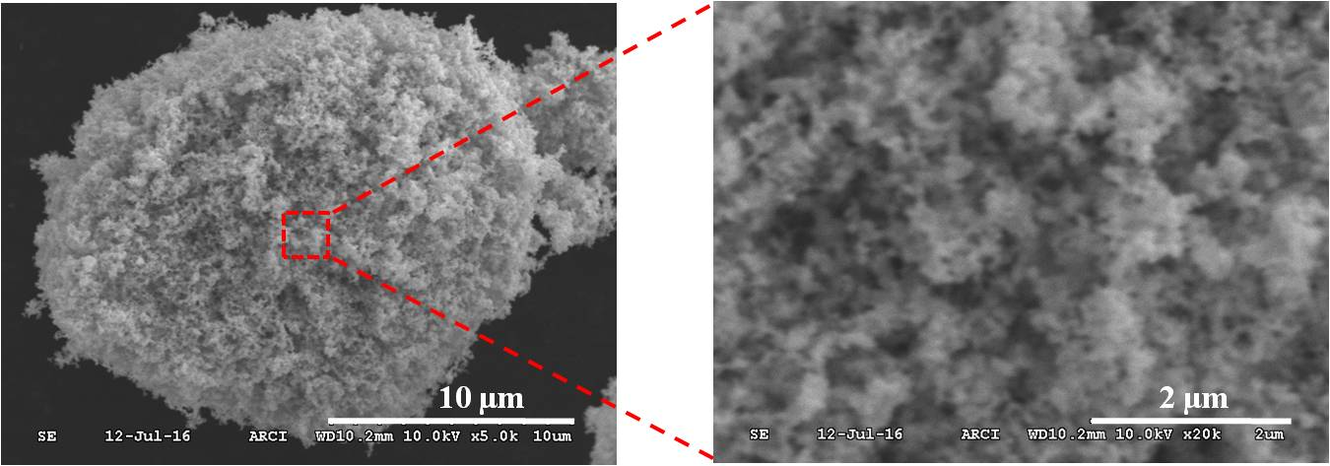

Fig. S2 SEM image (left) of flame synthesized SnO₂ nanoparticles. High magnification SEM image (right) of marked region reveal the presence of loosely agglomerated primary nanoparticles.

Fig. S3 Digital photographe of sealed dye-sensitized solar cell fabricated with flame-SnO₂(left) and control-SnO₂(right) photoanode.

