The control of stem cell morphology and differentiation in 3D using 3D printed scaffold architecture
Guvendiren et al.

Supplementary Information

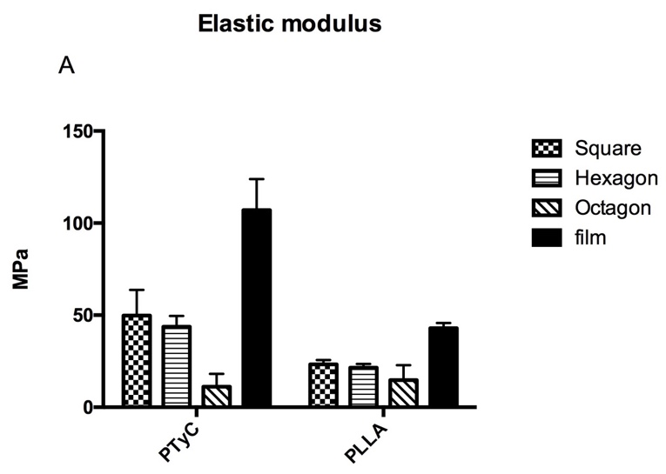
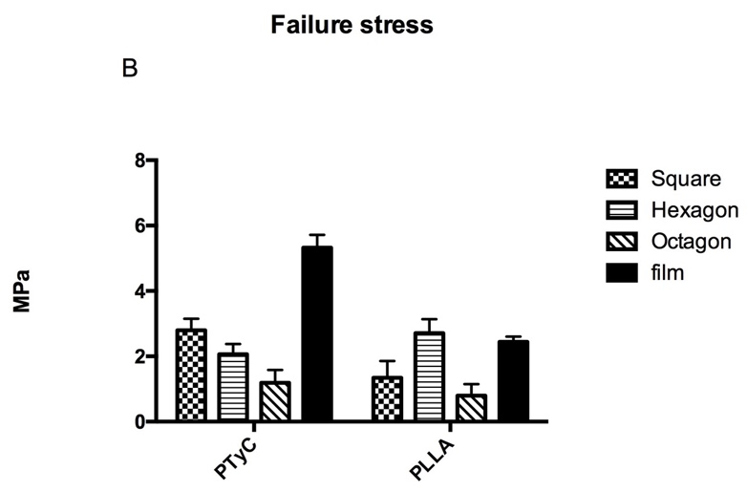
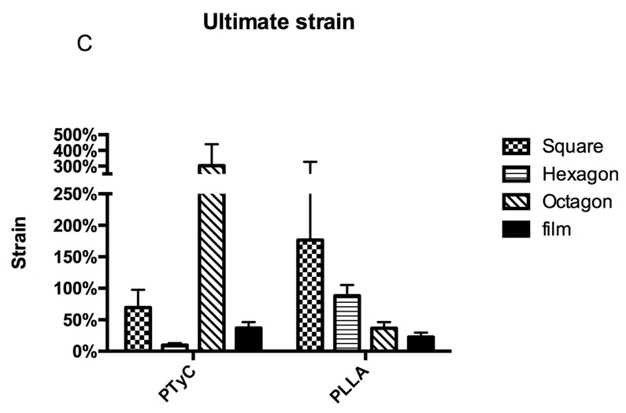
Figure S1. Plots showing (A) elastic modulus, (B) failure stress, and (C) ultimate strain values of scaffolds.

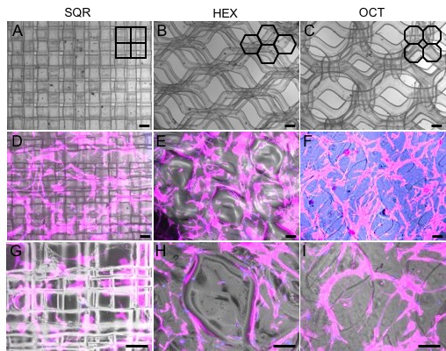

Figure S2. (A-C) Phase contrast images of the 3D scaffolds printed from PTyC using square (SQR), hexagon (HEX), and octagon (OCT) architecture. (D-I) Merged images of the phase contrast and fluorescent channels for hMSCs cultured on these scaffolds for 14 days (F-actin in magenta and cell nuclei in blue). Scale bars for the top two rows are 200 microns and for the bottom row are 100 microns.

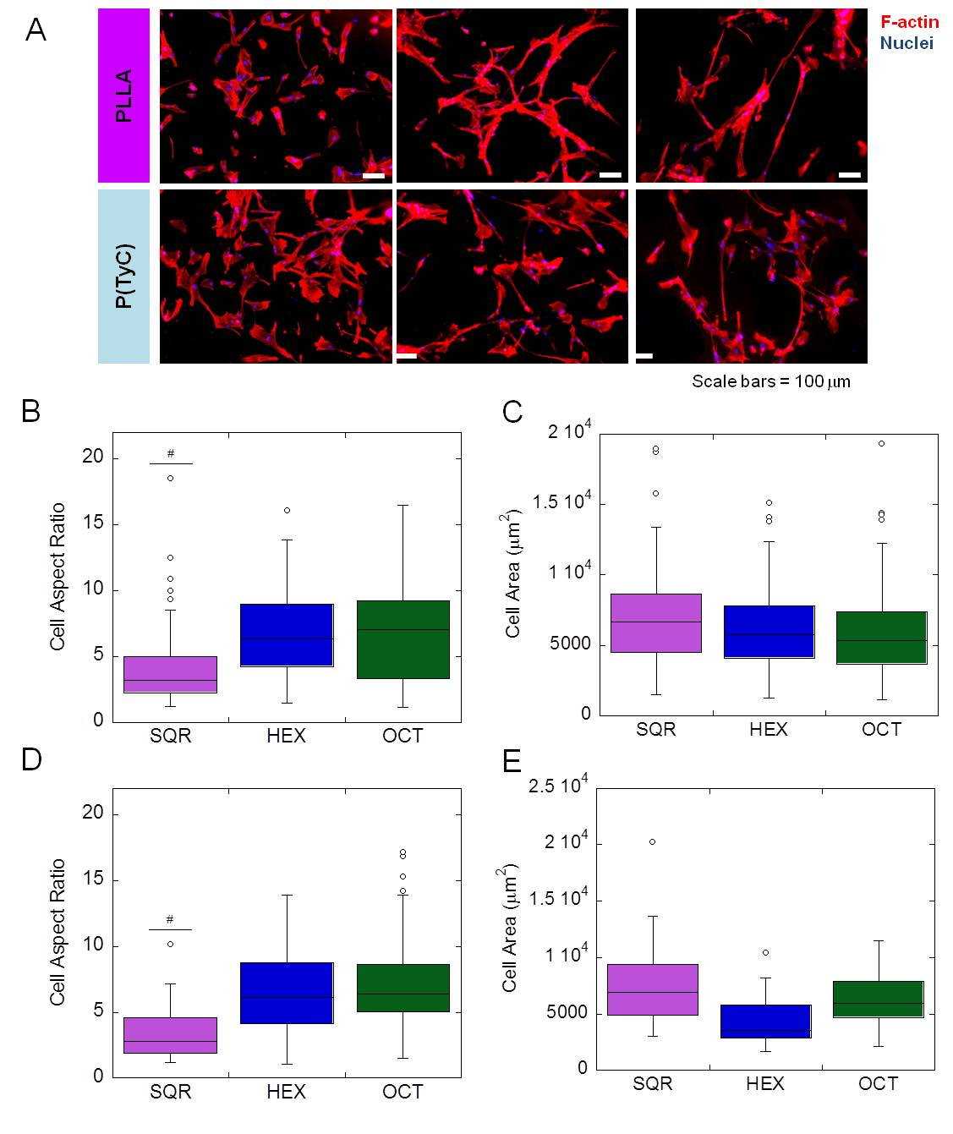

Figure S3. (A) Fluorescent images of hMSCs cultured on SQR, HEX and OCT scaffolds (from left to right) from PLLA (top) or PTyC (bottom). Corresponding cell aspect ratio and cell area for PLLA (B and C) and for PTyC (D and E). # p<.0001 for SQR as compared to HEX and OCT.

