REPORT ON LiFePO₄ SAMPLES M1 AND M2

Experimental

Mössbauer data were recorded at room temperature using a conventional constant acceleration spectrometer. Absorbers were prepared to have approximately 5 mg Fe/cm². The velocity scale was calibrated using a 6 μm thick natural iron foil. All the spectra were computer-fitted and the isomer shifts were referred to the centroid of the room temperature spectrum of α-Fe.

Results

Figure 1 shows the room temperature Mössbauer spectra recorded from LiFePO4 samples M1 and M2. They contain three contributions, two corresponding to Fe²⁺ and a third characteristic of Fe³⁺ (see Table 1). The respective spectral areas show small differences depending on the sample. The most intense quadrupole doublet is characteristic of the high spin octahedral Fe²⁺ in the LiFePO₄ structure [1]. The second, minor paramagnetic Fe²⁺ doublet is also characteristic of octahedral Fe²⁺. Mössbauer parameters similar to those of this additional Fe²⁺ doublet have been found both in samples where the synthesis procedure has lead to incomplete lithiation of the final materials or in amorphous lithiated compounds [2]. Alternatively, Mössbauer parameters close to these have been reported for the impurity phase Fe₂P₂O₇ [3]. Unless a such impurity has been detected in the corresponding XRD pattern, the assignment of this doublet remains uncertain. The identification of the remaining Fe³⁺ doublet needs of careful examination. In a first approximation one might think that this Fe³⁺ contribution would arise from Fe³⁺ within the structure of LiFePO₄. In such a situation, there would be two possible scenarios [4]. The first one would contemplate the substitution of three Fe²⁺ ions by two Fe³⁺ ions leaving an iron vacancy in the M2 site, or the substitution of a Li⁺ Fe²⁺ pair by one Fe³⁺ ion leaving a vacancy of Li in the M1 site or Fe in the M2 site and Fe occupation of the M1 site. Since the ionic radius of Fe³⁺ in octahedral coordination (78.5 pm) is much smaller than that of Fe²⁺ (90 pm) this would be reflected in a large reduction of the lattice parameters of LiFePO₄. The second scenario would consider the presence of amorphous impurities. The presence of amorphous FePO₄ can be discarded as its hyperfine parameters do not match those of our Fe³⁺ component [2]. Although the presence of amorphous iron oxides cannot be discarded (low temperature Mössbauer data would be necessary) we think that this Fe³⁺ contribution could arise more likely from the ageing of LiFePO₄ brought about by its exposure to the laboratory atmosphere. It has been reported [5] that exposure of lithium iron phosphate to the atmosphere can result in the formation of amorphous ferric phosphate phases whose concentration can amount to very large percentages depending on the exposure time and conditions, even at ambient temperature. The data indicate that the Fe³⁺ contribution is much more important in sample M2 than in sample M1.

References
[1] A.S. Anderson, B. Kalska, L. Haggstrom, J.O. Thomas, Solid State Ionics 130 (2000) 41-50.
[2] K. Galoustov, M. Anthonisen, D.H. Ryan, D.D. MacNeil, J. Power Sources 196 (2011) 6893-6897.
[3] F.B. Khan, K. Baruth-Ram, D.H. Ryan, D.D. MacNeil, Hyperfine Interact. 197 (2010) 317-323.
[4] B. Hannoyer, A.A.M. Prince, M. Jean, R.S. Liu, G.S. Wang, Hyperfine Interact. 167 (2006) 767-772.
[5] M. Cuisinier, J.F. Martin, N. Dupré, A. Yamada, R. Kanno, D. Guyomard, Electrochem. Comm. 12 (2010) 238-241.

Figure 1. Room temperature Mössbauer spectra.
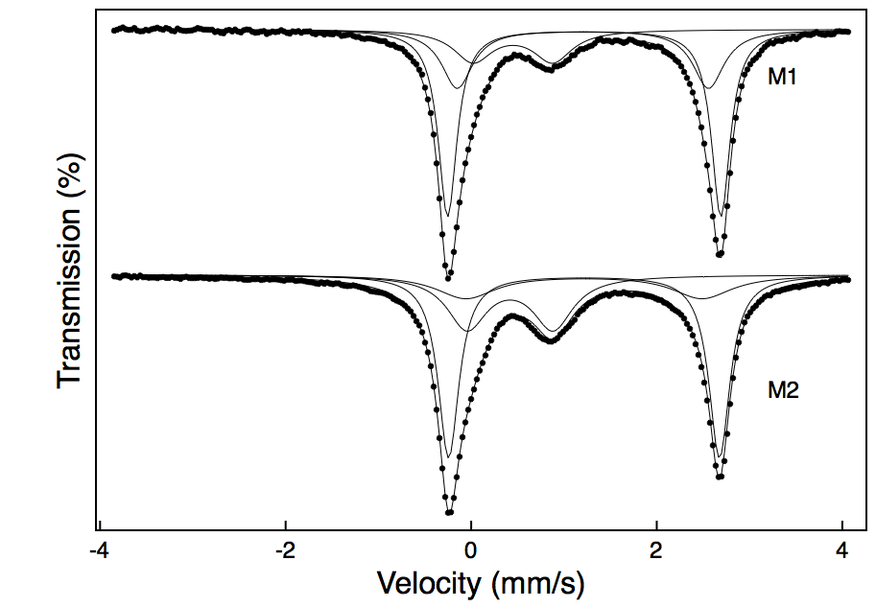

Table 1.- Mössbauer parameters and spectral areas obtained from the fit of the spectra
Sample | Component | δ (mms⁻¹) | Δ (mms⁻¹) | Area (%)
M1 | Fe²⁺ | 1.22 | 2.94 | 54
 | Fe²⁺ | 1.20 | 2.71 | 28
 | Fe³⁺ | 0.45 | 0.86 | 18
M2 | Fe²⁺ | 1.26 | 2.92 | 52
 | Fe²⁺ | 1.26 | 2.55 | 19
 | Fe³⁺ | 0.42 | 0.93 | 29

