Supporting Information for

Assessment of Trends in the Electrochemical CO2 Reduction and H2 Evolution Reactions on Metal Nanoparticles

**Dominic R. Alfonso** and **Douglas R. Kauffman**, National Energy Technology Laboratory, United States Department of Energy, Pittsburgh, Pennsylvania 15236, USA

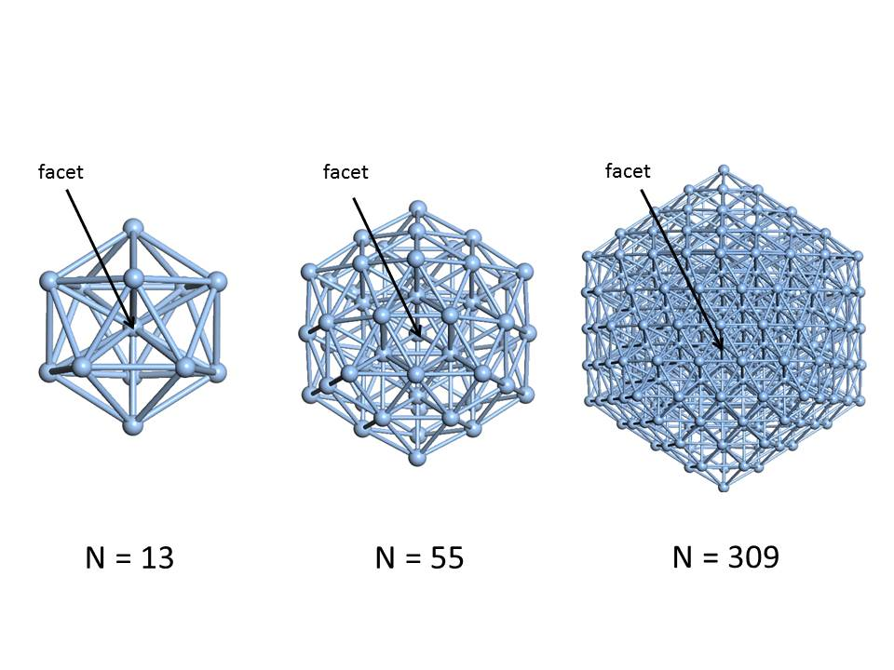

**Figure S1.** Schematic view of models of icosahedron metal nanoparticles with different sizes showing the location of the “facet” adsorption sites. The 13, 55 and 309 atom models have diameters of 0.49, 0.98 and 1.96 Å, respectively.