Supplementary information for “Lifetime limitations in organic electronic devices due to metal electrochemical migration”

Robert Abbel¹, Linda van de Peppel¹, Gerwin Kirchner¹, Jasper J. Michels²*, Pim Groen^{1,3}*

¹ Holst Centre – TNO, High Tech Campus 31, 5656 AE Eindhoven, The Netherlands
² Max Plack Institut für Polymerenforschung, Ackermannweg 10, 55128 Mainz, Germany
³ Delft University of Technology, Faculty of Aerospace Engineering, Kluyverweg 1, 2629 HS Delft, The Netherlands

Experimental Section

Materials: Spin-coatable acidic PEDOT:PSS (Clevios P VP AI 4083) was purchased as an aqueous dispersion (solid content 1.3 – 1.7 wt%, PEDOT vs. PSS ratio 1 : 6 by weight, pH 1.2 – 2.2) from Heraeus Electronic Materials Devision. Pure PEDOT-free PSS was purchased as a solution in water (18 wt%, M_{w} 75000) from Sigma Aldrich and diluted to 1.4 wt% using 2-butanol (Fisher Emergo). Conductive inkjet ink (Suntronic U5603), a dispersion of silver nanoparticles (average particle size 50 nm, metal content 20 wt%) in a mixture of ethanol, ethylene glycol, glycerol and 2-isopropoxy ethanol, was obtained from Sun Chemicals. The nanoparticle surfaces are stabilized by a coating of poly(vinylpyrrolidone). A second conductive inkjet ink (UTDAg 40), a dispersion of silver nanoparticles (average size 10 nm, metal content 40 wt%) in a proprietary hydrocarbon, was obtained from UTDots, Inc. Silver nanowire ink (NovaWire-Ag-CI-A30; a water-based coating formulation containing 0.2 wt% silver nanowires of 30 nm average diameter) was bought from Novarials Corp. L-Ascorbic acid and anhydrous magnesium chloride were purchased from Sigma Aldrich. Light emitting polymer (Super Yellow PPV) was obtained from Merck Performance Materials and dissolved in toluene (0.4 wt/v %) prior to processing.

Probe design and production: Evaporated electrodes (size 1000 by 500 µm) with gap sizes of 100, 200, 500 and 1000 µm were prepared by physical vapor deposition of metals. The design of the probes allows to measure the electrical resistance across the interelectrode gap by the four point method. Glass slides (Eagle XG no-facet) of 152 x 152 x 0.7 mm size were placed in a vacuum evaporator, and covered with a stainless steel shadow mask. The mask was kept in place on the glass surface by means of a magnetic mat, and several small magnets were placed on the mask to prevent displacement due to the increasing temperatures. The metal films were evaporated at a pressure between 5 · 10⁻⁷ and 10⁻⁶ bar and a deposition rate of 3 Å/s. In order to prevent deformation of the mask due to overheating, the deposition was carried out in three steps of ca. 150 nm, resulting in total metal film thicknesses in the range of 450 – 500 nm.

Sample preparation: L-Ascorbic acid was added to the PEDOT:PSS dispersions as a solid and shaken at room temperature until it was completely dissolved. Prior to printing the PEDOT:PSS formulations, the substrates were treated with nitrogen plasma for 5 minutes at 600 W and 0.58 mbar in a Branson/1PC barrel etcher in order to improve the wetting behavior. Silver inks, pure PEDOT:PSS dispersion, PSS solution and PEDOT:PSS/ascorbic acid mixtures were printed using a Dimatix materials inkjet printer (DMP 2800 series), Jetpowered Dimatix Materials cartridges (DMC-11610; droplet volume 10 pl, droplet spacing 20 µm) and customized waveforms. All inks were filtered through a polypropylene or teflon syringe filter with 450 nm pore size (Whatman) before filling the cartridge. U5603 was used to print electrode structures (1000 by 500 µm, interelectrode gap 500 µm design width) which were thermally sintered in a hot air oven at the conditions stated in Table S1, resulting in a film thickness of 400 – 500 nm. PEDOT:PSS and pure PSS films (5 by 5 mm) with and without the ascorbic acid additive were dried after printing at 180 ºC for 5 minutes in a hot air oven, resulting in a film of approximately 200 nm average thickness for all types of formulations. For sheet resistance determination, two lines of UTDAg40 silver ink (dimensions 20 x 2 mm with a spacing of 2 mm) were printed on microscope covers of 0.3 mm thickness (borosilicate glass from Menzel Gläser) and sintered in a hot air oven for one hour at 180 ºC. Thin films for UVvis spectrophotometric characterization and sheet resistance determination were prepared by spin coating of PEDOT:PSS formulations at 500 rpm for 60 seconds and subsequent drying for 5 minutes at 180 ºC on a hot plate. Film thicknesses so obtained were 145 nm (pure PEDOT:PSS) and 160 nm (0.1 wt% ascorbic acid).

Migration experiments and process monitoring: The migration experiments were carried out at a constant temperature of 20 ºC in a glove box in which the relative humidity was controlled at 33 % by the presence of anhydrous MgCl₂ [S1] and monitored using an Alarm-Hygrometer Testo 608-H2. They were then connected to a direct current voltage source Delta Elektronika power supply (E060-0.60), and the current at constant voltage (varied between 5 and 50 V) was measured by a four-point probe as a function of time using a Keithley 2100 6 ½ digit Multimeter. The data were read out by a computer with a specially designed Labview software which allows real time monitoring of the current at a frequency of 20 Hz. The dendrite formation was continuously monitored by optical microscopy using a DigiMicro Pro camera. The backlight needed for the optical microscope was provided by a Lightbox A4, LP LCD A4S, and the software used for the optical microscope was MicroCapture Pro, Version 2.2.

Sample characterization: After having finished the experiments, the samples were taken out of the glove box and characterized by optical microscopy (Leica DMLM) and scanning electron microscopy (Philips XL30 Field Emission ESEM). Cross-sectional images were obtained by fast ion bombardment (FIB) and also taken using scanning electron microscopy (FEI Nova200 NanoLab). Before FIB preparation, the samples were coated with a few nm of conductive carbon on the entire sample to avoid charging. Subsequently, a 1-2 µm Pt layer (electron and ion beam induced) was deposited at the region of interest to protect the top layers during milling. The cross sections were obtained by milling a trapezoidal trench into the surface creating using a gallium ion beam. After FIB polishing, the cross-section was studied at a tilted angle (52º) using secondary electron and back scattered electron mode. Time-of-flight Secondary Ion Mass Spectrometry (ToF-SIMS) was carried out using an Ion-Tof TOF-SIMS IV instrument, operated in positive mode using 25 keV bismuth ions. Thermal gravimetric analysis was performed using a Discovery TGA from TA Instruments. Film thicknesses were determined by locally removing the printed materials with a scalpel blade and measuring a height profile across the resulting scratch by profilometry (Dektak XT Stylus). Specific electric conductivities of the sintered silver inks were calculated using printed test lines from their geometric dimensions (cross section obtained by profilometry) and their electrical resistances (measured with a two point probe ohmmeter). UVvis transmission spectra were recorded on a UV-VIS-NIR3600 spectrophotometer (Shimadzu) in the range of 1200 – 300 nm. Sheet resistances for PEDOT:PSS formulations were obtained from samples spin coated over printed silver lines (vide supra for conditions), removing any material outside these lines, measuring the resistance between them (Fluke 177 True RMS multimeter) and correcting for the non-square geometry.

OLED production, characterization and lifetime testing: OLED devices were prepared on Eagle XG no-facet glass slides of 152 x 152 x 0.7 mm size glass substrates with sputtered indium tin oxide (ITO) patterns, containing nine individual devices. A silver film of approx. 10 nm thickness was deposited by thermal evaporation through a shadow mask on the final illuminating areas (23 x 23 mm), followed by 1 min of nitrogen plasma at 400 W (Microwave Plasma System 400 Inline from PVA TePla AG). PEDOT:PSS formulations were filtered through Teflon syringe filters (Whatman, pore size 220 nm), and then spin coated on the substrates (1200 rpm), dried at 50 ºC for 2 min and baked at 150 ºC for 30 seconds. The PEDOT:PSS was then removed from between the individual OLED devices by wiping to avoid short circuit formation and finally baked for 10 min at 150 ºC. This resulted in a layer thickness of ca. 100 nm. Subsequently, light emitting polymer solution was spin coated on the PEDOT:PSS (1200 rpm), giving a ca. 80 nm thick layer. On top of that, a barium/silver electrode was thermally evaporated through a shadow mask and the finished devices were encapsulated with a metal cap with getter to avoid device degradation by oxygen or moisture from the ambient environment. The resulting devices were characterized with respect to their performance (IV curves, EL spectra) and then placed in a lifetime tester at 20 ºC, 50 % relative humidity and a constant current of 50 mA and their performance was continuously monitored in time with respect to current, voltage and light output.

A semi-discrete numerical model for electrodeposition: As mentioned in the body text, the most important asset of the present model is to account for the coupling between changes in electrode structure due to corrosion (anode) and dendrite growth (cathode) with the electric field during the electrodeposition process. As it is not known if, and in what way, the solid medium PEDOT:PSS reacts under influence of an electric potential, it is questionable whether the model benefits from including an extensive description of the electrochemistry. For this reason we mainly focus on migration and corrosion itself, which we treat in a partly phenomenological manner.
The model includes the following three processes: i) ionization, i.e. ejection of ionized atoms from the anodic electrode grid with concomitant corrosion, ii) drift-diffusive motion in the electric field present in and around the electrode structure, and iii) reduction at the cathode. For simplicity we consider the latter process to be infinitely fast by setting the reduction probability to unity. The ionization (jump) probability of an atom within a (known) reference time interval dt₀ is given by:
$p\left({dt}_{0}\right)=\frac{f}{f_{0}}=p_{H}p_{v}p_{ε}$ (S1)
Here, f and f₀ are an actual and a limiting jump frequency. The factors p_{H}, p_{v}, and p_{ε} are probabilities that can be expressed as a function of the physical parameters of the system. The first factor is an analytical approximation of the unit step function:
$p_{H}=\frac{1}{2}\left[1+erf\left(aV_{r}\right)\right]$, (S2)
with a >> 1 and V_{r} = (V – V_{ox})/V_{ox} the reduced voltage, with V_{ox} the oxidation potential of the metal. The second probability determines how fast the jump probability rises with voltage for V > V_{ox}.
$p_{v}=1-exp\left(-bV_{r}\right)$, (S3)
with b the steepness of the function. The product p_{H}p_{v} hence assures that no oxidation takes place for V ≤ V_{ox} and that for V > V_{ox} the initial rise in the oxidation probability with voltage is continuous and saturating at p = 1.
The third probability on the RHS of Equation (S1) is based on the assumption that the jump of an ion from the metal to the electrolyte is thermally activated and that the associated energy barrier (E_{a}) is lowered by the local electric field strength |ℰ| according to:
$p_{ε}=exp\left\{-\frac{E_{a}\left[1-{\left(\left|E\right|/\left|E_{∞}\right|\right)}^{n}\right]}{k_{B}T}\right\}$ (S4)
Here, $\left|E_{∞}\right|$ is a normalization constant, k_{B}T is the thermal energy and n a phenomenological exponent governing how strong the barrier lowering depends on the electric field. In the calculations $\left|E_{∞}\right|$ is set to the maximum achievable field strength. In other words, for $\left|E\right|$ = $\left|E_{∞}\right|$ the energy barrier for ionization completely vanishes. The magnitude of $\left|E_{∞}\right|$, E_{a} and n may be determined by matching with experimental observations.
The jump probability is taken to depend exponentially on the magnitude of the time interval dt used in the numerical calculation:
$p\left(dt\right)=1-exp\left(-k∙dt\right)$, (S5)
with k a jump rate coefficient which magnitude can be determined realizing that for dt = dt₀ we have:
$1-exp\left(-k∙{dt}_{0}\right)=p_{H}p_{v}p_{ε}$, (S6)
which rearranges into:
$\tilde{k}=k∙{dt}_{0}=-ln\left(1-p_{H}p_{v}p_{ε}\right)$, (S7)
with $\tilde{k}$ the dimensionless jump rate coefficient. The jump probability is hence written as a function of the dimensionless time step $δt=dt/{dt}_{0}$ as:
$p\left(δt\right)=1-exp\left(-\tilde{k}∙δt\right)$ (S8)
As an example, Figure S8 shows the dependence of the jump probability as a function of the normalized field ($\left|E\right|/\left|E_{∞}\right|$) for various parameters sets {n, δt}. The limiting field value was set at $\left|E_{∞}\right|=V_{0}/h$, i.e. the maximum attainable field with h the mesh spacing of the numerical grid. All curves were calculated for the same arbitrary activation barrier of E_{a} = 1 · 10⁻¹⁹ J. [S2] We stress similarly shaped curves can be obtained for different parameter sets {E_{a}, n, δt}. Typically, the field-dependence becomes less steep when either E_{a} or n is decreased, whereby δt may be adjusted to establish a suitable ion generation rate during the simulation. This way, a phenomenological model for ionization is obtained, in which the dependence of the ionization rate on local electric field is determined by physical principles.
The calculations are performed on a two-dimensional grid (800×800 points) comprising “metallic regions” (dark red in Figure S9a) representing the electrode structure, embedded in a “polyelectrolyte medium” (green). The electrodes are assumed to consist of “atoms”, each having the size of a single grid point. This simplification is implemented for the sake of computational tractability but of course implies that an electrode consists of relatively few atoms in comparison to physical reality. A voltage is applied across cathode and anode and the initial potential (Figure S9b) and electric (Figure S9c) fields are obtained by numerically solving the Laplace equation using the finite difference method in combination with asymptotic boundary conditions.

At each subsequent time step, the metal atoms situated at the edges of the anode are given the opportunity to become oxidized, since they are subject to a non-zero oxidation probability and non-zero electric field strength. Once oxidized, an ion becomes susceptible to the electric field and starts drifting towards the cathode. The site at which the atom resided in its zero-valent state becomes vacant, in effect representing corrosion. The fact that the atomic size is exaggerated in the model means that the corrosion rate of the anode is strongly enhanced, especially in a purely 2D geometry. To account for this, the model includes the possibility of defining the electrodes such that they consist of multiple layers of atoms. The transport of cations in the electric field is governed by a Metropolis algorithm biased by the local electric potential, allowing for an attempted move per ion, per time step. This way, a stochastic (diffusive) component is added to the drifting motion.
After each ionization or displacement event the Poisson equation is solved numerically, which accounts for the coupling between charge density, electrode shape and dendrite morphology with the electric field. Upon reaching the cathode, ions are instantaneously reduced to the zero-valent state. During electrodeposition, the model keeps track of the numbers of ionized and non-ionized atoms, through which mass-conservation is guaranteed. The dendritic structures that form as a consequence of the electrodeposition process (see Figure S9d,e,f) are assumed to be at the same potential as the cathode. However, upon contacting the anode the voltage is assumed to drop across the dendrite, in effect simulating a short circuit event. Parts of the bridging dendrite are at negative potential and hence available to become re-oxidized, which loosely represents a “burn-through” of the dendrite. This approach in principle allows modelling of the experimentally observed spiking of the current between the electrodes during electrodeposition (see main text Figure 2c and Figure S10). Nevertheless, an in-depth study of how the current behaves as a function of time is considered outside the scope of this work.

Supplementary Figures

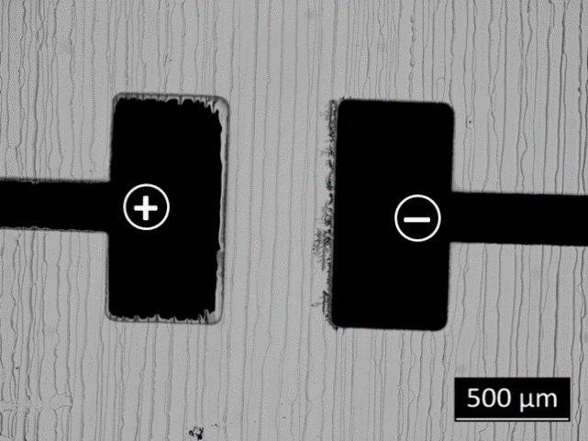

FIG. S1. Dendrite formation in PEDOT-free PSS (20 min, 20 V). The stripe pattern in the PSS is caused by the drying of the solution in 2-butanol.

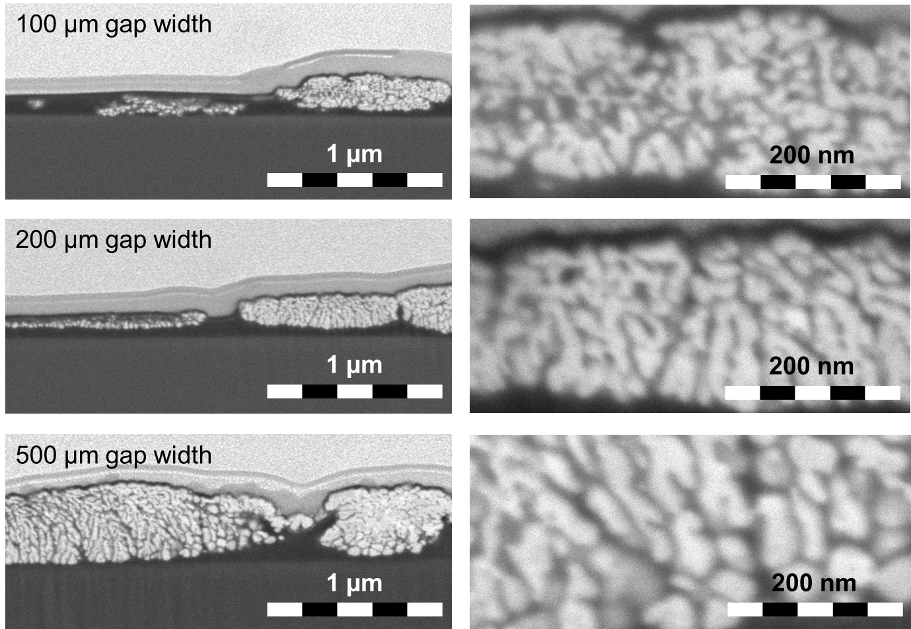

FIG. S2. Cross sectional SEM images obtained by FIB treatment of dendrites from different electrode gap sizes. The light grey top layer is a protection layer of evaporated platinum.

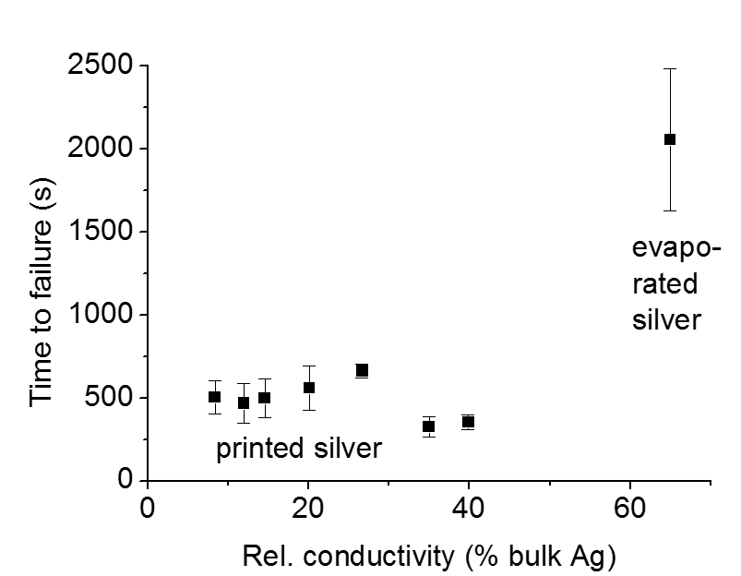

FIG. S3. Time-to-failure for printed and thermally sintered silver electrodes at 10 V as a function of their relative conductivities. (Note that the interelectrode gap for printed samples was around 400 µm due to ink spreading, whereas the evaporated sample had a gap width of 500 µm.)

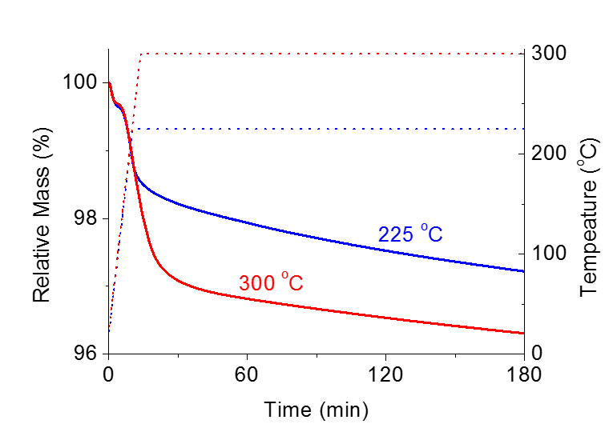
FIG. S4. TGA graphs of the solid contents of the used silver ink at two different temperatures.

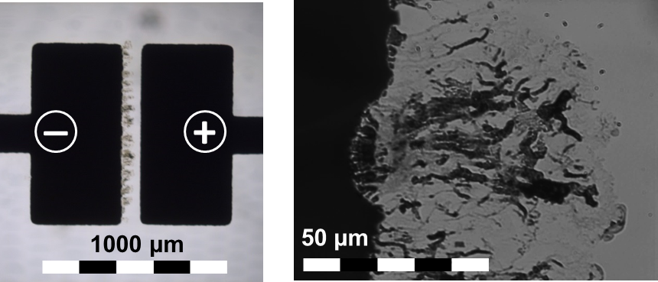

FIG. S5. Optical micrographs of dendrites formed between evaporated copper electrodes (distance 100 µm) after two days at 50 V.
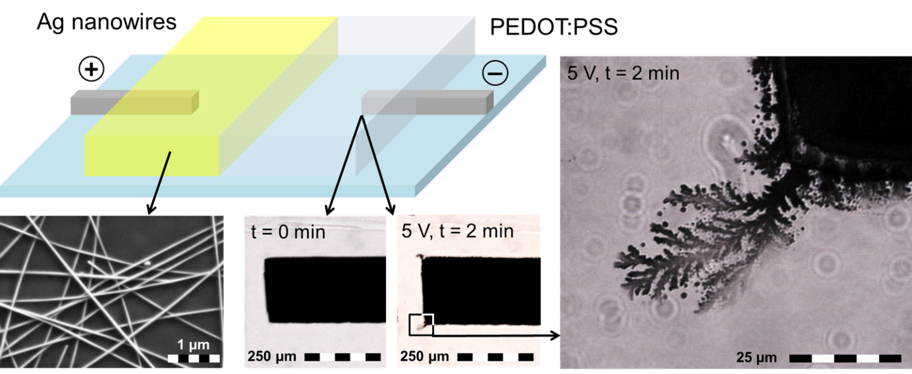

FIG. S6. Demonstration of metal electrochemical migration from silver nanowires: Schematic representation of the experimental setup (top), SEM image of the silver nanowire network (bottom left), optical micrograph of Pd cathode prior to and after current stress (bottom center), magnification of the silver dendrite formed after current stress (right).

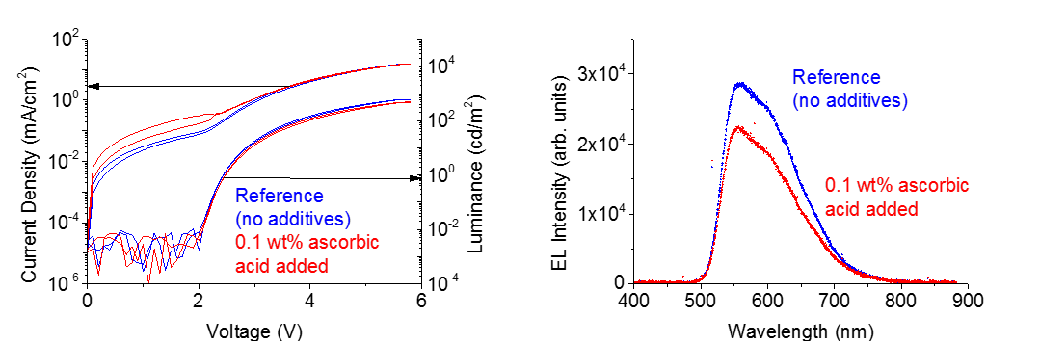

FIG. S7. IVL curves (left) and EL spectra (right) of OLEDs with and without the addition of ascorbic acid.
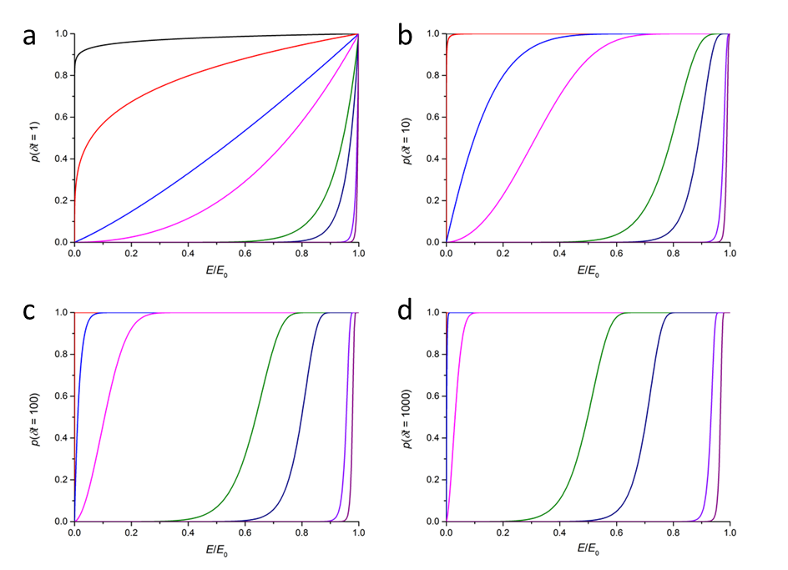
FIG. S8. Ionization probability plotted as a function of the normalized electric field. Probabilities are calculated using Equation (8) for the same arbitrary activation barrier (E_{a} = 1 · 10⁻¹⁹ J), but for different values of the dimensionless time step ((a) δt = 1, (b) δt = 10, (c) δt = 100, (d) δt = 1000) and exponent n (black to purple): n = 0.001, 0.01, 0.05, 0.1, 0.5, 1, 5, 10.

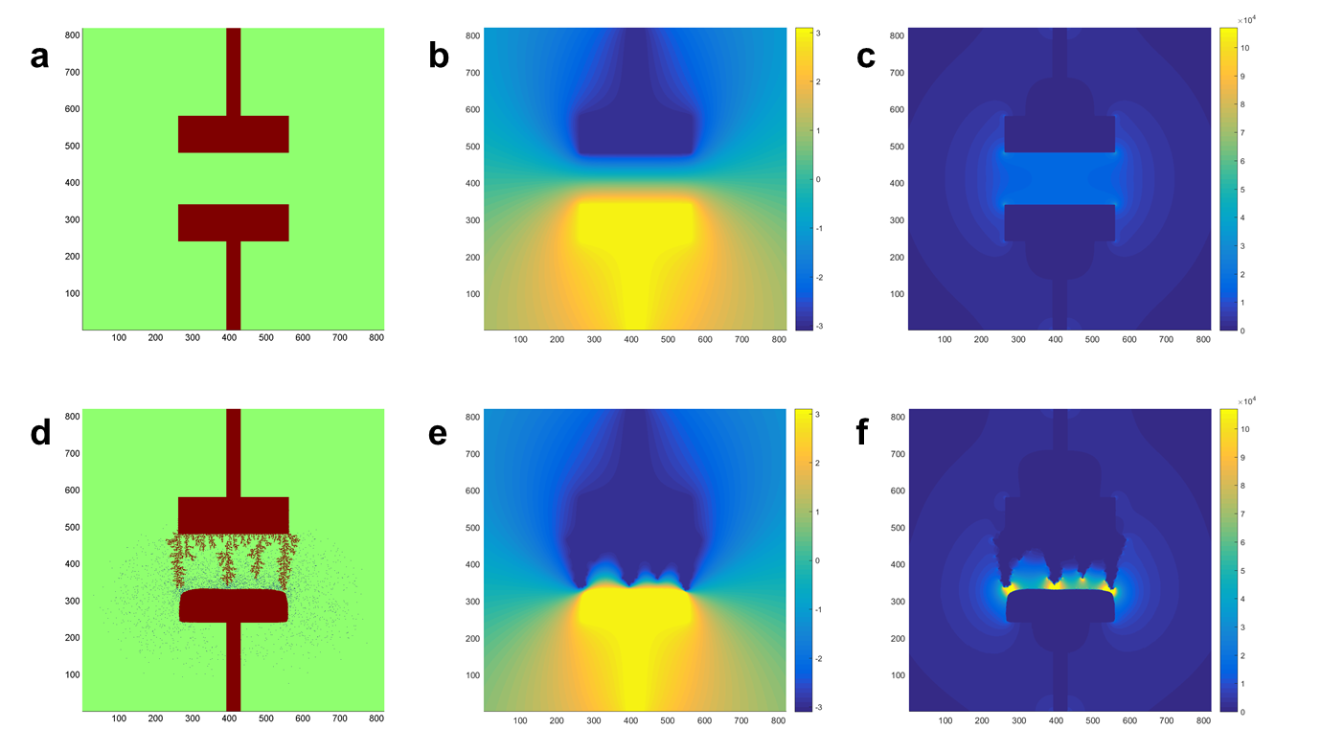
FIG. S9. Graphical representation of the simulated (a) initial (t = 0) electrode structure (top: cathode, bottom: anode), (b) voltage and (c) electric field, and after a deposition time just before the first dendrite reaches the anode (d,e,f). Zero-valent metal and cations are indicated in dark red and blue, respectively.

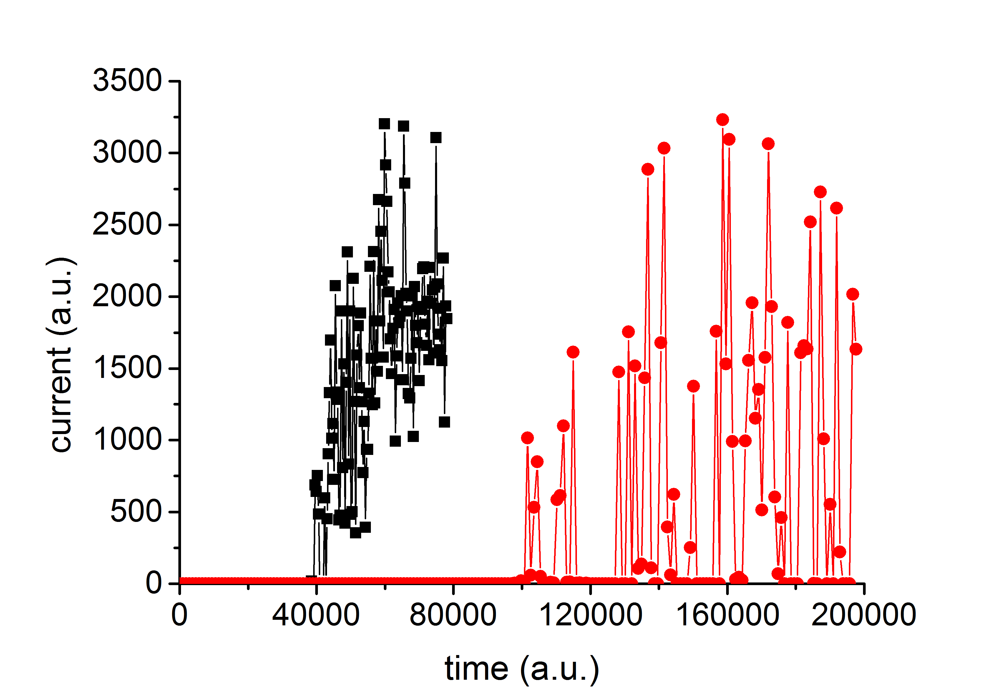
FIG. S10. Current plotted as a function of time during simulated electrodeposition and dendrite growth for electrode spacings of 94 (black) and 142 grid points (red).

Supplementary Tables

Table S1. Thermal sintering conditions applied to the printed electrodes and conductivities achieved.

Sample number | Temperature (ºC) | Time  (min) | Electrical Conductivity  (S/m) | Relative Conductivity  (% of bulk Ag value)
1 | 180 | 5 | 5.3 · 10⁶ | 8.4
2 | 180 | 15 | 7.6 · 10⁶ | 12.0
3 | 180 | 45 | 9.2 · 10⁶ | 14.6
4 | 180 | 120 | 12.6 · 10⁶ | 20.1
5 | 225 | 120 | 16.9 · 10⁶ | 26.7
6 | 300 | 120 | 22.0 · 10⁶ | 35.0
7 | 300 | 600 | 25.2 · 10⁶ | 39.9

Table S2. Effect of the addition of 0.1 wt% ascorbic acid to PEDOT:PSS on materials properties and OLED device performance parameters (J = 12.5 mA/cm²)

 | Pure PEDOT:PSS | 0.1 wt% ascorbic acid added
Film Thickness (nm) | 145 ± 10 | 165 ± 10
Transparency (%) | 89 ± 1 | 88 ± 1
Sheet resistance (10⁶ Ω/sq) | 60 ± 5 | 35 ± 5
Initial OLED luminance (cd/m²) | 325 ± 4 | 274 ± 5
Initial efficiency (cd/A) | 2.2 ± 0.1 | 2.0 ± 0.1
Initial driving voltage (V) | 4.76 ± 0.04 | 4.83 ± 0.06

Supplementary Movie Captions

Movie S1: Optical microscopic video file showing electrochemical metal migration and dendrite formation through an interelectrode gap of 100 micrometers width at 30 V (original speed).

Movie S2: Infrared microscopic video file showing local temperature variations during electrochemical metal migration through an interelectrode gap of 500 micrometers width at 30 V (movie accelerated to thirty times the original speed).
References

[S1] L. Greenspan: Humidity Fixed Points of Binary Saturated Aqueous Solutions. J. Res. Nat. Bur. Stand. A Phys. Chem. 81A, 89 (1977).
[S2] R. K. Gordon, S. H. Fook: A Finite Difference Approach that Employs an Asymptotic Boundary Condition on a Rectangular Outer Boundary for Modeling Two-Dimensional Transmission Line Structures. IEEE Trans. Microwave Theory Techn. 41, 1280 (1993).

We note here that in the model the size of an ion (one numerical grid cell) is relatively large in comparison to the size of the electrode (practically a couple of tens to a couple of hundreds of grid points). For this reason, it is not possible to give the mentioned “activation energy” a real physical interpretation.

