Supplementary Information
Mechanical Properties of APbX₃ (A=Cs or CH₃NH₃; X=I or Br) Perovskite Single Crystals
Yevgeny Rakita, Sidney R. Cohen* †, Nir Klein Kedem, Gary Hodes, David Cahen*

Materials and Interfaces Department and †Surface Science Laboratory (Chemical Research Support),
Weizmann Institute of Science, Rehovot. 76100, Israel

* corresponding authors: sidney.cohen@weizmann.ac.il ; david.cahen@weizmann.ac.il

Figure S1: Characteristic Load vs. Displacement curves of APbX₃ crystals. The number in the round parenthesis indicates the crystallographic plane facing the indenter.
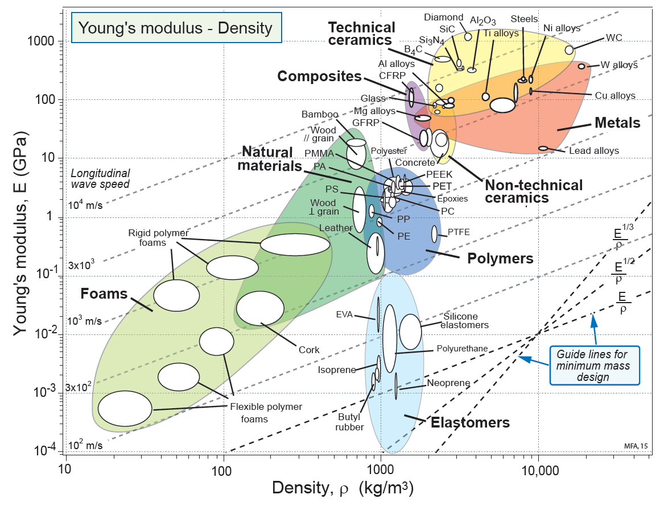
Lead alloys

Figure S2: Ashby 2D map: density vs. Young’s modulus. Experimentally derived values (from this work or other cited works – see Table 1) are added in the area, designated “ABX₃” to which the arrow points: Red - CH₃NH₃PbBr; Black - CH₃NH₃PbI₃; Yellow - CH₃NH₃SnI₃; Orange - CsPbBr₃; Green - CsPbI₃; Magenta – PbI₂ ; Blue – PbBr₂. Reprinted with permission from Ashby, M. F. Materials Selection in Mechanical Design, Fourth Edition. (Elsevier/ Butterworth-Heinemann, Amsterdam, 2011).

Figure S3: Ashby 2D map: linear thermal expansion coefficient vs. Young’s modulus. Experimentally derived values (from this work or other cited works – see Table 1) are added in the area, designated “ABX₃” to which the arrow points: Red - CH₃NH₃PbBr; Black - CH₃NH₃PbI₃; Orange - CsPbBr₃; Magenta – PbI₂; Blue – PbBr_{2.} Reprinted with permission from Ashby, M. F. Materials Selection in Mechanical Design, Fourth Edition. (Elsevier/ Butterworth-Heinemann, Amsterdam, 2011).

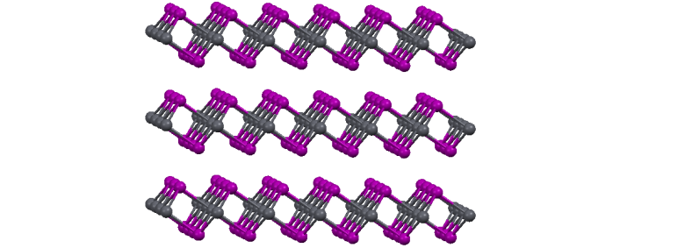
Weak I-I VdW
strong I-Pb
(mostly) ionic bond
00
c axis
c(0001) plane
PbI₂

CH₃NH₃PbI₃
c
a
b
c
a
I
Pb
C
b
N

Figure S4: Ball-and-stick crystal structure representation of (top) PbI₂ and (bottom) CH₃NH₃PbI₃, illustrating the close relation between the Pb-I in the c(0001) plane and in CH₃NH₃PbI_{3.}

Table S1: Values for Figure 3.

 | B-X bond distance (@ RT) [Å] | K [GPa]
CH₃NH₃PbI₃ | 3.16 | 12.2
CH₃NH₃PbBr₃ | 2.97 | 15.6
CH₃NH₃PbCl₃  CH₃NH₃SnI₃ | 2.86  3.13 | 16.5 *  12.6
CsPbI₃ | 3.23 | 19.8
CsPbBr₃ | 2.96 | 15.5
MgSiO₃ | 1.64 | 264
SrTiO₃ | 1.95 | 183
GdMnO₃ | 2.03 | 190
PbBr₂ | 3.14 | 23.5
c-plane PbI₂ | 3.23 | 16.7

* the bulk modulus of CH₃NH₃PbCl₃ was estimated using the measured Young’s modulus of the (100) plane from Ref. 19 (see below), 19.8 GPa, and assuming a Poisson ratio of 0.3.

_______________
Ref.19: Sun, S., Fang, Y., Kieslich, G., White, T. J. & Cheetham, A. K. Mechanical properties of organic–inorganic halide perovskites, CH3NH3PbX3 (X = I, Br and Cl), by nanoindentation. J. Mater. Chem. A, . 6, 2622–2628 (2015). doi:10.1039/C5TA03331D

