Supporting Information

Electrochemical characterization of the reagent containing layer.
A working glassy carbon electrode was coated with the sol-gel electrolyte, and the measurements were performed versus Ag/AgCl reference electrode. We used the ferrocene-modified chitosan, with and without the sol-gel matrix. We did not see significant changes in the response of the sensor, except that we noticed a delamination of the chitosan layer without sol-gel matrix. To validate the wiring of the mediator and the enzyme with the working electrode, Cyclic Voltammetry (CV) was performed. Figure S1.a shows the reversible peak of ferrocene binding to the chitosan. Upon addition of 25 mM of glucose in solution, a catalytic current appears (Figure S1.a solid line), proof of the effective wiring between the ferrocene and the enzyme. We noticed no change in the capacitive behavior of the layer and in the half-wave potential, which provides evidence for the fact that there is no change in the electrolyte layer. Figure S1.b depicts stationary currents at 400 mV after successive addition of 100 µL glucose solution at 250 mM in an initial volume of 15 mL PBS. The first two peaks at 425 s and 525 s are control injections of PBS. A last injection of PBS is performed in the end of the test, with no big impact on the current compared to glucose addition.

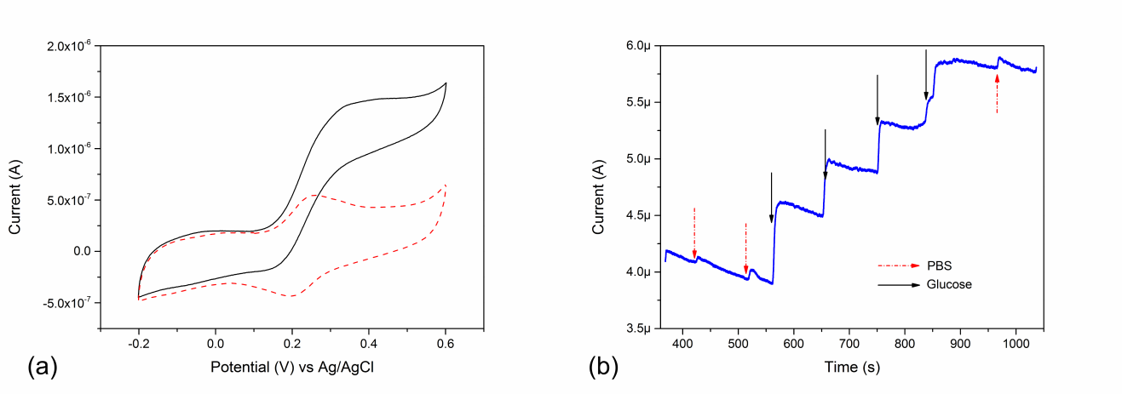
Figure S1. a) Cyclic voltammograms of the ferrocene-branched chitosan on glassy carbon electrode before (dashed line) and after addition of 25 mM glucose (solid line) vs Ag/AgCl reference electrode in PBS. b) Chronoamperograms obtained at +0.4V with the ferrocene branched chitosan with successive addition of 100 µL glucose at 250 mM in 15 mL PBS.

