Supplementary Information
Structural origins of enhanced capacity retention in novel copolymerized sulfur - based composite cathodes for high-energy density Li-S batteries

Vladimir P. Oleshko,^{†ǂ} Jenny Kim,† Jennifer L. Schaefer,† Steven Hudson†, Christopher L. Soles,† Adam G. Simmonds¥,, Jared J. Griebel¥, ‡ Richard S. Glass,¥, Kookheon Char‡, Jeffrey Pyun¥‡

†Materials Science & Engineering Division, Materials Measurement Laboratory, National Institute of Standards and Technology, Gaithersburg, MD 20899, USA
¥Department of Chemistry and Biochemistry, University of Arizona, Tucson, AZ 8721, USA
‡Department of Chemical and Biological Engineering, The World Class University Program of Chemical Convergence for Energy & Environment, The National CRI Center for Intelligent Hybrids, and Center for Nanoparticle Research, Institute for Basic Research, Seoul National University, Seoul 151-744, Korea
^{ǂ}Department of Materials Science and Engineering, University of Maryland, College Park, MD 20742, USA

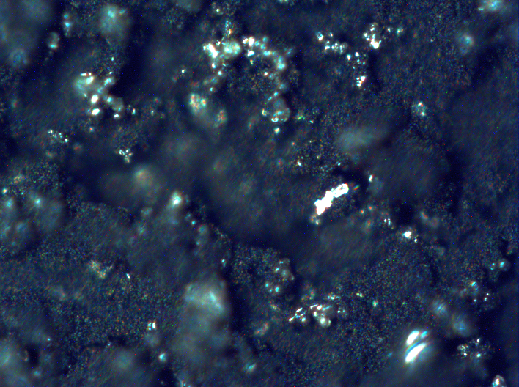
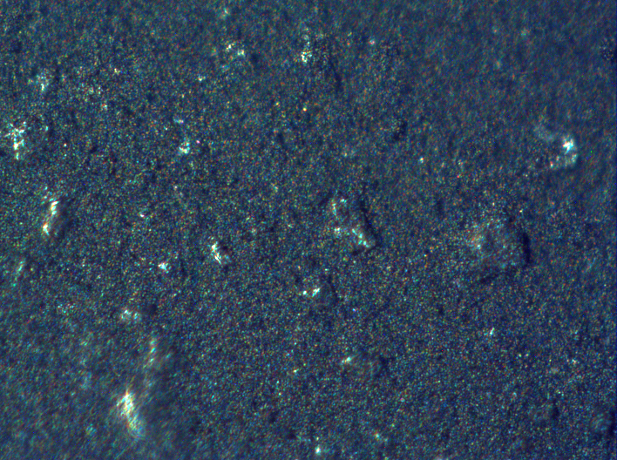
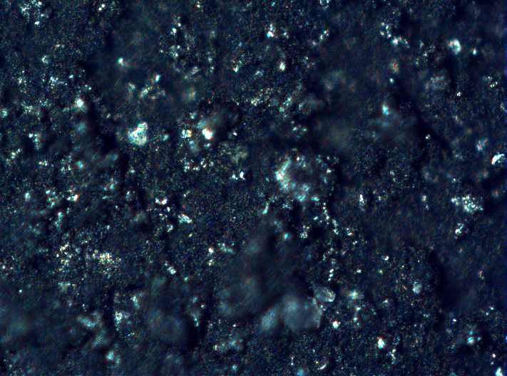
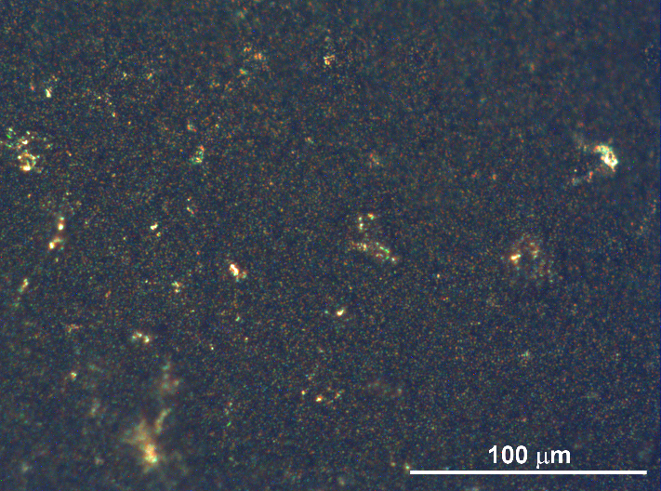
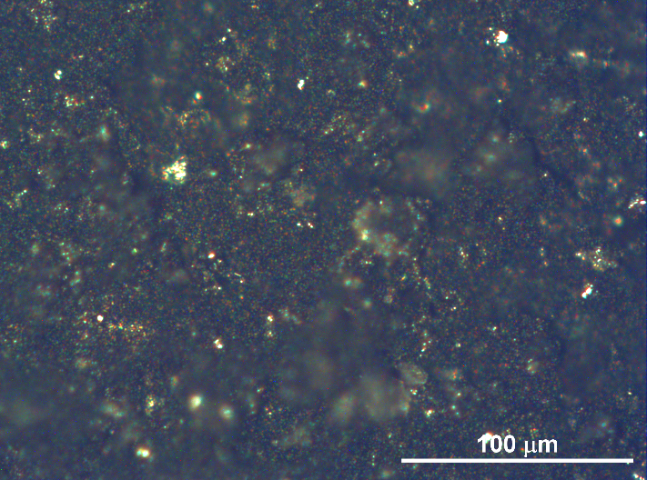
- Light microscopy (LM) of pristine composite cathodes
(a1)
(a2)

(b1)
(b2)
crack

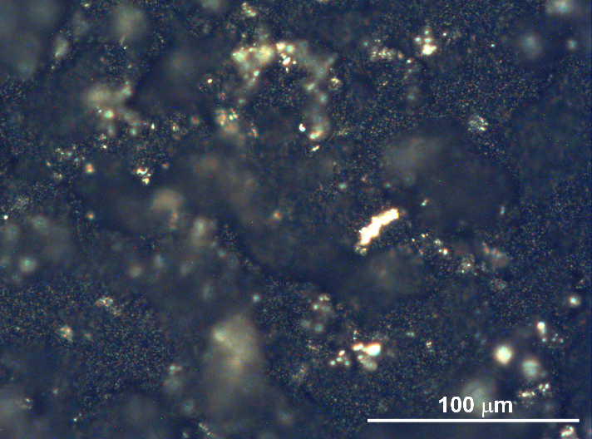
(c1)
(c2)

cracks

Figure 1S. Plane view color LM images of surfaces of the pristine composite cathodes obtained in reflection mode at working magnification of x200 under bright field illumination (left column) and under dark field illumination (right column) from the same areas: (a1, a2) the poly(S-r-DIB_{50 %} copolymer-based cathode; (b1, b2) the poly(S-r-DIB_{10 %}) copolymer-based cathode, and (c1, c2) the conventional S₈ - carbon cathode, respectively. Note that the poly(S-r-DIB) copolymer particles are red-orange, sulfur microparticles are yellow, and C65 carbons are black. An OLYMPUS BX60M light microscope equipped with an OptiCam Summit v.5.0 USB color digital camera was used to record the images. Some rough surface regions in images b1-b2 and c1-c2 are out of focus because of the limited focus depth of a light microscope. For comparison with FESEM data, see low-magnification secondary electron images in Figure 2a-c.
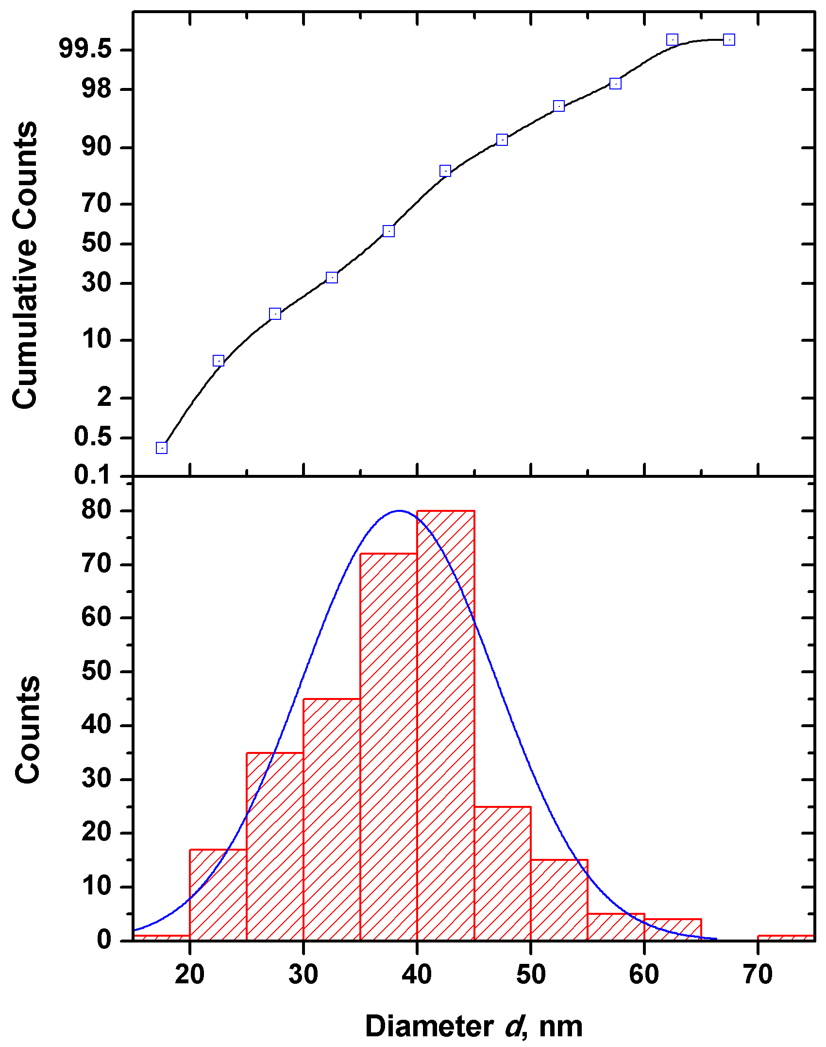
- Size distributions of C65 carbon particles

(a)
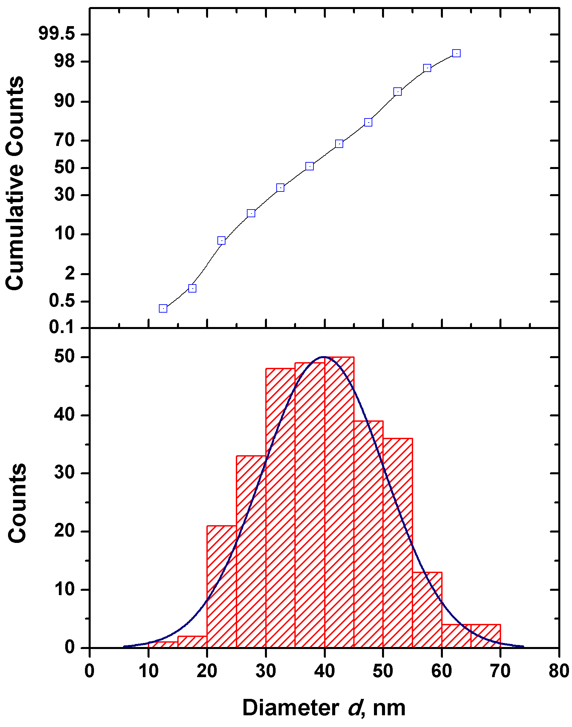
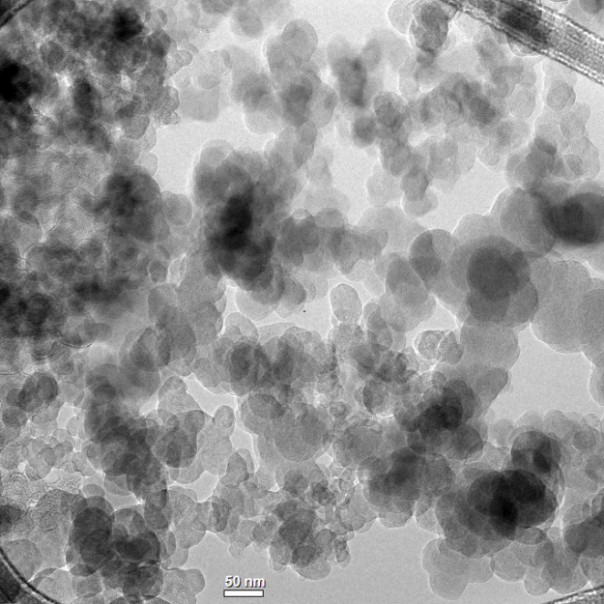

(b)
(c)
Figure 2S. Cumulative (top) and differential (bottom) histograms on diameter distribution of C65 carbon particles, d, 300 counts: (a) the size distribution obtained by counting of C65 particles from the BF-TEM image of a thin cross-section of the poly(S-r-DIB_{50%}) copolymer-based cathode in Figure 4a1, d = 38.4 ± 1.0 nm; (b) BF-TEM image of pristine C65 carbon particles deposited onto a lacey carbon film; (c) the C65 particle size distribution obtained from the BF-TEM micrograph in (b), d = 39.8 ± 1.2 nm. Blue curves in differential histograms (a) and (c) correspond to the normal curve.

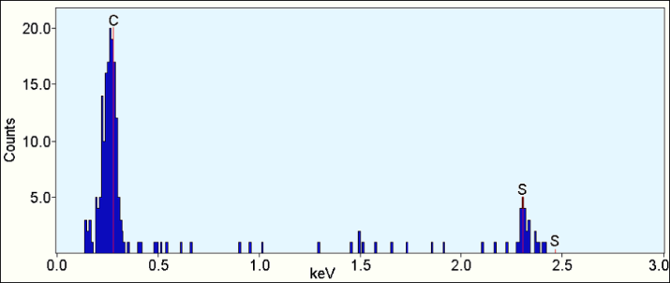
- Spatially - correlative AEM of poly(S-r-DIB) copolymer-based composite cathodes
(a)

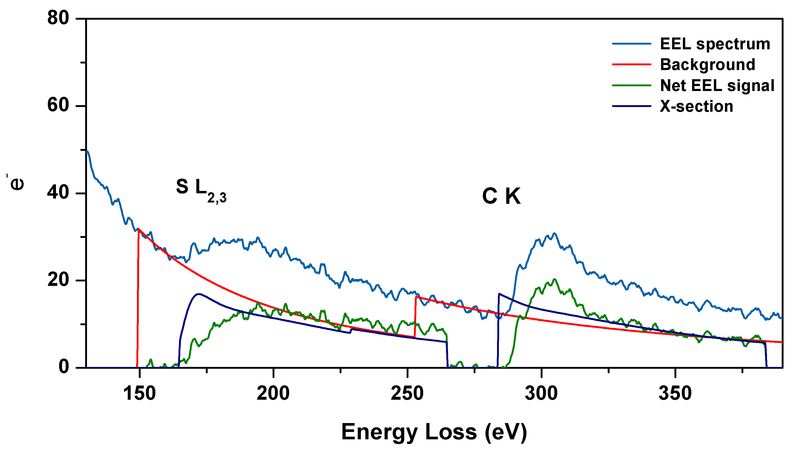
(b)

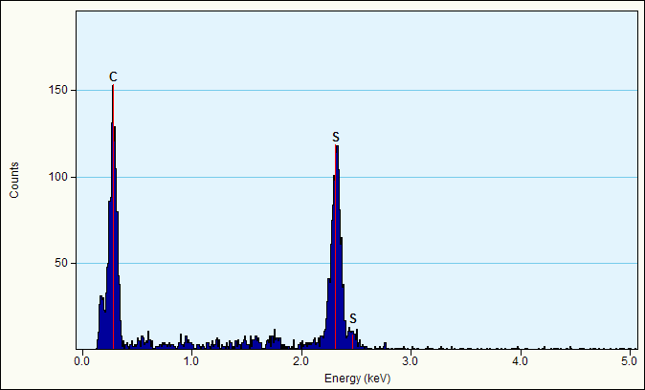
(c)

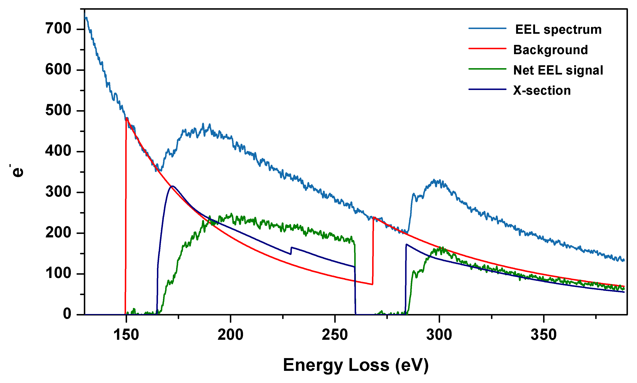

(d)

Figure 3S. (a-b)The poly(S-r-DIB_{50 %} ) copolymer–based cathode, X-ray spectrum acquired in the point marked by red cross in Figs. 5b and 5c; (b) EEL spectrum (blue line) exhibiting the SL_{2,3}-edge at 165 eV and the CK-edge at 284 eV from the same point. (c-d) The poly(S-r-DIB_{10 %}) copolymer–based cathode, X-ray spectrum acquired in the point 1 marked by red cross in Fig. 5f and black line in Fig. 5g, respectively; (d) EEL spectrum (blue line) exhibiting the SL_{2,3}-edge at 165 eV and the CK-edge at 284 eV from the same point. The net SL_{2,3}- and CK-edges obtained by subtracting a power-law fitted background (red lines) are shown in green. Navy lines denote Hartree-Slater ionization cross-sections calculated for both edges. ³⁹
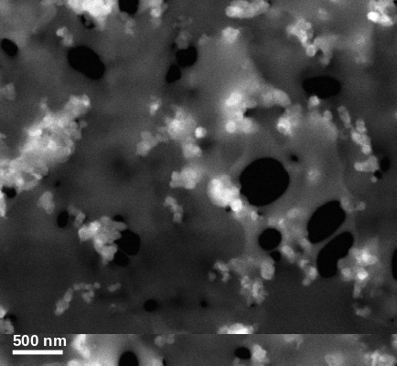
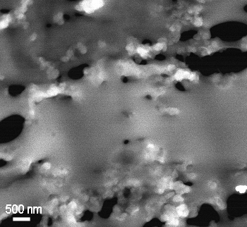
- STEM-EELS of composite poly(S-r-DIB) copolymer –carbon cathodes
12
23
(a)
Poly(S-r-DIB_{50-wt.%})
C65
3
4
(b)
C65
Poly(S-r-DIB_{10-wt.%})

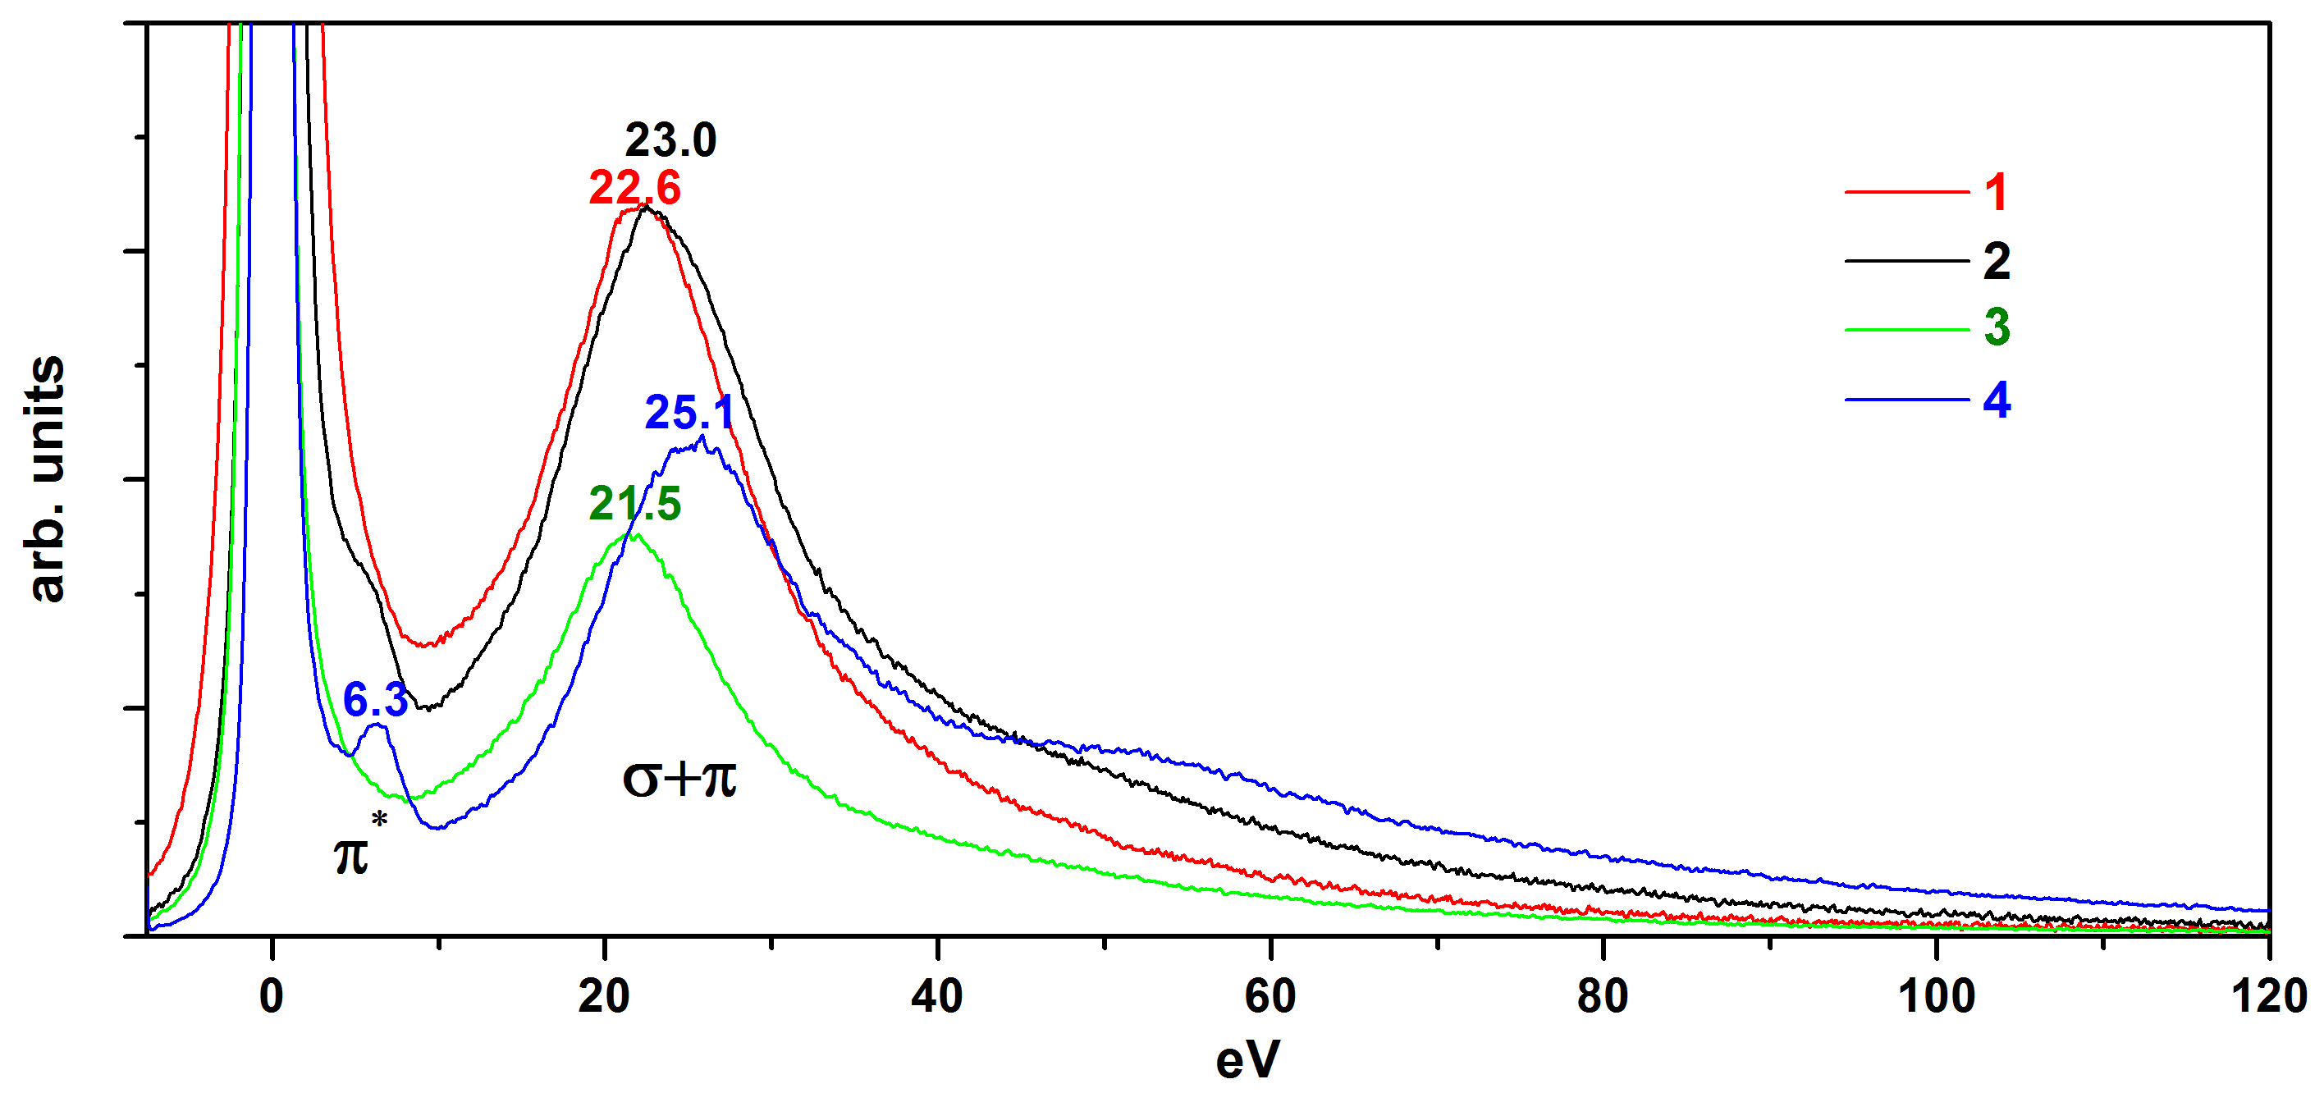

(c)

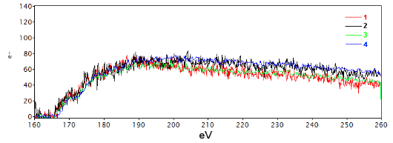
S L_{2,3}

(d)
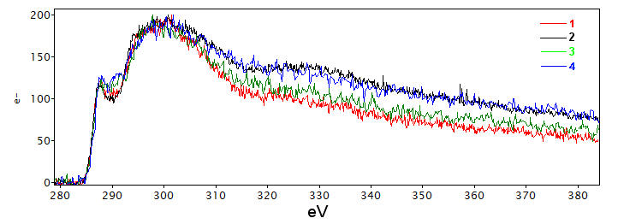

C K
1s → σ*
sp³

1s → π*
sp²
(e)

Figure 4S. HAADF STEM images (a, b), low-loss EEL spectra (c) and core-loss EEL spectra (d, e) of an ultrathin cross section of the poly(S-r-DIB_{50 %}) copolymer-based composite cathode at points 1 (red), and 2 (blue) and of the poly(S-r-DIB_{10 %}) copolymer-based composite cathode in points 3 (green) and 4 (blue). Figure (d) shows the delayed net S L_{2,3}-edge for the same locations as in Figures (a) and (b). Figure (e) shows the net C K-edge indicating mixed sp²/sp³ bonding in the poly(S-r-DIB) copolymers and C65 carbon particles. The spectral intensities in the EEL spectra of Figures (d) and (e) are aligned by maximum for convenience.
- DC conductivity of conventional S₈ cathode, poly(S-r-DIB_{50 %}) copolymer-based cathode, and poly(S-r-DIB_{10 %}) copolymer–based cathode
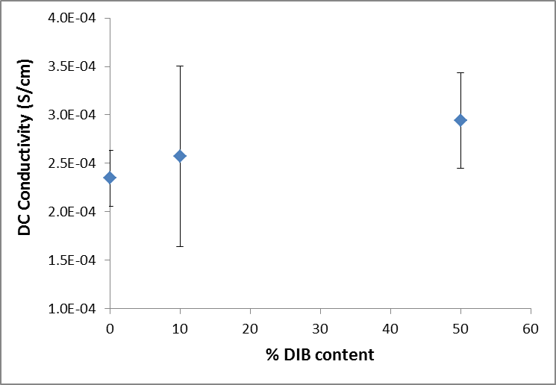
Figure 5S. Through-plane DC conductivity of the carbon-containing layers (primer + active) of the pristine cathode sheets

Electrical conductivity of the coated cathode sheets at room temperature was measured using impedance spectroscopy with an applied AC potential of 10 mV with a Novocontrol Broadband Dielectric Spectrometer. The thickness used to compute the conductivity was the thickness of the total carbon layer, including both primer and active layers. The values displayed are the average and standard deviation of a minimum of 14 measurements at each cathode composition. The large error bars are expected to be due to local variations in both coating thickness and composition across the cathode sheet. The conductivity of the cathode sheet increases with increasing DIB content in the sulfur containing phase, though this result is within the error bars of the measurement.

