SUPPORTING INFORMATION

Continuous and Patterned Deposition of Functional Block Copolymer Thin Films Using Electrospray
Hanqiong Hu¹, Kristof Toth¹, Myungwoong Kim², Padma Gopalan³, Chinedum O. Osuji^{1*}
¹Department of Chemical and Environnemental Engineering, Yale University, New Haven, Connecticut 06511
²Department of Chemistry, Inha University, Incheon 402-751, Republic of Korea
³Department of Materials Science and Engineering, University of Wisconsin, Madison, Wisconsin 53706

KEYWORDS: Spray deposition; Polymer; Self-assembly;

Corresponding author: Chinedum Osuji (chinedum.osuji@yale.edu)

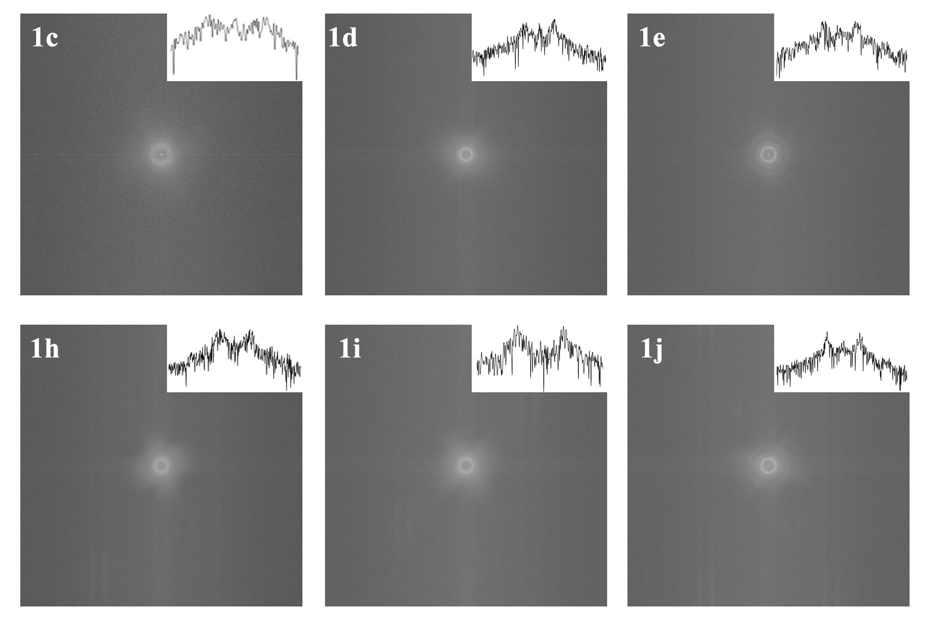
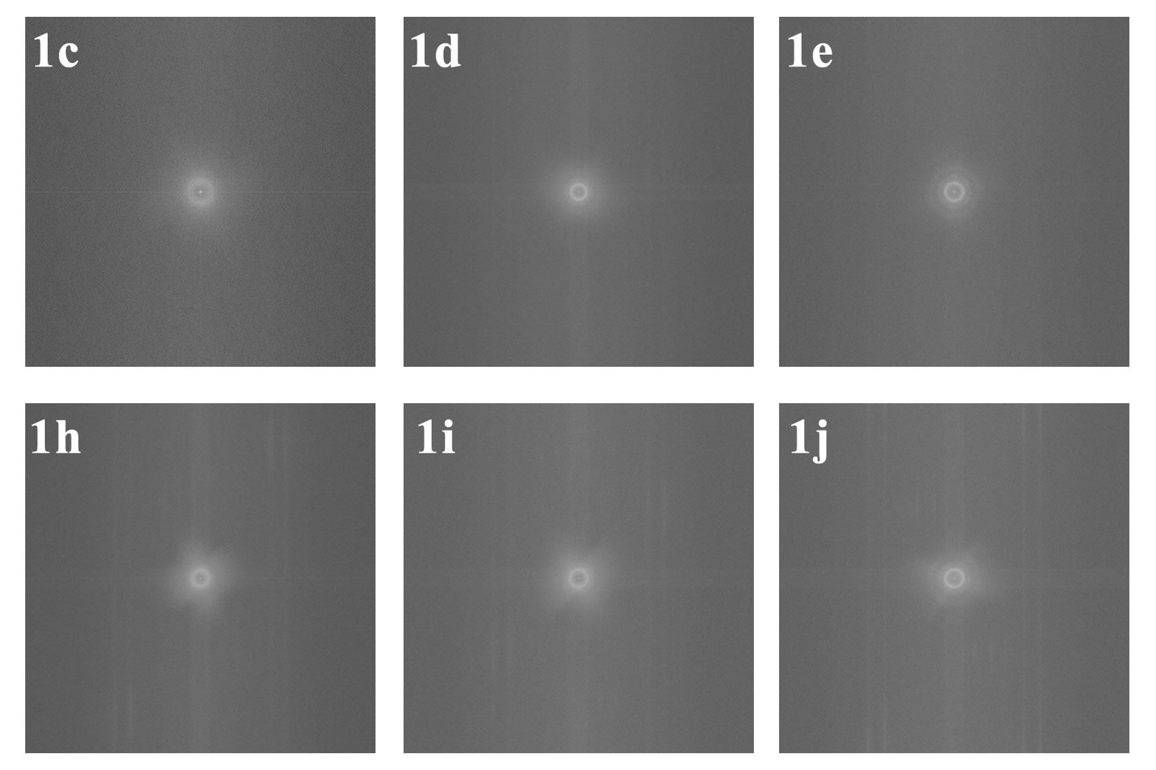
Figure SI 1. Fast Fourier transform (FFT) of SEM images in Figure 1. The insets are the line profiles of intensity across the center of the FFT images.
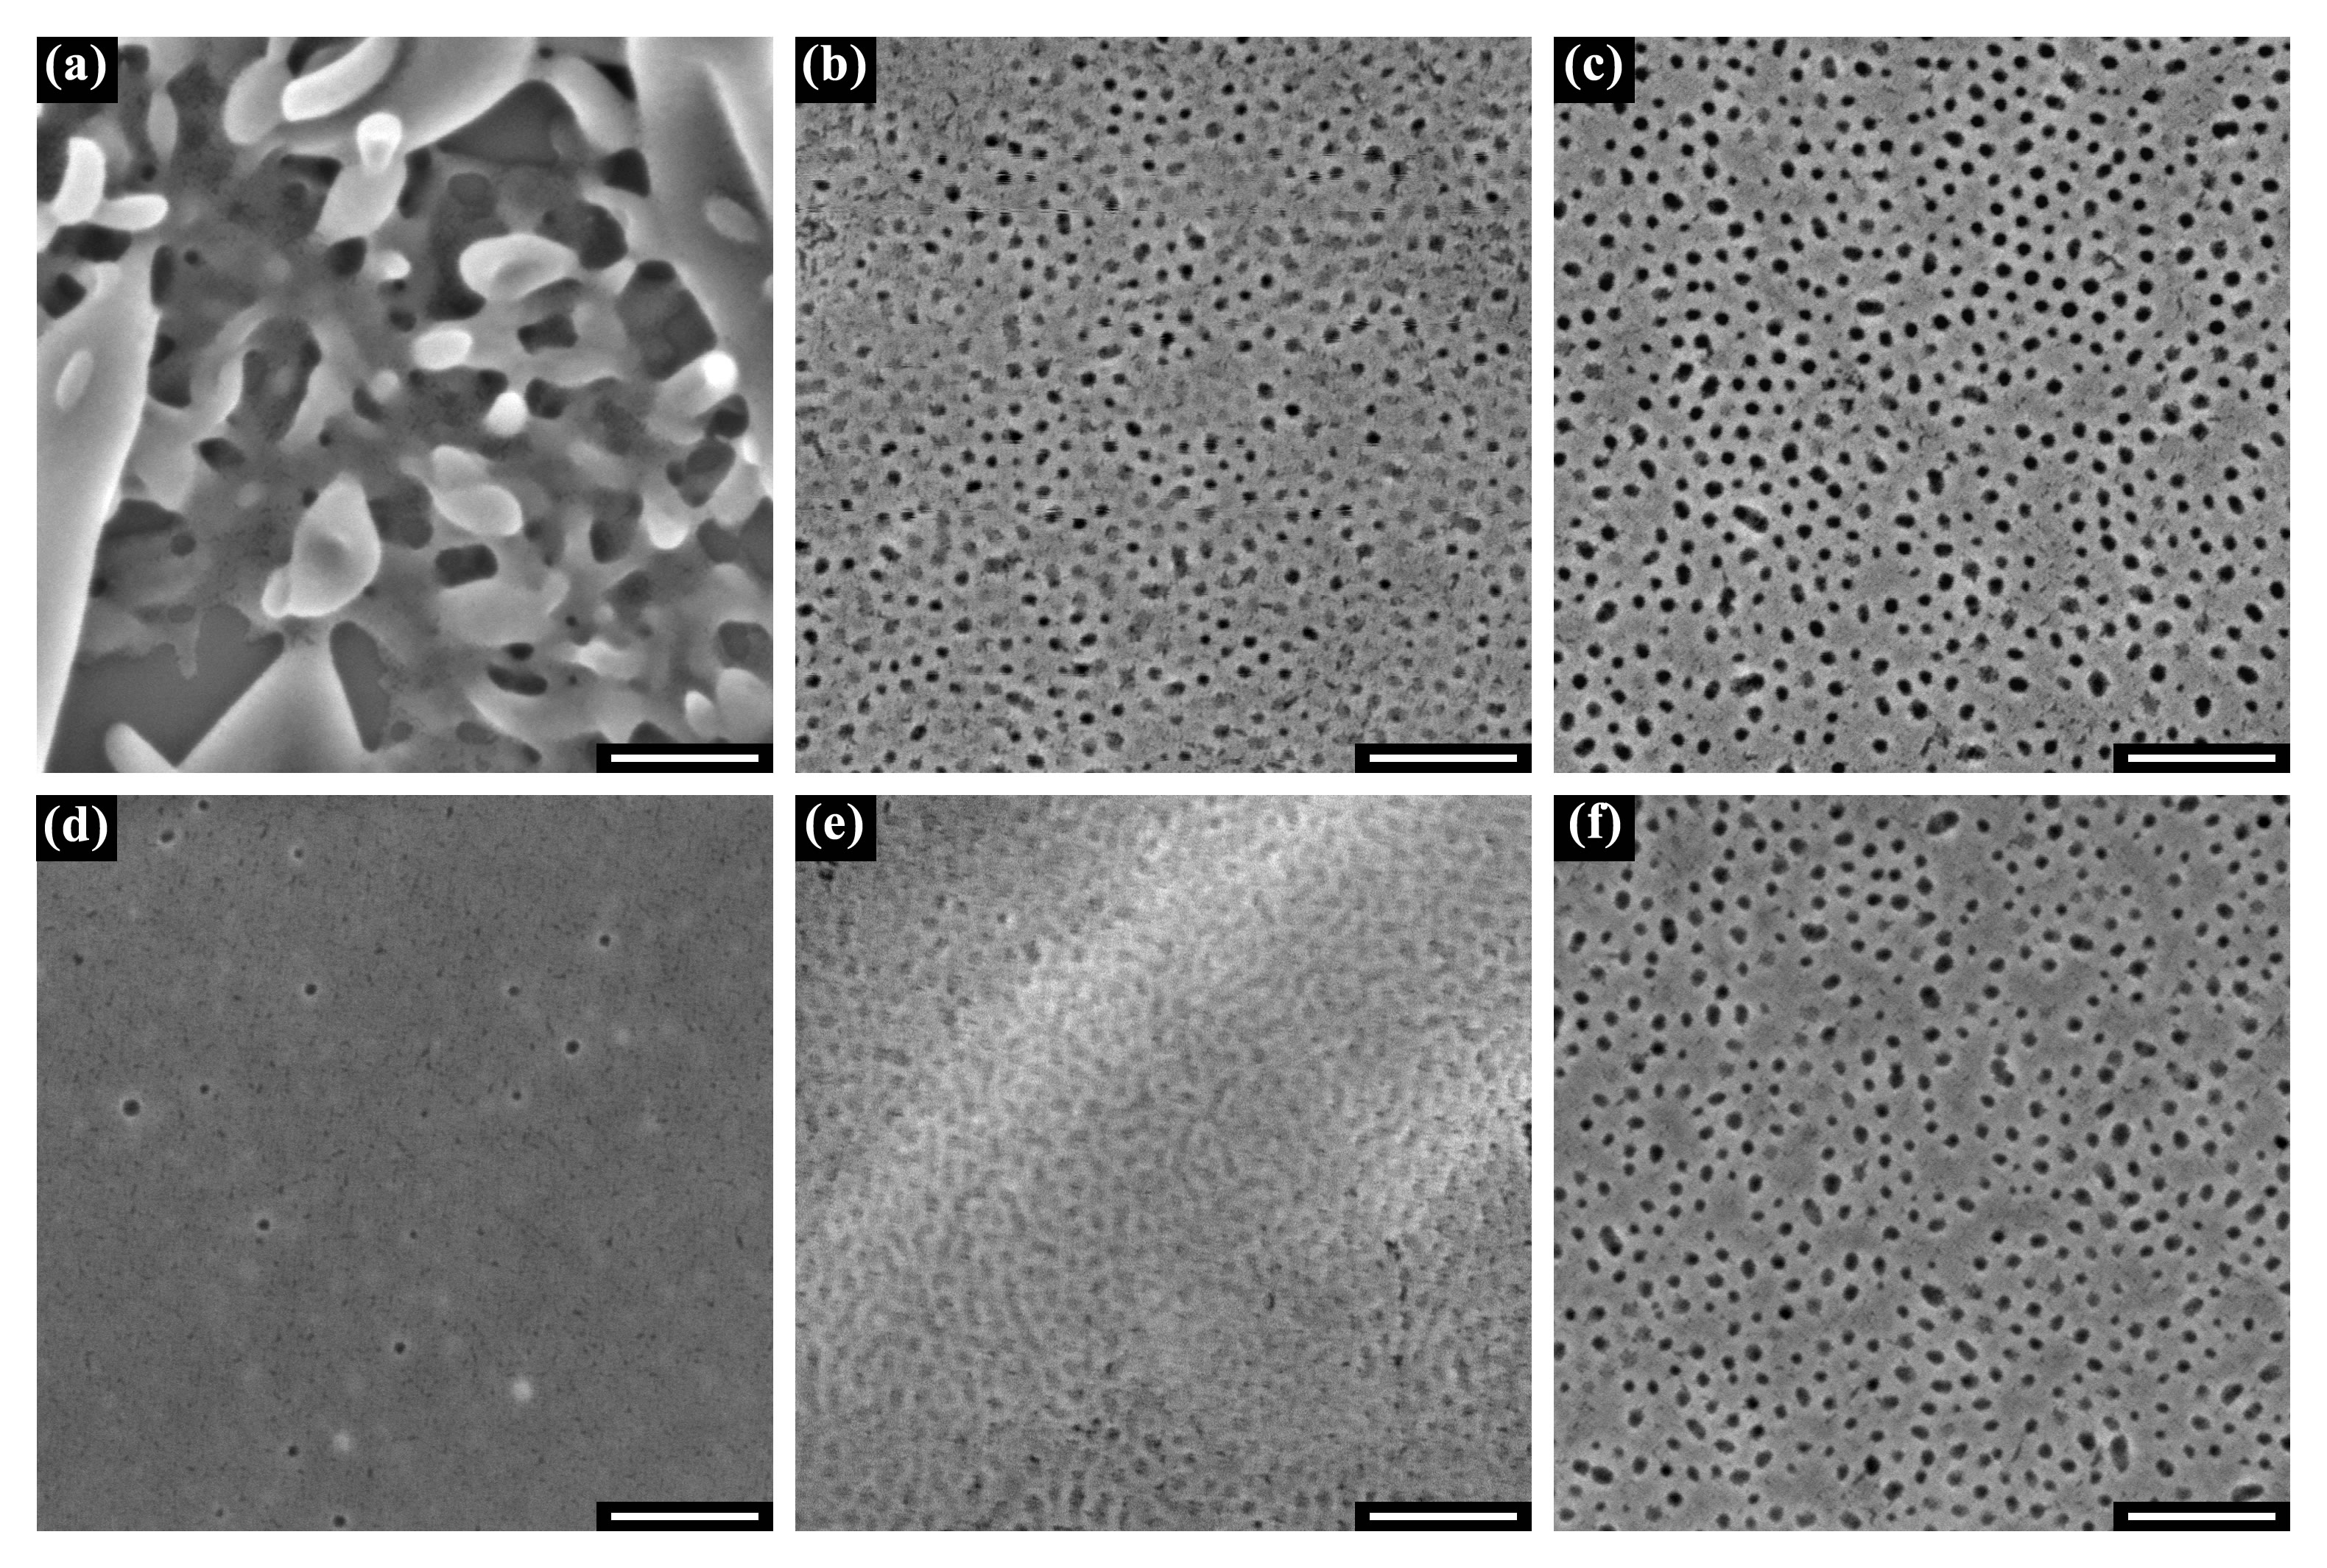
Figure SI 2. Top-down SEM images of electrosprayed PS-b-PMMA thin film from CHCl₃ & acetone (volume ratio 8:2) solution onto preferential substrates at low flow rate 3 μL/min (a, b, c) and high flow rate 16 μL/min (d, e, f) at a substrate temperature of (a, d) 105 °C, (b, e) 150 °C and (c, f) 195 °C. Scale bar: 200nm.
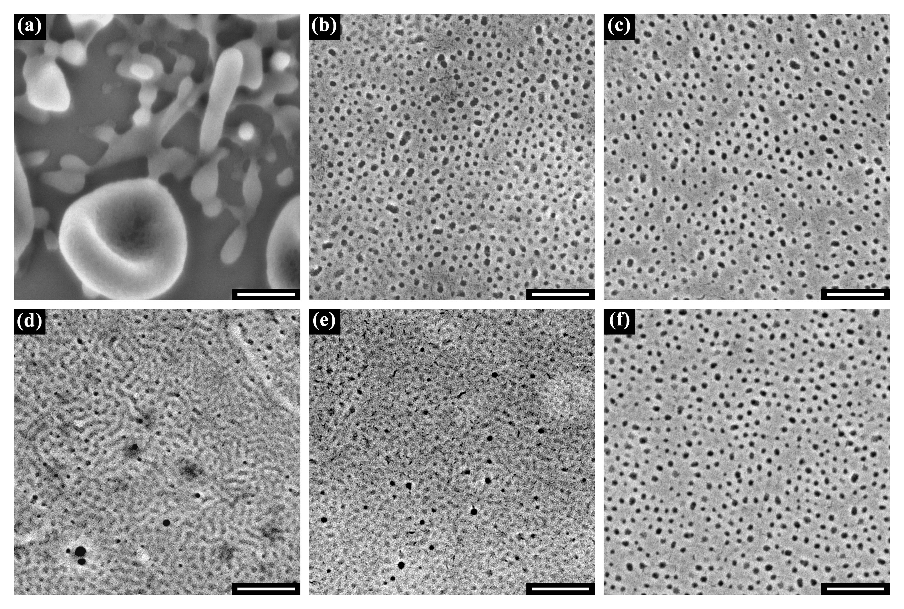
Figure SI 3. Top-down SEM images of electrosprayed PS-b-PMMA thin film from THF & acetone (volume ratio 8:2) solution onto preferential substrates at low flow rate 4 μL/min (a, b, c) and high flow rate 16 μL/min (d, e, f) at a substrate temperature of (a, d) 105 °C, (b, e) 150 °C and (c, f) 195 °C. Scale bar: 200nm.

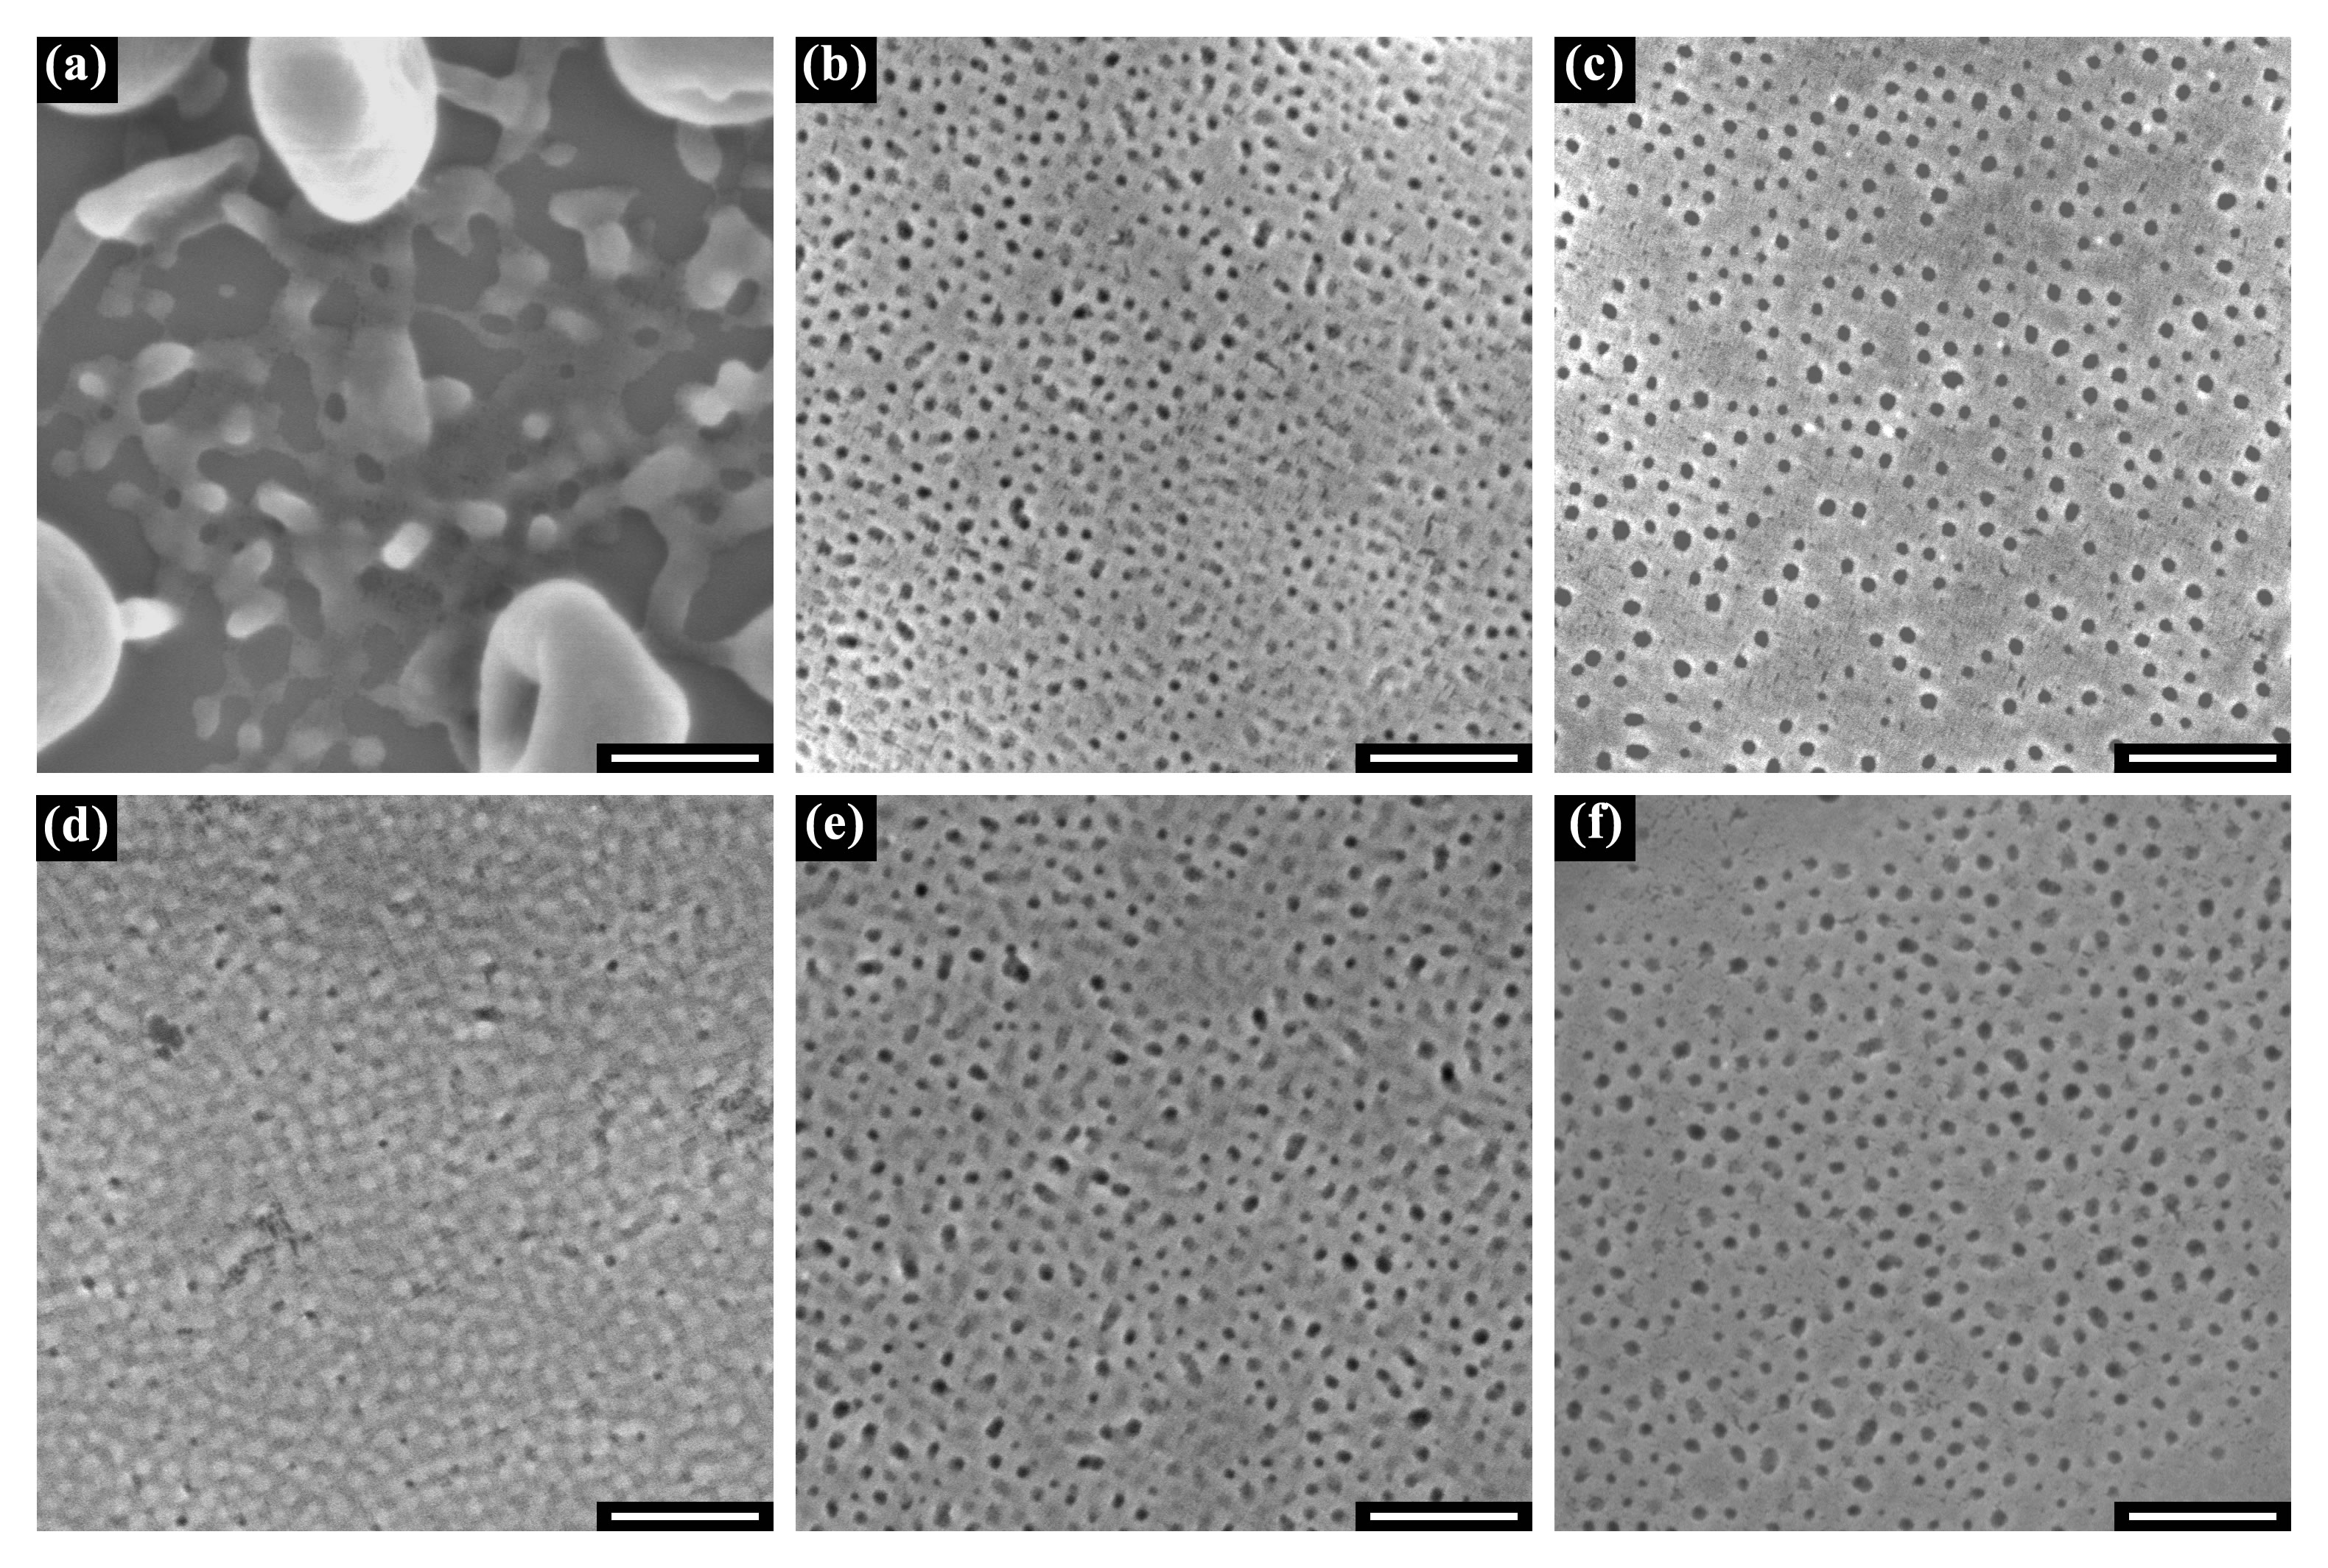
Figure SI 4. Top-down SEM images of electrosprayed PS-b-PMMA thin film from THF & acetic acid (volume ratio 9:1) solution onto preferential substrates at low flow rate 4 μL/min (a, b, c) and high flow rate 16 μL/min (d, e, f) at a substrate temperature of (a, d) 105 °C, (b, e) 150 °C and (c, f) 195 °C. Scale bar: 200nm.

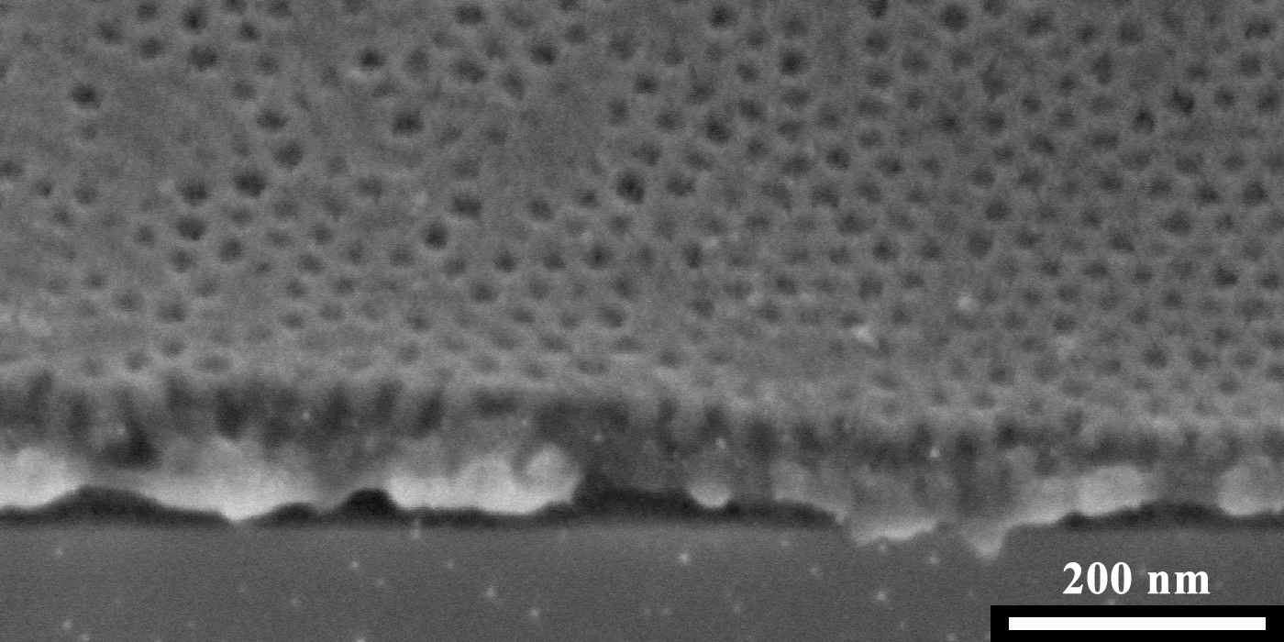
Figure SI 5. Tilted SEM view of PS-b-PMMA sprayed onto preferential substrate showing that perpendicular orientation of PMMA cylinders on the top surface does not propagate all the way to the bottom of the film.

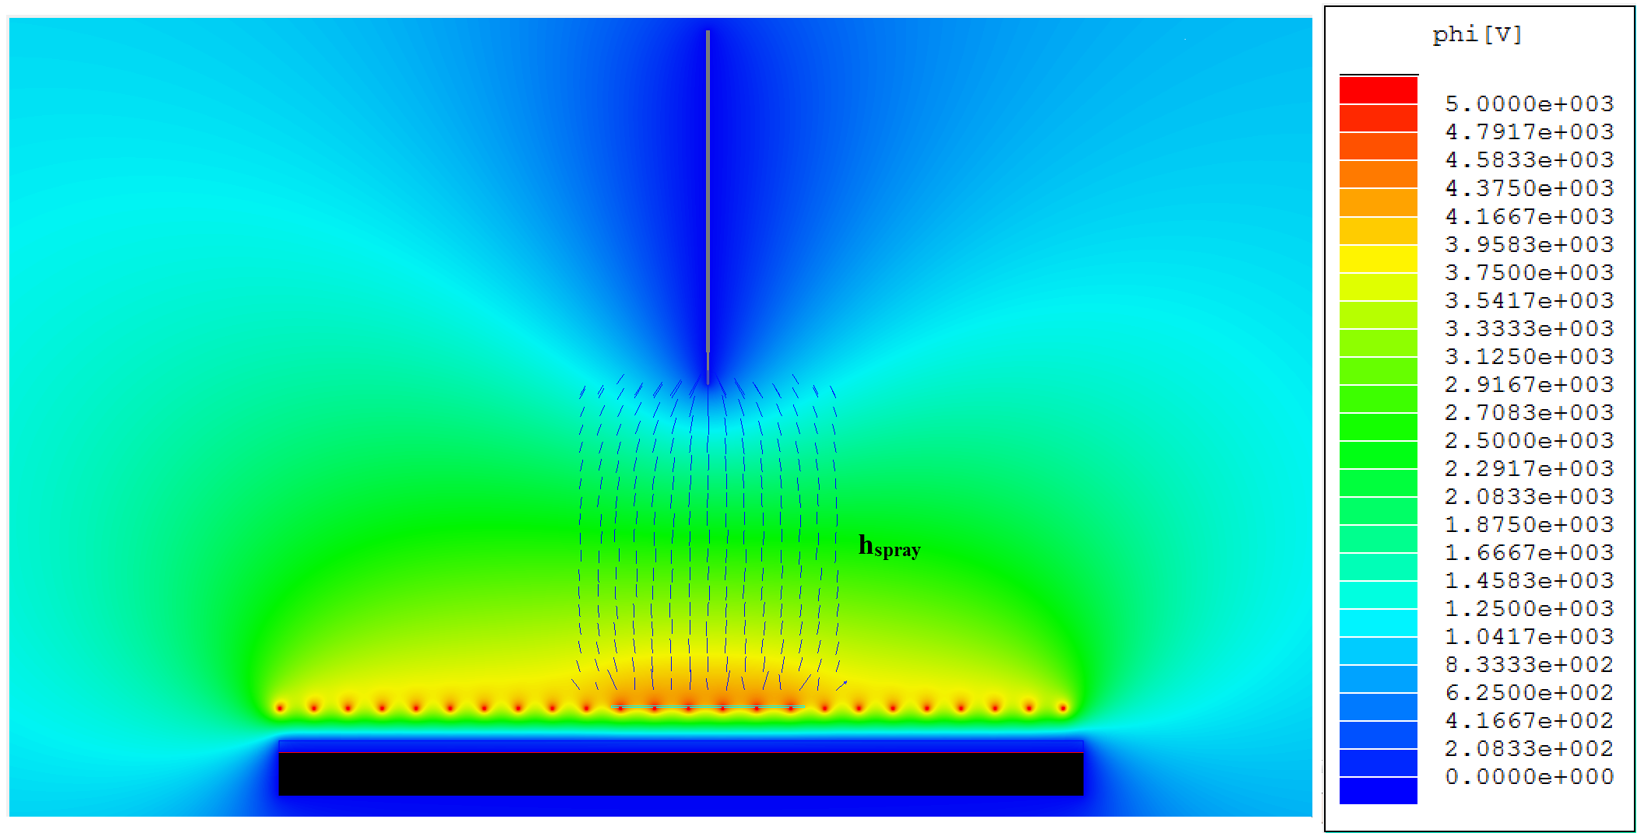
Figure SI 6. Simulated electric potential plot in “positive” pattern deposition process showing electric field lines in selected region of interest. Distance from needle to deposition area, h_{spray}, is 0.03m.
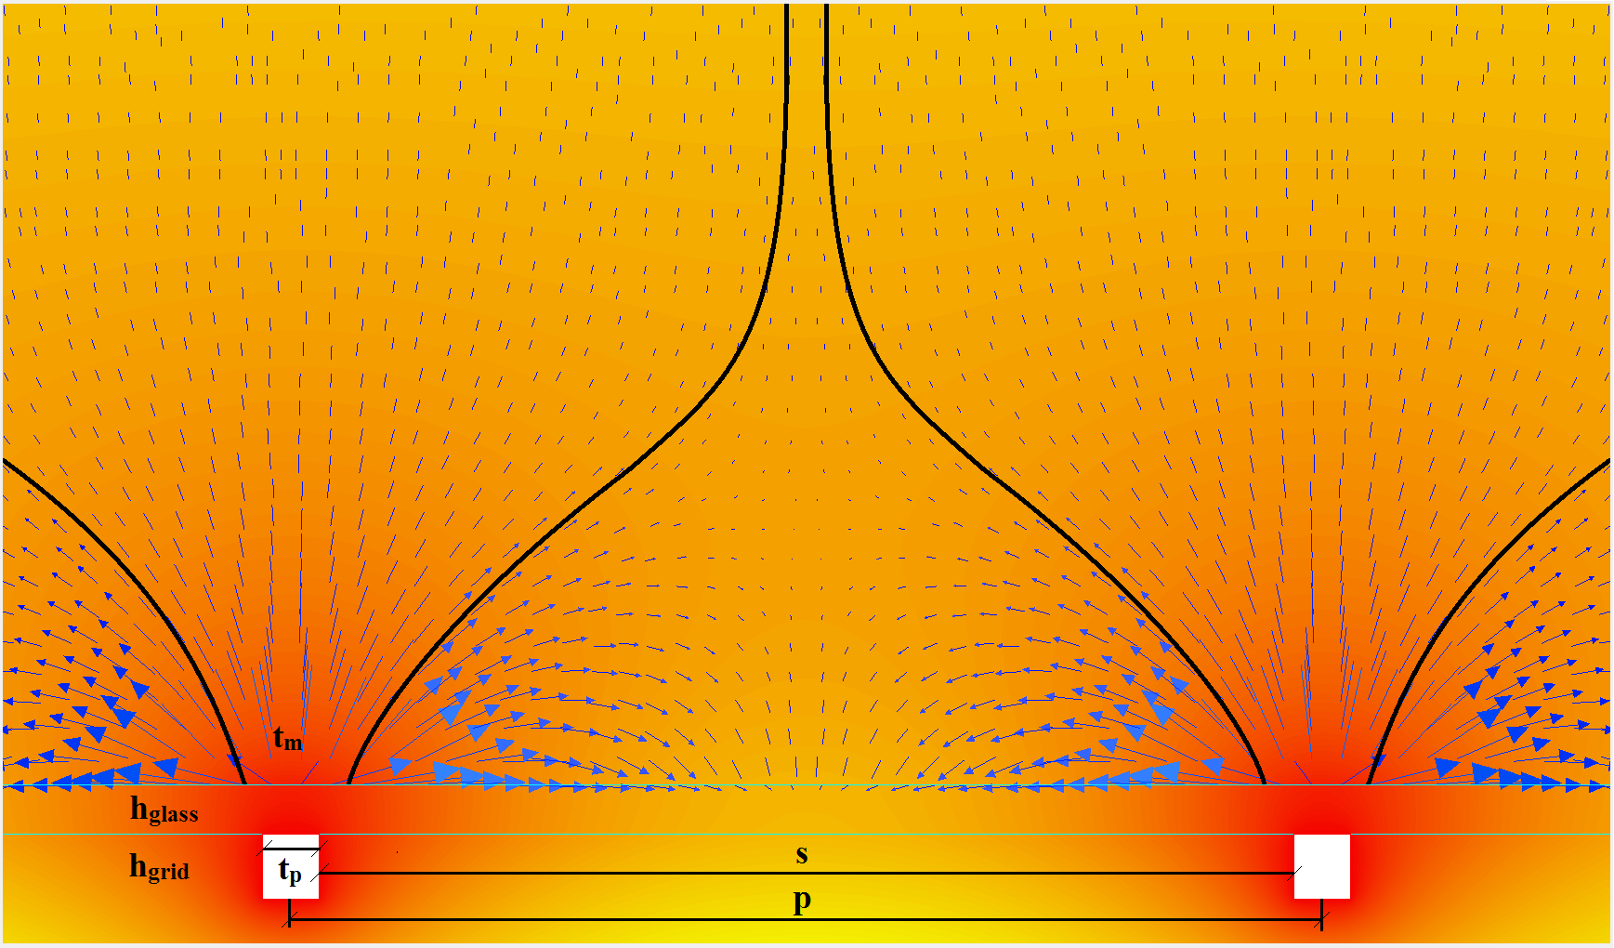
Figure SI 7. Zoomed in simulated electrical potential plot in “positive” pattern deposition process between two brass grid lines. Arrows depict electric field vectors. Space between grid, s, is 3mm. Thickness of individual grids, t_{p}, is 0.175 mm. Total distance between adjacent grid centerlines, p = s + t, is 3.175mm. The height of the deposition glass substrate, h_{glass}, and the brass grid, h_{grid}, are 0.15mm and 0.2mm, respectively. Figure SI 5 scale applies to electric potential.
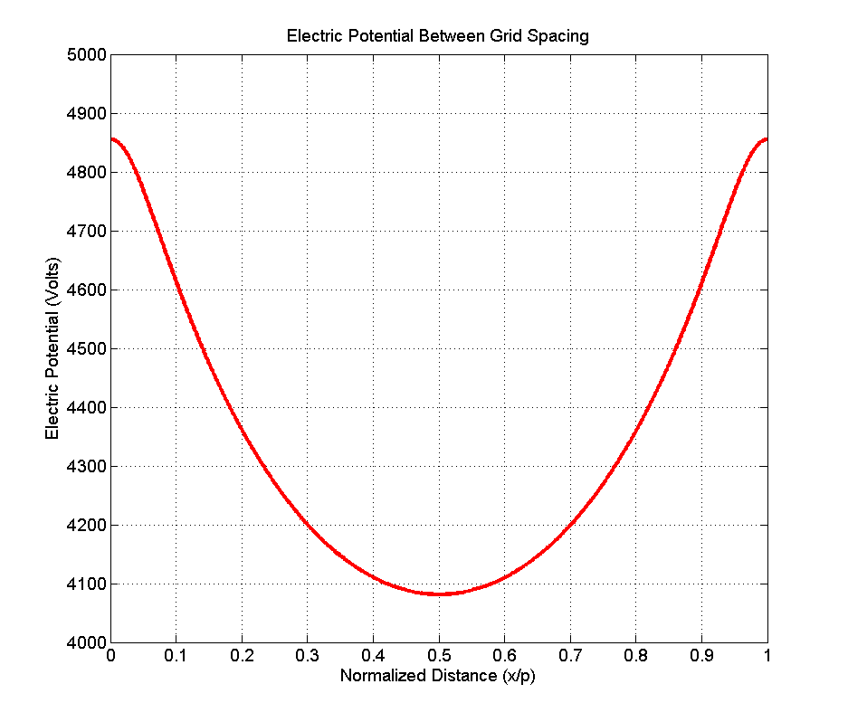
Figure SI 8. Electric potential on the surface of the deposition area as a function of displacement normalized to the distance between two adjacent brass grid centerlines, p, of 3.175mm.

Species | PS | PMMA | Acetone | Chloroform | THF | Acetic Acid
T_{g} (°C) | 110 | 124 | - | - | - | -
ε_{r} | - | - | 20.7 | 4.81 | 7.58 | 6.15
b.p. (°C) | - | - | 56 | 61 | 66 | 118
δ (MPa^{1/2}) | 18.6 | 19.2 | 19.7 | 18.7 | 18.5 | 21.4

Table 1. Summary of solvent properties used in this study. T_{g}: glass transition temperature, ε_{r}: dielectric constant, b.p.: boiling point, δ: Hildebrand solubility parameter.

