Supporting Information
Synthesis and Thin Film Self-Assembly of Radical-Containing Diblock Copolymers

Lizbeth Rostro, Aditya G. Baradwaj, Alexander R. Muller, Jennifer S. Laster, and
Bryan W. Boudouris*

480 Stadium Mall Drive, School of Chemical Engineering, Purdue University, West Lafayette, IN 47907

* To whom correspondence should be addressed: boudouris@purdue.edu

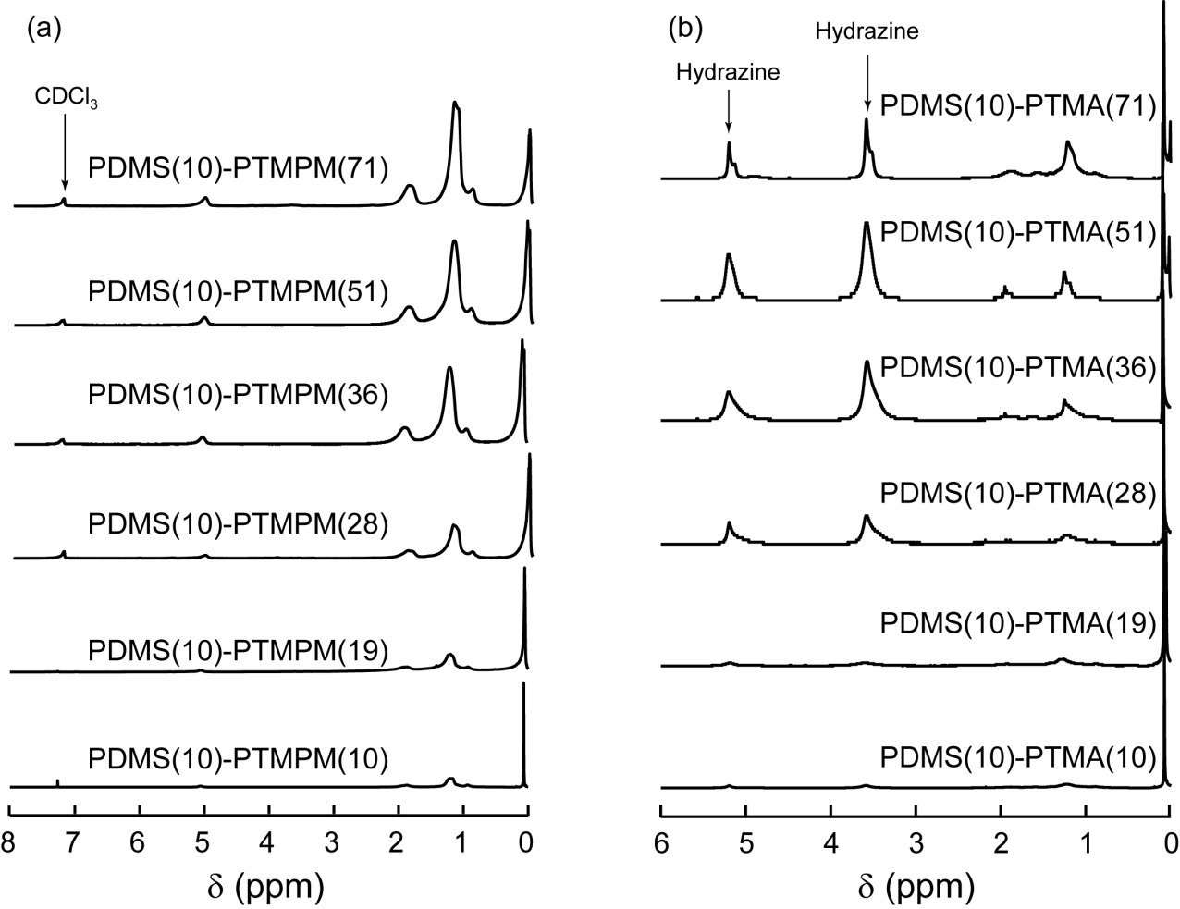

Figure S1. (a) The ¹H NMR spectra for the purified PDMS(10)-PTMPM(X) diblock copolymers dissolved in deuterated chloroform (CDCl₃). Here, X corresponds to the number-average molecular weight of the PTMPM block in kg mol⁻¹. (b) The ¹H NMR spectra of the PDMS (10)-PTMA(X) diblock copolymers after the radical was quenched by treatment with hydrazine. Now X corresponds to the number-average molecular weight of the PTMA block in kg mol⁻¹.
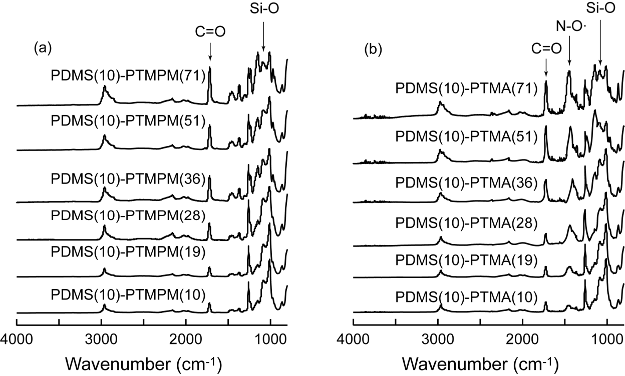

Figure S2. (a) The ATR-FTIR spectra of PDMS-PTMPM powders demonstrate the distinct PDMS functionality (i.e., Si-O) and the carbonyl group (i.e., C=O) from the PTMPM block. Note that the relative ratio of the C=O signal to the Si-O signal increases with increasing PTMPM content in the diblock copolymers. (b) The oxidized PDMS-PTMA samples show an increase in absorption at 1467 cm⁻¹; this corresponds to the formation of the radical oxygen pendant group.

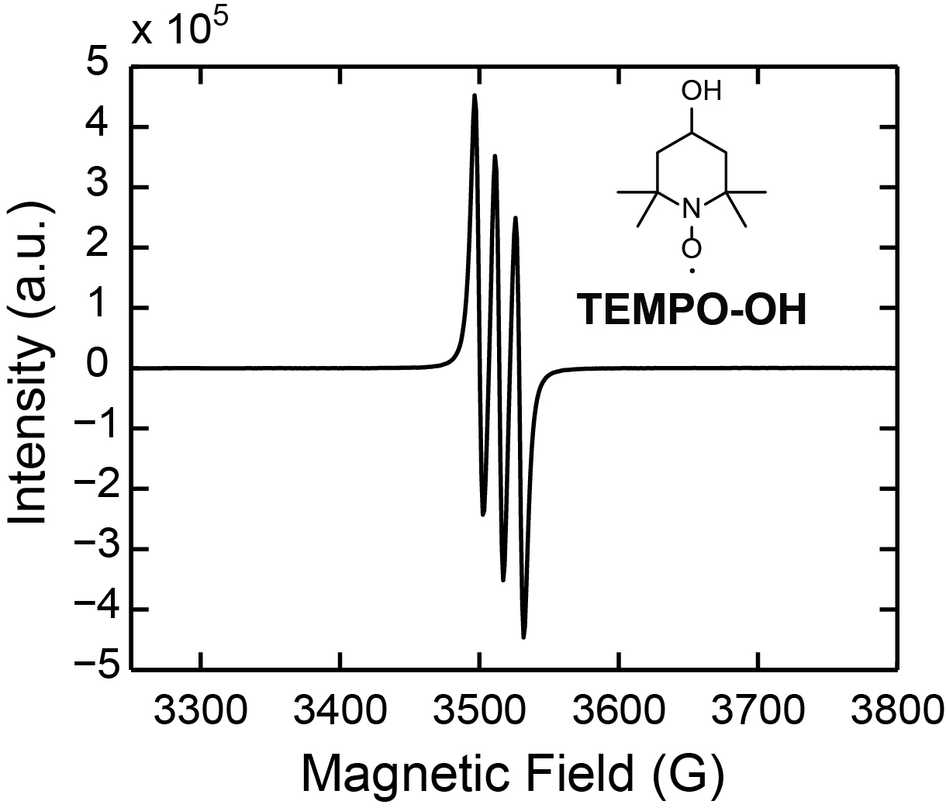

Figure S3. The EPR spectrum of the small molecule TEMPO-OH in toluene at 2 mg mL⁻¹. The integrated absorption intensity is used to determine the radical fraction in PDMS-PTMA. The chemical structure of the TEMPO-OH molecule is inset into the image.

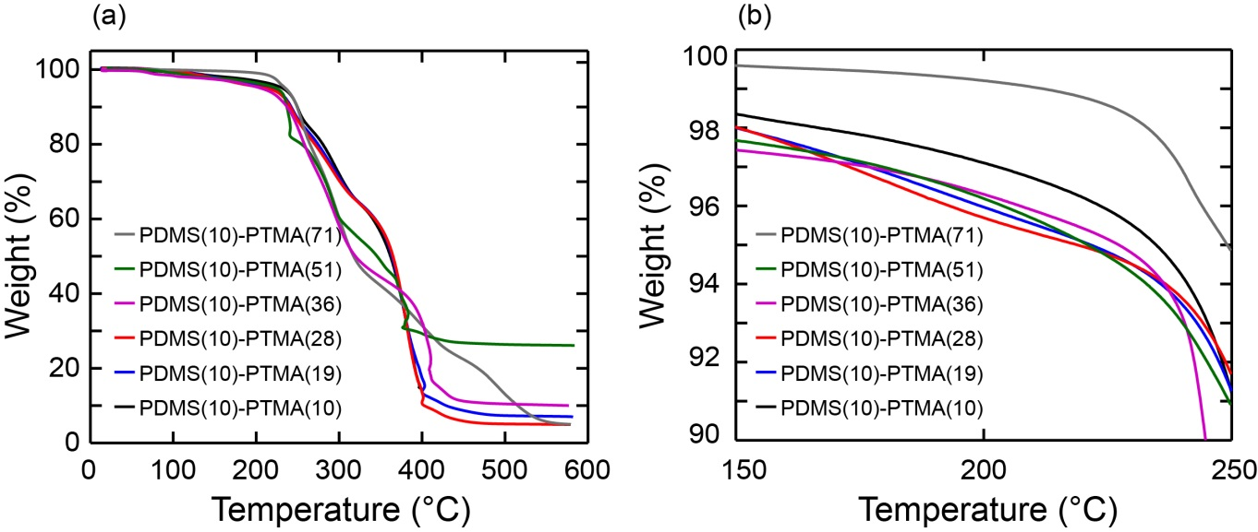

Figure S4. (a) Thermogravimetric analysis (TGA) curves of the PDMS-PTMA diblock copolymers. Note that the molecules are almost completely degraded by 420 °C. (b) The TGA profile of the PDMS-PTMA diblock copolymers in the area of the glass transition temperature of the PTMA moiety. Note that significant mass loss begins to occur at ~210 °C. This causes thermal annealing of the PDMS-PTMA block polymers to be difficult.

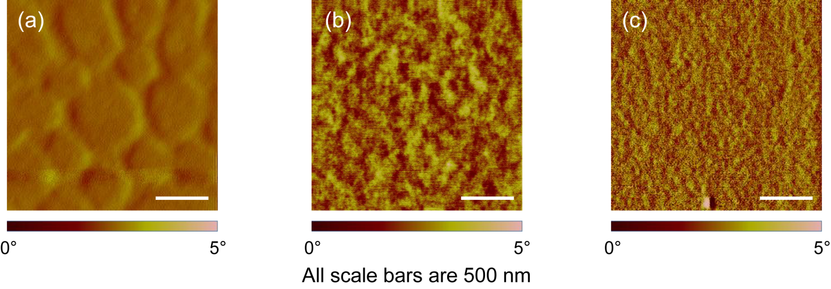

Figure S5. AFM phase images of (a) PDMS(10)-PTMPM(10), (b) PDMS(10)-PTMPM(36), and (c) PDMS(10)-PTMPM(51) thin films after annealing with chloroform vapors for 24 h at room temperature. There is no observed self-assembly in the PDMS-PTMPM diblock copolymer systems.

