Supplementary Information

Novel one-pot synthesis of hierarchically porous Pd/C monoliths by a co-gelation method
Trupti Kotbagi, Yasemin Hakat and Martin Bakker*
Department of Chemistry, The University of Alabama, Tuscaloosa, Alabama 35487-0336, USA

S1. EXPERIMENTAL
S1.1. Viscosity and pH measurements
The viscosity measurements were carried out using a Ostwald capillary tube viscometer of Max USA size 150 with bulb volume of 3.1 mL (±5%) and inner diameter of capillary of 0.78 mm (±2%) for the following- DI water (A); Pd(NH₃)₄Cl₂.H₂O salt (0.145 g)+10 mL DI water (B);1,6 DAH (0.0585 g)+10 mL DI water (C); DAH (0.0585 g)+Pd(NH₃)₄Cl₂.H₂O salt (0.0291 g)+10 mL DI water (D) and DAH (0.0585 g)+ Pd(NH₃)₄Cl₂.H₂O salt (0.145 g)+10 mL DI water (E);. The amounts of DAH and Pd salt were taken according to match the synthesis procedure. The reported values are the average of three separate measurements. The viscosity of pure water was used to calibrate the instrument, using a linear calibration.
The pH of solutions A, B, C, D and E were measured using a Mettler Toledo SevenEasy pH meter. The pH meter was calibrated using pH 4.00 and 7.00 buffers prior to the measurements.

S2. Results

Table S1. Viscosity and pH of DAH and Pd complex Solutions.

No. | Sample | Viscosity (cSt) | pH
A | DI Water | 5.05 | 7.34
B | 5 wt% Pd | 5.09 | 8.04
C | DAH | 5.08 | 11.88
D | DAH + 1 wt% Pd | 5.14 | 11.71
E | DAH + 5 wt% Pd | 5.25 | 11.34

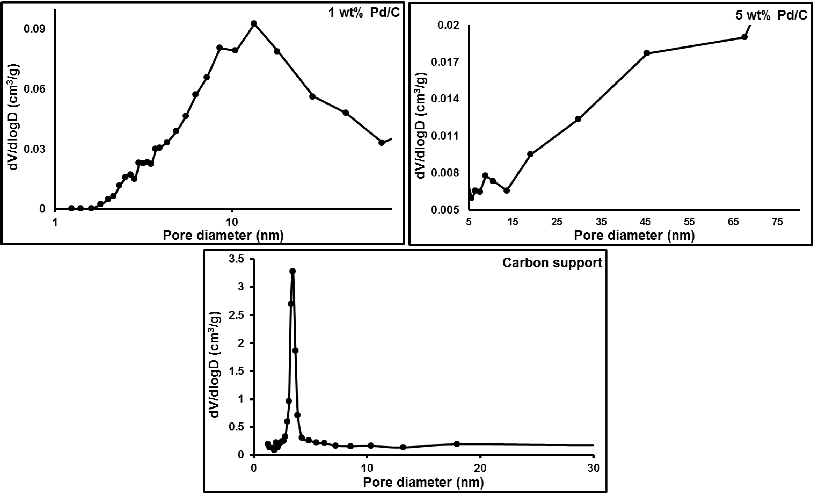
Figure S1. BJH Pore size distributions

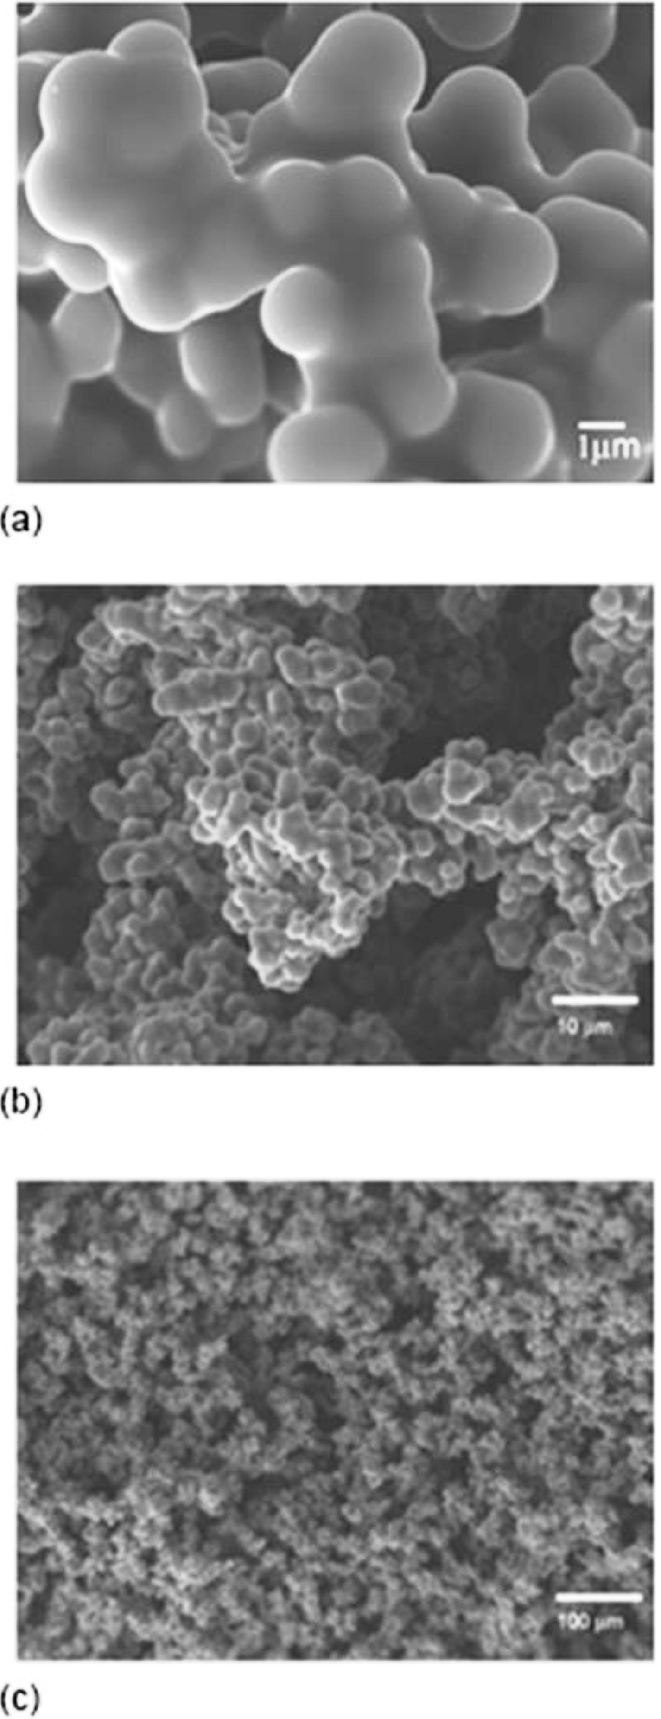

Figure S2. SEM images of carbon support.

