Supplementary Materials (SM)

Graphene oxide film as a template for the creation of 3D lamellar metal oxides and reduced graphene oxide/metal oxide hybrids

Xiguang Gao, Mahyar Mazloumi, Louis Cheung, Xiaowu (Shirley) Tang

Department of Chemistry & Waterloo Institute for Nanotechnology, University of Waterloo, Waterloo, ON, Canada N2L 3G1

Graphene oxide synthesis by modified Hummers method
Graphite flakes (3.6 g; Sigma-Aldrich, particle size +100 mesh) were ground with NaCl (30 g) for 20 minutes. Afterwards, copious water was added to dissolve NaCl, the mixture was filtered and washed several times to remove NaCl. The solid was dried at 80 °C for 1 h. The dried solid (3.0 g) and NaNO₃ (1.5 g) were transferred into a 500 ml round-bottom flask, 70 ml concentrated H₂SO₄ was added into the flask. The mixture was stirred for 30 minutes, and then transferred to a 0 °C ice bath. KMnO₄ (15.0 g) was added slowly with stirring (over a period of 15 minutes) to keep the temperature of the mixture below 20 °C. The mixture was heated for 2 h with stirring in a 35~40 °C water bath. After that the mixture was carefully diluted with 140 ml deionized water (violent effervescence occurred with an increase in the temperature of the solution inside the flask to 92~98 °C), the temperature of the water bath was raised to close to 90 °C, and the stirring continued. The solution turned yellow after about 1 h. Then the flask was removed from the water bath, and the mixture was transferred to a large beaker. 420 ml deionized water was added, followed by 20 ml 30 wt% H₂O₂. The suspension was stirred for 15 minutes, then repeatedly centrifuged at 14,000 rpm for 10 minutes, and washed with 5% HCl for three times, followed by deionized water twice (the precipitate was collected each time). The slurry-like precipitate was re-dispersed in 350 ml Milli-Q water and stirred for 10 minutes. Afterwards the suspension was treated with bath sonication for 30 min. After that the suspension was repeatedly centrifuged at 3,700 rpm for 4~5 times to remove any insoluble particles (the supernatant was collected each time). Finally the brown homogenous solution was dialyzed against Milli-Q water for 1 week and stored for future use.^{[1]}
The concentration was determined by filtering 8.0 ml GO stock solution using a 0.02 μm Anodisc membrane filter (Whatman) and weighing the mass of the resultant GO film. The concentration of GO solution is about 4.0~5.0 mg/ml using the preparation method described above.

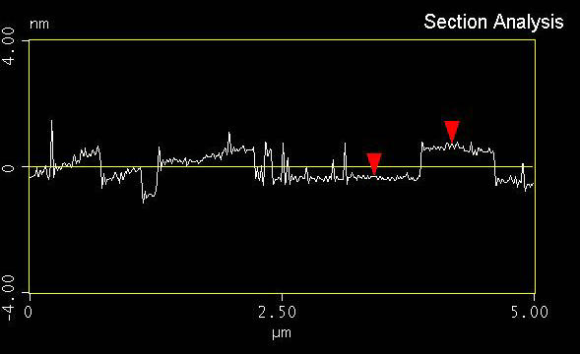
Figure S1. AFM height profile of a GO platelet across the indicated line in Fig. 2 in the main manuscript.
d = 1.025 nm

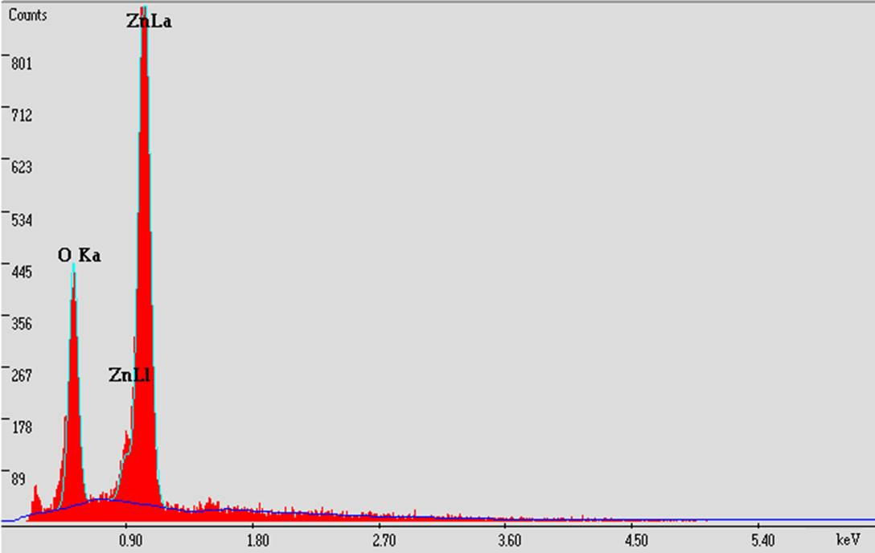
Figure S2. EDX spectrum of a ZnO film.

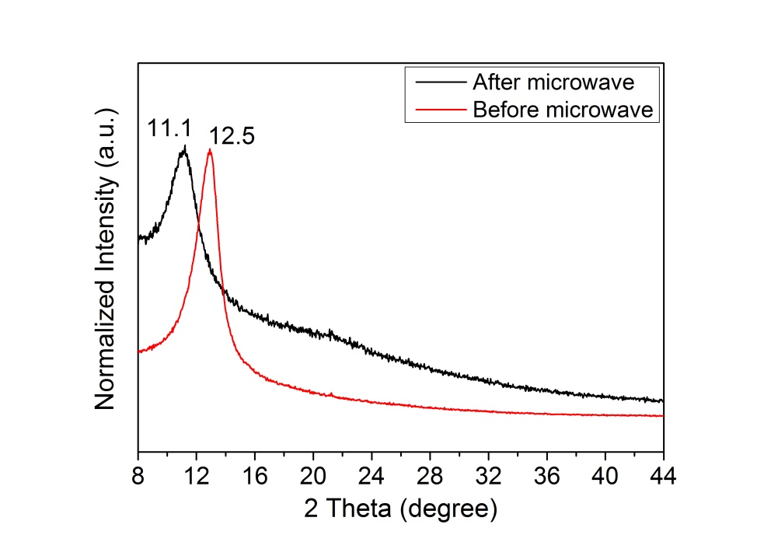
Figure S3. XRD patterns of GO films before and after the microwave irradiation.
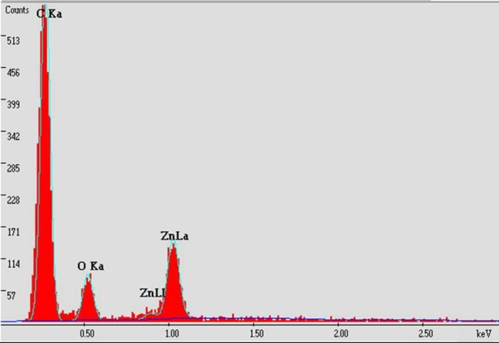
Figure S4. EDX spectrum of an rGO/ZnO hybrid film.

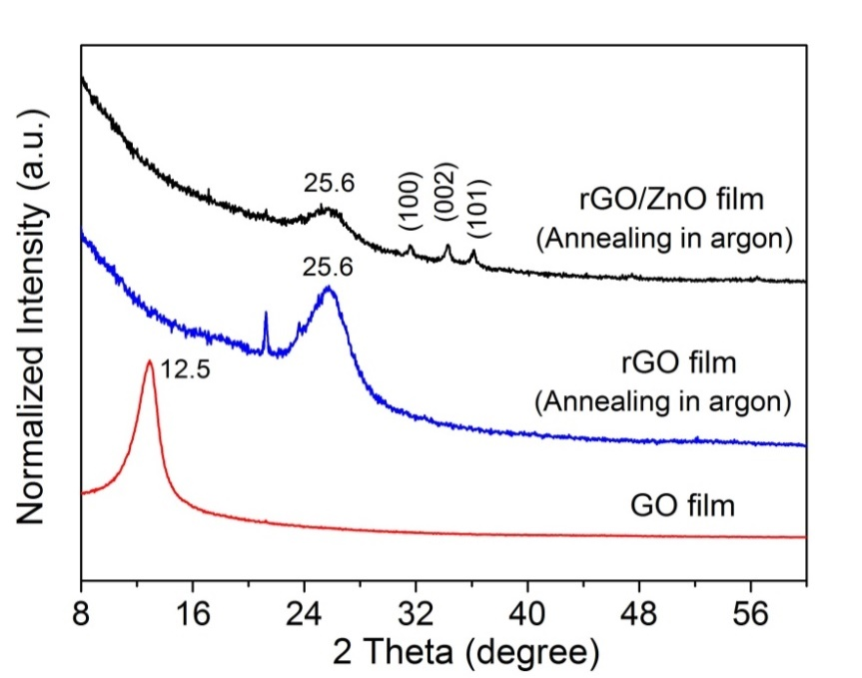
Figure S5. XRD patterns of a GO film (bottom), a thermally reduced GO (rGO) film (middle), and an rGO/ZnO film (top).

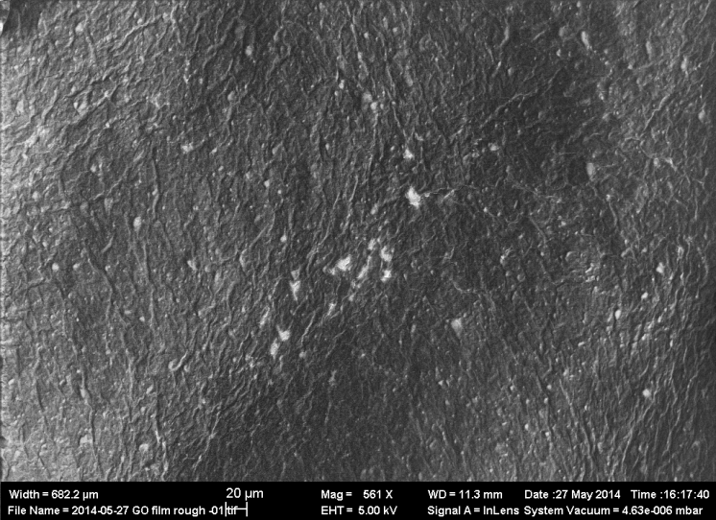
Figure S6. SEM image of GO film surface showing the wrinkles as indicated by the arrows.

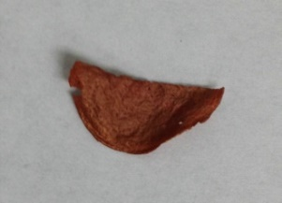
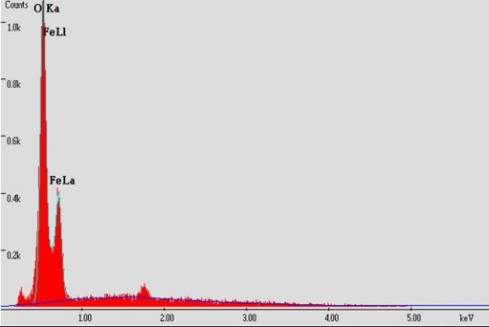
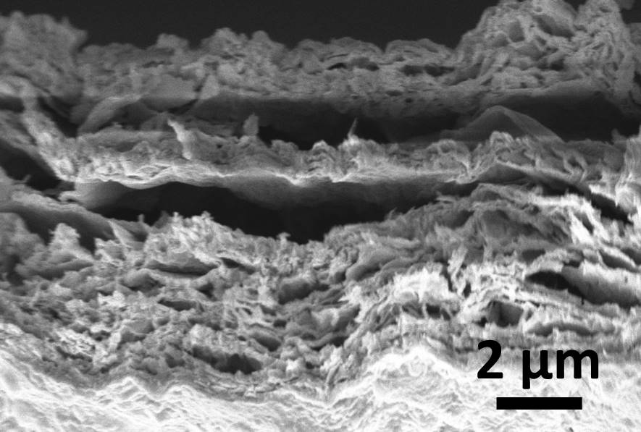
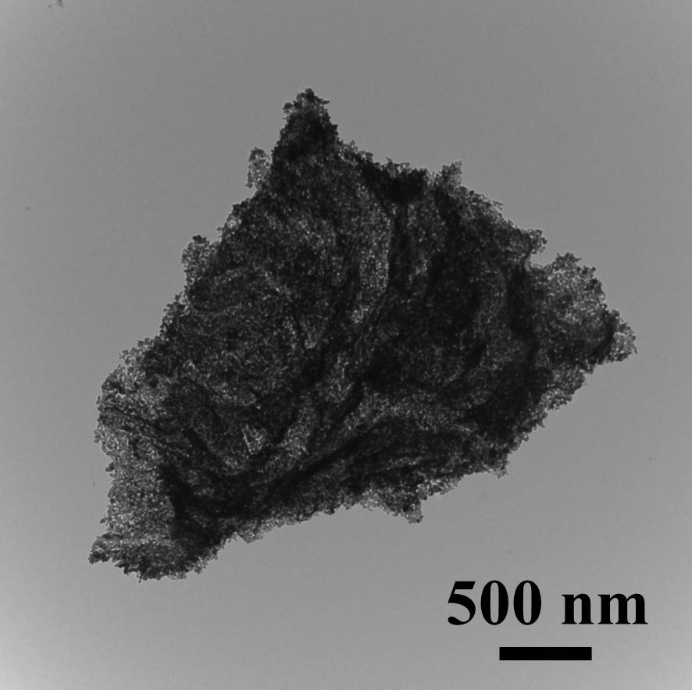
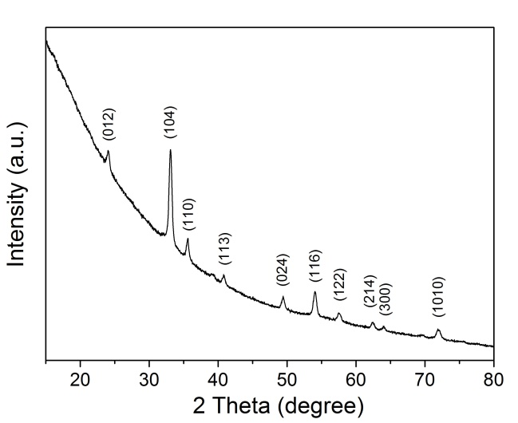
Figure S7. a) Optical image of a free-standing α-Fe₂O₃ film. b) SEM image of the cross section of a α-Fe₂O₃ film showing the layered order. c) TEM image of an isolated α-Fe₂O₃ sheet. The yellow circle indicates a part of the sheet likely consists of a monolayer of α-Fe₂O₃ nanocrystallites. d) EDX analysis of a α-Fe₂O₃ film. e) XRD pattern of a α-Fe₂O₃ film.
(a)
(d)
(b)
(c)
(e)

A certain amount of Fe(NO₃)₃ aqueous solution is filtered through a GO film. The film was carefully washed with deionized water to remove the iron salts adsorbed on the surfaces and then dried in air. After that the film was first calcined at 300 °C for 1 h to induce iron oxide formation, and then calcined at 600 °C for 1 h. A free-standing red-brownish film was obtained after the calcination, as shown in Figure S7a. SEM characterization showed the lamellar order of the film (Figure S7b). Small pieces of the as-prepared film were treated with mild sonication in ethanol and then deposited on copper grid for TEM imaging, which showed the sheet-like structure of α-Fe₂O₃ (Figure S7c). EDX analysis (Figure S7d) and XRD pattern (Figure S7e) showed that the film consisted of only α-Fe₂O₃ (ICSD No. 082136).^{[2,3]}
α-Fe₂O₃ was formed by the thermal decomposition of Fe(NO₃)₃, which is shown below:
4 Fe(NO₃)₃ → 2 α-Fe₂O₃ + 12 NO₂ ↑ + 3 O₂ ↑

References
[1] W. S. Hummers, JR., R. E. Offeman, J. Am. Chem. Soc. 1958, 80, 1339.
[2] J. Chen, L. Xu, W. Li, X. Gou, Adv. Mater. 2005, 17, 582.
[3] F. Jiao, A. Harrison, J.-C. Jumas, A. V Chadwick, W. Kockelmann, P. G. Bruce, J.
Am. Chem. Soc. 2006, 128, 5468.

