SUPPLEMENTARY INFORMATION
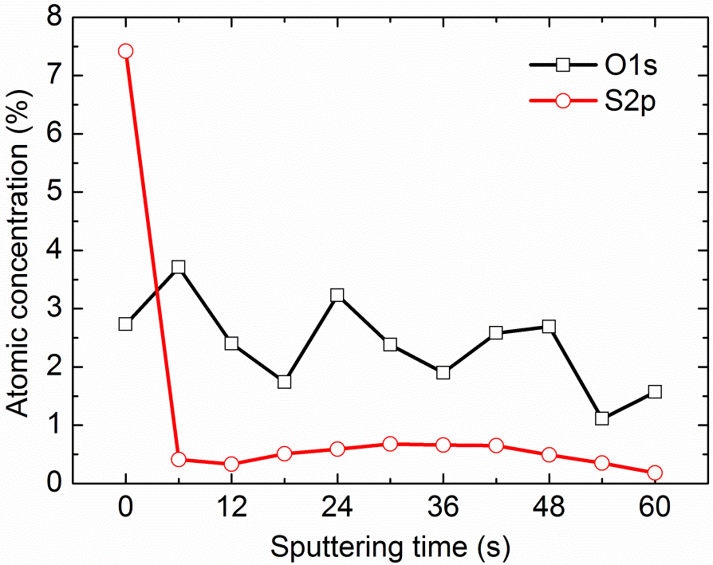
FIG. S1. X-ray photoemission spectroscopy depth profile of 10 wt% P3HT:PLLA blend film on PET. The atomic concentration of oxygen and sulfur have been measured and calculated using the oxygen 1s (O1s) and sulfur 2p (S2p) orbital peaks respectively, and are plotted as a function of Ar sputtering time. The sulfur concentration (P3HT) is at its highest at the surface, but there is also sulfur present throughout the bulk of the blend. The concentration of oxygen (PLLA) remains constant throughout the film. This supports the hypothesis that there is both vertical and lateral phase separation present in the blend.

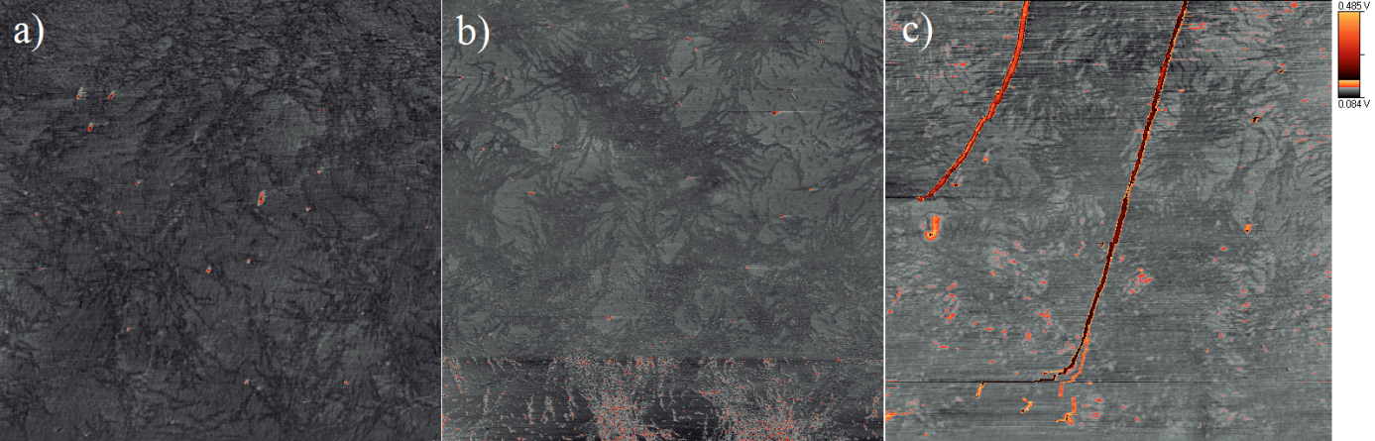
FIG. S2. Atomic force spectroscopy phase images of a) 0.2 %, b) 0.5 % and c) 0.8 % P3HT:PLLA blend films on PET. The yellow peaks are mostly dust or dirt caught on the tip. We assume that the dark parts are P3HT strands that form on the surface of the blend. The surface seems to be increasingly more covered with P3HT when going from 0.2 % to 0.8 %. The strands are not visible above 0.8 % and the surface appears to be fully covered by P3HT. This suggests that at higher concentrations the vertical phase separation is present and that the surface is always covered by P3HT.

