Supporting Information: PES scans, charge density difference plots for all systems, and an example diffusion barrier by constrained optimization
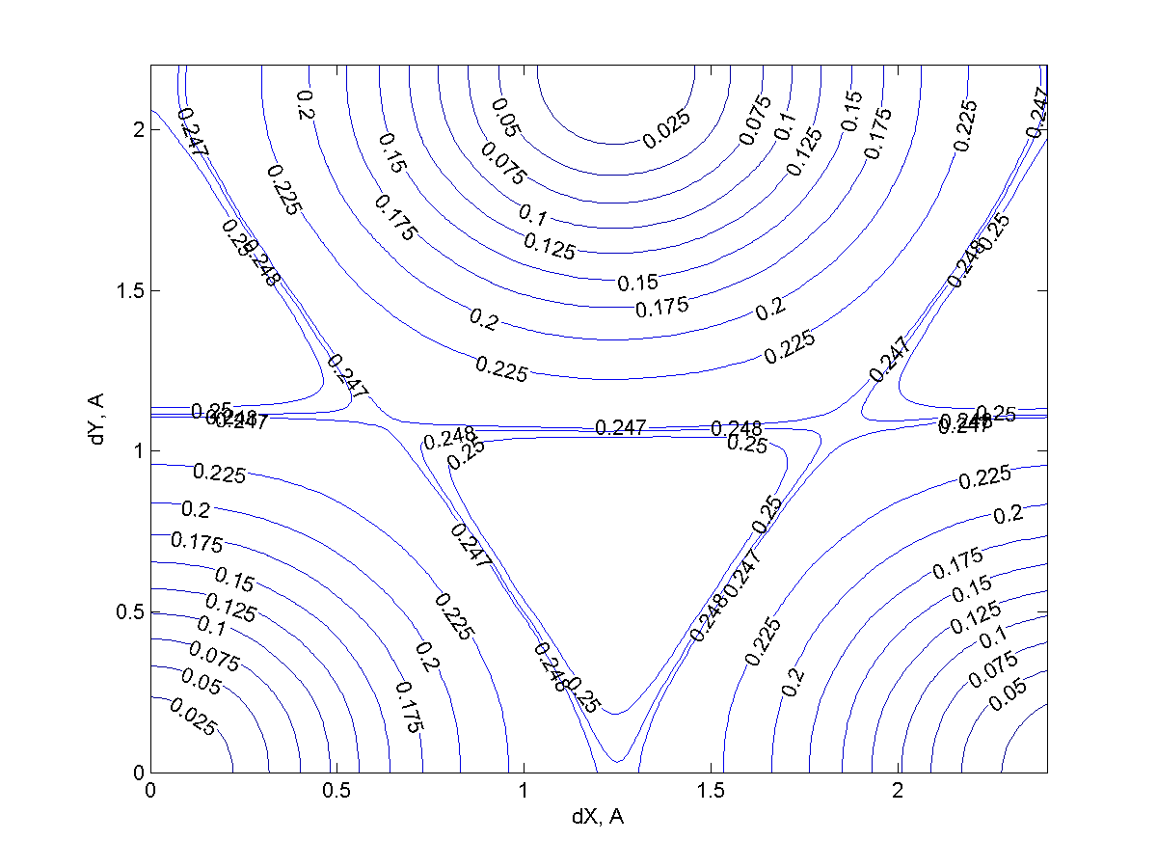
FIG. S1. PES scan of Li on planar graphene. Here and elsewhere, dX and dY are Cartesian displacements from the hollow adsorption site at the point of maximum curvature, and isovalues are in eV. X is the direction of maximum curvature, see FIGS. 1-2.

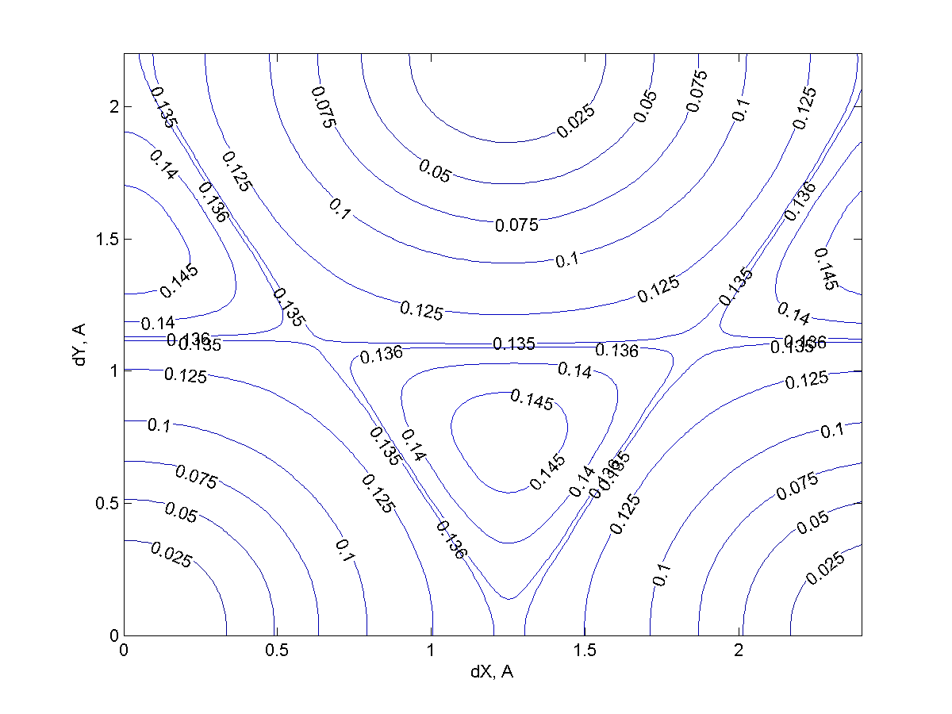
FIG S2. PES scan of Na on planar graphene.

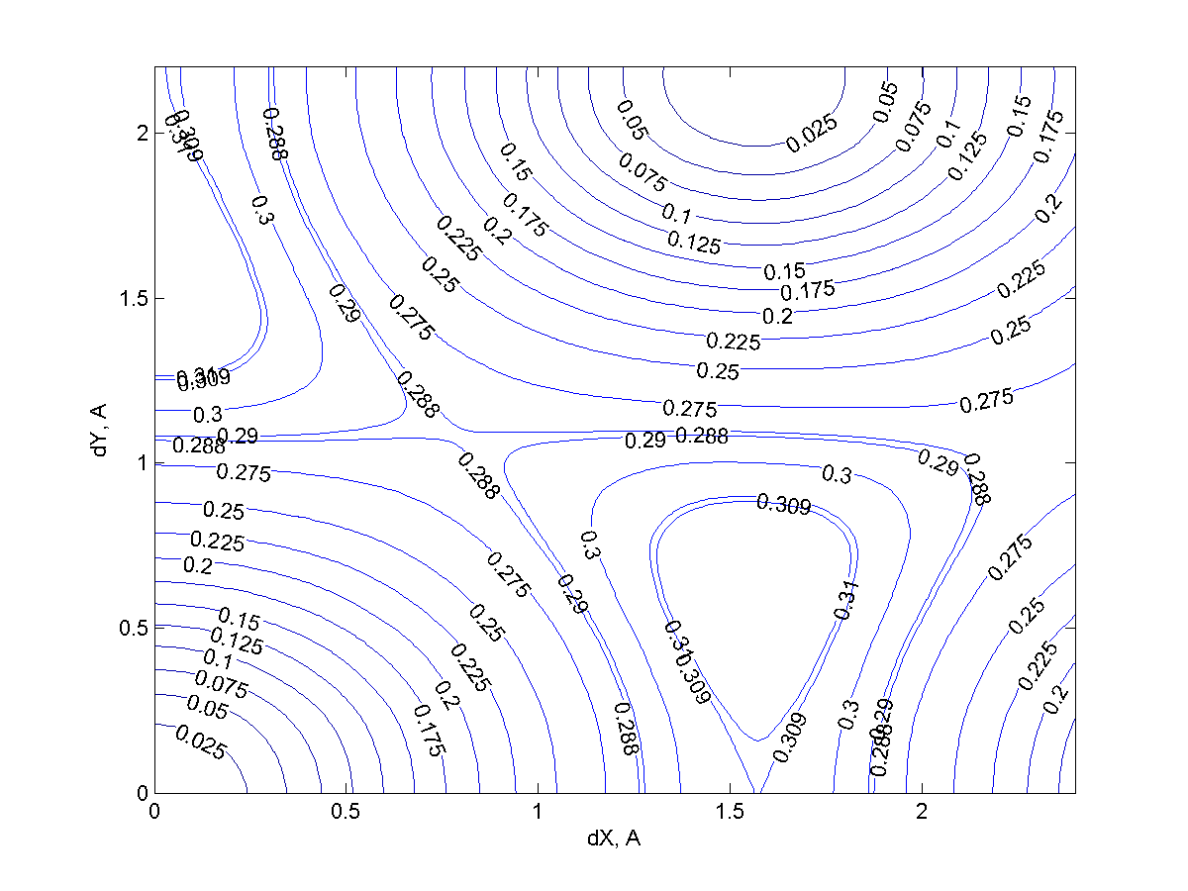
FIG. S3. PES scan of Li on 84% graphene, convex.

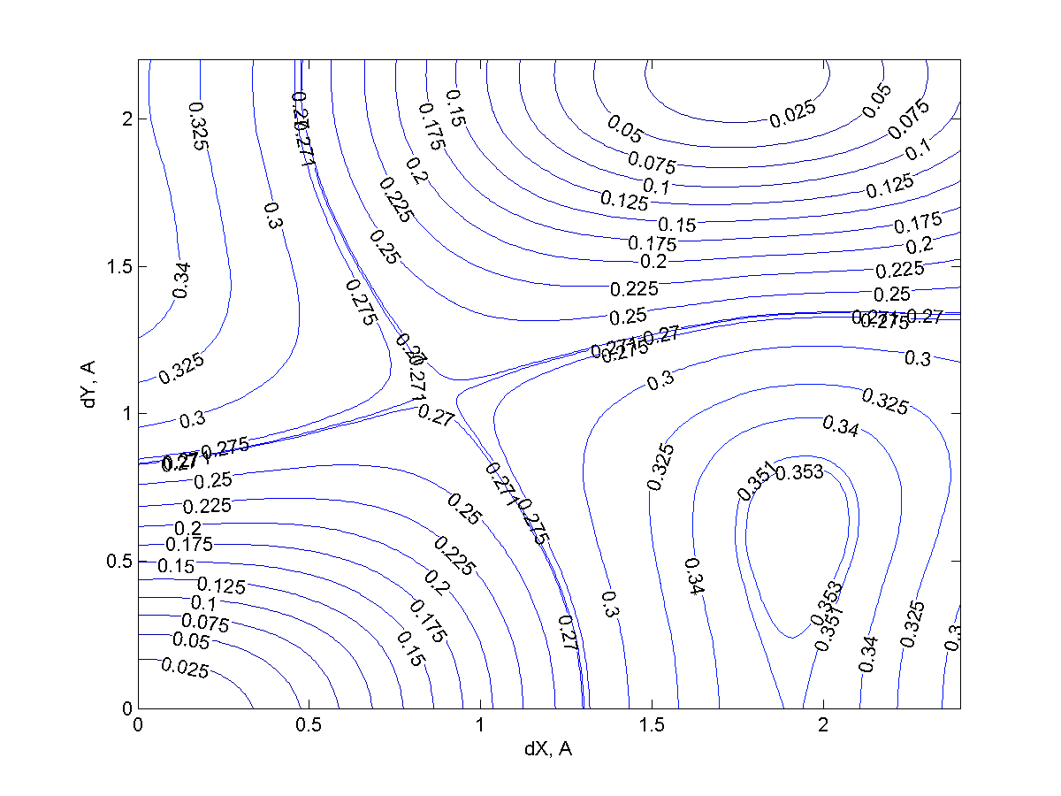
FIG. S4. PES scan of Li on 65% graphene, convex.

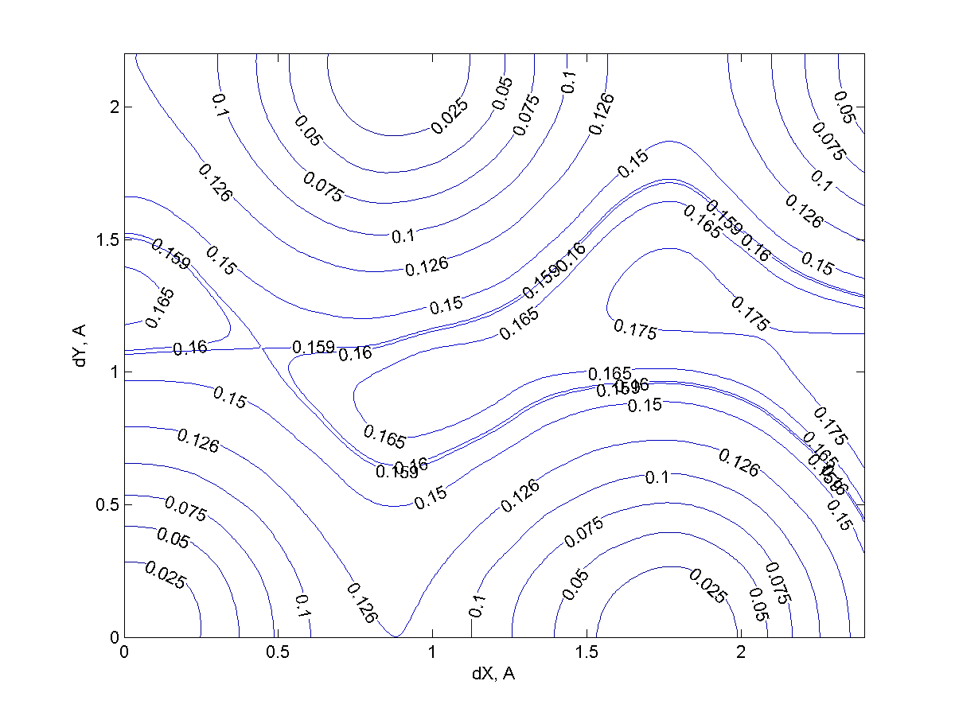
FIG. S5. PES scan of Li on 84% graphene, concave.

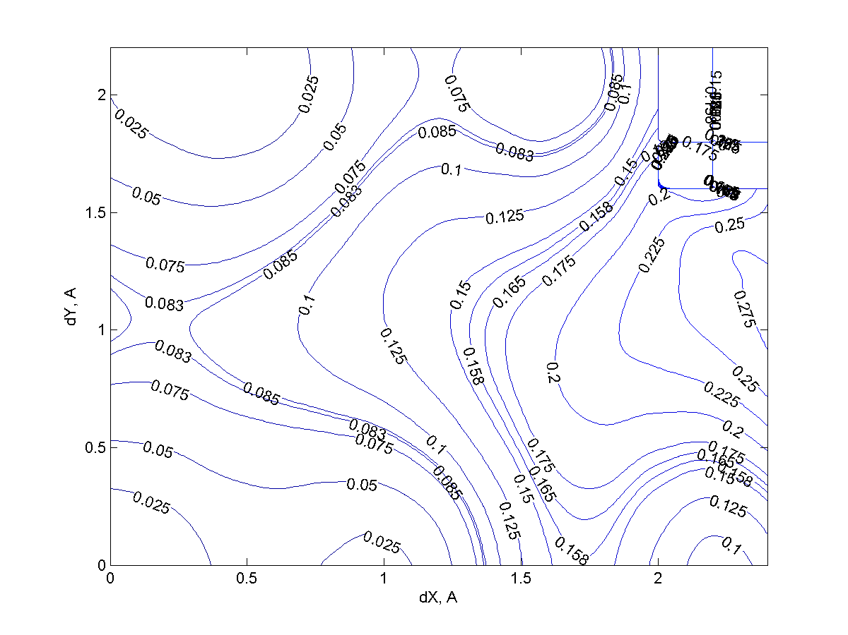
FIG. S6. PES scan of Li on 65% graphene, concave.

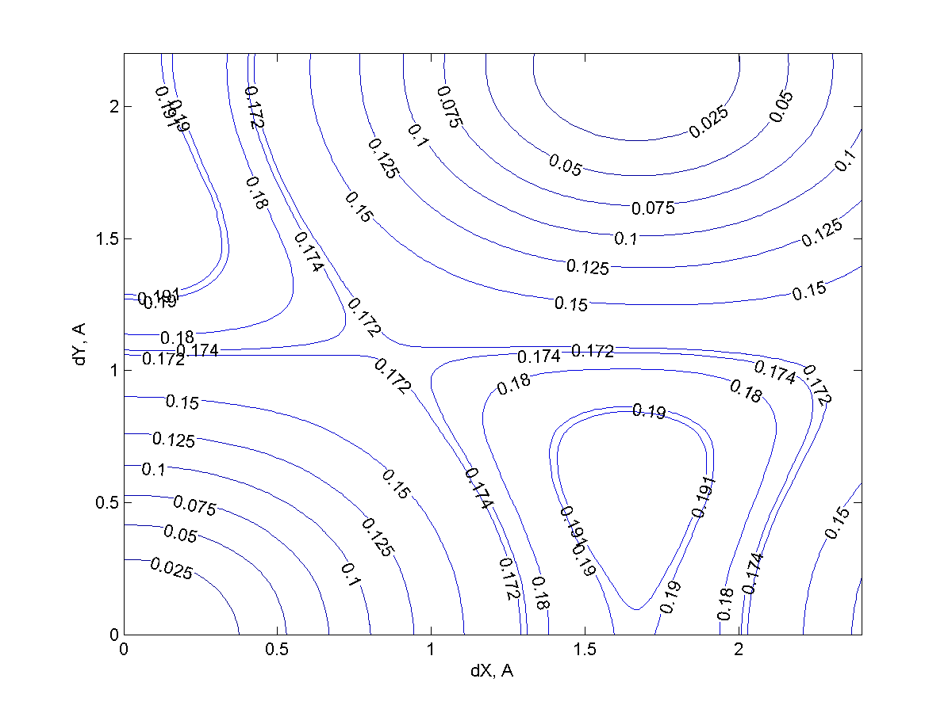
FIG. S7. PES scan of Na on 84% graphene, convex.

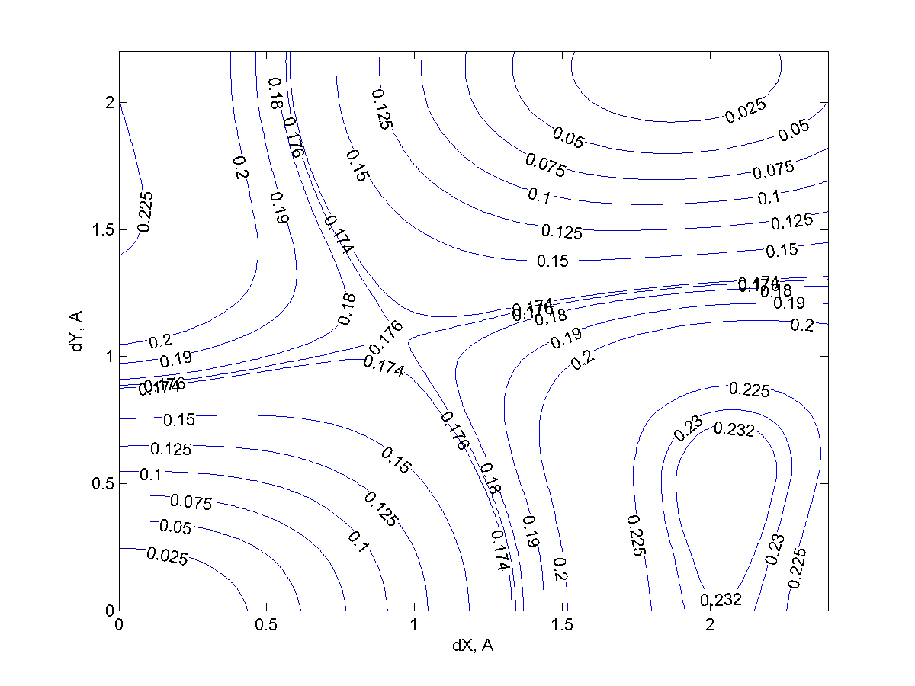
FIG. S8. PES scan of Na on 65% graphene, convex.

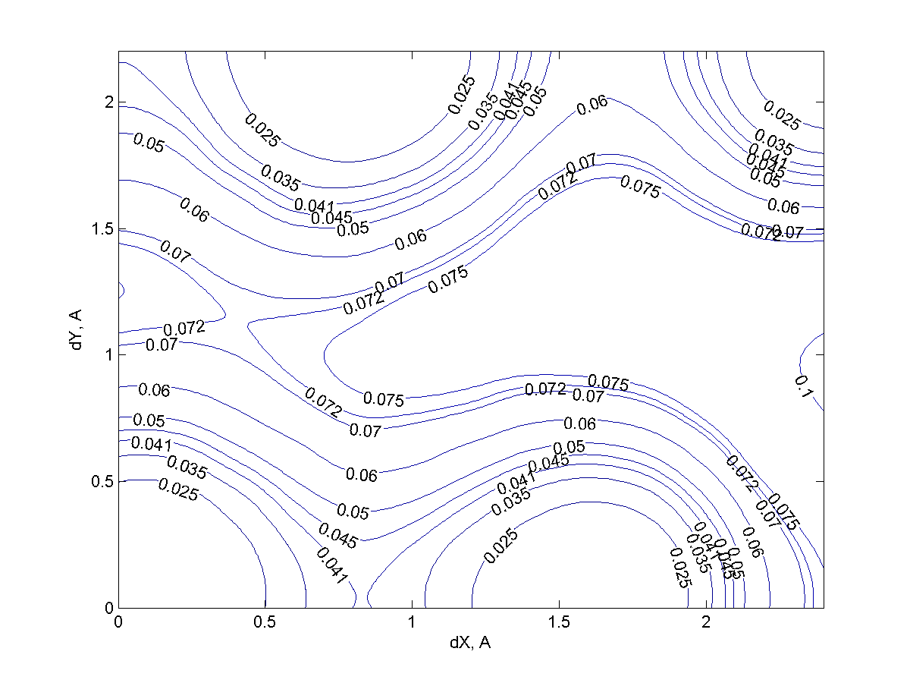
FIG. S9. PES scan of Na on 84% graphene, concave.

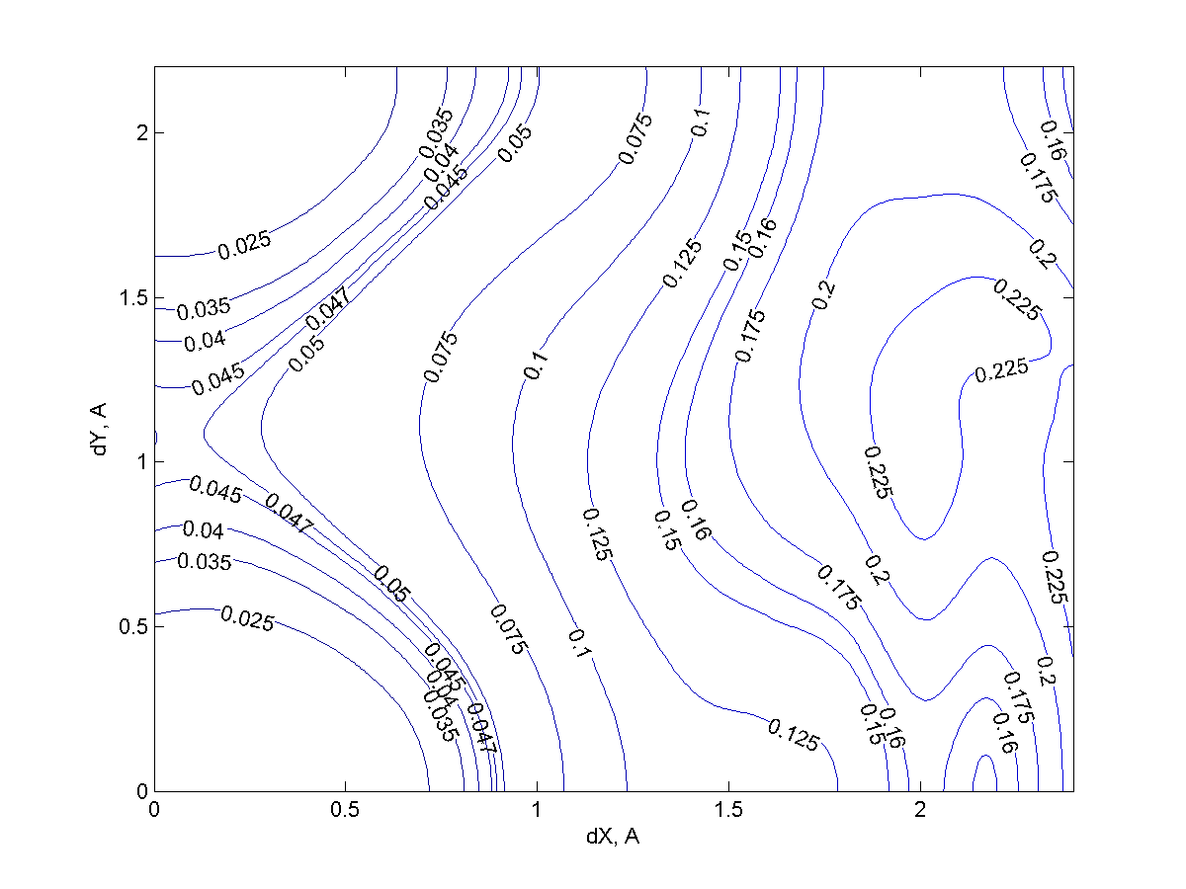
FIG. S10. PES scan of Na on 65% graphene, concave.

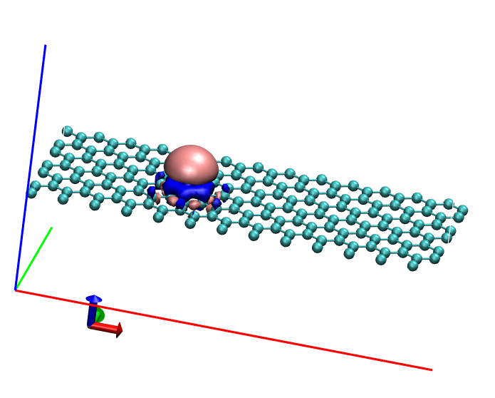

FIG. S11. Li on planar graphene.
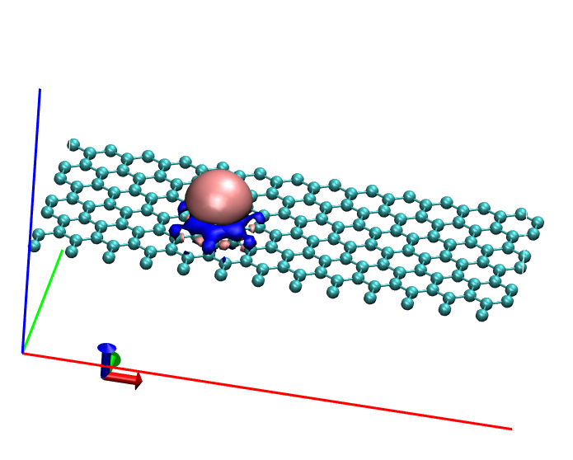
FIG. S12. Na on planar graphene.
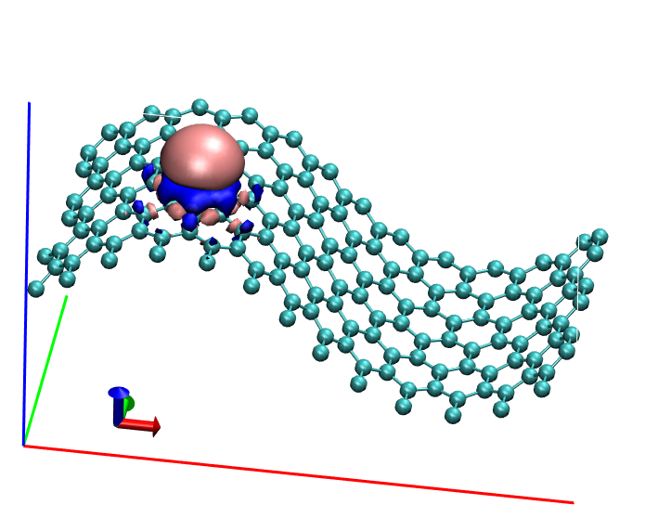
FIG. S14. Li on 84% sheet, convex adsorption.
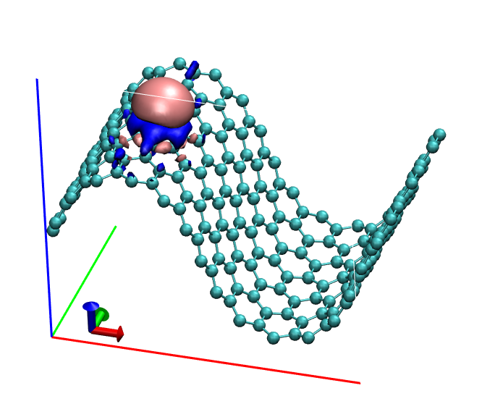
FIG. S14. Li on 65% sheet, convex adsorption.
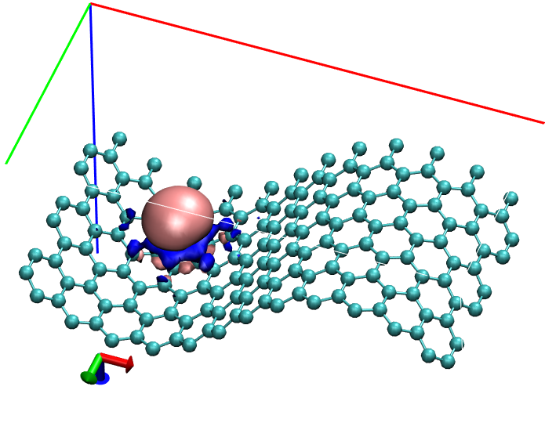
FIG. S14. Li on 84% sheet, concave adsorption.
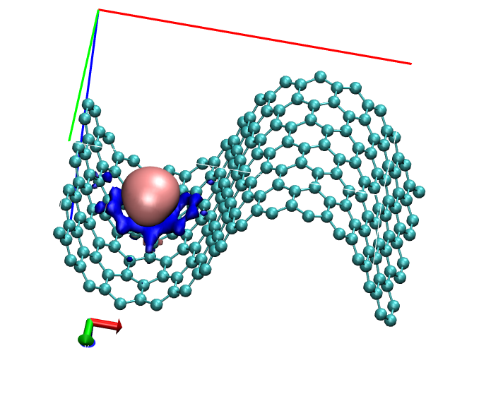
FIG. S14. Li on 65% sheet, concave adsorption.
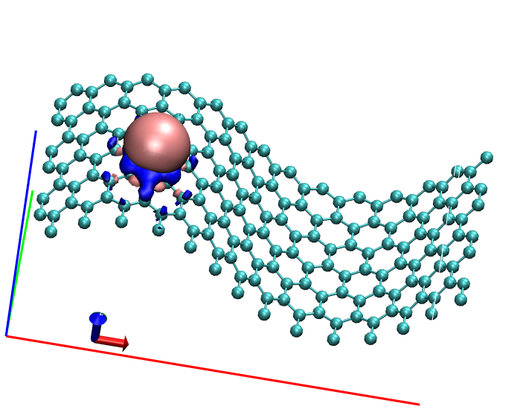
FIG. S14. Na on 84% sheet, convex adsorption.
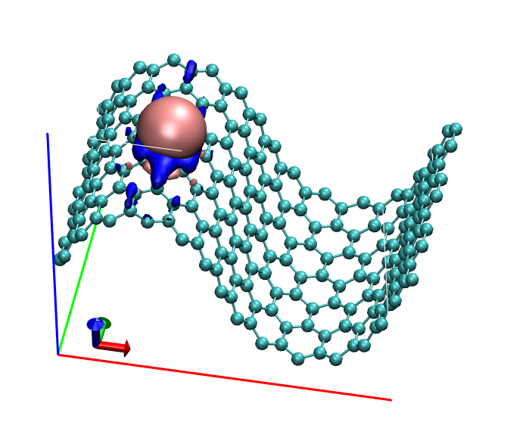
FIG. S14. Na on 65% sheet, convex adsorption.
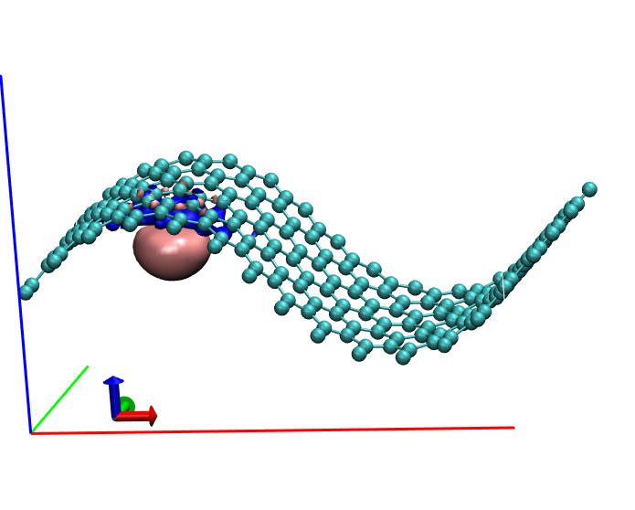
FIG. S14. Na on 84% sheet, concave adsorption.
FIG. S14. Na on 65% sheet, concave adsorption.

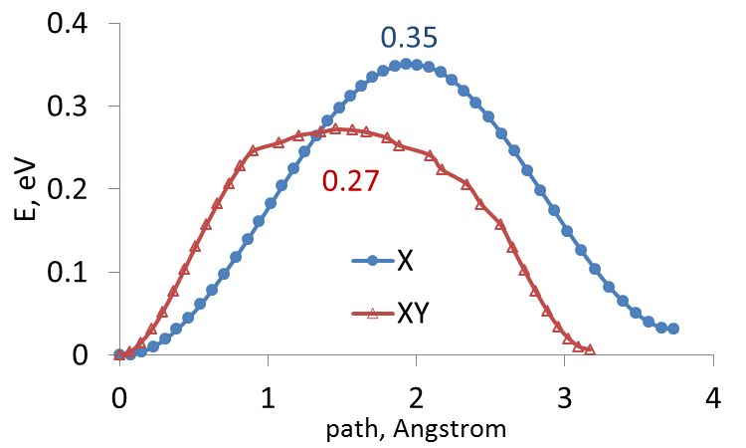

FIG. S15. Example of a diffusion barrier obtained by constrained optimization: Li on the convex side of the 65% sheet, X and XY pathways (see also FIG. S4).

