Supplementary Materials for:
The Nanostructure of the Si-Al eutectic and its use in lithium batteries
Wenchao Zhou¹, Tianchan Jiang², Hui Zhou¹, Yuxuan Wang²,
Jiye Fang^{1,2}, and M. Stanley Whittingham^{1,2,*}
²Department of Chemistry and ¹Institute for Materials Research, State University of New York at Binghamton, Binghamton NY, 13902 USA
*To whom correspondence should be addressed. Email: stanwhit@gmail.com
- Synthesis
Nanostructured Si spheres were synthesized by etching eutectic Al-Si powder (−325 mesh, 99%, Al:Si = 88:12 wt. %, Alfa Aesar) in an excess of a 3 M aqueous solution of HCl. An ice bath was used to control the etching rate. The etching lasted for ~6 hours until no further bubbles were evolved. The suspended solid was filtered, washed with de-ionized water and dried under vacuum. Overnight etching with vigorous stirring was used to break the Si spheres.
- Characterization
The structure of the samples was characterized by Scintag XDS2000 diffractometer that was equipped with a Ge(Li) solid-state detector and Cu Kα sealed tube (λ = 1.54178 Å). Data were collected over the range of 10 to 90 degree with a step size of 0.02 degree and exposure time of 10 s; the samples were rotated to diminish the effects of possible preferred orientation. The Rietveld refinement of the powder XRD data was done with the GSAS/EXPGUI package. The lattice constant of the Si was determined by the refinement to be 5.454(3) Å with a R_{p} of 6.08%.
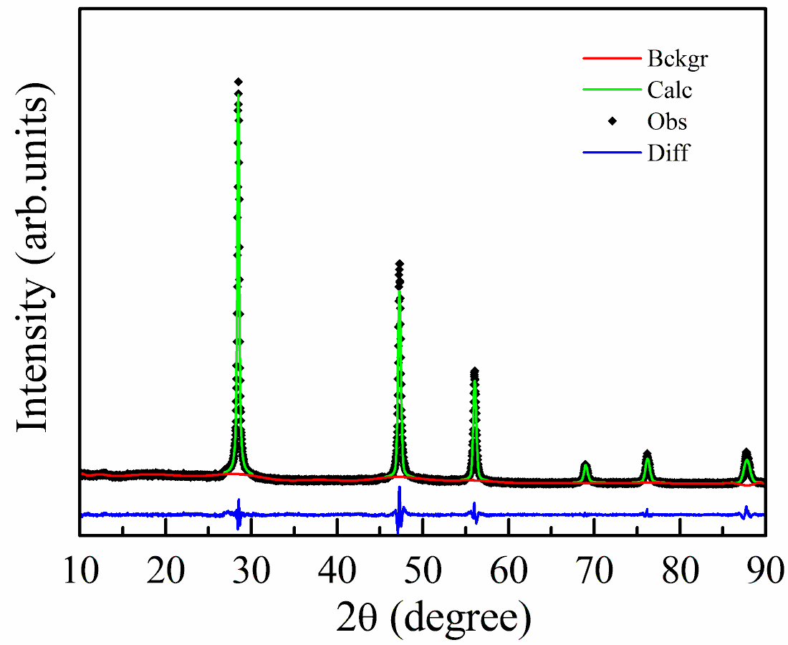
Figure S1. The Rietveld refinement of the powder XRD data for nanostructured Si spheres.
- Surface morphology and elemental mapping.
The surface morphology and elemental mapping were determined by scanning electron microscopy (SEM, ZeissSupra-55). TEM was collected with Hitachi H-7000 electron microscope (75 kV).
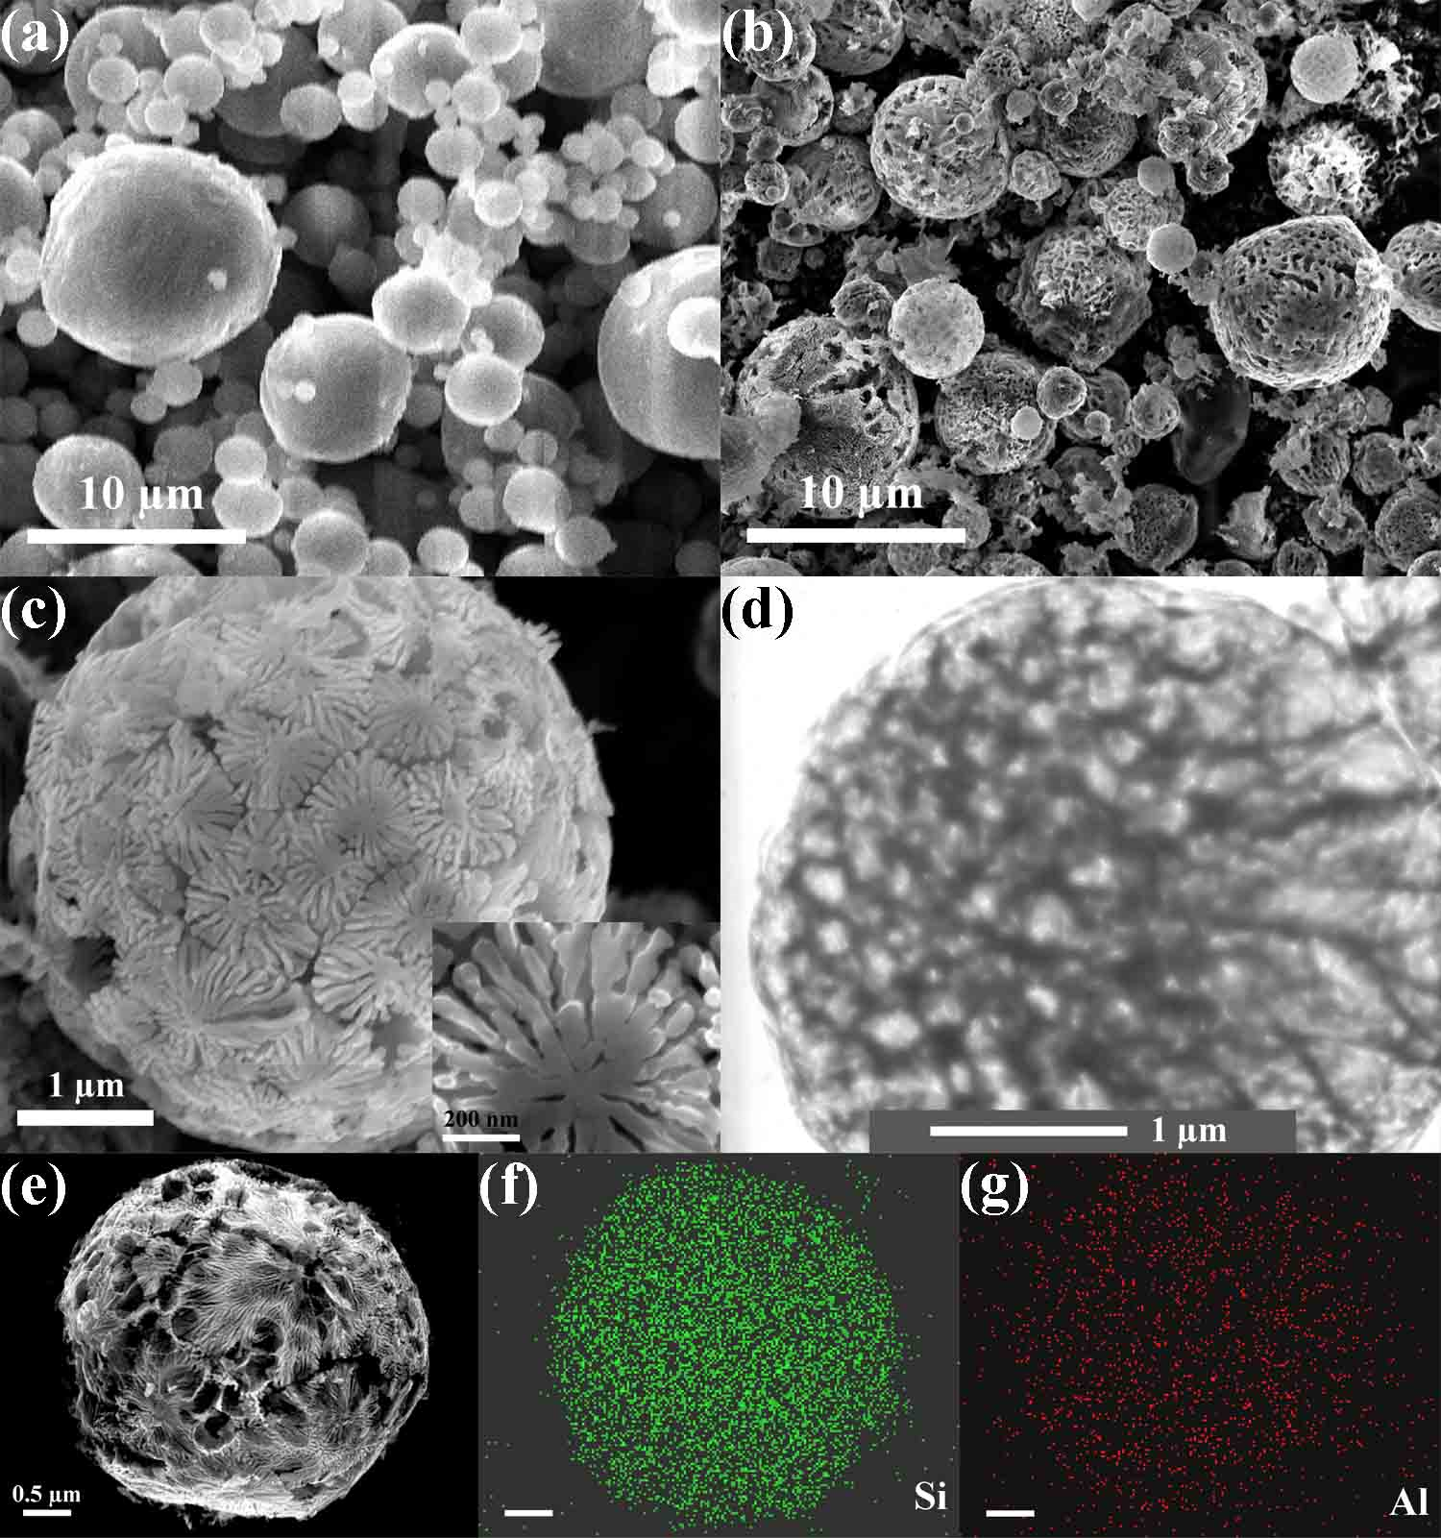

Figure S2. SEM of (a) initial Al-Si, and of (b) and (c) Si spheres; (d) TEM of the Si spheres and (e, f, g) SEM-EDX mapping of Si and Al.

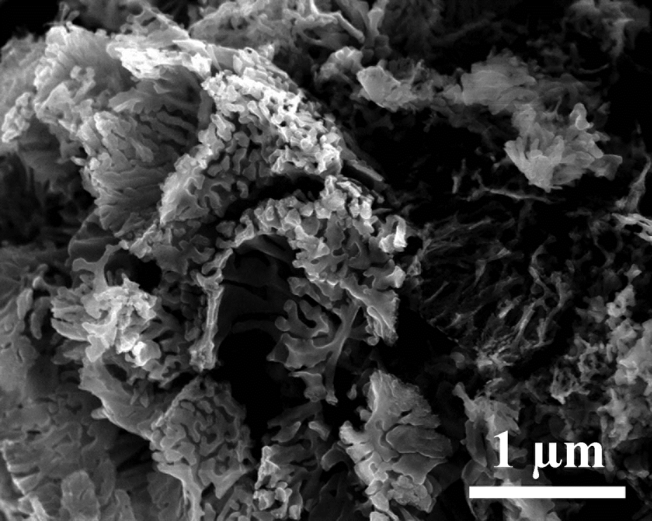

Figure S3. SEM of the broken Si spheres.

- BET surface area test of the Si spheres
The specific surface area of the nanostructured Si sphere was determined to be 103.3 m²/g from the results of N₂ adsorption/desorption measurements using an ASAP 2020 Accelerated Surface Area and Porosimetry (Micromeritics Inc., USA).
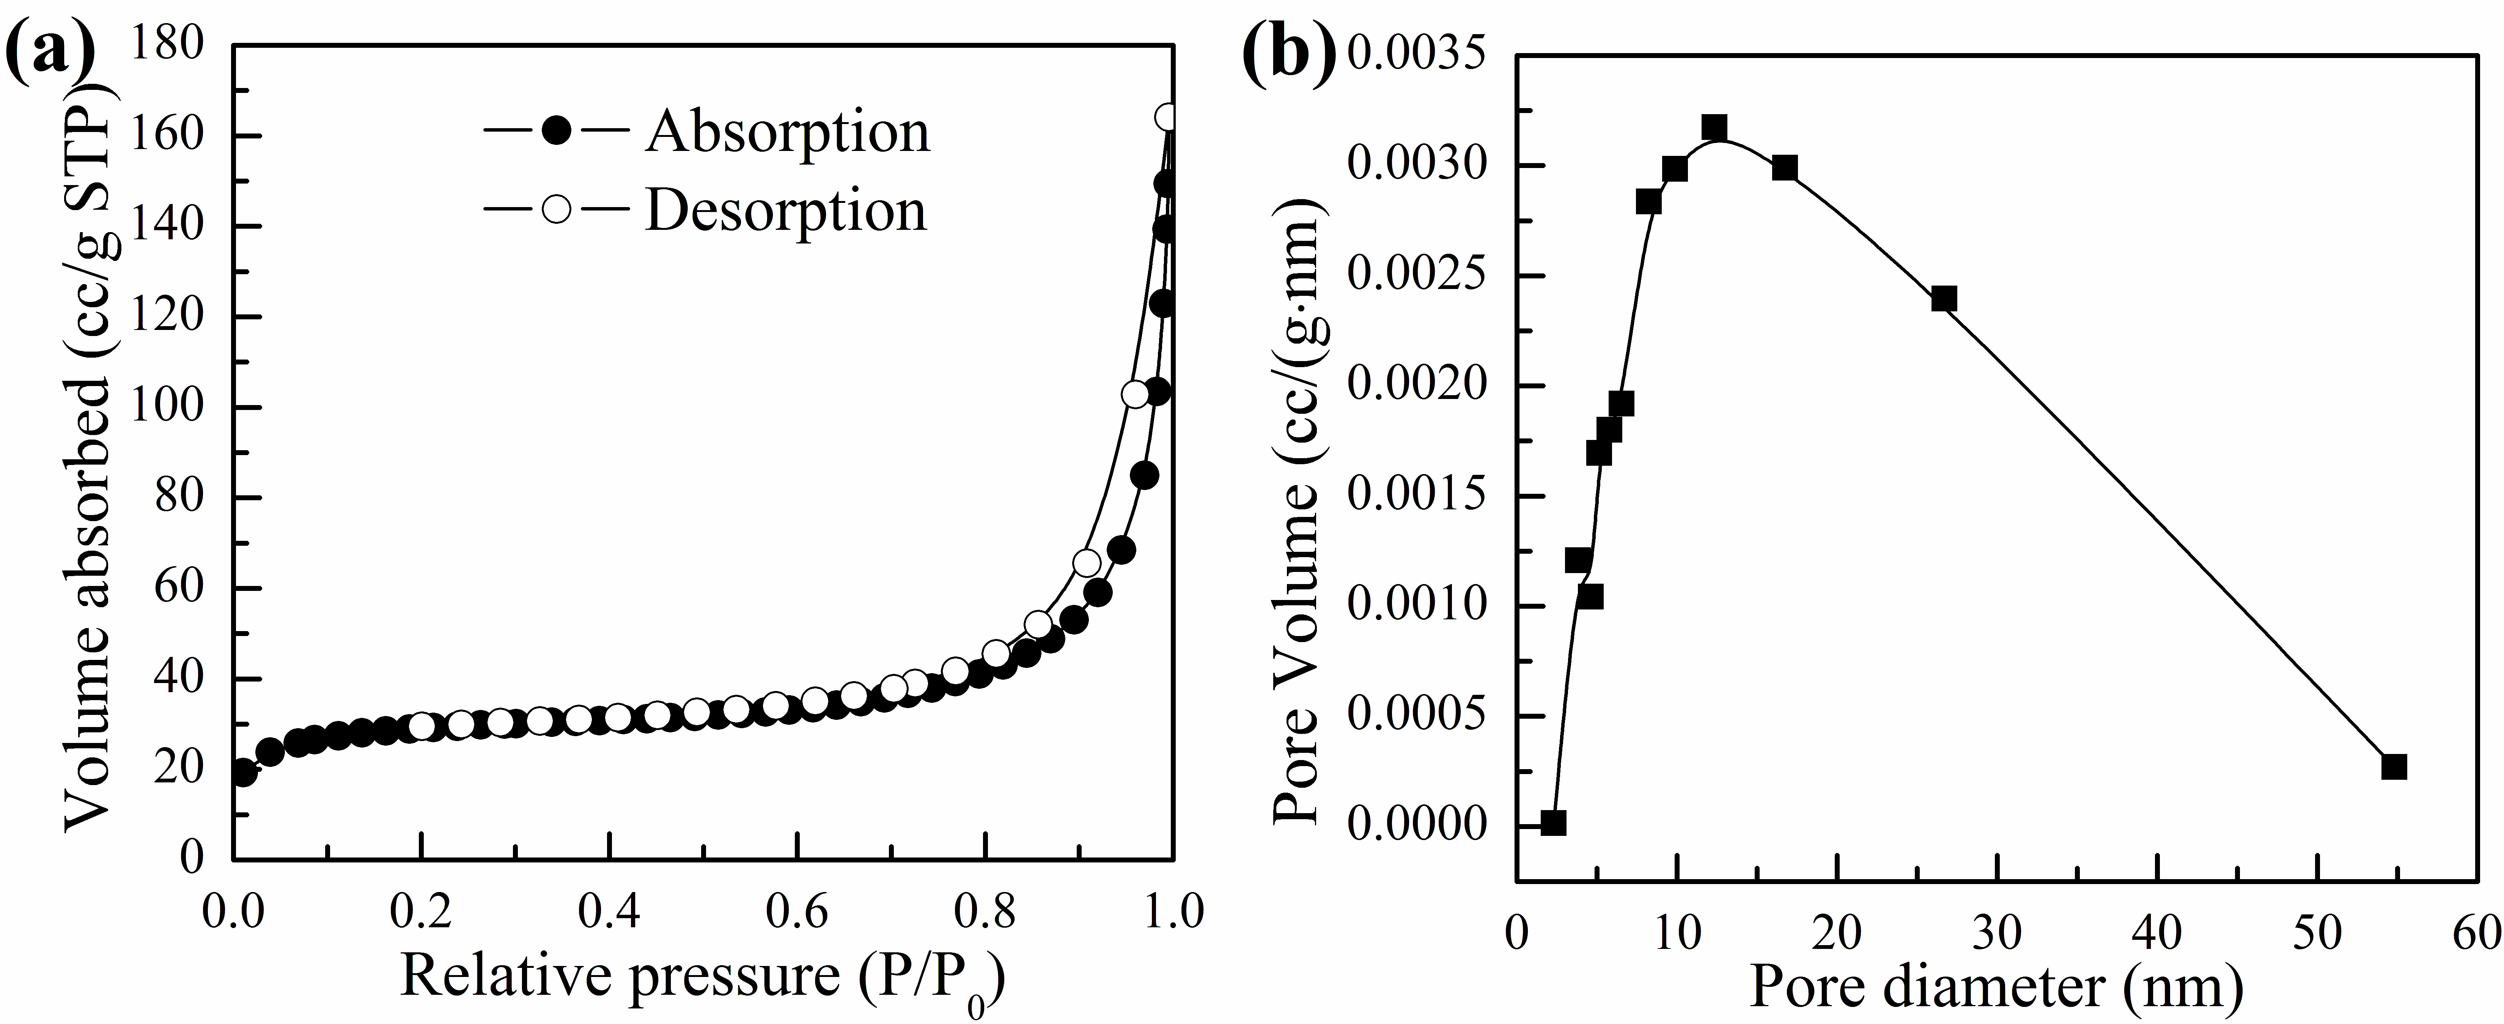
Figure S4. Nitrogen adsorption/desorption measurement of the porous Si spheres, (a) nitrogen adsorption/desorption isotherms, (b) BJH pore diameter distribution.
- The electrochemical analysis was done using 2325-type coin cells and a VMP potentiostat (Bio-logic) at room temperature. The Si was mixed with SuperP carbon (Timcal) and lithium polyacrylate (LiPAA) binder¹ in a weight ratio of 70:20:10. De-ionized water was used to make a slurry, which was cast onto copper foil; the casting was cut into 1.2 cm² circular electrodes, active loading 2 ~ 3 mg, and dried overnight at 100 °C in vacuum. Lithium foil was used as the counter electrode. The electrolyte was 1 M LiPF₆ dissolved in a 1:1 mixture of EC and DMC to which 6 wt. % FEC was added. The coin cell was cycled between 0.01 V ~ 1.5 V. The current density in the 1st cycle was 0.3 mA/cm².
REFERENCES
(1) Li, J.; Le, D.-B.; Ferguson, P. P.; Dahn, J. R. Electrochim. Acta 2010, 55, 2991-2995.
(2) Toby, B. H. J. Appl. Cryst. 2001, 34, 210-213.
(3) Larson, A. C.; Von Dreele, R. B. General Structure Analysis System (GSAS), Los Alamos National Laboratory Report LAUR 86-748 2004.

