Supplementary data
Ancient inspired fast fabrication of “PbS bird feathers”

Xiaowei Liuª, Yongwen Tan^{a,1}, Fangyu Zhang^{a,1}, Peilu Ouyang^{b,1}, Jiajun Gu ^{a,}*, Di Zhang ^{a,}*
ª State Key Laboratory of Metal Matrix Composites, Shanghai Jiao Tong University, Shanghai 200240, PR China
^{b} Shanghai Nan Yang Model High School, Shanghai 200030, PR China
Author Contributions
¹These authors contributed equally.
Corresponding authors
* State Key Laboratory of Metal Matrix Composites, Shanghai Jiao Tong University, 800 Dongchuan Rd., Shanghai 200240, PR China. Tel.: +86 21 34202634; Fax: +86 21 34202584. E-mail addresses: gujiajun@sjtu.edu.cn (J.-J. Gu), zhangdi@sjtu.edu.cn (D. Zhang).

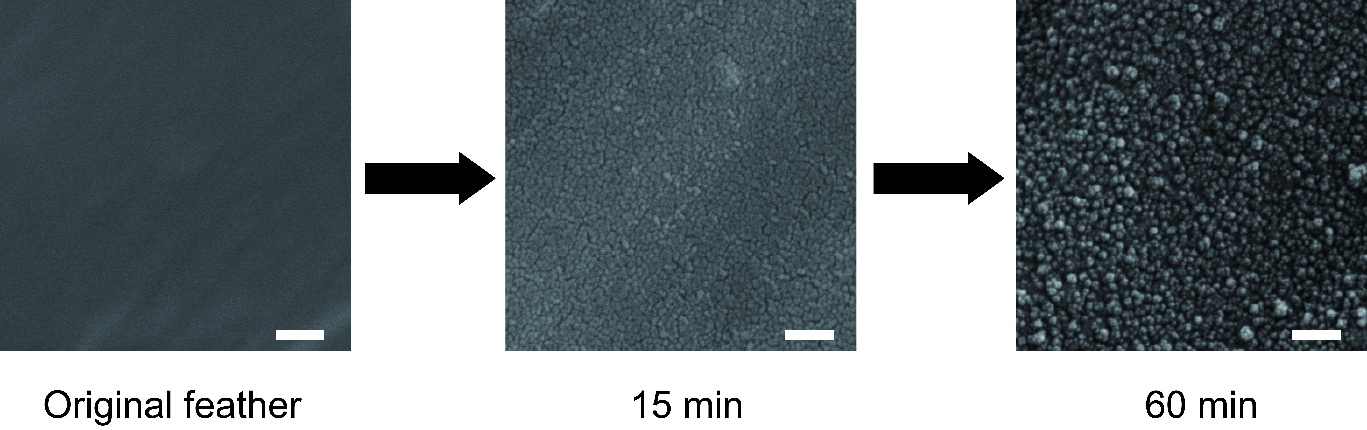
Figure S1. Formation of PbS particles on the pigeon feathers. Sixty minutes were needed for the generation of continuous PbS layers. Scale bars: 200 nm.

