Supplementary Materials
Self assemblly of Ni₂P nanowires as high efficiency electrocatalyst for dye-sensitized solar cells†
Qiwei Jiang, Yongcai Qiu, Keyou Yan, Junwu Xiao and Shihe Yang*
Department of Chemistry, The Hong Kong University of Science and Technology, Clear Water Bay, Kowloon, Hong Kong (China)

I. Supplementary Data

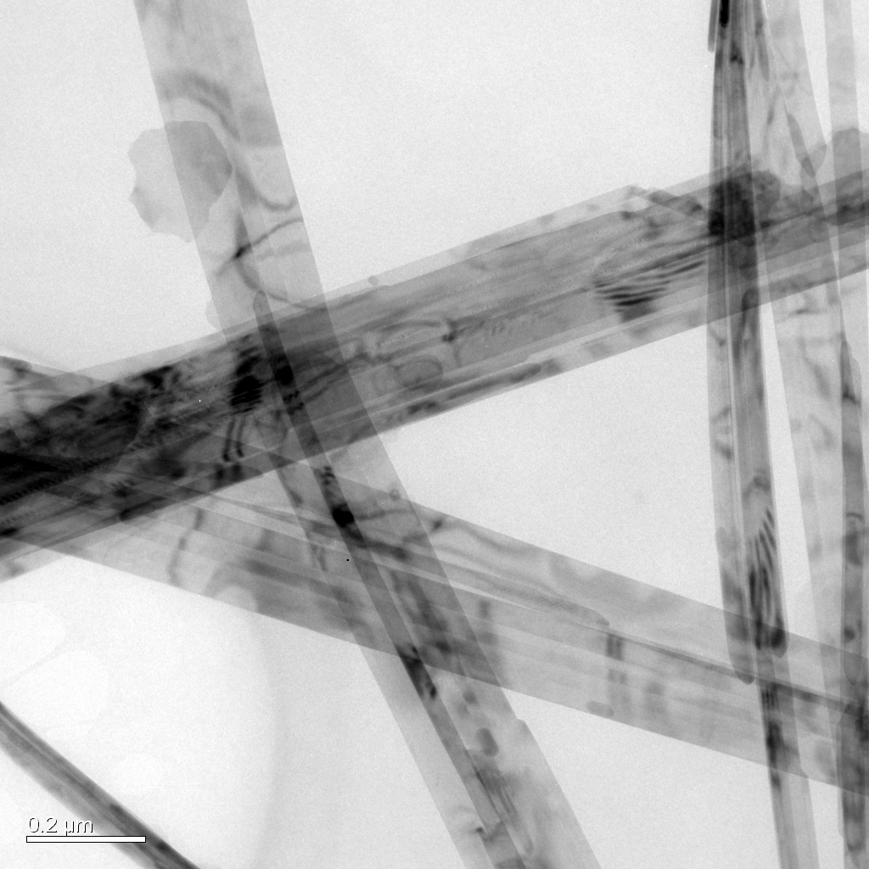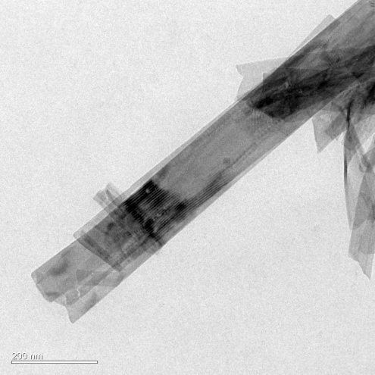

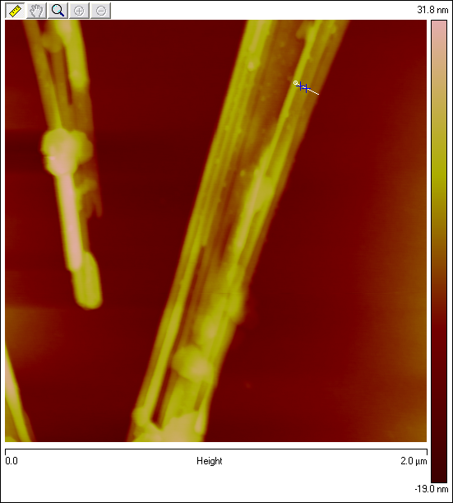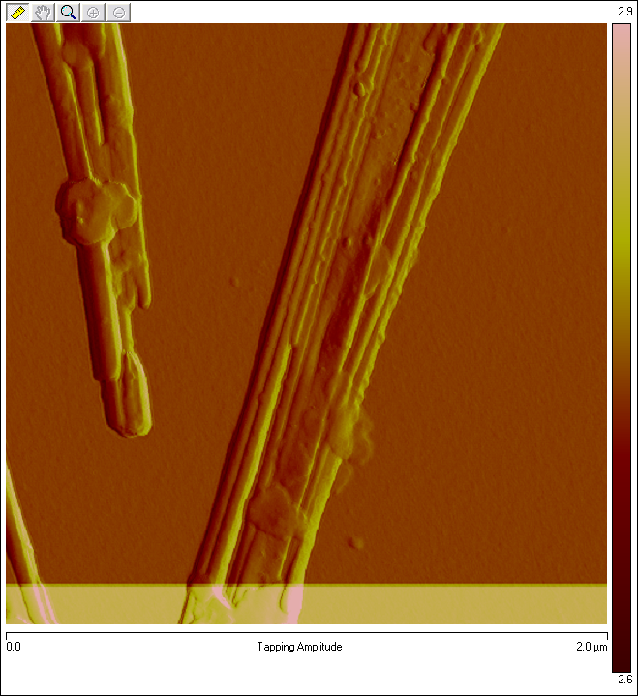
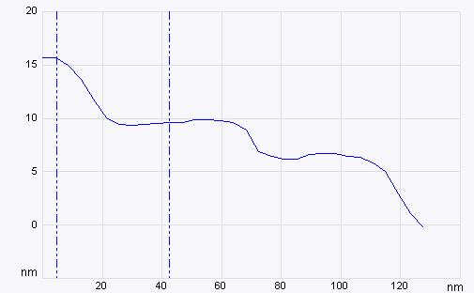

FIG. S1 TEM and AFM images of Ni(SO₄)_{0.3}(OH)_{1.4} nanobelts, illustrating the thickness of the nanobelts is about 4-6 nm.

FIG. S2 SEM images of Ni(SO₄)_{0.3}(OH)_{1.4} nanobelts (a), Ni₂P nanowires (b, c), Ni₂P nanowires 400 °C sintered in Ar atmosphere (d).

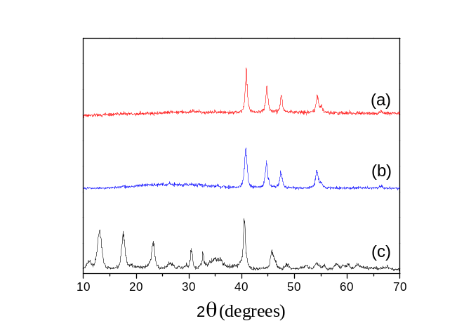
FIG. S3 XRD patterns of as-formed Ni₂P nanowires (a), Ni₂P nanowires sintered at 400 °C in Ar atmosphere (b), Ni(SO₄)_{0.3}(OH)_{1.4} nanobelts (c).
Ni(SO₄)_{0.3}(OH)_{1.4} Nanobelts |  | Ni₂P nanowires
d(nm) | (h,k,l) | d(nm) | (h,k,l)
0.795 | (1,0,0) | 0.23733 | (1,1,1)
0.681 | (0,0,2) | 0.21762 | (2,0,1)
0.5083 | (1,0,2) | 0.20587 | (2,1,0)
0.3944 | (2,0,0) | 0.18111 | (3,0,0)
0.3859 | (1,0,3) | 0.13636 | (2,1,1)
0.3775 | (2,0,1)
0.339 | (0,0,4)
0.3052 | (2,0,-3)
0.2946 | (0,1,0)

Table S1 Corresponding main lattice parameters summarized from the XRD, illustrating the lattice shrink of the transaction from Ni(SO₄)_{0.3}(OH)_{1.4} nanobelts precursor to Ni₂P nanowires.[See references Ref.S1 and Ref.S2]

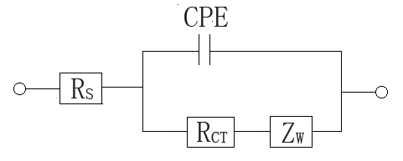
FIG. S4 Equivalent circuit of EIS for the CE-CE cell. R_{s} is a sheet resistance, CPE is a constant phase element, R_{CT} is a charge-transfer resistance, Z_{W} is Nernst diffusion impedance.

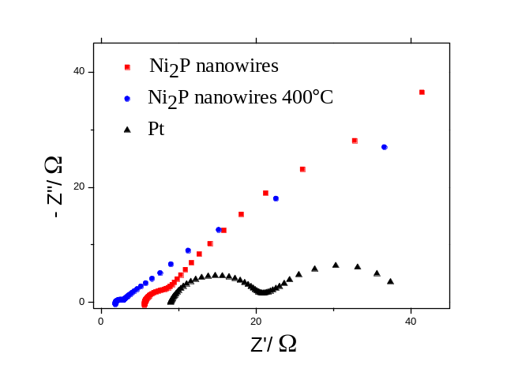
FIG. S5 Nyquist plots in a cell configuration consisting of two counter electrodes, the electrodes using the as-formed Ni₂P nanowires, Ni₂P nanowires sintered at 400 °C in Ar atmosphere and Pt, respectively. The cells were measured with the frequency range of 100 kHz - 100 mHz. The fitted electrochemical parameters from EIS are also summarized in Table 1.
The photovoltaic performance here is mainly related to the surface electrocatalytic activity of different counter electrodes, which can be obtained from electrochemical impedance spectra (EIS, see FIG. S5 and Table 1). The surface charge-transfer resistance (11.97 Ω) of the Pt electrode is little, indicating a good electrocatalytic activity. The charge-transfer resistance of the Ni₂P nanowires electrode is 6.13 Ω, which means that the Ni₂P nanowires provide an excellent electrocatalytic activity. In the case of the Ni₂P nanowires 400 °C electrode, the surface charge-transfer resistance is further reduced to 1.26 Ω, much smaller than the typical Pt electrode (11.97 Ω), which results in the excellent conversion efficiency. In the meantime, the capacitance (115.6×10⁻⁵ F) of the Ni₂P nanowires and (143.0×10⁻⁵ F) of the Ni₂P nanowires 400 °C electrodes are larger by two orders of magnitude as compared with that of the Pt electrode (4.9×10⁻⁵ F) owing to the porous structure and large active surface area. This is helpful for the improvement of the photovoltaic performance of the DSSC with the Ni₂P nanowires as the counter electrode.

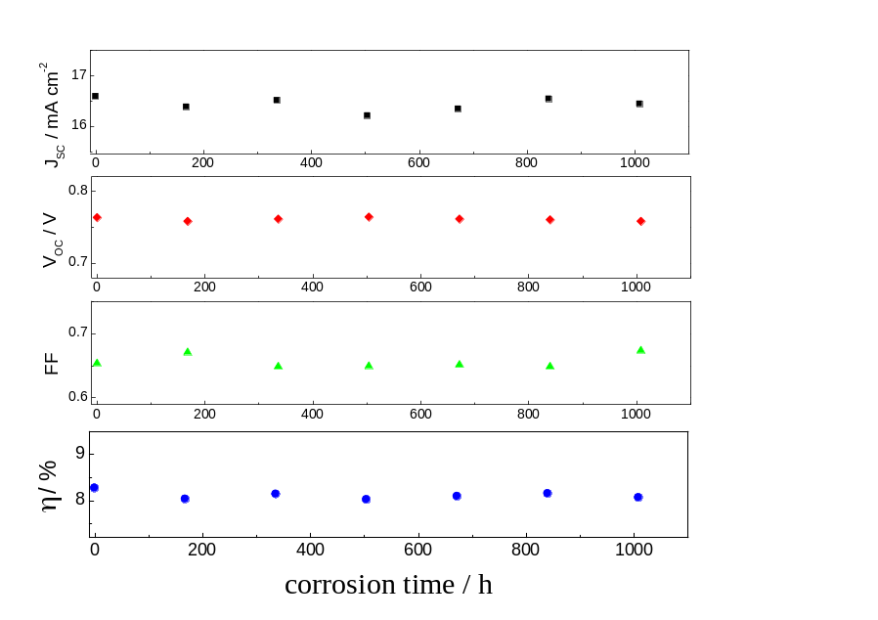
FIG. S6 Corrosion time / efficiency plot. To test the stability of the Ni₂P nanowires in the electrolyte, the counter electrodes made of the Ni₂P nanowires 400°C sintered electrodes were immersed into the electrolyte for different periods of time (corrosion time). The electrodes were immersed into the iodine/tri-iodine containing electrolyte used in this paper, and after different time periods of corrosion, the electrodes were cleaned with ethanol. Using these treated electrodes as the counter electrode of DSSCs, we got the different parameters from the corresponding J-V curves. From the plot, the overall efficiency does not show much decrease after 1000 hours of electrolyte corrosion, indicating the highly stability of Ni₂P nanowires in the iodine/tri-iodine containing electrolyte.

II. Experimental Details
1.22 mM of NiSO₄ . 6H₂0 and 1.65 mM of NaOH was added into 10 ml distilled water respectively, and then the two kind of solution was mixed together quickly under vigorously stir. The acquired solution was sealed into a 20 ml autoclave and heated at 180 °C for 6 hours, freedom cooling to room temperature. After the heating treatment, a green precipitate was obtained. The precipitate was collected from the solution by centrifugation, washed with distilled water and absolute ethanol in turn for three times. The resulting precipitate was the Ni(SO₄)_{0.3}(OH)_{1.4} nanobelts. Then disperse the Ni(SO₄)_{0.3}(OH)_{1.4} nanobelts precipitate into 20 ml toluene through vigorously stir. The acquired mixture was transferred into a 20 ml autoclave made of polytetrafluoroethene, then add 0.2 g of yellow phosphor into the autoclave, and heated at 200 °C for 6 hours, freedom cooling to room temperature. The resulting black precipitate containing Ni₂P nanowires were washed with toluene, ethanol and water respectively, until there is no phosphor and no smell. The structure and morphology of the resultant samples were detected using X-ray diffraction (XRD, model PW1825), scanning electron microscopy (SEM, JEOL6700F) and Transmission Electron Microscope (TEM, JEOL 2010F).
The prepared Ni₂P nanowires was dispersed in the ethanol, on the surface of the nickel foil (0.3mm in thickness), Ni₂P nanowires electrode (about 10 μm in thickness) was prepared by coating a layer of Ni₂P nanowires onto the surface of the metallic Ni foil (300 μm in thickness) with doctor scraping method. The prepared Ni₂P nanowires counter electrodes was sintered at 400 °C for 1h in flowing Ar atmosphere, and then the tubular furnace was cooled down to the room temperature. So the Ni₂P nanowires 400 °C film (about 10 μm in thickness) was got.
The mirror-like FTO/Pt (about 3-4Ω/sq) electrode was obtained by sputtering a platinum layer on the surface of fluorine-doped transparent conductive oxide (FTO, 15Ω/sq, Nippon Sheet Glass)
Dye-sensized porous TiO₂ film was prepared similar similar with the papers reported.^{[12]} The FTO glass plate was washed with water and ethanol, and treated with 40 mM TiCl₄ aqueous solution at 70 °C for 30 min to make a good interfacial contact between the TiO₂ layer and the conducting glass plate. Then adhesive tape was used fixed on the four sides of the conducting glass sheet to restrict the thickness and the apparent surface area of porous TiO₂ film. The TiO₂ colloid was spread on the FTO glass plate using a doctor scraping technique. After drying, a TiO₂ film (12 μm thick) was formed. After the calcination at 450 °C for 30 min in air, the TiO₂ film was treated with 40 mM TiCl₄ aqueous solution at 70 °C for 30 min, and then washed with distilled water. Finally, the semi-transparent porous TiO₂ film was formed by firing the conducting glass sheet at 450 °C for 30 min in air. After cooling to 80 °C, the TiO₂ film was immersed in 2.5×10⁻⁴ M ethanol solution of Ruthenium 535 bis-TBA (N719, Solaronix SA) for 24 h, then the dye-sensitized TiO₂ film was washed with anhydrous ethanol and dried in moisture-free air.
Dye-sensitized solar cells were assembled by injecting the electrolyte into the aperture between the sensitized TiO₂ porous film electrode and the counter electrode. The liquid electrolyte composed of 0.03 M I₂, 0.3 M 1,2-dimethyl-3-propylimidazolium iodide (DMPII), 0.1 M guanidinium thiocyanate and 0.5 M 4-tert-butyl pyridine (99 %, Aldrich) with acetonitrile as the solvent. Insulated adhesive tape was used as the spacer between the two electrodes. The two electrodes were clipped together and solid paraffin was used as sealant to prevent the electrolyte solution from leaking. The effective cell size was 0.25 cm².
The light source (Oriel solar simulator, 450W Xe lamp, AM1.5 global filter) was calibrated to 1 sun (100 mW cm⁻²) by using an optical power meter (Newport, model 1916-C) equipped with a Newport 818P thermopile detector. Both the photocurrent-voltage (J-V) characteristic curves of the DSSCs and the electrochemical impedance spectroscopy (EIS) of the counter electrodes were recorded using an IM6ex (Zahner, Germany) electrochemical workstation. The frequency range was from 100 kHz to 100 mHz.

References
[Ref.S1] K. Zhang, J.B. Wang, X. L. Lu, L. Y. Li, Y. W. Tang and Z. Y. Jia, J. Phys. Chem. C , 113, 142(2009).
[Ref.S2] S. L. Liu, X. Z. Liu, L. Q. Xua, Y. T. Qian and X. C. Ma, J. Crystal Growth, 304, 430(2007).

