Supplementary Material
“Strain Induced Phase Transformation and Piezoresistivity in VO₂ Nanowires”
The VO₂ nanowires studied in this work were grown in a home-built tube furnace. An alumina crucible contaminated with VO₂ powder (99.9% pure, Aldrich) was placed in the furnace and oxidized Si (100) substrates were positioned in the vicinity of the powder. The furnace was heated to 800°C and kept there for 2 hours at a constant flow of Ar at 800 sccm. This leads to the growth of individual nanowires by vapor-solid growth, which is assisted by the oxide of the Si wafer.
In situ tensile testing of the nanowires was carried out inside the vacuum chamber of a FEI Nova Nanolab 200 dual beam focused ion beam and scanning electron microscope. Many of the as-grown wires were found extending the edges (Fig. S1), which carried two main advantages, (i) harvesting and manipulation of these specimens is relatively easy since the manipulator can be brought close to the edge to grip and break off single wires and (ii) since the nanowires grow along the surface the alignment in the focal plane is guaranteed from the beginning. Figure S1 shows a nanowire, which was glued to the tip of a Kleindiek nanomanipulator and separated from the substrate by small movements of the manipulator. Then the individual nanowire was transferred and gripped by local Pt-organic deposition to a transducer on one side and to a flat substrate on the other side and subsequently the nanowire was strained in feedback-enabled displacement control. Tests on 10 nanowires were performed at quasi-constant strain rates of 10⁻⁴/s.
For the electrical measurements the nanowire was gripped by local electron beam induced deposition of a Pt-organic composite between the Kleindiek MM3A manipulator, which is also used for harvesting, and a piezo actuator equipped with the same W probe on the other side. A schematic of the testing setup is shown in Figure 4A of the main manuscript. Displacement was applied by the piezo actuator and the corresponding tensile strain was measured by digital image correlation (DIC). Using a Keithley 2400 series source meter, a constant voltage was applied between the two tips and currents as low as several nA were measured. In this two point measurements, a voltage between 0.2 and 2.0 V was applied in steps of 0.1 V until a current could be detected. The wire was then strained and the current vs. time as well as the scanning electron microscopy (SEM) images were recorded.
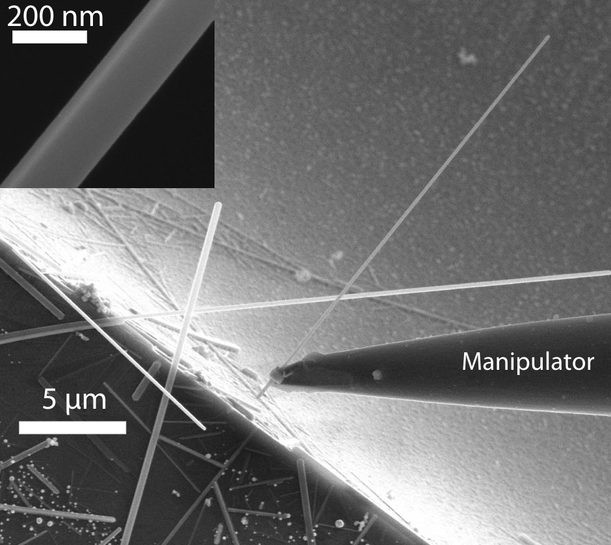
Figure S1: Growth and manipulation/harvesting of the nanowires. VO2 nanowires are growing along the Si substrate. If wires grow close to the edges they extend over the edges of the substrate, which makes them easy to harvest and assures that the in-plane alignment is good. The wire is glued to the manipulator tip and separated from the substrate. The inset shows the facets of the single crystal.

