Supplemental Figures

Figure S1. Artistic rendering of a dominant shear band for a ZrCuAl nanowires with a 17 K/ns quenching rate at 12% compressive strain. The regions that do not participate in deformation (low local strain) are transparent while regions that deform are opaque. The nanowire is rotated along the cylindrical axis so that the shear band plane is perpendicular to the paper plane. It is evident from this transparent view that there is only one dominant shear band formed during compression (highly localized plastic deformation).

Figure S2. Shear band initialization and propagation for ZrCuAl nanowires with a 17 K/ns quenching rate. The viewpoint is along the nanowire axis and the strain ranges from 6 to 8%. Atoms with a local shear strain lower than 20% are not shown for clarity. Zr, Cu and Al atoms are colored blue, red and green, respectively.

Figure S3. Percentage of icosahedral centers over all atoms within MG nanowires as the projected position (shown in the inset graph). The projection direction is chosen such that the shear band at 12% nominal strain is perpendicular.

Figure S4. Deformation morphologies for ZrCuAl nanowires with three quenching rates under uniaxial compression tests (0.00001 ps⁻¹ , or 10% of those plotted in Figure 2 in the main text) at 12% nominal strains. Gray indicates zero local shear strain while black indicates 35% local shear strain.

Figure S1

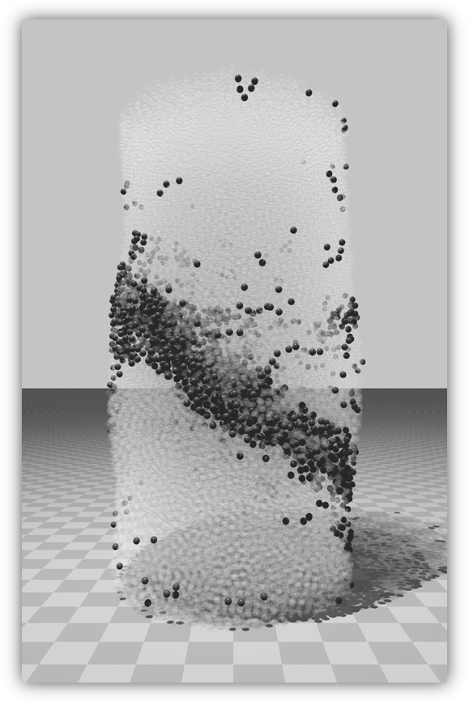

Figure S2

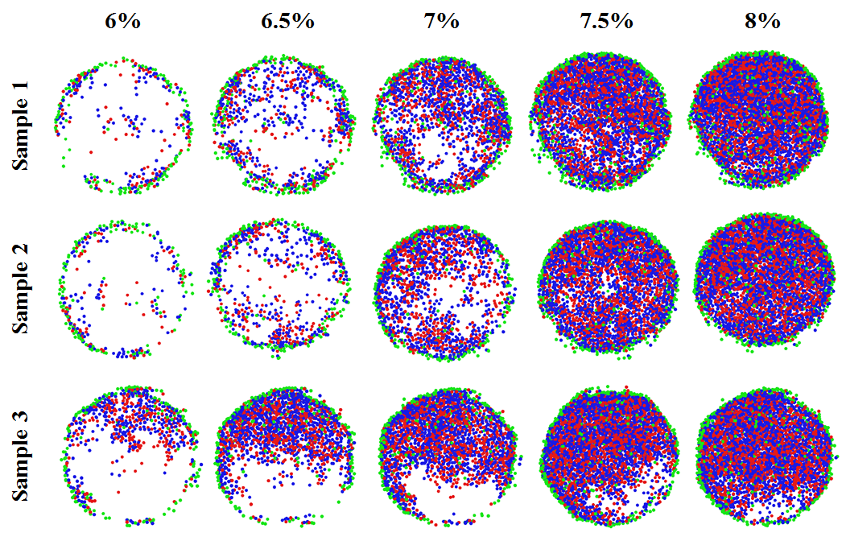

Figure S3

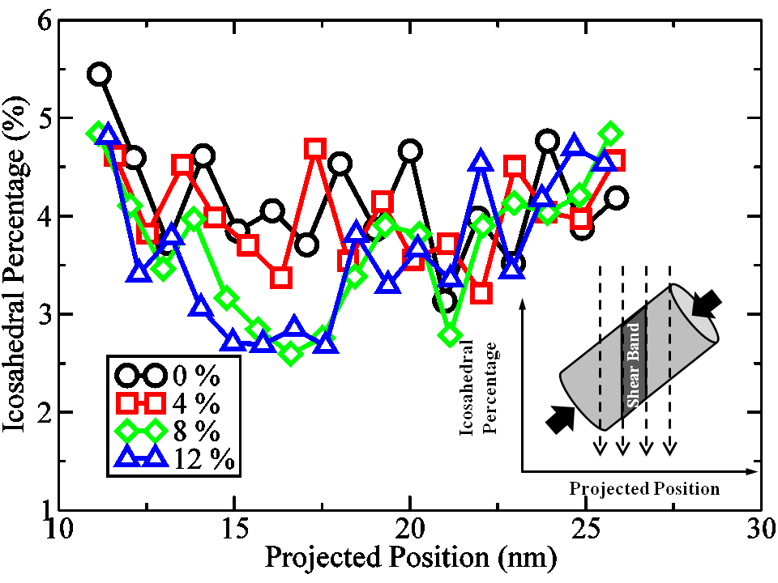

Figure S4



