Supporting Information
Strong Piezoelectricity in Individual GaN Nanowires

Majid Minary-Jolandan, Rodrigo Bernal, and Horacio Espinosa
Department of Mechanical Engineering
Northwestern University, Evanston IL 60208-3111

Frequency Sweep
FIG. S1 shows the frequency sweep acquired on the NW, indicating the insensitivity of the measured piezoresponse to the applied frequency in the experimental range.
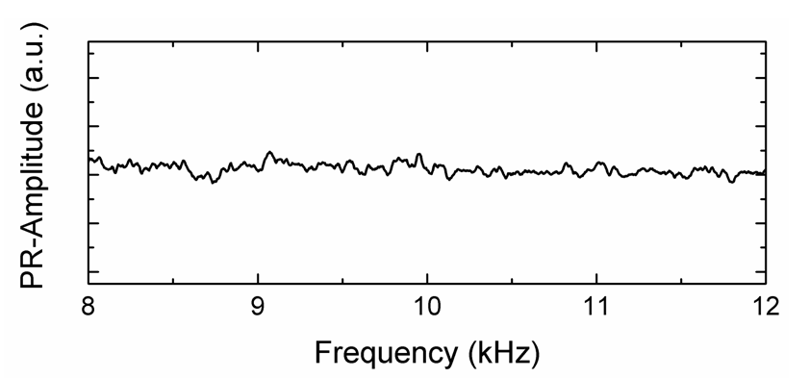
FIG. S1 Lateral piezoresponse amplitude vs. frequency, for a GaN NW

Performance of the PFM setup
The performance of the PFM setup was examined by imaging piezoelectricity in calibration samples of polycrystalline PZT films. Figure S2 shows the topography, amplitude and phase image obtained in vertical PFM mode from from PZT sample under 8V_{pp}. Piezoelectric domains clearly appear as expected, particularly in the phase image.
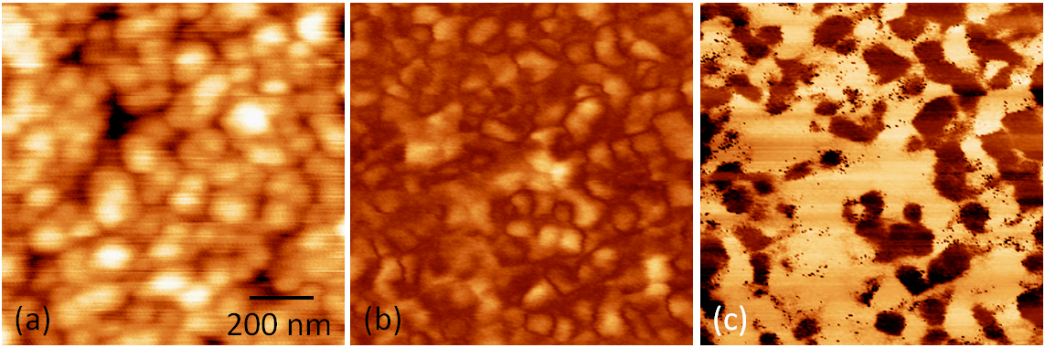
FIG. S2 PFM images obtained on polycrystalline PZT sample. (a) Topography, (b) PFM amplitude, and (c) PFM phase image obtained in 10 kHz, under 8V_{pp}.

Calibration of Lateral Sensitivity using Single Crystal LiNbO₃
Calibration of the lateral sensitivity in PFM is nontrivial. We calibrate the lateral sensitivity using optical-grade Y-cut single crystal LiNbO₃ . LiNbO₃ belongs to 3m crystal symmetry, with a strong in plane shear response, 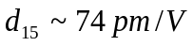 . Y-cut single crystal was aligned with its Z-axis perpendicular to the long axis of the cantilever. The same alignment was used for the nanowires. Lateral PFM response was acquired under sweeping AC voltage up to 10 V_{pp}, and 10 kHz, the same conditions as for the nanowires. A representative lateral response is shown in FIG. S3. The same cantilever was used for the measurements on the GaN NWs.
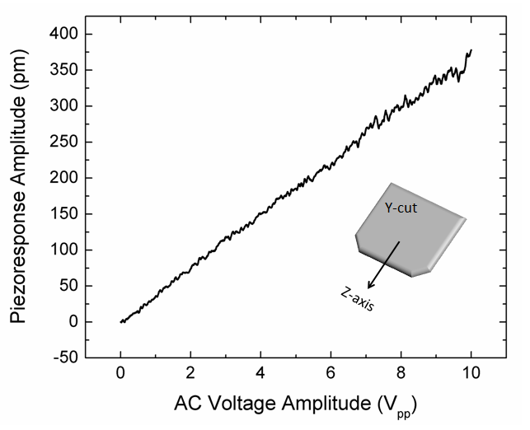
FIG. S3 The acquired lateral piezoresponse from the Y-cut single crystal LiNbO₃.

Vertical PFM on GaN Nanowires
Vertical PFM, which measures the out-of-plane deformation in the sample through monitoring the flexural bending of the cantilever, was performed on a GaN nanowire. FIG. S4 (a) and (b) shows the topography and vertical PFM amplitude response obtained from a GaN NW. As clear from the contrast, the top facet shows the same contrast as the substrate indication of no piezoresponse. Only the side facets shows a weak piezoresponse that results from the contribution from the 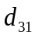 piezoelectric constant, which should be negative for GaN [3].

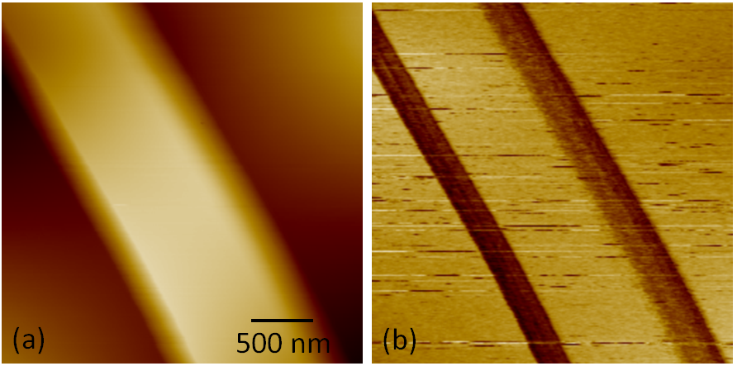
FIG. S4 (a) Topography, and (b) vertical PFM response from a nanowire with 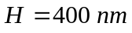. As it can been the vertical signal is absent from the top facet, and only the lateral facets show a weak response

1. Bdikin, I.K., J. Gracio, R. Ayouchi, R. Schwarz, and A.L. Kholkin, "Local piezoelectric properties of ZnO thin films prepared by RF-plasma-assisted pulsed-laser deposition method ", Nanotechnology, 2010. 21: p. 235703.
2. Newnham, R.E., Properties of materials: anisotropy, symmetry, structure. First ed. 2005, New York: Oxford University Press.
3. Bernardini, F. and V. Fiorentini, "First-principles calculation of the piezoelectric tensor d of III–V nitrides", Applied Physics Letters, 2002. 80: p. 4145.

