- Compared experiment for the random fiber laser (RFL) output supercontinuum(SC) with feedback introduced after and before the pump laser at low pump power
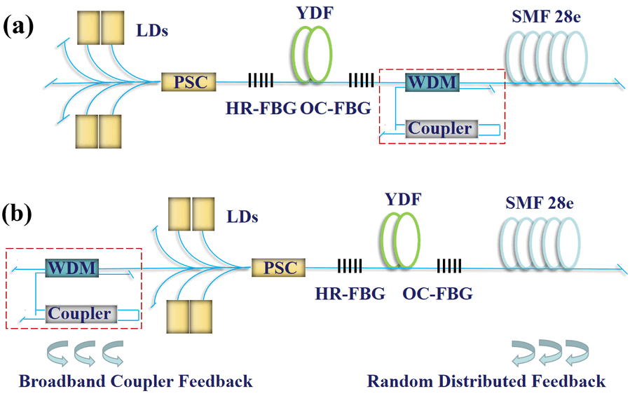
Figure 1 Experiment setup of half-opened RFL with feedback introduced (a) after and (b) before the pump laser.
The position of the loop mirror means where the feedback is introduced. Figure 1(a) and 1(b) show the schematic diagrams of the half-opened RFL with feedback introduced after and before the pump power, respectively. Both structures consist of a 1064 nm fiber oscillator, a piece of 2 km SMF 28e, a 1064/1120 nm wavelength division multiplexer (WDM), and a loop mirror formed by the coupler with the bandwidth of 1064±10 nm. The fiber oscillator is formed by four 976 nm laser diodes (LDs), a pump/signal combiner, a piece of 10/130 μm ytterbium-doped fiber (YDF), and a pair of high-reflectivity fiber Bragg grating (HR-FBG) and output coupler fiber Bragg grating (OC-FBG). The broadband feedback is provided by the loop mirror. Different from Fig. 1(a), the light with different wavelengths in Fig. 1(b) will pass through the YDF multiple times in the feedback loop formed by the broadband loop mirror feedback and random distributed feedback provided by the SMF 28e, forming a broadband wavelength oscillation. Fiber output end and all idle fiber output ends of the system are cleaved at an angle of 8°to prevent end-face feedback.
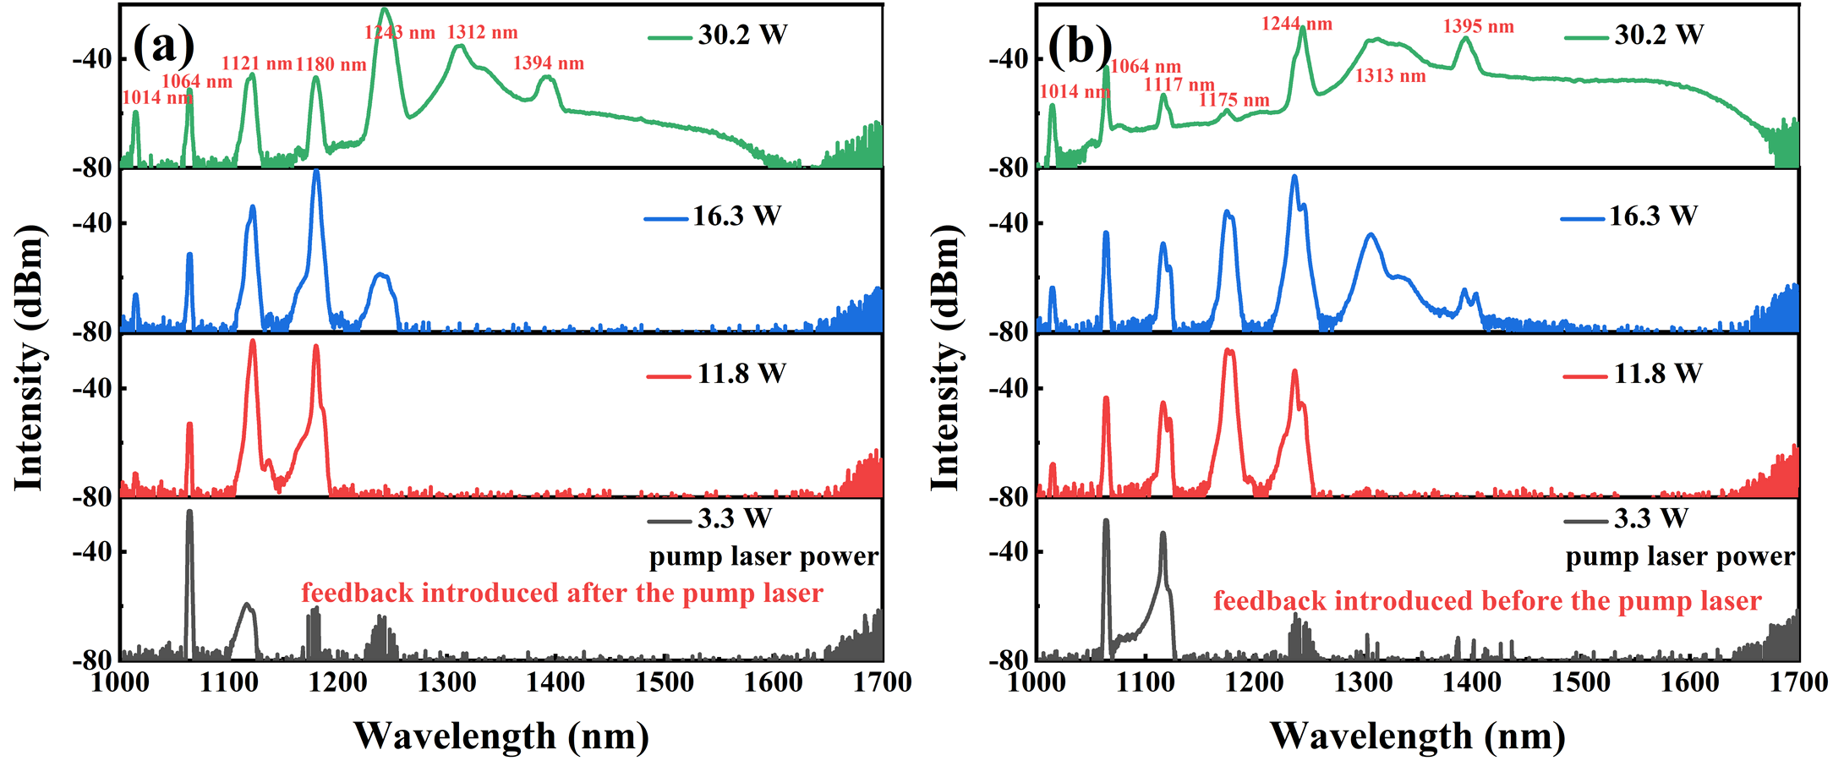
Figure 2 SC evolution of feedback introduced (a) after and (b) before the pump laser.
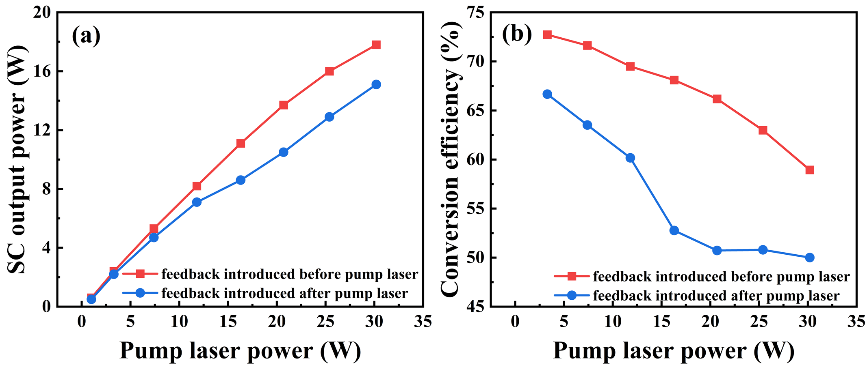
Figure 3 (a) SC output power and (b) optical efficiency versus pump laser power
Figure 2(a) and 2(b) show the measured results for SC spectral evolution with feedback introduced after and before the pump laser, respectively. It can be seen that by comparing Fig. 2(a) and 2(b) at the same pump power, the output spectrum is extended obviously when the feedback is introduced before the pump laser. This is due to the light with different wavelengths will pass through the YDF multiple times in the feedback loop formed by the broadband loop mirror feedback and random distributed feedback, forming a broadband wavelength oscillation and enhancing the energy transfer to the whole spectrum of SC.
Figure 3(a) shows the SC output power versus pump laser power with the feedback introduced after and before the pump laser and Fig. 3(b) shows the dependence of SC conversion efficiency on pump laser power with the feedback introduced after and before the pump laser. When the pump laser power reaches 16.3 W, the conversion efficiencies of SC with feedback introduced after and before the pump laser are 53% and 68%, respectively. At this time, they difference of the SC conversion efficiency is the largest. With the pump laser power increasing to the maximum value of 30.2 W, the conversion efficiencies of the SC with feedback introduced after and before the pump laser are 50% and 59%, respectively.
Based on the above discussion, we can see that the obvious SC spectrum improvement, the boosting of SC output power and conversion efficiency are occurred in the half-opened RFL with feedback introduced before the pump laser.

