Supplementary Information for Angle amplifier in 2D beam scanning system based on peristrophic multiplexed volume Bragg gratings
Yuanzhi Dong^{1,2,3}, Yunxia Jin^{1,3,4}, Fanyu Kong^{1,3*}, Jingyin Zhao^{1,3}, Jianwei Mo^{1,3}, Dongbing He^{1,3}, Jing Sun^{1,3}, and Jianda Shao^{1,2,3,4,5}
1 Thin Film Optics Laboratory, Shanghai Institute of Optics and Fine Mechanics, Chinese Academy of Sciences, Shanghai 201800, China
2 School of Physical Sciences, University of Science and Technology of China, Hefei 230026, China
3 Key Laboratory of High Power Laser Materials, Shanghai Institute of Optics and Fine Mechanics, Chinese Academy of Sciences, Shanghai 201800, China
4 CAS Center for Excellence in Ultra-Intense Laser Science, Chinese Academy of Sciences, Shanghai 201800, China
5 Hangzhou Institute for Advanced Study, University of Chinese Academy of Sciences, Hangzhou 310024, China
___________________________________________________________________________
Correspondence to: Fanyu Kong, Key Laboratory of Materials for High Power Laser, Shanghai Institute of Optics and Fine Mechanics, No.390 Qinghe Road, Jiading District, Shanghai 201800, China. Email: kfanyu123@siom.ac.cn

Elimination of the stray valley
Owing to peristrophic multiplexing, other channels may be read out when scanning one grating channel, and several valleys will be detected in the zero-order beam direction. However, the stray light valley (red circle in Fig. S1) appears at an angle that does not coincide with the expected Bragg angle, as depicted in Fig. S1. Hereby, it will be eliminated after the DE calculation of eq. (13) in the main text.
Fig. S1 The scheme to interpretate the elimination of stray valley.
Beam quality and temperature rise measurement.
The high-power performance of the prepared VBGs is tested by the device shown in Fig. S2. The pump source is a power-adjustable fiber laser with a diameter of 2 mm, and the probe laser is the same as in the DE measurement. The pump beam irradiates the sample center at an incident angle of 10° while the probe beam incident at the Bragg angle to the same position on the sample. Diffraction beam is collected by a beam quality analyzer (M2-200s-USB) to measure the M², and an infrared thermal imager is set to observe the temperature rise on the sample surface.
Fig. S2 Scheme of the beam quality and temperature rise measurement.
We see from Fig. S3 that under high power load, the beam quality degradation direction of VBG1 and VBG3 is consistent with the angular dispersion direction, but the M²x of VBG2 perversely maintains at a low level, and even has a downward trend. The abnormity may be attributed to the distortion of grating fringes caused by the non-parallelism of the exposure beams.
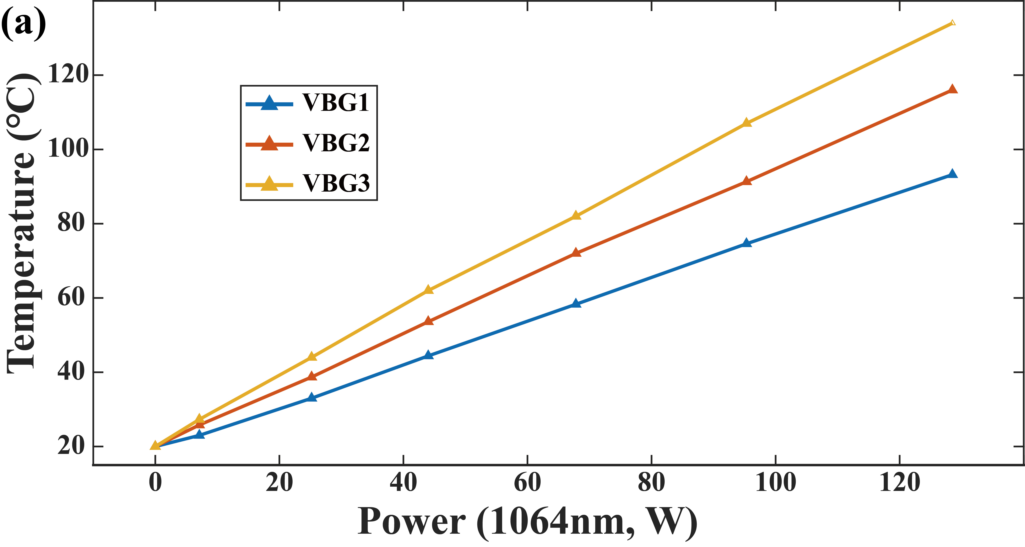
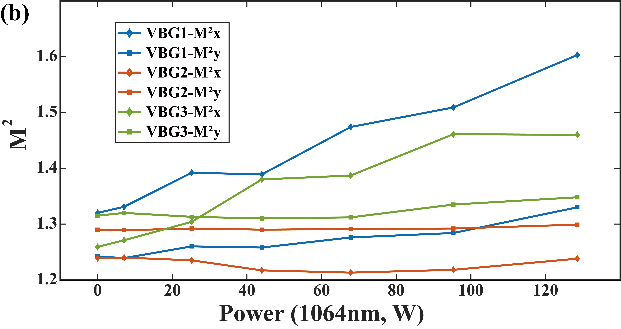
Fig. S3 Temperature rise (a) and M2 (b) at different pump laser power. The M² of the probe source is 1.218 and 1.255 in the x-direction and y-direction.

