Supplementary Material

High-peak-power random Yb-fiber laser with intracavity Raman-frequency comb generation

Xinxing Liu, Wenhui Hao, Zhihui Yang, and Yulong Tang*
Key Laboratory for Laser Plasmas (MOE), School of Physics and Astronomy, Collaborative Innovation Center of IFSA, Shanghai Jiao Tong University, Shanghai 200240, China

*yulong@sjtu.edu.cn

1 The evolution from mode-locking to self-Q-switching
As shown in Fig. 2 (the main context), as the pump power is increased the laser goes through four states, i.e. continuous wave (~0.4-0.58 W), mode-locking (0.58-1.02 W), hybrid state (1.02-1.67 W) and random Q-switching (1.67-3.35 W). To make this dynamics process clearer, detailed evolution from the mode-locked state to the self-Q-switched regime is exhibited in Fig. S1. Figure S1(a) shows the self-mode-locked pulse train under the pump power of 1.02 W (a zoomed-in curve is indicated as the inset). Increasing pump power to 1.12 W, sparsely distributed random giant pulses can be observed (Fig. S1(b)). As such giant pulses generated, their surrounding mode-locked pulses were consumed. Consecutively increasing the pump power, more and more random giant pulses come into being, and the mode-locked pulses are gradually consumed. Finally, when the pump power is increased to 1.67 W, only the Q-switched pulses remain, and the laser transits into the complete random Q-switching state. From 1.58 to 1.67 W pump power (Fig. S1(e) and (f)), it can also be seen that some weak Q-switched pulses are depleted by strong Q-switched pulses, and only those very strong pulses finally sustain. The whole process is indicated in Fig. S1(a)-(f).
Figure S2 shows the radio frequency (RF) spectrum of the laser in the self-mode-locked state under the pump power of 1.02 W (measured with a resolution of 100 kHz). The RF spectrum indicates repetition rate of ~855 kHz (consistent with the 1.17-μs period of the self-mode-locked pulse train) and over 30-dB signal-to-noise ratio (SNR).

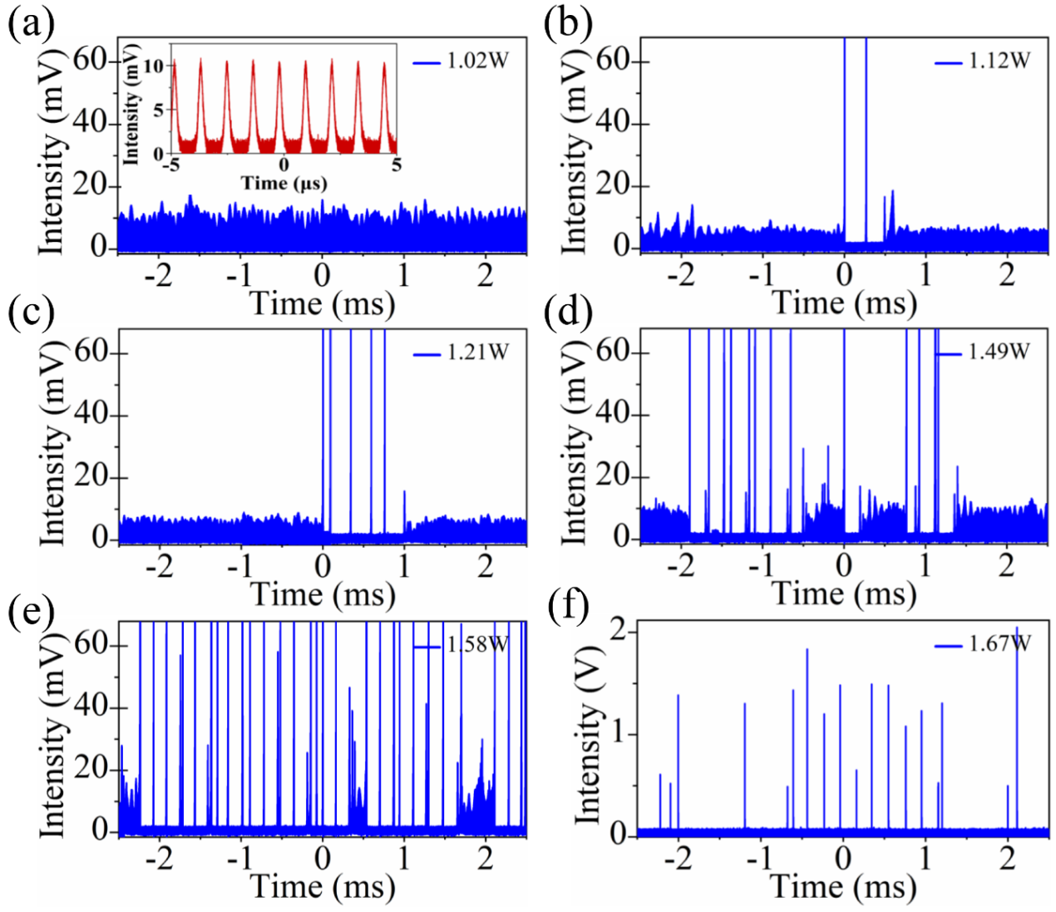
Figure S1. Output dynamics evolution of the laser from mode-locking to self-Q-switching under different pump powers (from 1.02 to 1.67 W). Inset of (a) shows the zoomed-in mode-locked pulse train in the 10-μs window.

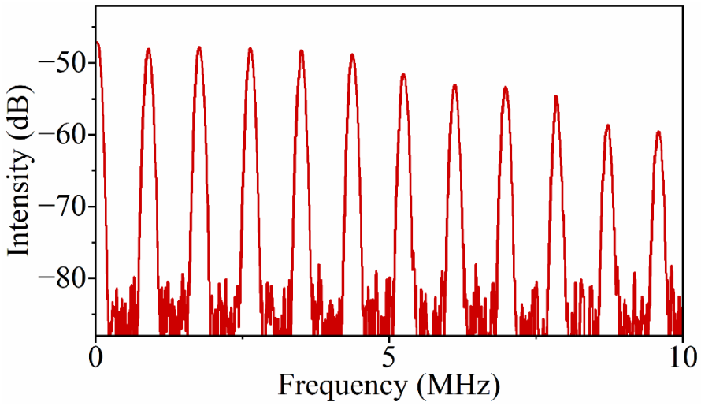
Figure S2. RF spectrum of the laser in the self-mode-locked state under the pump power of 1.02 W.

2 Comparison of mode-locked and self-Q-switched single-pulse
Figure S3 displays typical single-pulse profiles of the laser in the mode-locked (1.02 W) and self-Q-switched (1.67 W) states, respectively. As shown in Fig. S3(a), the mode-locked single-pulse has a pulse width (FWHM) of 200 ns, which is much larger than that (~2.5 ns) of the self-Q-switched pulse (Fig. S3(b)).
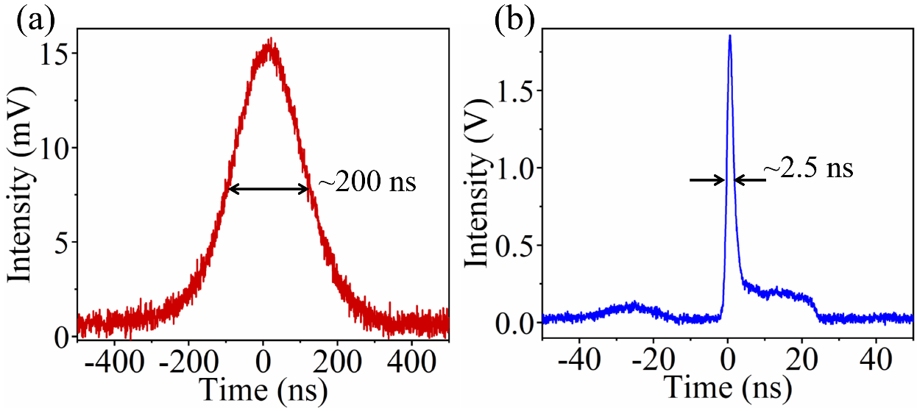
Figure S3. Single-pulse profiles of the laser in (a) the mode-locked state and (b) the self-Q-switched regime.

3 Random pulse train in the Q-switching regime
Unlike conventional Q-switched or mode-locked pulses, the random Q-switched pulses here have significant fluctuations in both the pulse period and pulse intensity. To show that, several pulse trains measured at different times under the same pump power (3.35 W) are indicated in Fig. S4.
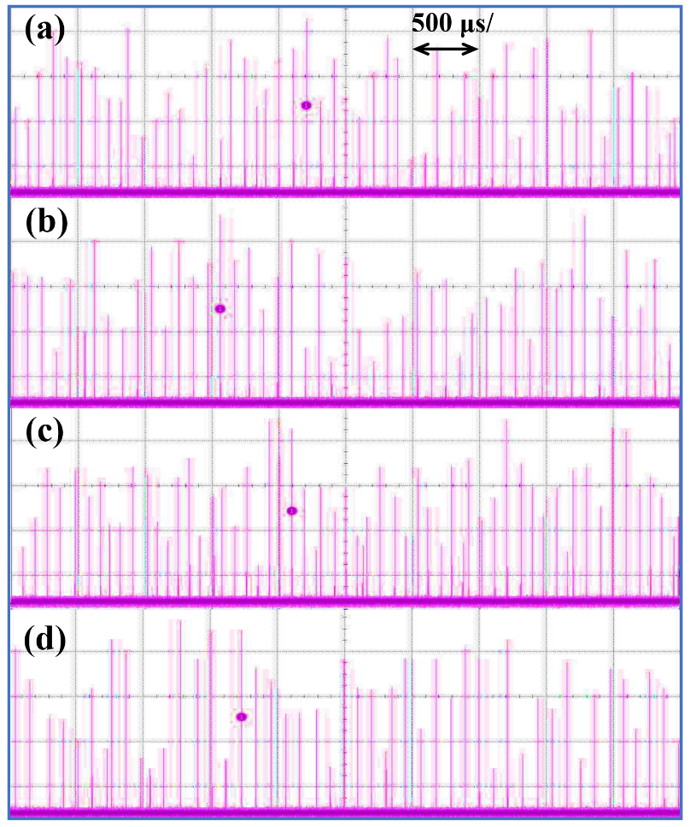
Figure S4. Typical pulse trains measured (pictures taken from an oscilloscope) at different times
under the identical pump power of 3.35 W. The time window is 5 ms.

