Supplementary
Diode-pumped high-power continuous-wave intracavity frequency-doubled Pr³⁺:YLF ultraviolet lasers around 349 nm
Xiuji Lin, Zheng Zhang, Shuaihao Ji, Run Fang, Bo Xiao, Huiying Xu, Zhiping Cai*
Department of Electronic Engineering, Xiamen University, Xiamen 361005, China

Multi-wavelength CW UV lasers
Results
Thanks to the transmission peak broadening effect introduced by the β-BBO crystal, multi-wavelength CW UV lasers could also be obtained by the scheme for the discrete tunable UV lasers. The laser spectra results are presented in Fig. 1. As seen, Multi-wavelength CW UV lasers at 348.7/354.4/360.3 and 348.7/351.1/353.3/356.8 nm were obtained. The output powers of the two lasers were measured to be 63 and 23 mW, respectively. To get the multi-wavelength UV lasers, we first rotated the Lyot filter to achieve multi-wavelength deep red lasers, and then inserted the β-BBO crystal and tilted the β-BBO crystal to find the proper angles for multiple UV emittings. The output powers were low due to the relatively small acceptance angle band of the β-BBO crystal^{[1]}.
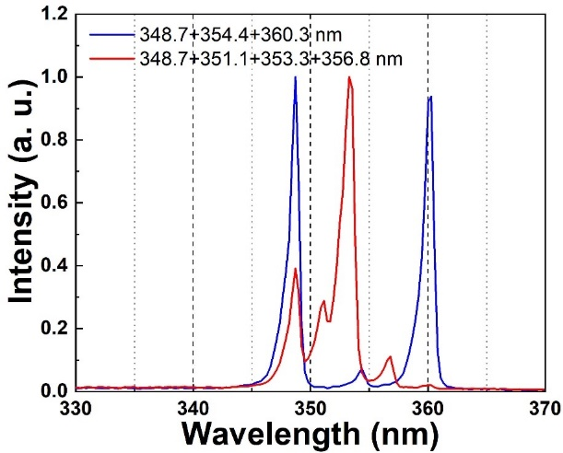
Fig. 1. The laser spectra of the multi-wavelength CW UV lasers.

Analyses
The acceptance angles at different wavelengths could be calculated through^{[2]}:
$ΔθL=\frac{0.886λ_{ω}}{n_{o,ω}^{3}\left|n_{o,2ω}^{-2}-n_{e,2ω}^{-2}\right|sin⁡(2θ)}$ (6)
where $Δθ$ is the acceptance angle, $L$ is the length of the nonlinear crystal, $λ_{ω}$ is the fundamental laser wavelength, $θ$ is the phase-matching angle, the refractivities ($n$) at different frequencies and polarization directions can be intuitively read by the subscripts. The simulation results are presented in Fig. 2. As seen, the acceptance angles of the β-BBO crystal used in the experiment were much smaller than the relative phase-matching angles listed in the previous section. Thus, it’s rational that the conversion efficiencies of the multi-wavelength UV lasers were extremely low.
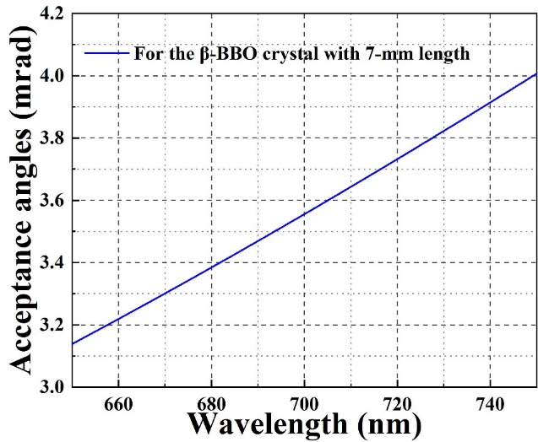
Fig. 2. The acceptance angles of the 7-mm-long β-BBO crystal used in the experiment.

References
1. D. N. Nikogosyan, "Beta barium borate (BBO): A review of its properties and applications," Appl. Phys. Solids Surf. 52(6), 359–368 (1991).
2. T. Kellner, F. Heine, and G. Huber, "Efficient laser performance of Nd: YAG at 946 nm and intracavity frequency doubling with LiJO₃, β-BaB₂O₄, and LiB₃O₅.," Appl. Phys. B Lasers Opt. 65(6), (1997).

