Supplementary Material

Temporal-filtering dissipative soliton in optical parametric oscillator

Hui Tong,a,† Fuyong Wang,a,b,† Zhipeng Qin,a Guoqiang Xiea,*, Liejia Qiana

aShanghai Jiao Tong University, School of Physics and Astronomy, Key Laboratory for Laser Plasmas (Ministry of Education), Collaborative Innovation Center of IFSA(CICIFSA), Shanghai, China, 200240

bHebei University of Engineering, School of Information and Electrical Engineering, Handan, China, 056038

**\*** Guoqiang Xie**,** E-mail: xiegq@sjtu.edu.cn

† These authors contributed equally to this work.

# 1 Numerical Model of Temporal-filtering Dissipative Soliton in OPO

For an idler-resonant OPO, transformed to a frame of reference moving with velocity *vgi* = *∂ω*/*∂ki* by use of coordinate *T* = *t*-*z*/*vgi*, the coupled-wave equations describing OPO and SHG are as follows:

 (1)

 (2)

 (3)

 (4)

 (5)

where *Ep,s,i,*2*i* represent the optical fields of the pump, signal, idler, and SHG of the idler, respectively. *λp,s,i,*2*i* and *np,s,i,*2*i* are the wavelengths and refractive indices, respectively (*λi* > *λs* > *λp*).  and *kp,s,i,*2*i* are their group-velocity dispersions and wave vectors, respectively.  represents group-velocity mismatches of the pump, signal, and SHG of the idler relative to the idler, where *deff* is the second-order nonlinear coefficient. The parameter of the third-order nonlinearity on the idler is expressed by , where *n*2 is the intensity-dependent refractive index coefficient. In the simulation, coupled-wave equations describing OPO and SHG were numerically solved using the split-step-Fourier-transform algorithm, and parameters were chosen to match the experimental setup of Fig. 3.

# 2 Numerical Simulation of Oscillating Pulse when Intracavity Dispersion is Very Small

As shown in Fig. 2(b), the spectral width of the temporal-filtering dissipative soliton can be broadened by reducing the intracavity dispersion. However, when the intracavity dispersion in Fig. 2(b) is further reduced, the numerical simulation results of the spectrum and pulse profile of the oscillating pulse are shown in Figure S1. The chaotic spectrum and pulse indicate that the pulse has collapsed. Therefore, a certain amount of dispersion is necessary for the formation of temporal-filtering dissipative solitons in the OPO.

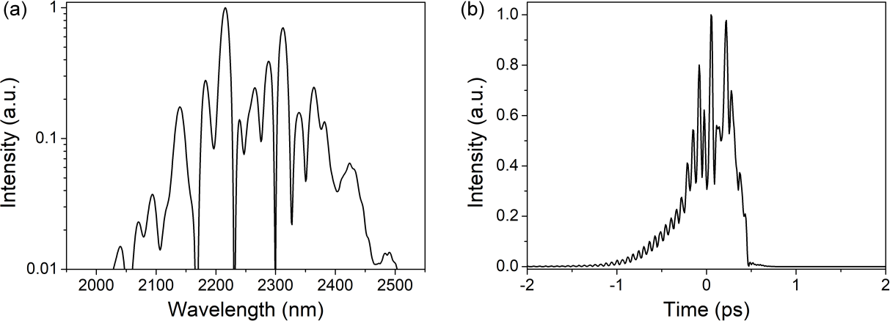

**Fig. S1** Numerical simulation results of spectrum (a) and pulse profile (b) of the oscillating pulse when the intracavity dispersion is 190 fs2.

# 3 Numerical Simulation of Formation Conditions for Temporal-filtering Dissipative Soliton

To further verify the formation conditions of the temporal-filtering dissipative soliton in the OPO, the output characteristics of the idler under four different combinations for positive/negative nonlinear phase shift and normal/anomalous dispersion were numerically simulated. The system parameters were chosen to match the experimental conditions. Figure S2 shows the results of the numerical simulations. For the two cases of positive nonlinear phase shift combined with normal dispersion and negative nonlinear phase shift combined with anomalous dispersion (first and third quadrants in Fig. S2), the output pulses have stable broadband spectra with steep edges and can be significantly compressed. However, for the two cases of positive nonlinear phase shift combined with anomalous dispersion and negative nonlinear phase shift combined with normal dispersion (second and fourth quadrants in Fig. S2), the output spectra are chaotic and unstable. The numerical simulations are consistent with the experimental results, further confirming that a temporal-filtering dissipative soliton can be formed only if the nonlinear phase shift and dispersion have the same sign.

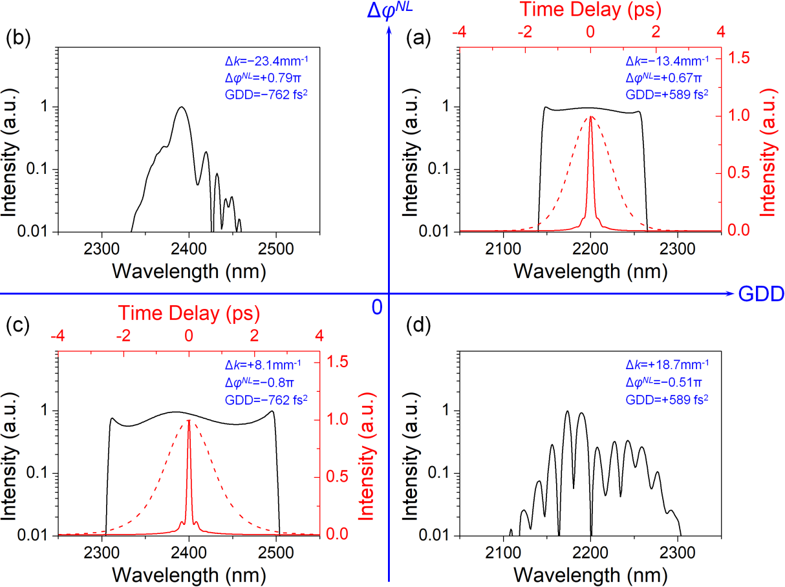

**Fig. S2** Numerical simulation results of OPO for four different combinations of the positive/negative nonlinear phase shift and normal/anomalous dispersion. Black line: spectra of the idler. Red dash line: autocorrelation traces of pulses before compression. Red solid line: autocorrelation traces of pulses after compression. ∆*k*: wavevector mismatch of the SHG process of the idler. Δ*φNL*: single-pass nonlinear phase shift. GDD: net intracavity dispersion. (a), (c): dissipative solitons; (b), (d): collapsed solitons. The system parameters are the same as those shown in Fig. 5.