SUPPLEMENTARY INFORMATION
Fabrication of micron-sized periodic gratings in free-standing metallic foils for laser-plasma experiments
C. C. Gheorghiu ¹, M. Cerchez² , E. Aktan², R. Prasad² , F. Yilmaz², N. Yilmaz², D. Popa ¹, O. Willi², and V. Leca ¹
¹ Extreme Light Infrastructure – Nuclear Physics, Horia Hulubei National Institute for Physics and Nuclear Engineering. 30 Reactorului Street, RO-077125, Magurele, Romania
² Institut für Laser- und Plasmaphysik, Heinrich-Heine-Universität, Universitätstr 1, D-40225, Düsseldorf, Germany

1. Micro-gratings fabrication.
The patterning process of the metallic foils, from cold rolling and cleaning step, to electron beam exposure, development and dry etching, is depicted in Figure S1.
Figure S1. Scheme of the micro-grating process showing the fabrication steps from the as-received metallic foil (Au or Cu) to the patterned foil (representation not at scale).

2. Optimization of the resist removal process
Regarding the optimization of the resist removal, different physical and chemical methods have been used. Physical methods include: Ar-ion milling (using the same conditions as for the cleaning step) and plasma etching in a RIE system, specifically: oxygen plasma (HF at 250 W; ICP at 500 W) and Ar plasma (HF at 250 W). As for the chemical methods, several stripper solutions have been considered, as follows: i) for Cu foils: acetone (at RT and 55 °C), P1316 stripper (tetramethylammonium hydroxide solution <2.5%, at RT and 90 °C); ii) for Au foils: acetone (at RT and 55 °C), nitric acid (HNO₃, ACS reagent, 70%), ACI2 etchant (potassium iodide solution 2.5-10%), P1316 stripper, chloroform, and potassium hydroxide solution (30-50 %). Chemical removers have been used both as a puddle and/or in an ultrasound (US) bath with controlled frequency, time, and temperature.
As the results indicate (Figure S2 for the Cu foil and Figure S3 for Au foil, along with Table S1), washing P1316 stripper (at RT or heated) or with acetone is not sufficient to remove all the remaining resist (Figure S2.a-b, for acetone and Figure S2.c-d, Figure S3.a, for stripper). Long-term US bath (Figure S2.b) or oxygen plasma by RIE process (Figure S2.g) proved to be destructive for the Cu grating-patterns (strong oxidation occurs in the latter case), and insufficient for Au gratings (Figure S3.d-e). Although resist removal for structures on Cu foils (Figure S2.e-f) by means of RIE Ar plasma was more efficient at higher power (HF and ICP) and longer etching time, the process was detrimental to the quality of the gratings and to the smoothness of their edges.
For Au structures, long-term puddle solution of nitric acid (Figure S3.b) was found to be an inefficient removal method (similar as for chemical etching), while the use of short-time puddle solution of Au etchant resulted in a sand-like aspect morphology due to high KI reactivity with the Au surface (Figure S3.c). Chloroform puddle and potassium hydroxide solution (not depicted here) also did not show any significant influence in the removal process.
Table S1. Summary of the efficiency of the physical and chemical methods used in this work
Method/solution | Etching conditions | Results (Cu) | Results (Au)
Physical methods
RIE etching O₂ plasma | HF at 250 W; 10 min  ICP at 500 W; 10 min | reduced efficiency  n.a. | average efficiency  increased efficiency
RIE etching Ar plasma | HF at 250 W; 20 min | average efficiency | average efficiency
Ar-ion milling | 100 mA, 450 V, 30 min | complete removal | complete removal
Chemical methods
acetone | puddle and US; 10-25 min;  RT and 55 °C | average efficiency | average efficiency
P1316 stripper | 120 min puddle, RT  5 min puddle, 90 °C | reduced efficiency  increased efficiency | increased efficiency  average efficiency
HNO₃ | sol. 70%; 40 min puddle, RT | n.a. | average efficiency
ACI₂ etchant | sol. 2.5-10%; 10 s puddle, RT | n.a. | reduced efficiency
chloroform | puddle, RT | n.a. | reduced efficiency
KOH | sol. 30-50 %, puddle, RT | n.a. | reduced efficiency
Note: reduced efficiency - gratings quality affected; average efficiency - hardened resist remained; increased efficiency - minor amount of resist remained; n.a. - not measured.

Overall, Ar-ion milling process was found to give the best results among the different methods, with complete removal of hardened PMMA resist, and high quality aspect of the gratings (see Figure S2.h and Figure S3.f).
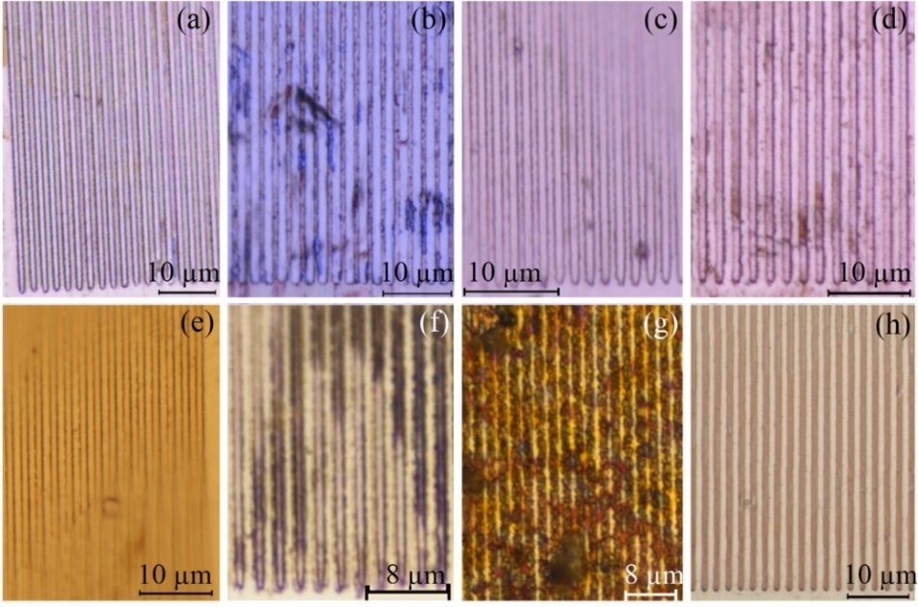
Figure S2. Optical images of Cu foils after different chemical or physical processes used for resist removal: a) acetone puddle, 10 min; b) acetone US bath, 25 min; c) P1316 puddle, 30 min and 2 min US bath; d) P1316 puddle, 5 min and 2 min US bath, both at 90°C; e) RIE Ar plasma, 5 min, HF 150W; f) RIE Ar plasma, 20 min, HF 250W; g) RIE O₂ plasma, 15 min, HF 150W; h) Ar-ion milling, 30 min. Where not mentioned, chemical etching process was performed at RT.
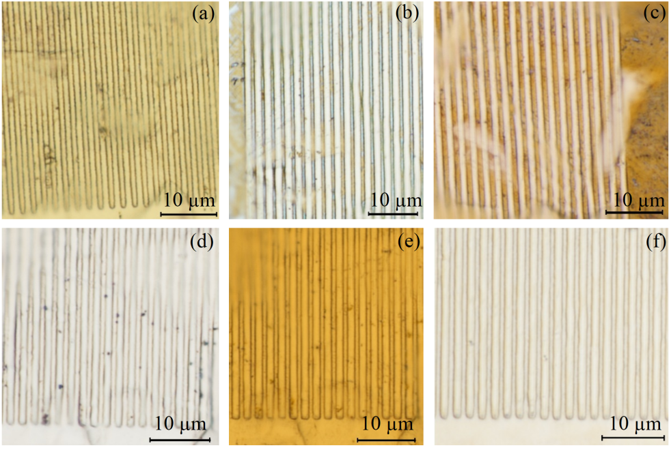
Figure S3. Optical images of Au foils after different chemical or physical processes used for resist removal: a) P1316 puddle, 120 min; b) HNO₃ puddle, 40 min; c) ACI₂ puddle, 10 sec; d) RIE O₂ plasma, 10 min, HF 250W; e) RIE O₂ plasma, 10 min, ICP 500W; f) Ar-ion milling, 30 min and acetone puddle, 10 min. Where not mentioned, the solution was at RT.
Examples of incomplete and optimal development are also given, optical image of an optimized developed structure being shown in Figure S4.a, along with examples of incomplete and over-developed profiles on the Cu foil (Figure S4.b-c). The non-exposed areas show PMMA-gratings of about 200 nm height (with a continuous layer of resist underneath), for incomplete resist development (Figure S4.b), and about 400 nm height, for overdeveloped (Figure S4.c), the height being determined from AFM analysis. The development data indicate not only the amount of resist removal between the structures, but also partial removal of the resist on non-exposed areas for underdeveloped process, with further reduced width of the gratings due to resist overdevelopment.
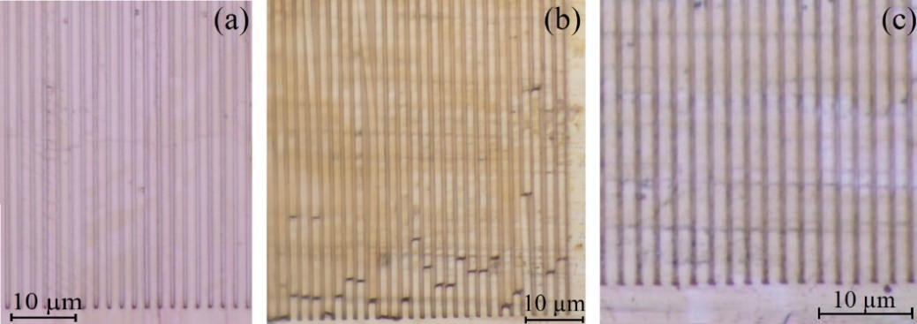
Figure S4. Optical images of Cu foils showing: (a) a complete, (b) underdeveloped, (c) and overdeveloped photoresist pattern.

2. EBSD characterization
In order to determine the modifications of the material microstructure and of the crystallographic orientation due to cold rolling and Ar-ion milling processes, a microstructural-crystallographic analysis has been performed by means of EBSD technique. Furthermore, grain size and grain distribution may have an important effect on the micro-processing of the foils and, therefore, on the quality of the gratings^{[1]}. The average grain size in a metallic material is also closely associated with its physical properties and mechanical characteristics, according to Hall-Petch strengthening relation which mainly describes the strength of a material inversely dependent to the square root of grain size. Also, as Pham et al.^{[2]} numerically and experimentally demonstrated in their study of metallic thin foils (stainless steel sheets, less than 100 μm thick), the grain distribution through foil thickness influences significantly their mechanical properties. In our study the mechanical properties required for the thinned self-supported cold rolled foil and for the patterned structures which have to survive the laser pre-pulse are decisive for an effective target. Any surface polishing of the foils, as preparation for the EBSD analysis, was avoided in order to prevent any mechanical modifications to the surface, especially for the as-received foils. The Inverse Pole Figure maps (IPF) on z-direction (normal to the surface) obtained by EBSD analysis display the orientation data of the crystal grains. Figure S5 illustrates the EBSD data of the Au foils as-received (Figure S5.a,d,g), after cold rolling (Figure
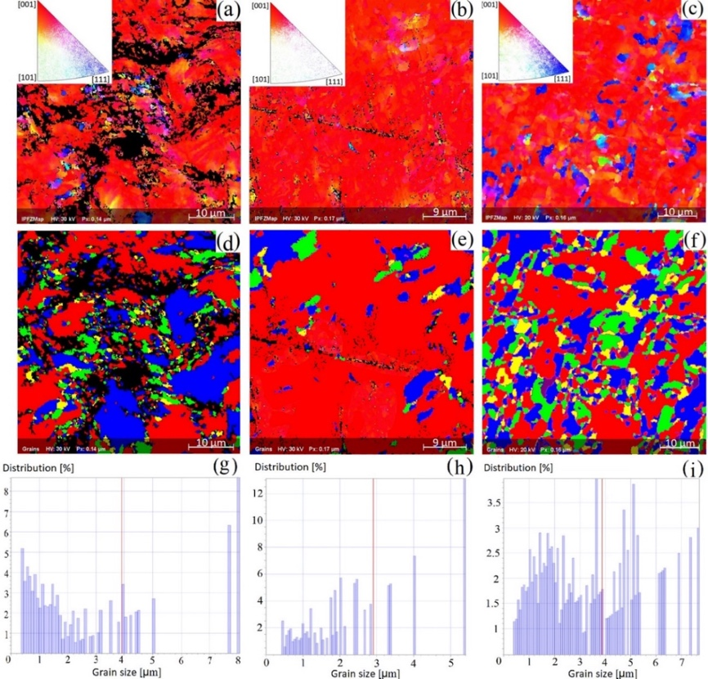
Figure S5. EBSD data analysis for the Au foil: as-received (a,d,g), after cold rolling (b,e,h), and cleaned by Ar-ion milling (c,f,i) representing: inverse pole figure maps (a-c), grains distribution maps (d-f), and area weighted grain size distribution histograms (g-i). Insets: stereographic projections. Note different scale for the distribution histograms.

S5.b,e,h), and after Ar-ion milling cleaning step (Figure S5.c,f,i). Specifically, the IPF maps (Figure S5.a-c), the grains distribution maps (Figure S5.d-f), and the grain size distribution histograms (Figure S5.g-i) are given for Au foils, with similar information in Figure S6 for Cu foils. The insets from the IPF maps in Figure S5 represent the stereographic projections corresponding to Au cubic structure (using Laue group dependent colour index). For the as-received Au foils the crystalline orientation maps showed a non-preferred orientation of the grains (Figure S5.a), while after the cold rolling process a <001> preferred orientation is observed (Figure S5.b). Following the etching step, the IPF map suggests that this process induces also the <111> orientation additionally to the <001> direction (Figure S5.c), thus reverting to the initial crystalline orientations of the as-received foils.
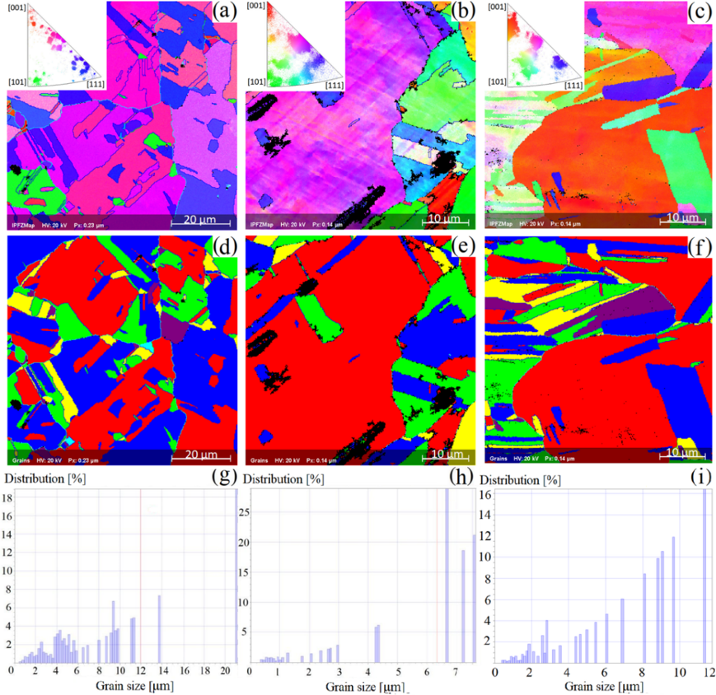
Figure S6. EBSD data analysis for the Cu foil: as-received (a,d,g), after cold rolling (b,e,h), and cleaned by Ar-ion milling (c,f,i), representing: inverse pole figure maps (a-c), grains distribution maps (d-f), and area weighted grain size distribution histograms (g-i). Insets: stereographic projections. Note different scale of the distribution histograms.

This change in the surface orientation may be due to the recrystallization process of the damaged surface layer, which occurs during sample cooling down after etching by Ar-ion milling. It can also indicate a post-cold rolling stress release mechanism through heating during the milling process, the foils reaching temperatures of at least 200 °C during Ar-ion milling. This change in surface orientation with temperature confirms the thermal annealing studies by Mariano et al.^{[3]}, that indicated no preferential orientation for Au foils after thermal treatments up to 970 °C. However, our data indicated that by a simple cold rolling process preferred orientation can be attained, at least on the surface depth probed during EBSD studies. On the contrary in the Cu (cubic structure, space group) foils, the random crystallographic orientation
of the as-received foil is maintained after cold rolling and Ar-ion milling, an indication of less or no influence on the surface microstructure of these processes (see Figure S6.a-c).
Grain distribution maps and distribution histograms show an equiaxed microstructure in the case of Au foils (Figure S5.d-f), with an average equivalent grain diameter of about 4 μm (Figure S5.g-i), while for Cu foils bigger and elongated grains are observed (Figure S6.d-f), with an average diameter of about 8 μm (Figure S6.g-i). It should be noted that the grain colours in the grain distribution map is not related to any orientation information, but automatically assigned by the software as correlated to their neighbours. The results are in agreement with the reported study by Yin et al.^{[4]} on cold-rolled 10 μm thick commercial copper foils, showing elongated, uniform microstructure, with some large grains, similar to the data presented in Figure S6.e-f.
According to the distribution histograms (Figure S5.g-i, for Au; Figure S6.g-i, for Cu), after the surface cleaning by Ar-ion milling a more uniform distribution of the grain size is observed for both metallic foils. Moreover, for Au foils, a more uniform dispersion of the grain size is noticed after the final milling process (Figure S5.f). It is worth mentioning that as EBSD is a surface technique and the diffraction pattern is the result of the electrons coming from the first few tens of nanometres at the sample surface, the conclusions on the surface characteristics of the dry-etched foils do not imply that the same modifications took place also in the “bulk” of the foils.

2. Optimization of the electron-beam lithographic process
Analysis of the interaction of accelerated electrons with the resist and substrate, by means of Monte Carlo simulation, revealed the electron scattering process, allowing the optimization of the acceleration voltage, exposure dosage, and beam step size for gratings structure on different substrate materials. The number of simulated electrons () has been calculated from the correlation with the test dose (Equation 1) and corresponds to 16875 electrons. For this, the experimental tests and the simulated absorbed energy reveal an optimum dose of 300 μC/cm² and 30 nm step size. Accordingly, the program simulated a number of 17 000 electron trajectories, using a beam energy of 30 keV and 18.5 nm beam radius, for 600 nm thick PMMA resist over Au, Cu and, for comparison purposes (low atomic number), also on Si, as substrates.
(1)
The computation data provided the interaction, scattering, and penetration depth of the incident electrons in the material. Figure S7 shows 200 trajectories of the transmitted or absorbed electrons (in blue) and backscattered electrons (in red) for 600 nm thick PMMA on different substrates: Si (Figure S7.a), Cu (Figure S7.b), and Au (Figure S7.c). As observed, for substrates with high atomic number (e.g., Au), the number and spread of the backscattered electrons increase significantly in the PMMA resist, providing an additional exposure (overexposure) of the resist. Hence, a deep undercut and blurred edges of the pattern profile are expected in the case of the metallic substrates, after development. This hypothesis is corroborated by the results of Samardak et al.^{[5]} which compares the high-resolution nanopatterns obtained by EBL
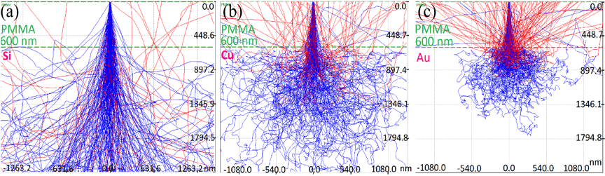
Figure S7. 200 simulated electron trajectories at 30 keV acceleration voltage in 600 nm thick PMMA layer on: (a) Si (Z=14), (b) Cu (Z=29), and (c) Au (Z=79) substrates. The dotted line represents the PMMA-substrate interface.

technique on silicon substrates and on metallized surfaces (gold-coated substrates). They observed similar effects with our results for the resist overexposure for both substrates, silicon and gold. As shown in Figure S7, the interaction volume and the penetration depth of the primary electrons in the substrate decreases with the increase of the atomic number due to electron interaction with heavy atom nuclei, while the angle of the forward scattered electrons widens.
The validation and accuracy of the Monte Carlo simulation have been verified by means of the electron backscatter coefficient (η), which represents the ratio of the number of backscattered electrons over the total primary electron trajectories resulted from the simulation. The obtained coefficient has been subsequently compared with the one calculated according to Love and Scott (Equation 2) and Hunger and Küchler (Equation 3) analytical expressions, extrapolated from E₀=20 keV to 30 keV. The first equation was proposed by Love and Scott^{[6]} as a correction model for the microanalysis measurements. In their study the correction procedure takes into account the atomic number and absorption effects, proving its accuracy for heavy and light-elements data. The latter equation was introduced by Hunger and Küchler^{[7]} which, compared to the previous correction, includes the energy dependence in the analytical expression of η coefficient, thus improving the accuracy especially for low atomic number materials.
The η coefficient according to Love and Scott, η_{L&S}, is expressed as:
(2)
where is the backscatter coefficient associated with electrons of 20 keV energy, while the gradient G(Z) is a function of the atomic number of the foil material, which is expressed as:
The η coefficient according to Hunger and Küchler, , is expressed as:
(3)
Table S2. Comparison of calculated and simulated backscatter coefficients at 30 keV electron energy for Si, Cu, and Au substrates.
Substrate
Si (Z=14) | 0.165 ± 0.003 | 0.169 | 0.157
Cu (Z=29) | 0.299 ± 0.004 | 0.303 | 0.298
Au (Z=79) | 0.493 ± 0.001 | 0.498 | 0.491

where m(Z) and c(Z) are the following calculated continuous functions:
In all equations Z is the atomic number of the substrate and E₀ is the electron acceleration energy (in keV).
As shown in Table S2, the simulated values of the backscatter coefficient () are in good agreement with both theoretical values calculated using Love-Scott or Hunger-Kuchler equations, confirming the coefficient tendency to increase with the atomic number of the substrate. The obtained results are in correlation with the reported data by Zhu et al.^{[8]} who compared the behaviour of Si and Au substrates for fabrication of complex nanostructures by means of Casino modelling simulation. Their study indicated a similar increase of the η BSE coefficient with the atomic number of the substrate, with comparable η coefficients, leading to a more pronounced proximity effect for the Au substrate.

References
1 Wu, X., Li, L., He, N., Zhao, M. and Zhan, Z., Int. J. Adv. Manuf. Technol., 79, 321–327, (2015).
2 Pham, C. H., Thuillier, S. and Manach, P.-Y., Mater. Sci. Eng. A, 678, 377–388, (2016).
3 Mariano, R., Mckelvey, K., White, H. and Kanan, M., Science (80-. )., 358, 1187–1192, (2017).
4 Yin, X.-Q., Peng, L.-J., Kayani, S., Cheng, L., Wang, J.-W., Xiao, W., Wang, L.-G. and Huang, G.-J., Rare Met., 35, 909–914, (2016).
5 Samardak, A., Anisimova, M., Samardak, A. and Ognev, A., Beilstein J. Nanotechnol., 6, 976–986, (2015).
6 Love, G. and Scott, V. D., J. Phys. D. Appl. Phys., 11, 1369–1376, (1978).
7 Hunger, H.-J. and Küchler, L., Phys. status solidi, 56, K45–K48, (1979).
8 Zhu, S., Cheng, H.-H., Blakey, I., Stokes, N., Ostrikov, K. (Ken) and Cortie, M., Microelectron. Eng., 139, 13–18, (2015).

